Insurance Intermediaries
Quality Assurance Scheme

Long Term Insurance Examination

Study Notes

2016 Edition

PREFACE

These Study Notes have been prepared to correspond with the various Chapters in the Syllabus for the Long Term Insurance Examination. The Examination will be based upon these Notes. A few representative examination questions are included at the end of each Chapter to provide you with further guidance.

Immediately following the descriptions of some aspects of the practice of long term insurance, you will find actual cases of long term insurance claims, which are there mainly to facilitate your understanding of the subject and to make your learning more interesting. The decisions you will find in those cases were based on their particular facts, including the actual wording used in the insurance policies in question. They being decided cases of the Insurance Claims Complaints Bureau (ICCB), it is worth noting that the Insurance Claims Complaints Panel of the ICCB is empowered by the Articles of Association of the ICCB to look beyond the strict interpretation of policy terms in making a ruling. In addition, as far as good insurance practice is concerned, the Insurance Claims Complaints Panel relies heavily on the expected standards set out in The Code of Conduct for Insurers, with particular reference to “Part III: Claims”.

It should be noted, however, that these Study Notes will not make you a fully qualified underwriter or other insurance specialist. It is intended to give a preliminary introduction to the subject of Long Term Insurance, as a Quality Assurance exercise for Insurance Intermediaries.

We hope that the Study Notes can serve as reliable reference materials for candidates preparing for the Examination. While every care has been taken in the preparation of the Study Notes, errors or omissions may still be inevitable. You may therefore wish to make reference to the relevant legislation or seek professional advice if necessary. As further editions will be published from time to time to update and improve the contents of these Study Notes, we would appreciate your feedback, which will be taken into consideration when we prepare the next edition of the Study Notes.

First Edition: August 1999
Second Edition: June 2001
Third Edition: January 2005
Fourth Edition: June 2007
Fifth Edition: June 2011
Sixth Edition: December 2016

© Office of the Commissioner of Insurance 1999, 2001, 2005, 2007, 2011, 2016

Please note that no part of the Study Notes may be reproduced for the purposes of selling or making profit without the prior permission of the Office of the Commissioner of Insurance.

TABLE OF CONTENTS
Chapter |  |  |  |  | Page
1. INTRODUCTION TO LIFE INSURANCE |  |  |  |  | 1/1
 | 1.1 |  | Definition of Life Insurance |  | 1/1
 |  |  | 1.1.1 | Needs for Life Insurance
 | 1.2 |  | Principles of Life Insurance |  | 1/2
 |  |  | 1.2.1 | Insurable Interest
 |  |  | 1.2.2 | Duty of Disclosure
 |  |  | 1.2.3 | Other Insurance Principles
 | 1.3 |  | Calculation of Life Insurance Premium |  | 1/10
 |  |  | 1.3.1 | Rating Factors
 |  |  |  | a. Mortality, Interest and Expenses
 |  |  |  | b. Other Factors
 |  |  | 1.3.2 | Pricing Systems
 |  |  |  | a. Natural Premium (Pricing) System
 |  |  |  | b. Level Premium (Pricing) System
2. | TYPES OF LIFE INSURANCE AND ANNUITY |  |  |  | 2/1
 | 2.1 |  | Traditional Types of Life Insurance |  | 2/2
 |  |  | 2.1.1 | Term Insurance
 |  |  |  | a. Level/Decreasing/Increasing Term Insurance
 |  |  |  | b. Renewable/Convertible Term Insurance
 |  |  | 2.1.2 | Endowment Insurance
 |  |  | 2.1.3 | Whole Life Insurance
 | 2.2 |  | Non-Traditional Types of Life Insurance |  | 2/6
 |  |  | 2.2.1 | Universal Life Insurance
 |  |  | 2.2.2 | Unit-Linked Long Term Insurance
 | 2.3 |  | Annuities and Pensions |  | 2/9
 |  |  | 2.3.1 | Annuities
 |  |  | 2.3.2 | Pensions
 | 2.4 |  | Group and Individual Insurance Plans |  | 2/11

3. | BENEFIT RIDERS AND OTHER PRODUCTS |  |  | 3/1
 | 3.1 | Disability Benefits |  | 3/1
 |  | 3.1.1 | Disability Waiver of Premium
 |  | 3.1.2 | Disability Income
 | 3.2 | Accident Benefits |  | 3/4
 |  | 3.2.1 | Accidental Death and Dismemberment
 |  | 3.2.2 | Other Accident Benefits
 | 3.3 | Accelerated Death Benefits |  | 3/6
 |  | 3.3.1 | Critical Illness Benefit
 |  | 3.3.2 | Long-Term Care (LTC) Benefit
 | 3.4 | Medical Benefits |  | 3/9
 | 3.5 | Insurability Benefits |  | 3/10
 |  | 3.5.1 | Guaranteed Insurability Option
 | 3.6 | Inflationary Adjustment |  | 3/11
 |  | 3.6.1 | Cost of Living Adjustment (COLA) Benefit
4. | EXPLAINING THE LIFE INSURANCE POLICY |  |  | 4/1
 | 4.1 | Entire Contract Provision |  | 4/1
 | 4.2 | Incontestability Provision |  | 4/1
 | 4.3 | Grace Period |  | 4/4
 | 4.4 | Beneficiary Designation |  | 4/4
 | 4.5 | Nonforfeiture Benefits |  | 4/5
 | 4.6 | Policy Loan |  | 4/6
 | 4.7 | Reinstatement |  | 4/7
 | 4.8 | Misstatement of Age or Sex |  | 4/7
 | 4.9 | Assignment |  | 4/8
 | 4.10 | Dividend Options |  | 4/9
 | 4.11 | Settlement Options |  | 4/10
 | 4.12 | Suicide Exclusion |  | 4/10

5. | LIFE INSURANCE PROCEDURES |  |  | 5/1
 | 5.1 | Company Operation |  | 5/1
 |  | 5.1.1 | Typical Company Operational Structure
 | 5.2 | Application |  | 5/4
 |  | 5.2.1 | Application Procedure
 |  | 5.2.2 | Receipts and Policy Effectiveness
 |  | 5.2.3 | Client Service - Policies and Standards
 |  |  | a. The Importance of Client Service
 |  |  | b. How to Achieve Quality Client Service
 |  | 5.2.4 | Cooling-Off Period
 |  | 5.2.5 | Policy Switching
 |  | 5.2.6 | Sales Illustrations for Linked and Non-Linked Policies
 |  |  | a. Linked Policy Illustration Document
 |  |  | b. Standard Illustration for Universal Life (Non-Linked) Policies
 |  |  | c. Standard Illustration for Participating Policies
 |  | 5.2.7 | Distributions of Policy Dividends
 |  |  | a. Basic Principles of Dividend Distributions
 |  |  | b. Methods of Dividend Distributions
 |  |  | - Advantages of Participating Policies
 |  |  | - Transparency of Life Insurers with regard to Dividends
 |  | 5.2.8 | Guidance Note on Underwriting Long Term Insurance Business (Other Than Class C Business) (GN16)
 |  | 5.2.9 | Initiative on Financial Needs Analysis
 |  | 5.2.10 | Important Facts Statement for Mainland Policyholder
 |  | 5.2.11 | Relevant Guidelines by Approved Bodies of Insurance Brokers

 | 5.3 | Underwriting |  | 5/37
 |  | 5.3.1 | Underwriting Factors
 |  | 5.3.2 | Medical Reports
 |  | 5.3.3 | Sub-Standard Life and Underwriting Measures
 | 5.4 | Policy Issuance |  | 5/41
 |  | 5.4.1 | Policy Delivery
 | 5.5 | After Sales Service |  | 5/42
 |  | 5.5.1 | Policy Changes
 | 5.6 | Claims |  | 5/43
 |  | 5.6.1 | Maturity Claims
 |  | 5.6.2 | Death Claims
 |  | 5.6.3 | Surrenders

APPENDICES
A. | Customer Protection Declaration Form and Explanatory Notes to Customer Protection Declaration Form |  |  |  | 6/1
B. | Information to be disclosed in the Illustration Document for Investment-Linked Policies |  |  |  | 6/7
C. | Standard Illustration for Universal Life (Non-Linked) Policies |  |  |  | 6/10
D. | Standard Illustration for Participating Policies |  |  |  | 6/16
E. | Guidance Note on Underwriting Long Term Insurance Business (Other Than Class C Business) (GN16) |  |  |  | 6/21
F. | Initiative on Financial Needs Analysis |  |  |  | 6/43
G. | Important Facts Statement for Mainland Policyholder  (Only Chinese version available) |  |  |  | 6/48
H. | Guidance Note on Conducting “Know Your Client” Procedures for Long Term Insurance Business (CIB-GN(4)) |  |  |  | 6/52
I. | Guidance Note on Product Recommendation for Long Term Insurance Business (CIB-GN(12)) |  |  |  | 6/55
GLOSSARY |  |  |  | (i) – (xviii)
INDEX |  |  |  | (1) - (7)
ANSWERS TO REPRESENTATIVE EXAMINATION QUESTIONS
- o - o - o -
NOTE

If you are taking this Subject in the Insurance Intermediaries Qualifying Examination, you will also be required, unless exempted, to take the Subject "Principles and Practice of Insurance". Whilst the examination regulations do not require you to take that Subject first, it obviously makes sense to do so. That Subject lays a foundation for further studies and many of the terms and concepts found in that Subject will be assumed knowledge with this Subject.

For your study purposes, it is important to be aware of the relative “Weight” of the various Chapters in relation to the Examination. All Chapters should be studied carefully, but the following table indicates areas of particular importance:

Chapter | Relative Weight
1 | 10%
2 | 20%
3 | 24%
4 | 24%
5 | 22%
Total | 100%

1 INTRODUCTION TO LIFE INSURANCE

1.1 DEFINITION OF LIFE INSURANCE

In the first of an excellent series of textbooks produced by the U.S. Life Office Management Association Inc. (LOMA), life insurance (or ‘life assurance’ in British terminology) is defined as follows:

"Life insurance provides a sum of money if the person who is insured dies whilst the policy is in effect."

Anybody who has some knowledge about life insurance will be tempted to say "Yes, BUT.....". In other words, surely this is too brief an explanation for a financial service that provides a very sophisticated range of savings and investment products, as well as mere compensation for death. Nevertheless, this is apt for the first chapter on life insurance for beginners.

The definition captures the original, basic intention of life insurance: i.e. to provide for one's family and perhaps others in the event of death, especially premature death (i.e. death occurring at such a time that financial hardship will likely be caused to the dependants). Originally, policies were for short periods of time, covering temporary risk situations, such as sea voyages. As life insurance became more established, it was realised what a useful tool it was for a number of situations, which would include:

(a) Temporary needs/threats: the original purpose of life insurance remains an important element in life insurance and estate planning, as things like children's education, etc. occupy responsible people's thoughts.

(b) Savings: providing for one's family and oneself, as a long-term exercise, becomes more and more relevant as society evolves from a tribal, clan, family orientated community to relatively affluent individual independence.

(c) Investment: can be defined as a process of purchasing an asset, with an expectation that it will in the future provide an income or appreciate. The accumulation of wealth and safeguarding it from the ravages of inflation become realistic goals as living standards rise.

(d) Retirement: provision for one's own later years becomes increasingly necessary, especially in a changing cultural and social environment.

So our purpose, as we begin this study, is not so much to remember certain facts, but rather to understand something of the fundamentals of long term insurance, and to appreciate its role in modern society.
1.1.1 Needs for Life Insurance

Whilst 1.1 above outlines the developing appreciation of the many uses of life insurance, the modern scene tends to look upon available life insurance products from the perspective of meeting various needs. These we may think of as:

(a) Personal needs:

(i) dependants’ living expenses;

(ii) final (end of life) expenses;

(iii) educational funds;

(iv) retirement income;

(v) mortgage repayment fund;

(vi) emergencies fund (usually needed to meet unexpected expenses);

(vii) disability income.

(b) Business needs:

(i) key persons;

(ii) business owners;

(iii) partnerships;

(iv) employee benefits.

1.2 PRINCIPLES OF LIFE INSURANCE

In the Core Subject for this Insurance Intermediaries Quality Assurance Scheme, "Principles and Practice of Insurance", the principles of insurance were studied in detail. By way of reminder, but not detailed comment at this stage, these principles are:

(a) Insurable Interest: the legal right to insure;

(b) Utmost Good Faith: a duty to reveal material information actively;

(c) Proximate Cause: determining the effective cause of a loss in the context of insurance claims;
(d) Indemnity: the insurer providing an exact financial compensation;

(e) Contribution: insurers sharing an indemnity payment;

(f) Subrogation: the indemnifying insurer taking over and then exercising the insured’s rights of recovery against third parties.

1.2.1 Insurable Interest

In simple terms, insurable interest is such relationship with the subject matter of insurance (a person’s life, in the case of life insurance) that is recognised at law or in equity as giving rise to a right to insure that person’s life. This is a concept that has applied for two and a half centuries in England and is obviously based on common sense. If you have no relationship with a given person, why should you have the right to insure his life and thus gain from his death? Some particular points to be noted with this principle are:

- Statutory requirement: in life insurance, the requirement for an insurable interest is derived from section 64B of the Insurance Companies Ordinance (ICO).

- Effect of lack of insurable interest: Section 64B renders a contract of life insurance void where the person for whose use or benefit or on whose account it is made has no interest.

(c) Insurable interest in oneself and in spouse: it is judicially presumed that we all have an insurable interest in our own lives for an unlimited amount, and that any one person has an insurable interest for an unlimited amount in the life of his or her spouse, so that no proof of such an interest is required.

(d) Insurable interest in others: with the exceptions of insurable interests founded on judicial presumptions (see (c) above) or statute (see (f) below), as case law reveals, there must be an interest which is capable of valuation in money. Some examples which may be reasonably common are:

(i) debtors: if a person owes you money, you may insure his life for the amount of the loan, plus accrued interests;

(ii) business partners: especially where personal services are involved, such as performers and musicians;

- contractual relationships: if another person's services have been engaged under contract (booking a singer for a concert, a professional sportsperson, etc.), that person's death may cause the other contracting party to suffer financially. That potential loss is insurable.

Note: This heading would include a type of life insurance known as Key Person Life Insurance (or Key Employee Life Insurance), where an employer insures the life of an important employee, in case of loss to the business from the employee's death.

(e) Blood relationships and family members: in some countries (e.g. in most jurisdictions of the U.S.), a family relationship prescribed by the relevant law (brother, sister, parent, child, grandparent, grandchild, etc.) is sufficient to constitute an insurable interest.

(f) Statutory extension of insurable interest: in Hong Kong, by virtue of Section 64A of the ICO, a parent or guardian of a minor (i.e. a person aged under 18) is given an insurable interest in that young person. It means that, apart from one’s spouse, only the relationships just mentioned constitute an insurable interest arising from blood or family connection. An insurance effected on the basis of any other blood or family relationship is technically void (see (b) above).

(g) Sections 64C and 64D of the ICO: these Sections have two other important provisions:

(i) the person interested in the life insured, or for whose use or benefit or on whose account the contract is entered into, must be named in the contract;

(In practice, this provision is not construed so widely as to include all those who the policyowner intends to benefit by receiving the policy proceeds. Therefore, where a life insurance policy is payable to the executors of the policyowner, no one cares whether the names of the executors and of the persons who are intended to benefit under the will appear in the policy.)

(ii) no more than the amount of the interest the insured (i.e. policyowner) has in the life insured is recoverable under the contract [this provision is significant only where the life insurance concerned is effected on an indemnity basis, credit life insurance being an example (see 2.1.1a(b)(i))].

(h) When is the interest needed?: this is a key question, and very important consequences flow from its answer. The answer is that an insurable interest is only needed when the contract begins, and becomes irrelevant thereafter. What could be the (quite legal) consequences of this? Some examples are:

(i) Divorce: a spouse, who insures his/her spouse and then becomes divorced, can keep the policy in force and be perfectly entitled to collect the benefit in due time.
(ii) Debts: it is legally possible to insure your debtor’s life, have the debt repaid, keep the policy in force, and be "paid again" in due time by the insurer.

(iii) Assignment: a policyowner is capable of assigning a properly arranged life insurance contract to a third party even though the latter has no insurable interest in the life insured, provided that this is not a premeditated act of getting round the requirement for an insurable interest. The latter act will be ineffective on the grounds that it is done for the purpose of defeating the object of a statute, and the contract is indeed void as from inception because the de facto insured (i.e. the intended assignee) has not the required insurable interest. Therefore, what matters is the intention of the policyowner when he is effecting a life policy. Taking out a life policy with the general intention of assigning it is legitimate, but doing so with the intention of assigning it to a specific person who has no insurable interest in the life insured is another matter.

1.2.2 Duty of Disclosure

This concerns another important insurance principle, that of utmost good faith. Put simply, utmost good faith requires the applicant to disclose all material facts, whether the insurer requests them or not. A material fact is legally defined as ‘every circumstance which would influence the judgment of a prudent insurer in fixing the premium, or determining whether he will accept the risk’. Some points to note:

(a) What to disclose: clearly, the insurer wishes to know all important facts, but you cannot be expected to disclose what you reasonably cannot be expected to know. Some conditions, for example, may be easily recognisable to qualified doctors, but the average layman cannot be expected to self-diagnose and reveal such things.

Case 1 At law insurance applicants are required to disclose material facts to the insurers

Operating a trading firm in the Guangdong Province, the policyowner effected a life insurance policy. He suffered from recurrent fever three months later for over two months, and finally died of cancer. From the medical report of a hospital on the Mainland, the insurer noted that the deceased had complained of tiredness and lack of strength the year before. On the other hand, it also noted that when he was asked in the application form if he had in the past three months experienced or sustained symptoms of tiredness for more than a week, he replied "no". The insurer therefore rejected the claim on account of a material non-disclosure.

The Insurance Claims Complaints Panel (or the “Complaints Panel”) of the Insurance Claims Complaints Bureau felt that it was uncommon for an insurer to ask in an application form whether the applicant had in the past three months experienced or sustained symptoms of tiredness for more than a week. It considered that the policyowner's non-disclosure of his symptoms of "tiredness and lack of strength over a year" was not material enough for the insurer to reject the claim.

Remarks : Apparently the Complaints Panel’s decision was based on the rules that (1) an insurance applicant is only required to disclose material facts, rather than any facts he is being asked about, and that (2) the scope of “material facts” is restricted by an objective test so that those facts which only a particular insurer deems to be material are not actually material enough to enable this insurer to rely on the principle of utmost good faith.

Case 2 At law insurance applicants are required to actively disclose to the insurers material facts he knows or should know

The policyowner was diagnosed as suffering from carcinoma of colon nine months after he had taken out a policy. His claims for critical illness benefit and waiver of premium benefit were rejected by the insurer on the grounds that he had not disclosed on the application form the medical history of his obstructive sleep apnoea.

It was noted from the medical report that the policyowner had consulted a doctor for heavy snoring and was first diagnosed as having obstructive sleep apnoea in a sleep study 12 years before his insurance application. He had five follow-up consultations in the following year. Continuous positive airway pressure therapy was recommended which he declined. Since then he defaulted follow-up consultation. He was referred to have sleep study assessment again, one year before the insurance application. It was revealed that the symptoms of snoring and excessive daytime sleepiness had not gone away. Further sleep study was arranged but he did not return for follow up.

The policyowner admitted that he had suffered from obstructive sleep apnoea for a long time, but pointed out that such symptoms were in no way related to his colon cancer. He also emphasised that the symptoms had not affected his work as a bus driver for 20 years and he had passed the annual body check provided by the bus company.

The Complaints Panel learnt from the insurer's underwriting manual that the severity of an applicant's obstructive sleep apnoea and the co-existence of associated diseases would affect the underwriting decisions for the benefits of critical illness and waiver of premium.

As no detailed sleep study had been done to assess the severity of the policyowner’s obstructive sleep apnoea, the insurer had no access to information for risk assessment. The Complaints Panel believed that had the insurer been informed of his condition at the time of the insurance application, it would have asked for more related information or arranged further medical examination of the policyowner before accepting the risk. Since the non-disclosed condition was so material as would have affected the underwriting decision of the insurer, the Complaints Panel upheld the insurer's decision to reject the claims.

Remarks: In face of insurers’ declinature of claims on grounds of non-disclosure, the claimants rather frequently argue that the losses in question had no connection with the (alleged) non-disclosures, without being aware that such a connection is not among the criteria for relying on the principle of utmost good faith.

Case 3 At law insurance applicants are required to disclose material facts to the insurers

The life insured died of tongue carcinoma. Finding out that the deceased was a chronic drinker who consumed 10 cans of beer every day, the insurer declined the death claim on the basis of non-disclosure – to the insurer’s question "Have you ever smoked tobacco or taken drugs or narcotics or alcohol as a habit?" on the application form, the deceased replied in the negative.

The deceased's son insisted that his father did not have a drinking habit and would only drink on special occasions. More importantly, there was no direct relationship between alcoholic consumption and tongue carcinoma.

The Complaints Panel's attention was drawn to the medical reports of two different hospitals indicating that the deceased had a habit of taking several cans of beer daily for 30 years and was convinced that the deceased was a chronic drinker. Since this piece of non-disclosed information would be material enough to have affected the underwriting decision of the insurer, the Complaints Panel supported the insurer's decision to reject the claim.

Remarks: As stated before, in face of insurers’ declinature of claims on grounds of non-disclosure, the claimants rather frequently argue that the losses in question had no connection with the (alleged) non-disclosures, without being aware that such a connection is not among the criteria for relying on the principle of utmost good faith.

(b) Non-medical application: if the insurance is arranged without a physical examination of the applicant, the insurer will normally have great difficulty alleging non-disclosure of a material fact not covered by questions on the application or the personal physician's form.

(c) Medical application: if the insurance is arranged with a physical examination of the applicant, the insurer cannot hold against the applicant negligent omissions or mis-diagnosing by the medically qualified person concerned.

Case 4 At law insurance applicants are required to actively disclose material facts to the insurers

The policyowner applied for a life policy and undertook a medical examination at the insurer's appointed clinic. The application was accepted by the insurer at an increased premium. Later, the policyowner passed away due to a ruptured aortic aneurysm and pneumonia. The insurer rescinded the policy from inception as an echocardiogram revealed that the policyowner had suffered from a tachycardia attack, ectopic heart beat and ischcaemic change two years before the insurance application.

The Complaints Panel felt that the policyowner had an onus to disclose all his medical history, even though a medical examination had been provided by the insurer, and therefore upheld the insurer's repudiation of the claim.

Remarks: Submitting himself to a medical examination as required by the insurer may not constitute full disclosure of the applicant’s medical history and condition to the insurer, unless the nature of such medical examination is such that it will fully reveal such information.

- Medical tests: the insurer’s requests to supplement information supplied verbally with reasonable medical examinations or tests are normally met, but great care must be taken not to breach the Personal Data (Privacy) Ordinance, which has the effect of requiring insurers to explain the need for gathering information before any testing takes place. The subject of the tests also has the right under that Ordinance to be told their results.

(e) Breach of the duty on the part of the policyowner: at law, a breach of utmost good faith renders the contract voidable by the insurer. But with most life policies in Hong Kong, regard has to be taken of a policy condition known as an Incontestability Provision, which states that the insurer will not contest the policy after it has been in force for a specified period (contestable period), unless there is proof of fraud on the part of the policyowner (see 4.2 for more details).

1.2.3 Other Insurance Principles

(a) Proximate cause: this principle is concerned with the identification of the dominant, effective cause of the loss being claimed for under the insurance. The principle does apply to every class of business, but it is very likely to have rather less significance with life insurance partly because of the minimal use of exclusions. The application of proximate cause is very much concerned with different kinds of perils (i.e. causes of loss):

(i) Insured Perils: are those which are covered by the policy. Non-life policies may specify the perils which are covered, and one of those must be the proximate cause of the loss or it is irrecoverable. In life insurance, the cause of death is not critical, unless a suicide exclusion clause operates or an accidental death benefit rider applies.

(ii) Excepted (or Excluded) Perils: in non-life insurance, all policies carry some exclusions. If one of these operates with a claim, the insurer is not liable for the whole of or part of the loss, depending on the specifics of the exclusion. Life insurance policies seldom have exclusions (but see Note 1 below).

(iii) Uninsured Perils: these are causes of loss which are neither included nor excluded, for example water damage with fire insurance. If property is damaged by water (e.g. by rain) with no other cause involved, the damage is not covered. But if the water damage is proximately caused by an insured peril (say fireman fighting a fire with water hoses), the water damage is covered. Such complexities are unlikely to arise with life insurance claims.

Note: 1 Suicide is a life policy exclusion, and the principle of proximate cause will be an important tool to determine whether death arose from suicide or not. However, even here the principle does not have full impact, because suicide is only excluded for a limited time period (suicide exclusion period) (see 4.12).

2 We may conclude that the principles of insurance, especially those concerned with claims, have less application in life insurance than in non-life insurance.

(b) Indemnity: this means an exact financial compensation for the loss sustained and is very important in most types of General Insurance. As far as life insurance is concerned, however,

(i) it is immediately obvious that the policy proceeds (or ‘insurance proceeds’) in no way pretend to (or can) represent an exact financial compensation. That is why life policies are called benefit policies, not indemnity policies;

- it is impossible to over indemnify. It is because the insurable interests (closely linked with indemnity) in the majority of cases is unlimited (see 1.2.1(c)).

(c) Indemnity corollaries: a corollary is a sub-principle and indemnity has two corollaries, Contribution and Subrogation.

(i) Contribution: in most General Insurance classes, if by some chance a person has more than one policy covering a loss, he does not get paid twice. Each policy contributes to (shares) the loss rateably. On the other hand, if the insured has effected more than one policy purposely, a vigilant claims handler might well take that as an indication of fraud!

Life insurance policies are normally not subject to the principle of indemnity, so it is quite normal for a person to have more than one life policy and each must pay in full upon the insured event happening.

- Subrogation: this relates to the legal right of the insurer who has provided an indemnity to take over any remedies the “policyholder” (the UK equivalent of the American term “policyowner”) possesses against third parties, to seek to recover his payment to the policyholder. This does not apply to life insurance.

If, for example, a third party negligently damages a person's car (which has a comprehensive cover), the person's motor insurer must pay but can attempt to recover its payment from the third party. In that same accident if an innocent victim in the car is killed, his life insurer must pay without an ensuing right of recovery from the third party.

1.3 CALCULATION OF LIFE INSURANCE PREMIUM

The premium required for insuring a given life may have to take into account individual features which make the risk better or worse than the average for a person of that age and sex. That, however, is essentially a matter of underwriting, which we shall consider in more detail in 5.3. Life insurance (premium) rates, which may be thought of as the normal or standard premiums applicable according to age and sex, are subject to certain common features considered below.

1.3.1 Rating Factors

The classic criteria usually applied to life insurance premiums are that they should be:

(a) adequate: so that the insurer will have money to pay the benefit and meet other obligations under the contract; and

(b) equitable (fair): so that each policyowner is paying an amount in line with the risk and contracted benefits.

To achieve these criteria, a number of factors must be taken into account in the course of rating.

1.3.1a Mortality, Interest and Expenses

(a) Mortality: perhaps more accurately phrased as the Rate of Mortality, this indicates the rate at which insured lives are expected to die. Whilst this sounds very morbid, it will be immediately obvious that this is absolutely at the heart of life insurance premium calculation. To know, on average, when the life to be insured may be expected to die is a crucial factor in determining the correct premium to charge.

Of course, individual lives may live much longer or shorter than the average, but following the "law of averages" (which is sometimes called the "law of large numbers") reasonable predictions and calculations can be made. These are greatly facilitated by the use of mortality tables, which are published tables showing the expected rate of mortality at any given age.

As mentioned above, individual risks may call for special terms and consideration, but that is an underwriting matter. Premium rating using mortality tables merely deals with normal risks and normal expectations.

(b) Interest: in very simple terms, life insurance involves collecting money now and at specified intervals, to provide for a benefit at some time or upon some event in the future. This, by definition, means we have some time, and as the old saying goes "time is money"!

How much time we have, on average, largely concerns (a) above. The fact that we have some time means that we have an opportunity for investment. The interest to be earned on invested premiums is another crucial factor in determining premium rates. If a particular insurer is anticipating above average returns of investment, it can charge lower premium rates than a fair number of its competitors, and/or make more profit for its shareholders.
Note: The above two factors combined will produce what is called the net premium (sometimes called the pure premium), i.e. the money required to be collected from the policyowners just to meet death claims arising in the future under normal statistical expectations. But there is more to consider.

(c) Expenses: the net premium has to be subject to a loading (surcharge or additional sum) to take care of all expected and probable expenses. These will include all internal operating costs, commissions, tax and overheads to which any business is subject. With life insurance, there is also the possibility (however remote) of unusual mortality rates from some new disease or other disaster - and existing premiums cannot be increased later to deal with changed circumstances. Loading the net premium will include an amount to cover that kind of contingency.

Note: The loading added to the net premium produces the gross premium, which takes into account all three basic factors mentioned above.

1.3.1b Other Factors

As mentioned, premiums for existing policies cannot be changed. Life insurance belongs to long term business, and this implies that the contract not only is very likely to last several years, but also it cannot be cancelled or amended by the insurer without the consent of the policyowner. Therefore, other factors which may arise from time to time can only affect premiums for new policies. Some of the influences which might have an effect on life premium rating are mentioned below:

(a) PAR or NON-PAR: this is extremely important. One unique feature of life insurance is that a policy is either a "participating" (PAR) policy or a "non-participating" policy (NON-PAR). The owner of a participating policy is entitled to receive a varying share of (or to "participate" in) the divisible surplus, if any, of the insurer, normally on the policy anniversary dates. Such proceeds are termed policy dividends or dividends. Though no policy dividends are guaranteed, participating policies are subject to higher premium rates than equivalent Non-Participating policies.

Note: 1 While U.S. insurers talk of par and non-par policies and dividends, U.K. insurers issue policies which are either With-Profit or Without-Profit, and declare bonuses. The concept is the same, although there are differences between the U.S and U.K. practices. Bonuses are usually reversionary (i.e. payable only when the policy benefit is payable), whereas dividends are payable upon annual declarations. Having said that, reversionary bonuses can be surrendered without terminating the policy (see 1.3.2b(c)(i) for surrender values). Suppose a whole life policy has earned an accumulated reversionary bonus of £5,000. The policyowner is entitled to an immediate payment out of such value, but only at a discount. Further suppose that according to the insurer’s calculation based on factors such as the current age of the life insured and the expected rates of interest, the future bonus value of £5,000 is equivalent to an immediate surrender value of £1,000. Then by surrendering, say, half of the accumulated bonus value, the policyowner will be paid £500 immediately.

2 Not all life insurance policies can be par or non-par. Term insurance plans (see 2.1.1) are normally not on a participating basis.

3 For discussions on distribution of policy dividends, please see 5.2.7.

(b) Competition: no insurer enjoys a monopoly position. What the market is charging cannot be ignored.

(c) Economic changes: extended times of affluence or recession will doubtlessly have an impact on all product prices, including insurance.

(d) Public health: abnormal developments in this area (e.g. the AIDS epidemic) cannot be ignored in rating.

(e) Fiscal changes: a lasting increase in tax levels must be reflected in higher premium rates.

(f) Company objectives and marketing strategies: if a company is determined to increase its market share, competitive premium rating is surely one of the possible marketing strategies.

1.3.2 Pricing Systems

The natural and level premium systems for life insurance premium calculations might well be described as "ancient" and "modern" respectively, for reasons that will be clear shortly.

1.3.2a Natural Premium (Pricing) System

The natural premium system (or the natural premium pricing system) was used by some life insurers in the early days of the business. It was very logical, but it was doomed to failure because of its built-in features which virtually guaranteed that it could not work long-term in practice. Such features were:
(a) Premiums: these were not to be constant throughout the policy term, but individually calculated each year so that they reflected the natural risk position (age, etc.) of the life insured at each policy anniversary.

(b) Short-term consequences: with increasing age, there is increased mortality risk. Premiums for existing policies therefore increased every year.

(c) Longer-term consequences: these, in hindsight, were very predictable and included:

(i) increasing premiums with increasing age and, in later years, decreasing disposable resources or earning power of the policyowner, often presented real problems with continuation of insurance;

(ii) the system was vulnerable to anti-selection (also known as selection against the insurer), whereby the better risks - those in good health and with real prospects of a long life - dropped out of the scheme as it became more expensive, and the bad risks would normally decide to continue, for obvious reasons. This creates an imbalance of risks, or a failure to satisfy a criterion of the law of large numbers, i.e. the existence of a large, if not infinite, number of homogeneous exposure units in the pool.

(d) Present day: the Natural Premium System is no longer practised, at least not for policies which are truly "long-term".

Note: We may be tempted to be scornful of a scheme which we can now see to have such obvious defects. But it is easy to live life in retrospect. Problems and shortcomings usually only appear through experience.

1.3.2b Level Premium (Pricing) System

The level premium system (or the level premium pricing system) is now the norm and its features are described below:

(a) Basic concept: by the judicious use of mortality tables and actuarial calculations, it was realised that it was possible to quote an annual premium that would remain level (unchanged) for the duration of the contract, based upon the age, sex and individual underwriting features of the life to be insured. This, of course, assumes that the death benefit level also remains unchanged.

Compared with the cumbersome and unsatisfactory features of the natural premium system, the advantages and attractiveness of such a system are obvious. Therefore, it quickly superseded the old system.
(b) Short-term consequences: clearly, the level premium system envisages a long-term contract, where an unchanging annual premium will effectively "average out" over the years. It implies that the annual premium is "too much" for the risk involved in early years, and may be "too little" for the risk involved in later years.

Of course this is a simplification, but it is not inaccurate. From this concept, it may be seen that once the initial expenses and costs of setting up a policy have been absorbed, the early years’ "excess" premiums plus the interest earnings thereon start to create a fund or reserve against the future liability.

In the usual practice of non-life insurance, the premium is calculated each year and at the end of the year the premium is considered fully earned by the insurer. The life policy, under the level premium system, soon begins to build up a cash value for the policyowner.

(c) Longer-term consequences: some of the implications and products of (b) above will be examined in more detail in Chapter 4, but we may briefly mention the features that developed from the early years’ "surplus" premiums found with the level premium system:

- Cash value and surrender value: When a policy has been in force long enough to "clear" the set-up costs, part of the premiums received – after the risk premium for the past period has been deducted – can be considered to be "not yet earned" by the insurer; it is referred to as a “cash value”. Therefore, when a policyowner cancels a policy that is carrying a cash value, there should be a sum of money payable to him, representing a refund of premiums "unearned" by the insurer. This sum is known as “surrender value”. Surrender value equals cash value minus surrender charge, a charge that is applicable when a policy is surrendered for its cash value or when a policy, under some plans, is adjusted to provide a lower amount of death benefit.

Note: This is not true for Term Insurance (see 2.1.1), where the premium is geared only to the risk of death during a specified period of cover. Such policies have no cash value.

(ii) Policy loan: the cash value is an acceptable collateral security for a loan. Borrowing money from the insurer using the cash value as security is now a right under modern policy terms.

(iii) Nonforfeiture: without specific policy provisions to the contrary, a life insurance policy will lapse (i.e. discontinue) if renewal premiums are not paid when due. However, its cash value, if sufficient, may be used voluntarily by the policyowner or sometimes automatically under policy terms, to keep the insurance in force (see 4.5).

(iv) Paid-up insurance: should the policyowner decide that he cannot or does not wish to pay any further premiums, he may, as an alternative to policy surrender, pay up the policy. This means that he is not paying any more premiums and yet the policy stays in force exactly as before (so that a participating policy will continue to yield dividends), except that he is now insured for a lower amount of insurance called the “paid-up value”, in line with the net cash value and the premiums saved as a result of his choice. A paid up policy is sometimes referred to as a reduced paid up policy, to reflect the normal fact that the paid up value is smaller than the face amount. This alternative arrangement is largely possible because the premiums paid in the early years of the policy have yet to be "fully earned" by the insurer.

- o - o - o -

Representative Examination Questions

Type "A" Questions

1 "Life insurance provides a sum of money if the person who is insured dies whilst the policy is in effect." This quotation:

(a) is completely inaccurate; .....
(b) completely describes all life insurance contracts; .....
(c) does not completely describe all life insurance contracts; .....
(d) is totally misleading and contains no element of truth in it. .....

[Answer may be found in 1.1]

2 Which of the following represents a legitimate insurable interest for life insurance?

(a) insurance of oneself; .....
(b) insurance of one's spouse; .....
(c) insurance of one's 10-year-old child; .....
(d) all the above. .....

[Answer may be found in 1.2.1]

Type "B" Questions

3 Which two of the following statements are true?

(i) A benefit policy is the same as an indemnity policy.
(ii) Most life policies are subject to indemnity, but some are not.
(iii) Life insurance contracts are not normally subject to indemnity.
(iv) Indemnity does not normally apply to life insurance, where benefit policies are prevalent.

(a) (i) and (ii); .....
(b) (i) and (iii); .....
(c) (ii) and (iii); .....
(d) (iii) and (iv). .....

[Answer may be found in 1.2.3]
4 Which three of the following are features in calculating life insurance premiums?

(i) Interest
(ii) Expenses
(iii) Mortality
(iv) Morbidity

(a) (i), (ii) ad (iii); .....
(b) (i), (ii) and (iv); .....
(c) (i), (iii) and (iv); .....
(d) (ii), (iii) and (iv). .....

[Answer may be found in 1.3.1a]

Note: The answers to the above questions are for you to discover. This should be easy, from a quick reference to the relative part of the Notes. If still required, however, you can find the answers at the end of the Study Notes.

2 TYPES OF LIFE INSURANCE AND ANNUITY

To the public and perhaps inexperienced insurance intermediaries, there must seem to be a bewildering variety of life insurance contracts. Certainly, it is a sophisticated and well-developed market, but a few basic guide rules should prove helpful:

(a) Basic functions: it is good to distinguish the various products offered by life insurers by what the products seek to do. Another way of thinking about that is to ask the question: "Under what circumstances is/are the death benefit(s) payable?” Some basic formats are:

(i) payment on death only if it occurs during a specified period;

(ii) payment on death at any time;

(iii) payment on a specified date or on earlier death.

(b) Basic variables: some additions/modifications to the above are:

(i) the type of policy (called the plan) may be convertible, i.e. able to be changed into a different plan, at the policyowner's option;

(ii) renewable, if originally for a limited time period (e.g. five years);

(iii) Par or Non-par: see 1.3.1b(a);

(iv) various Riders, i.e. endorsements, are often added to the basic policy to provide additional cover.

(c) Basic questions: much heartache and misunderstanding in the whole business of life insurance selling would be avoided if insurers and insurance intermediaries clearly put the following two questions to potential policyowners (and of course acted in accordance with the answers):

(i) "What do you want the insurance to do for you?", i.e. what is it for?

(ii) "How much premium are you able and willing to pay?", i.e. what can you afford?

Note: The other basic question “How much life insurance do you need?” is of course important, but this is usually answered by the insurance intermediary rather than the applicant.

Given these important preliminaries, we may now think about specific policy types. We should just say, however, that we shall only be considering an outline of the various covers, so that you may be in a position to identify and broadly distinguish the various types of plan available. Professional skill and discrimination can only be obtained through experience.

2.1 TRADITIONAL TYPES OF LIFE INSURANCE

These will consist of the three basic formats mentioned in (a) above, although there are many possible variations and combinations of the different types of cover. The major traditional types we shall consider are as follows:

2.1.1 Term Insurance

Such kind of insurance provides cover for a specified period or term only, and may also be described as temporary life insurance. The policy benefit is only payable if:

(a) the life insured dies during the specified period, or term; and

(b) the policy is valid (in force) at the time of death.

In the great majority of cases, term insurance plans run their course without a claim. For these reasons, it is the cheapest form of cover available (but, of course, its limitations must be understood).

In theory, the term could be for any period of time, even a few hours to cover an aircraft flight, for example. In practice, it is rare to find a term insurance for a period of less than one year.

2.1.1a Level/Decreasing/Increasing Term Insurance

(a) Level term insurance: this policy plan is perhaps the most popular term insurance. It involves a level death benefit throughout the policy period. In the event of death during the term, the face amount (also known as face value) of the policy is payable. The level of annual premium usually remains the same throughout the policy term.

Popular largely because of its simplicity, this is a useful answer to a temporary need which neither increases nor decreases to any significant extent over the period of time involved (perhaps a loan which is not being repaid by instalments).
(b) Decreasing term insurance: under this plan, the death benefit decreases annually, or at other specified times. The level of annual premium usually remains the same throughout the policy term. Because the benefit is continually decreasing and is payable only on death during the term, this is the cheapest form of life insurance available. It is particularly suited for a temporary need which is reducing. Some typical examples are:

(i) Credit life insurance: designed to pay the balance of a loan direct to the lender should the borrower die before a full repayment of loan has been made. This plan is usually sold to lending institutions on a group basis to cover the lives of their borrowers.

- Family income insurance: perhaps linked with another policy plan which provides a lump sum payment on death, a family income plan will pay a stated monthly death benefit to the beneficiaries for the remainder of a specified period (the total amount payable (i.e. monthly benefit x number of payments) is therefore decreasing as time goes by). Suppose a life insured under a 5-year family income plan for a monthly benefit of $1,000 dies at the end of year 4. The plan will pay the beneficiary 12 monthly payments of $1,000 each, totalling $12,000. On the other hand, a death at the end of the 50th month will mean 10 monthly payments of $1,000 each, totalling $10,000.

- Mortgage redemption (or ‘mortgage protection’) insurance: a typical mortgage loan is reduced by monthly or other periodic payments. Mortgage redemption insurance is a decreasing term insurance designed to provide an amount of death benefit which corresponds to the decreasing balance of a mortgage loan. At any rate, the initial face amount and the subsequent reduced amounts are set at the time of purchase on the basis of the plan of repayments. Such a plan may be on a joint-life basis (e.g. husband and wife), the benefit being payable when the first life dies. A joint-life plan may in addition pay upon the second life’s death, to help pay funeral costs and expenses. (The major differences between mortgage redemption insurance and credit life insurance are that (a) the former insures the interests of the mortgagors (who may sometimes be required by the mortgagees to name the mortgagees as beneficiaries) whereas the latter insures the lenders’ interests, and (b) the former is a benefit insurance so that claims will still be payable even if at the time of death the debt has already been paid off whereas the latter is normally an indemnity insurance.)
Note: The above form of cover must not be confused with Mortgage Indemnity Insurance. This is quite different, being an insurance for mortgagees. It covers the risk of non-repayment of mortgage loans for any reason.

(c) Increasing term insurance: this plan, as the name suggests, insures a death benefit which increases annually or at other intervals. The increases may be at a fixed percentage, or in line with an agreed index (e.g. the Composite Consumer Price Index). The basic idea is to maintain the purchasing power of the benefit, which is especially important where severe inflation is anticipated. The premium generally increases in line with the increases in the level of benefit insured.

2.1.1b Renewable/Convertible Term Insurance

(a) Renewable term insurance: at first sight, this seems to be a contradiction, because a term insurance is for a fixed period, and this extends the period. The key point, however, is that the right to renew the policy is exercisable without submitting evidence of insurability (health) and the premium for the further period is increased to reflect the increased age of the life insured. (The new premium is said to be based on the attained age.)

Because such a plan can lead to anti-selection (see 1.3.2a(c)(ii)), some limitations such as the following may be put in place:

(i) renewals may only be for the original face amount or smaller face amounts;

- the number of renewals permitted may be restricted (e.g. three times);

- the premium rate for a renewable term policy is usually higher than that for a comparable non-renewable term policy.

Frequently, one-year term policies are made renewable, either by a basic policy provision or a rider. These have the obvious name Yearly Renewable Term (YRT) or Annually Renewable Term (ART) insurance.

(b) Convertible term insurance: such a plan gives the policyowner a conversion privilege, i.e. the right to convert (change) the policy to a permanent plan without providing evidence of insurability (health). If this privilege is exercised, the premium for the permanent plan must be calculated on the basis of the standard rate for such a plan based on the attained age of the life insured.
Because anti-selection is again a possibility with such a plan, restrictions are usually put in place:

(i) conversion may not be permitted beyond a certain age (say 55 or 65);

(ii) conversion may not be permitted after the policy has been in force for say 50% of its specified term (or a specified number of years);

(iii) the face amount of the permanent plan will be limited to that of the term insurance (probably less after the term policy has been in force for some specified time).

2.1.2 Endowment Insurance

An endowment plan will pay the face amount when the life insured survives a specified term but upon death in case he dies within the term. When the life insured survives the insurance period, the policy is said to mature. As with term insurance, the description of the policy must include reference to the number of years of insurance, e.g. a 20-year endowment. Features to be noted with this plan are:

(a) Premiums: are not cheap, since under normal circumstances the face amount must become payable not later than the specified term in the future; premiums are level, normally paid annually, although single premium endowments are possible;

(b) Technically: the plan is a combination of a term insurance and a pure endowment for equal amounts. (A pure endowment is a contract under which the death benefit is only payable if the life insured survives the term);

(c) Par or non-par: such a plan may be on a participating (with-profit) or non-participating (without-profit) basis, at an appropriate premium;

(d) Popularity: because in principle such a plan provides the best of both worlds (premature death protection and personal savings for the policyowner if the policy matures), these have an apparent attraction. However, probably because of the relatively high premium rates, such plans do not have great popularity here, or in many other markets at present.
2.1.3 Whole Life Insurance

Such a plan, quite literally, provides cover that will last the whole of one's life (sometimes it is called whole of life insurance). The fundamental feature is that the face amount is paid on death, whenever that occurs, and not before. Having said that, when the life insured reaches the age at the end of the mortality table that has been used to calculate premiums for that policy, usually 99 or 100, the insurer will pay the face amount, putting an end to the contract. The relevant policy features to note are:

(a) Premiums: are level, but may be subject to different provisions, including:

(i) payable throughout life: in which event the policy may be called a straight life insurance policy, or a continuous premium whole life policy;

(ii) payable for a limited period: the policy may specify a number of years during the lifetime of the life insured for premium payments;

(iii) premium subject to an age-related limitation: instead of specifying a number of years, the policy may stipulate an age (say 65) after which no more premiums are required. As with (ii) above, premiums are only payable up to the date of death if it occurs before the specified years/age;

(b) Par or non-par: either plan is permissible;

(c) Variations: many variations are possible, such as premiums which increase, or face amounts which change, at specified times during the policy's life, to cater for different needs as time goes by. One such variation is called a graded-premium policy, where the premium increases (against a level face amount) on a regular basis, say every three years, until it equals the level premium that has been prescribed for the rest of the life of the policy.

2.2 NON-TRADITIONAL TYPES OF LIFE INSURANCE

Life insurance, more or less in its present form, has been practised for approximately 400 years. During that time, the basic policy formats have become very established and they still form a practical and useful role in providing this important form of cover. However, the pattern of economic and social life does not stand still and new products have been developed, often providing a more flexible approach to life insurance cover and associated investment. We look at two such examples.

2.2.1 Universal Life Insurance

In an attempt to provide greater consumer choice and flexibility, this product has been developed, in the form of a variation of the whole life insurance. It has been well described as a life insurance contract which:

(a) is subject to flexible premiums;

(b) has an adjustable death benefit;

(c) has an “unbundled” pricing structure; and

(d) accumulates a cash value.

We examine these and other features of this innovative product:

(a) Flexible premiums: subject to a minimum level of first-year premium payment(s), the policyowner is allowed to enjoy the feature of flexible premiums. After the first policy year, he can even skip premium payments. Of course, the amounts of cover and cash value depend on how much premium has been paid and when the cash value is inadequate to cover the next, say 60 days of expense and mortality charges, the policy will lapse.

(b) Adjustable death benefit: subject to certain limits, the death benefit purchased may be increased or decreased, although proof of insurability may be required for an increase in benefit.

(c) “Unbundled” pricing: the insurer separates and individually discloses, both in the policy and in an annual report (see (f) below) to the policyowner, the three basic pricing factors, i.e.:

(i) the pure cost of protection (covering the death risk);

- interest; and

- expenses. (The calculation of life insurance premiums includes an item for expenses, called loading (see 1.3.1a(c)). Normally this is not disclosed to the policyowner, but with universal life insurance the expenses and other charges element is specifically disclosed to a purchaser.)

(d) Cash value: the intention is that the policy should acquire an increasing cash value. This of course is heavily influenced by the amount of premiums paid by the policyowner. After the first premium payment, additional premiums (subject to an individual limit) can be paid at any time. These, with interest earnings, are added to the cash value after the deduction of:
(i) a specified percentage expense charge; and

- the pure cost of protection (deducted monthly).

(e) Death benefit: according to the plan the policyowner chooses, this may be a face amount plus the cash value, or the face amount only. For a given face amount and given premium amounts, the former option will mean a lower rate of accumulation of cash value because the insurer needs to be compensated for running a risk of paying out a higher amount of death benefit.

(f) Annual report: each year the policyowner receives a report which shows the status of the policy. The information given includes:

(i) the death benefit option selected (see (e) above);

(ii) the specified amount of insurance in force;

(iii) the premiums paid during the year;

(iv) the expenses deducted during the year;

(v) the guaranteed and excess interests earned on the cash value;

- the pure costs of insurance deducted;

- policy loan outstanding;

- cash value withdrawals; and

- the cash value balance.

It will be seen that this is a sophisticated product, allowing great choice to the policyowner to adjust his insurance according to his needs and financial resources as time goes by. Insurance intermediaries are advised to consult the insurers on local forms of this modern insurance plan.

2.2.2 Unit-Linked Long Term Insurance

Also known as a “linked long term policy” and “investment-linked long term policy”, the unit-linked long term policy is one whose value is directly linked to, or directly reflects, the performance of the investments that have been purchased with the premiums paid. This may be achieved by formally linking the policy value to units in a special unitised fund run by the insurer, or to units in a unit trust. The value of the units is directly related to the value of the underlying assets of the fund or unit trust. Because of such linkage, the policy value naturally fluctuates according to the overall movements of those assets.
A detailed study of this sophisticated financial product is beyond the needs of this study and is instead within the scope of the Paper ‘Investment-linked Long Term Insurance’. The following features of the product suffice for your study here:

(a) Common principle: unit-linked policies may come in a variety of forms, but there is a common factor. All or part of the premiums will be used to purchase units in a fund at the price applicable at the time of purchase. The value of the policy will then fluctuate according to the value of the units allocated to it.

(b) Types of funds: a variety of funds may be used for linking purposes, including equities (ordinary shares), fixed interest investments and a whole range of cash and other asset funds.

(c) Types of policy: in theory, any kind of life insurance product may be unit-linked. The most common in practice are whole life and endowments, sometimes with a guaranteed minimum value, however unit prices may move.

Special care must be taken with products which are essentially investments, so that the consumer is aware that values may go up or down. This aspect is considered more in 5.2.6.

2.3 ANNUITIES AND PENSIONS

Each refers to income or other financial provision (usually) for retirement or old age. A definition of each term is:

(a) Annuity: a contract whereby an insurer promises to make a series of periodic payments (called “annuity benefit payments”) to a designated individual (called the “payee”) throughout the lifetime of a person (called the “annuitant”) or for an agreed period, in return for a single payment or series of payments made in advance (called “annuity considerations”) by the other party to the contract called the “contractholder” (or “annuity purchaser”). Very often, the payee, annuitant and contractholder are the same person.

(b) Pension: a plan to provide for a monthly (or other periodic) income benefit to a person in retirement, until his death. It may consist of an annuity.

2.3.1 Annuities

Under a simple annuity plan, the balance of the annuity considerations paid is “lost” if the annuitant dies before their exhaustion. This has very little public appeal, especially in Hong Kong, so annuities are not commonly found in practice. They have their uses, particularly with elderly people with a reasonable to considerable amount of capital and no living dependants or close family. In such circumstances, a guaranteed income for life may have its attractions, especially in view of the consequent removal of the temptation to spend the capital at an excessive rate.

Some features to be noted with annuities are:

(a) Immediate annuity: usually purchased with a single payment, it starts making annuity benefit payments one annuity period (time span between one scheduled payment and the next in the series; say, one month) immediately thereafter.

(b) Deferred annuity: the annuity benefit payments begin at some specified time or specified age of the annuitant, rather than immediately.

(c) Variations: a number of possible variations exist. The annuity certain provides for annuity benefit payments to be made for a fixed number of years only, whether death occurs in the meantime or not. The life annuity is one that provides for periodic benefit payments for the lifetime of the annuitant, and it is also referred to as a whole life annuity to distinguish it from a temporary life annuity, under which benefits payments are made during a specified period but only as long as the annuitant is alive. The life income annuity with period certain (or known as a guaranteed annuity) provides for benefit payments to be made for at least a specified number of years, even where death occurs within the period, and for the duration of the life of the annuitant if he survives the period.

(d) Underwriting: the underlying philosophy of annuities is completely opposite to that with life insurance. With the latter, the premium rate increases with age at inception and is higher for men than women of the same age. With annuities, the amount of each annuity benefit payment increases with age at payment commencement, and men receive a higher annuity benefit payment than women of the same age do. Put briefly, life insurance is based upon the chances of dying while annuities are based upon the chances of living!

2.3.2 Pensions

In Hong Kong pensions are often considered to be more in the Government realm (for example for most Civil Servants). More common in the non-Government sector are Provident Fund Schemes, which provide for a lump sum benefit on retirement or other specified time, rather than an income. The Mandatory Provident Fund System, implemented since December 2000, is having a profound effect in this area.
2.4 GROUP AND INDIVIDUAL INSURANCE PLANS

The majority of the plans we have considered so far have been with applications for the insurance of individuals, either insuring themselves or another person. This remains a key element in the field of life insurance, but group insurance is playing an increasing role. This is especially so with employee benefit plans, where an employer provides a form of life insurance, often as an additional benefit supplementing salaries and wages. Again, this is a complex area, but there are certain features that we may note:

(a) Basic difference: the most obvious difference between individual and group insurance plans is that the latter covers a number of people under a single policy. Sometimes this is called a master group insurance contract.

(b) Contracting parties: these are the insurer and the group policyholder, usually an employer, but possibly a club or other organisation insuring its members. The persons within the group who are covered may be referred to as group insured or sometimes group lives insured or persons insured.

(c) Different plans: plans may either be contributory (where the employees or other persons insured pay a share of the premium) or non-contributory (where individual members do not contribute towards the premium).

(d) Eligible groups: usually group insurance concerns a single employer, covering his staff members (collectively called a ‘group’), but the members of association groups (i.e. members of clubs, trade unions, sports associations, etc.) formed for a purpose other than purchase of insurance could equally be considered eligible. Besides, multiple-employer groups (consisting of the staff members of different companies) may participate in a single plan.

(e) Underwriting: doing business "in bulk" means that the high degree of underwriting attention applicable to individual insurance is neither possible nor necessary. Detailed individual information is usually not required with group plans.

(f) Individual eligibility: eligibility is usually decided by the employer, and the criterion for admission to group coverage is usually stated in an actively-at-work provision. This requires that the individual was not only employed, but also at work (not ill or on leave) when coverage became effective.

(g) Cover declined: an eligible person (particularly with contributory schemes) may initially decline coverage. Should that person change his mind later, evidence of insurability may be required (to counteract anti-selection).

(h) Termination of cover: for individual persons insured, their cover may terminate upon ceasing to be eligible (leaving the employer or group) or failing to pay any required premium. Some plans allow individuals to convert their previous group cover into individual cover, often without proof of insurability but normally within a specified time period.

- o - o - o -
Representative Examination Questions

Type "A" Questions

1 There are two common questions which can very usefully be asked by the honourable insurance intermediary with any enquiry about life insurance. One of these questions is "What do you want the insurance to do for you?" The other is:

(a) "How much money do you have?" .....
(b) "What is the commission rate for me?" .....
(c) "Do you really think you need this insurance?" .....
(d) "How much premium are you able and willing to pay?" .....

[Answer may be found in 2]

2 Decreasing term insurance means that:

(a) the death benefit goes down each year; .....
(b) the premium goes down each year; .....
(c) the death benefit and the premium go down each year; .....
(d) the commission to the agent goes down each year. .....

[Answer may be found in 2.1.1a]

Type "B" Questions

3 Anti-selection is a possibility with convertible term insurance. Which of the following are intended to discourage or counteract anti-selection?

(i) Conversion not allowed after say age 55.
(ii) The permanent insurance face amount must be for more than this policy.
(iii) Conversion not possible after the policy has been in force for some years.
(iv) The permanent insurance face amount must not be for more than this policy.

(a) (i) and (ii); .....
(b) (i), (iii) and (iv); .....
(c) (ii), (iii) and (iv); .....
(d) (i), (ii) and (iv). .....

[Answer may be found in 2.1.1b]
4 Which three of the following are not true in relation to whole life insurance?

(i) The death benefit payable decreases each year.
(ii) The death benefit is only paid when the life insured dies.
(iii) The death benefit is only payable after a fixed number of years.
(iv) The death benefit is payable after a fixed number of years or on earlier death.

(a) (i), (ii) and (iii); .....
(b) (i), (ii) and (iv); .....
(c) (i), (iii) and (iv); .....
(d) (ii), (iii) and (iv). .....

[Answer may be found in 2.1.3]

[If still required, the answers may be found at the end of the Study Notes.]

3 BENEFIT RIDERS AND OTHER PRODUCTS

Note: The term “policyowner-insured”, as readers will come across in this chapter, refers to cases in which the life insured and the policyowner are the same person. Most life insurance policies are issued to policyowners who are also the lives insured (or ‘lives assured’ in British terminology). However, readers should also be aware that when one person purchases insurance on the life of another person (the policy being referred to as a ‘third party policy’) the purchaser is the policyowner and the person whose life is insured is the life insured.

3.1 DISABILITY BENEFITS

Also known as an endorsement, a rider (or policy rider) is such an amendment to a policy that becomes part of the insurance contract and that either expands or limits the benefits payable under the contract. A rider that excludes coverage is known as an exclusionary rider. We shall consider two common riders applicable to situations where the policyowner-insured becomes subject to some form of physical disability.

3.1.1 Disability Waiver of Premium (known as a WP Benefit Rider)

A waiver is an act of voluntarily giving up a right or removing the conditions of a rule. Under a Disability Waiver of Premium Rider, which may be added to virtually all types of life insurance policies, the insurer agrees to waive his right to renewal premiums otherwise payable whilst the policyowner-insured is totally disabled. This does not mean that the policy is suspended. Instead it remains in force, so that a policy that builds a cash value will continue to do so, and a participating policy will continue to yield dividends, as if the policyowner had paid the premiums.

For the purposes of a WP Benefit Rider, “total disability” may mean that, because of disease or bodily injury, the life insured cannot do any of the essential acts and duties of his or her job, or of any other job for which he or she is suited based on schooling, training or experience. Another form of “total disability” is also covered, i.e. the life insured’s total loss, starting while the rider is in effect, of the sight in both eyes or the use of both hands, both feet, or one hand and one foot.

Case 5 Definition of “total and permanent disability” for purposes of “waiver of premium” rider

The insured, who was a fireman, had been suffering from chronic low back pain and bilateral knee pain since early 1998. An x-ray photo of the lumbosacral spine revealed degenerative changes. His employment contract with the Fire Services Department was terminated in July 1999 because the Medical Board had assessed him to be unfit to continue working as a fireman. The insured believed that his condition had met the policy definition of Total and Permanent Disability and submitted a claim for waiver of premiums.

According to the policy definition, Total and Permanent Disability means “the life insured is unable to engage in any gainful occupation as a result of sickness or injury”. The insurer declined his claim on the basis that a medical report had confirmed that the insured could work and walk unaided without functional limitation. Moreover, the Fire Services Department had confirmed that the insured’s particulars had been circulated to other government departments in search of alternative employment.

Having noted the above, the Complaints Panel was of the view that whilst the
disability had resulted in the life insured being unable to continue his old occupation as a fireman, it did not prevent him from engaging in another gainful occupation. As such, it supported the insurer's decision to decline the claim for waiver of premium.

Remarks: the policy concerned has adopted a rather restrictive definition for “total and permanent disability” for the purposes of its “waiver of premium” rider, while more liberal definitions are available.

There are normally some limitations, as follows:

(a) Waiting period: where the policyowner-insured has been totally disabled as defined in the policy for a minimum period (usually three or six months), renewal premiums will be waived. Once started, waivers will continue throughout the life of the policy until the disability ends. The original thinking behind Waiting Period probably was that most people continue to receive salaries and wages for at least short periods of disablement and so can still afford to pay premiums. But in fact some WP benefit riders will refund premiums which have been paid during the waiting period if the disablement extends beyond the waiting period, in which case the waiting period is a kind of "time franchise". (For illustrations of franchise, please read Chapter 3 of the Principles and Practice of Insurance Examination Study Notes.)

(b) Age limitation: usually waivers are only available to cover disabilities which begin during a specified age range, such as the age range of 15 - 65.

(c) Premium frequency: differing practices exist as to what mode of premium payment is assumed when premiums are being waived. For example, if premiums are being waived on a monthly basis, the insured person who recovers, say, 25 days after a premium has been waived would have to resume premium payments the following month. On the other hand, if premiums are being waived on an annual basis, his recovery after, say, 2 months would result in a waiver of premiums for an additional 10 months while he is no longer disabled, unless some adjustments are made. In view of such an undesirable situation, some policies provide that an annual premium-paying mode will automatically switch to a monthly mode for the purposes of premium waivers. Alternatively changes to the frequency of premium payments during disability periods are expressly disallowed.

(d) Exclusions: the cover given by this rider is similar to personal accident or medical insurance, so it normally carries some similar exclusions, such as:

(i) intentional self-inflicted injuries;

(ii) injuries sustained whilst engaging in criminal activities;

(iii) pre-existing conditions;

(iv) injuries resulting from war while the policyowner-insured is in military service.

3.1.2 Disability Income

Whereas a WP rider gives relief from expenditure during total disability, a Disability Income rider (as the name suggests) provides an income during periods of total disability. Again, a Disability Income rider may be added to virtually all types of life insurance.

The usual provisions of this rider include:

(a) Definition: “Total Disability” is defined in the manner as does a WP Benefit Rider (see 3.1.1 above).

(b) Amount payable: two alternative methods are used to establish the amount of disability income to be paid: an income formula and a flat benefit amount. A typical group disability income policy adopts an income formula, which expresses the income amount as a percentage of the insured member’s pre-disability earnings, less the amount of any disability income benefit he receives from another source. Where a flat benefit amount is payable, no regard is to be paid to any other income benefits the insured member receives.
(c) Waiting period: similar in concept to that applicable with the WP rider, but the period varies from one to six months.

(d) Not a loan or an advance payment: the basic policy remains in full force during total disability so that if death occurs during a period of total disability the face amount of the basic policy is payable in addition to any income benefits paid or payable.)

3.2 ACCIDENT BENEFITS

Accident benefits that are commonly added to any kind of life insurance policy relate to accidental death and dismemberment. Frequently they are combined in a single rider, known as an Accidental Death and Dismemberment (AD&D) Rider.

3.2.1 Accidental Death and Dismemberment

To consider these separately, although they are frequently combined:

(a) Accidental death benefit (ADB): this normally undertakes to pay a benefit equal to the face amount of the basic policy as an additional sum should death be caused by an accident. The customary provisions are:

(i) death must have been caused directly and independently of all other causes, by an accidental bodily injury, and have occurred within one year after that injury;

(ii) customary personal accident insurance exclusions apply, including:

(1) intentional self-inflicted injuries (e.g. as a result of suicide);

(2) war-related injuries;

(3) injuries whilst engaging in illegal activities;

(4) aviation injuries (except as a fare-paying passenger);

Note: 1 This benefit is often called a Double Indemnity Benefit. We know from earlier studies (see 1.2.3(b)) that the use of the term ‘Indemnity’ here is technically inaccurate, since life insurance is normally not subject to the principle of indemnity.

2 Also referring to previous studies (see 1.2.3(a)), proximate cause becomes important with this rider. By contrast, the cause of death is in most cases irrelevant in relation to claims under the basic life insurance plan.

(b) Dismemberment: literally "dismemberment" means losing one or more members (limbs), but the term within the AD&D rider relates to both the loss of limbs and the loss of sight. The usual provisions are:

(i) Basic cover: normally, a sum equal to the accidental death benefit is payable if the life insured loses any two limbs or the sight in both eyes as a result of an accident.

(ii) Lower benefit: often policies provide for payment equal to a stated proportion of the accidental death benefit if an accident results in the loss of one limb, the loss of sight in one eye, or another specified lesser injury.

(iii) Definition: the loss of a limb may be described as the actual loss of limb (by physical severance at or above the wrist or ankle) or the loss of the use of the limb.

(iv) Combination: normally, the policy provides that where the same accident has resulted in both dismemberment and death, it will pay either the dismemberment benefit or the death benefit, but not both.

3.2.2 Other Accident Benefits

Different insurers may provide various forms of cover, but a typical rider giving other accident benefits has the following features:

(a) Benefit schedule: accidental bodily injuries being covered, a schedule (or list) of specified injuries is given, with a corresponding benefit against each. The list usually includes:

(i) Death 100% of sum insured;

(ii) Loss of Two Limbs a specified percentage;

(iii) Total Loss of Sight a specified percentage;

(iv) 1 Limb & Sight in 1 Eye a specified percentage;

(v) Either 1 Limb or Sight in 1 Eye a specified percentage;

(vi) Various specified lesser injuries - see below

Lesser injuries: comprise a detailed list of possible injuries, ranging from serious impairments (e.g. loss of a thumb or index finger) to relatively minor ones (e.g. loss of a single finger joint).

(b) Other benefits: cover may include one or more of the following:

(i) Serious Burns - at least third degree burns: a specified amount $;

(ii) Weekly Benefits - during disability: a specified amount $ (for no more than 52 weeks);

(iii) Hospital Benefit - a specified daily benefit (for no more than 1,000 days);

(iv) "Double Indemnity" - all benefits (except hospital stay) doubled, if the injury arose whilst travelling on regular public transport or in the burning of certain public places (cinemas, etc.).

(c) Exclusions: the normally applicable exclusions, which are commonly found with personal accident covers, include:

(i) Self-inflicted injuries (including suicide, at any time);

(ii) War-related injuries;

(iii) Injuries whilst involved in illegal activities;

(iv) Disease or illness (unless caused by an accident);

(v) Childbirth & pregnancy;

(vi) Injuries resulting from hazardous sports (as defined).

3.3 ACCELERATED DEATH BENEFITS

The meaning of this is that when a policyowner-insured in a prescribed serious situation, all or part of the death benefit under the policy may be payable to him, although death has not yet occurred. Provisions for this are contained in an accelerated death benefit rider (ADB rider), also known as a living benefit rider. Common features with the different riders concerned are:

(a) Basic reasons: the benefits are released at times of great personal stress, under grave and life-threatening circumstances. They are to assist with related expenditure and to provide at least partial relief from the extra burden of financial worry at times which are already grief-laden.

(b) Eligible plans: the riders are only likely to be permitted with policies having a significant face amount for the sake of keeping administrative costs down.

(c) Beneficiaries: since pre-death payments to the policyowner-insured will have an impact upon the expectations of the beneficiaries, some insurers will, in the event of a claim under the rider, require the latter to sign a release (or release form), acknowledging that the death benefit stands reduced by the amount of the ADB payment.
(d) Assignees: if the policy has been assigned, the assignee must sign such a release form, before an ADB is paid.

(e) Types of benefits: we shall consider two such accelerated death benefits, namely the critical illness and the long-term care benefits.

3.3.1 Critical Illness Benefit

The basic features of this rider are:

(a) Meaning: a stated portion of the death benefit is paid to the policyowner-insured when:

- he is diagnosed with a specified disease;

- he is diagnosed with a terminal illness and has a life expectancy of 12 months or less; or

- it is necessary for him to undergo a specified medical procedure.

(b) Specified diseases: the list of insured diseases is not identical with all insurers, but they all can be categorised into the following:

(i) cancer;

(ii) illnesses related to the heart;

(iii) disability;

(iv) illnesses related to a major organ;

(v) illnesses related to the nervous system;

(vi) illnesses related to the immune system;

(vii) others.

(c) Medical evidence: a statement from an attending physician is necessary, confirming the condition and, in the case of a terminal illness, the assessed life expectancy as well.

(d) Amount of benefit: this will vary between companies and depend on the type of disease contracted, payment of the full death benefit being a possibility. Critical illness benefit is invariably paid as a lump sum.

(e) Restrictions: again, these are not universal, but typically they may include:

(i) critical illness cover is only available up to a specified age, say, age 80;

- critical illness cover is only available to standard risks;

- payments may not be made for multiple/recurring events, perhaps subject to exceptions with a couple of diseases;

- waiting period: the diagnosis mentioned in (a) above has to be one done when the rider has been in effect for a specified number of days, say, 90 days.

(f) Premium waiver: some riders offer to waive all renewal premiums due after say three months of meeting the incapacity definition.

Note: A critical illness package policy comprising a death cover and a critical illness cover is now widely available in Hong Kong, with both sharing the same face amount. Yet critical illness benefit plans offering no death benefit and critical illness benefit riders with death benefit are also available.

3.3.2 Long-Term Care (LTC) Benefit

This is not a very common product in Hong Kong at present, but the basic features of this rider are:

(a) Meaning: a stated portion of the death benefit is payable to a policyowner-insured who requires constant care for a condition.

(b) Types of care: these will be specified in the rider, e.g. to be cared for either in an approved nursing home or in the policyowner-insured's home by a duly authorised carer.

(c) Medical evidence: often the rider specifies that the care needs to be medically necessary. Confirmation of this is not always easy. Sometimes, the approval of the policyowner-insured's physician is acceptable, but many insurers require that the policyowner-insured be unable to perform a specified number of activities of daily living (ADLs) before the need is established. (ADLs will include basic human needs and functions, such as washing and dressing oneself, and mobility.)

(d) Amount of benefit: typically, this may be 2% of the death benefit per month for nursing home care and 1% for home health care. The maximum total payments may range between 50% and 100%.
(e) Waiting period: usually there is a 90-day waiting period before LTC benefits are payable. Also, some insurers require the policy to have been in force for one year or more before LTC benefits are payable.

(f) Premium waiver: it is common for premiums to be waived, both for the rider benefit and the basic insurance plan, during the period that LTC benefits are being paid to the policyowner-insured.

3.4 MEDICAL BENEFITS

In earlier days, medical benefits would not be provided under life insurance policies. Such cover was considered to be part of the "Accident" (Personal Accident) portfolio. In more recent times, the boundary lines between various classes of business have become less clearly marked. It is therefore quite common for life insurers to consider medical benefits insurance part of their "insurances of the person" range of products. Cover may be given as a rider to a life insurance policy, or separately as a general insurance policy (for which type of insurance the insurer must of course be duly authorised by the Insurance Authority (IA)).

A typical form of cover found in Hong Kong at present is very likely to include most of the following features:

(a) Basic plan: Intended to cover the expenses related to medical treatment and hospitalisation, the Basic Plan has a number of headings under which cover is given, typically as follows:

- Hospital charges: these are very likely to have three different categories, according to choice and premium paid, the usual descriptions being Private Room, Semi-Private Room and Ward Bed. Cover includes Room and Board, Miscellaneous Hospital Services and an available supplement for Intensive Care treatment.

(ii) Private nursing: again with three categories, this includes nursing treatment at home, in hospital by a qualified nurse or as recommended by the attending medical practitioner.

(iii) Surgeon's, anaesthetist's and operating theatre fees: maximum benefit / cover is specified according to the three categories and the seriousness of the operation involved.

(iv) In-patient physician's fees: for non-surgical cases.

(v) In-patient specialist's fees: for treatment, consultations, etc.

(vi) Out-patient follow-up care: within 6 weeks of hospital discharge.

(vii) Free worldwide assistance: a number of benefits and covers to help in the event of emergency needs whilst abroad. These range from instant telephone assistance to the return of mortal remains.

(b) Optional medical plan: various titles may be given to this option, available at extra premium. The basic intention is to provide coverage for much increased limits under the various headings and categories of the Basic Plan.

(c) Major exclusions: there are limits to the time during which various benefits under the Basic and Other Plans may be paid, but these are part of the description of cover. Specific exclusions are very likely to include the following:

(i) Pre-existing conditions;

(ii) Pregnancy and childbirth related expenses;

(iii) Drug or other substance abuse, self-inflicted injury and sexually transmitted diseases;

(iv) AIDS or HIV related conditions (sometimes only excluded for say the first five years of the insurance);

(v) Congenital abnormalities treatment.

3.5 INSURABILITY BENEFITS

Insurability means that by normal underwriting and business standards a particular risk is acceptable for insurance. The usual feature that affects this is, of course, the health of the person who is to be the life insured. Checking whether a person is insurable is a basic element in underwriting (see 5.3). Sometimes the question of insurability, however, arises for an existing client (perhaps with policy reinstatement - see 4.7 or on other occasions). This question, however, may be avoided if the policy is made subject to the Guaranteed Insurability (GI) Benefit.

3.5.1 Guaranteed Insurability Option

The GI benefit is also referred to as a Guaranteed Purchase Option. The basic features of this rider are:

(a) Meaning: the policyowner has the right to purchase additional insurance (of course for an additional premium) on specified option dates, at specified ages, or when a specified event happens, without having to supply evidence of insurability.

(b) Limitations: the amount of additional cover may be limited (to the existing policy's face amount, or less). Also the right must be exercised before the life insured reaches a certain age (typically aged 40).
(c) Not automatic: if the policyowner does not effect the extra cover when the right is triggered, that particular right is lost. He may, however, exercise the right when the next turn comes, if any.

(d) Specified event: the rider may specify the insured events as marriage, the birth of a child, etc.

(e) Temporary cover: some insurers grant term insurance cover automatically to cover the policyowner-insured during the period allowed for exercising his purchase option, so that if he dies before completing the option he will still have extra term insurance cover.

(f) Policy with WP: if the insurance also has a Disability Waiver of Premium rider (see 3.1.1) and the policyowner-insured is disabled at the time he is entitled to exercise an option for additional cover, the additional cover will granted automatically. The WP rider also provides for all premiums to be waived, until the recovery or death of the policyowner-insured.

3.6 INFLATIONARY ADJUSTMENT

Inflation, which reduces the purchasing power of money, is an important element to be considered with any long-term insurance linked to a specified face amount. Bearing in mind that long-term policies may continue for many years, perhaps a few decades, before they become payable, it will be realised that what was once a significant amount may in real terms have been reduced to a small or even trivial sum, because of inflation.

Clearly, this is a problem needing serious attention to the whole of one's life insurance programme, but in the context of this Chapter on Benefit Riders, provision has been made in relation to disability income benefits being paid, as follows:

3.6.1 Cost of Living Adjustment (COLA) Benefit

This rider or policy provision provides for periodic increases in the disability income benefits being paid to disabled policyowner-insured. As the name suggests, the increases are linked to increases in a recognised independent index, such as the Composite Consumer Price Index.

- o - o - o -
Representative Examination Questions

Type "A" Questions

1 The "waiting period" with a Disability Waiver of Premium rider means:

(a) a time period during which premiums are waived; .....
(b) the time allowed to a policyowner for payment of premium; .....
(c) the time period before a policy can be subject to this rider; .....
(d) a time period during disablement before premiums are waived. .....

[Answer may be found in 3.1.1]

2 A "Double Indemnity" provision under a life policy is incorrectly named because:

(a) life policies are normally not subject to indemnity; .....
(b) the amount paid is not always double the face amount; .....
(c) it is only paid in the event of death through an accident; .....
(d) it is illegal for the beneficiary to be paid twice for the same event. .....

[Answer may be found in 3.2.1]

Type "B" Questions

3 Which of the following remarks are true concerning the AD&D rider?

(i) Loss of a limb may mean the actual loss of a limb, or loss of its use.
(ii) A sum equal to the death benefit is paid for the loss of one limb.
(iii) A sum equal to the death benefit is paid for the loss of two limbs.
(iv) Dismemberment benefits can also be for the loss of sight in an accident.

(a) (i) and (ii) only; .....
(b) (i) and (iii) only; .....
(c) (i), (iii) and (iv); .....
(d) (ii), (iii) and (iv). .....

[Answer may be found in 3.2.1]
4 Which three of the following are usually included within the insured events of the Critical Illness Benefit?

(i) Disability
(ii) Illness related to the immune system
(iii) Influenza
(iv) Cancer

(a) (i), (ii) and (iii); .....
(b) (i), (ii) and (iv); .....
(c) (i), (iii) and (iv); .....
(d) (ii), (iii) and (iv). .....

[Answer may be found in 3.3.1]

[If still required, the answers may be found at the end of the Study Notes.]

4 EXPLAINING THE LIFE INSURANCE POLICY

It should be mentioned at the outset of this Chapter that the Hong Kong Life Insurance market tends to use policy wording commonly found in the United States and North America. The General Insurance market, on the other hand, mostly uses policy styles originating in the U.K. For the purposes of this study (the Life Insurance Policy), we shall follow the more common "U.S. style" policy provisions, making appropriate comments relating to possible variations should a local insurer be using U.K. style life insurance policy wording.

4.1 ENTIRE CONTRACT PROVISION

A Life Insurance Policy is a most important document. The contract is Long Term, i.e. lasting many years, perhaps decades. Unlike with most other classes of business, it is essential that the original policy document be presented when a claim is made. The "entire contract" provisions are therefore very important. They provide that:

(a) the entire contract consists of the policy, any attached riders and the attached copy of the application (such an insurance contract being termed a closed contract);

(b) only certain specified senior officials of the company are authorised to make changes to the contract;

(c) no change to the contract will be effective unless made in writing; and

(d) no change to the contract can be made unless the policyowner agrees to it in writing.

4.2 INCONTESTABILITY PROVISION

This means that within the terms of these provisions the validity of the contract cannot be contested (challenged) by the insurer. Disputes over the validity of an insurance contract may arise with an alleged breach of utmost good faith, i.e. certain material facts have been omitted or misrepresented.

(a) The typical Incontestability Provision (or Incontestable Clause) states that the insurer will not (normally - see below) contest the contract after it has been in force during the lifetime of the life insured for two years from the date of issue. (If the phrase ‘during the lifetime of the life insured’ was omitted and the life insured died during the contestable period, the beneficiary might possibly delay making a claim until the end of this period and seek protection of the provision);
(b) Under Hong Kong law, an Incontestable Clause cannot be relied upon in the event of fraud on the part of the claimant or the insured. Hong Kong law will not support fraud, whatever a contract may say.

[Example: suppose a life insurance policy is arranged solely on the basis of the health and other information declared by the policyowner-insured. He fails to reveal certain material information such that a prudent underwriter would not have insured him. The man dies after three years. Under the normal rules of Utmost Good Faith, the insurer could avoid the contract. Nevertheless, it cannot do that because of the overriding effect of the incontestability provision. However, if the policyowner’s failure constitutes a fraudulent breach of the duty of utmost good faith, the insurer may disregard the provision and avoid the contract if the applicable law is that of Hong Kong.]

Case 6 The Incontestability Provision often serves as an effective shield against an insurer’s attempt to repudiate liability on the basis of breach of the duty of utmost good faith

The policyowner died of nasopharyngeal carcinoma three years after he had effected a life policy. It was revealed that he attended a medical examination by the insurer's medical officer in the morning four days after he had signed an insurance application. In the afternoon of the same day, the insured consulted a private doctor, complaining of swelling of right neck gland and blood in post-nasal drip sputum for one month. The diagnosis of nasopharyngeal carcinoma was suggested. However, the insured failed to disclose any of the above symptoms on the application form or during the medical examination. The insurer therefore refused to pay the death benefit on grounds of material non-disclosure.

The wife of the policyowner stressed that her husband consulted the private doctor just because he did not feel well that afternoon. The consultation was not a pre-scheduled appointment. As the insured often contracted flu and cold in the previous months and his symptoms were very similar to those of flu and cold, he, not being a medical expert, believed himself to be suffering from flu and cold again. Moreover, he disclosed on the application form that he had previously suffered from flu and cold and had recovered after taking medicine. This served to prove that he had fully disclosed all his medical information to the best of his knowledge at the time of the insurance application.

The Complaints Panel noted that the questions on the application form that related to the alleged non-disclosure specifically asked about "disease" suffered or treated for. Although the policyowner presented himself as a result of certain symptoms, there was no evidence suggesting that he had failed to disclose on the application form a known or diagnosed disease. Therefore the Complaints Panel was convinced that the insured had honestly completed the application.

Further, the Complaints Panel found no warning clause on the application form that had imposed on the policyowner an obligation to notify the insurer of changes in his health condition occurring after signing the application form and before issuance of the policy, which condition in this instance deteriorated soon after the application was signed.

More importantly, there is a two-year contestable period applicable to life insurance policies, beyond which a policy cannot be rescinded unless fraud is proven. The policyowner passed away more than two years after his insurance policy came in force. As no evidence had been put forward to the Complaints Panel to suggest the presence of fraud, the Complaints Panel concluded that the incontestability provision should be invoked.

Based on the above, the Complaints Panel ruled in favour of the claimant and awarded her the death benefit.

Remarks: The claimant won her case on two alternative major grounds. Firstly, the Complaints Panel decided that the policyowner had not been in breach of the duty of utmost good faith. At law, the proposer is only required to disclose such material facts that he actually knows or ought to know. Apparently the Complaints Panel considered that the symptoms that the policyowner had at the time when he was signing the application form or undergoing the medical examination would not constitute material facts that he actually knew or ought to know. In addition, unless varied by private agreement, the duty of disclosure extinguishes as soon as the insurance contract is concluded. The Complaints Panel was apparently of the view that the subject insurance contract was concluded when the application was signed – not when the policy was issued, so that the diagnosis shortly after that critical moment, even though being material facts, would not be required to be disclosed to the insurer. Second, even if breach of the duty of utmost good faith on the part of the policyowner had been established, he should be allowed to take advantage of the Incontestability Provision unless fraud could be proved against him.

(c) Such a clause would not have the effect of preventing the insurer from raising the question of illegality, e.g. for lack of insurable interest.

(d) An Indisputable Clause (the UK equivalent of the Incontestability Provision) has been held by the English courts to be incapable of preventing an insurer from avoiding liability on grounds of negligent misrepresentation on the part of the insured unless the clause expressly mentions negligence or the clause does not otherwise make sense.
4.3 GRACE PERIOD

Under U.K. style policies, this is also called "Days of Grace". Essentially, this relates to a period of time after the date on which a premium is due, when cover is kept operative. But for this grace period provision, the policy would lapse if the premium is not paid by the due date. So it allows for a late payment of premium without penalty. The features of these provisions are:

(a) the grace period is usually a minimum of 30 or 31 days;

(b) the grace period does not apply to the initial premium for the policy;

(c) payment of premium within the grace period is deemed to be payment on time;

(d) this is not a period of free insurance; for example:

(i) if the life insured dies within the grace period before payment of the premium, the premium due will be deducted from the death benefit payable;

(ii) if the life insured survives the grace period without paying the premium due (and subject to any other policy provisions, such as nonforfeiture, see 4.5 below), a U.K. style policy will lapse from the date the premium was due, whereas a U.S. style policy will lapse at the end of the grace period (giving rise to “free insurance” for one month).

(e) special provisions may arise with non-traditional types of policy, e.g. universal life policy.

4.4 BENEFICIARY DESIGNATION

A beneficiary is a person to whom the policyowner of a life policy instructs the insurer to pay the death benefit when it is due. A fundamental condition for the payment is that the beneficiary must survive the life insured. In practice, there are various types of designations and beneficiaries:

(a) The beneficiary is usually named in the policy. But class designations (i.e. identification of a certain group of people as beneficiaries instead of naming each of the persons) can alternatively be done. Examples of class designation include "my children", and "my brothers and sisters".

(b) The primary (or first) beneficiary receives the death benefit, when payable (if more than one is designated, shares will be equal unless otherwise specified in the policy). One or more Contingent Beneficiaries may be designated in addition to primary beneficiaries, in case all the primary beneficiaries do not survive the life insured.

- A life policy usually allows the policyowner to change the beneficiary designation whilst the policy is in force, in which case the designated beneficiary is called a "revocable beneficiary". Alternatively, he may have a provision included in the policy making the designation irrevocable so that a change of beneficiary will require the written consent of the current beneficiary. Turning back to the usual policy wording, which allows a beneficiary designation to be revoked, equity will not allow the act of naming a substitute beneficiary in such a policy to prejudice any vested, beneficial interest of the original beneficiary, even if such an act is strictly within the terms of the contract. For instance, effecting a life insurance policy for the benefit of the policyholder’s spouse and/or any of his or her children will have the effect of creating a (statutory) trust under the Married Persons’ Status Ordinance, so that the spouse and/or the children will become beneficial owners of the policy, with the policyowner as the trustee. Under the strong protection of equity, these beneficial interests can simply be viewed as gifts (or “gifts inter vivos”, to be more precise, with “inter vivos” meaning “among living people”) that even the donor (policyowner) himself cannot take back! This is because these interests are now parts of the respective estate of the beneficiaries, whether or not the beneficiaries will survive the life insured being irrelevant.

- The wording of the typical beneficiary designation provision is apparently simple, giving rise to a general belief that any payable death benefit will certainly be paid to the beneficiary. In fact, a situation of conflicting claims may arise, possibly from policy beneficiaries, assignees, trustees of the policy, trust beneficiaries, trustees-in-bankruptcy, and personal representatives. An insurer in such a situation will face the risk of having to pay claims twice by taking it for granted that the beneficiary designation provision is paramount.

4.5 NONFORFEITURE BENEFITS

Most conventional life insurance plans (other than term insurance plans) acquire a cash value after an initial period in force. That cash value is important for a number of reasons, discussed elsewhere in these Study Notes, and has special relevance to the question of nonforfeiture. If something is "forfeited", it means that it is lost or rights to it are taken away. "Nonforfeiture" therefore means that rights are not lost under certain circumstances, in this instance the discontinuance of premium payments.

Without specific provisions to the contrary, the policy will lapse if the premium is not paid within the grace period. The customary nonforfeiture provision is that:

(a) the policy does not lapse because of non-payment of premium. Unless instructions are received to the contrary, the cash value of the policy is used to pay due premiums for as long as the cash value lasts, keeping the policy in force for the full amount;

Note: Some insurers do not regard this as a nonforfeiture benefit, but treat it as a quite separate policy provision known as an automatic premium loan (APL) provision.

(b) the owner of a policy which has a cash value or dividend value, who decides not to pay any more premiums, may exercise any one of the following options:

(i) cash surrender value (also known as surrender value): the cash surrender value is paid when the policyowner terminates the policy;

(ii) reduced paid-up insurance: the net cash value is used as a single premium to purchase life insurance of the same plan as the original policy for a lower amount of cover;

(iii) extended term insurance: the net cash value is used as a single premium to purchase term insurance for the same amount as the original face amount, for such period as the net cash value can provide.

Note: These options arise when the insurer receives notice of a decision to discontinue premium payments. If premium payments merely stop, with no notice of selection from the policyowner, the automatic provision in (a) above, if any, will be triggered. Those policies that haveno such clause often provide that option (b)(iii) above should apply automatically if the policyowner has failed to choose one of the options.

4.6 POLICY LOAN

Another feature directly arising from the existence of a policy cash value, is the facility of borrowing money from the insurer, using the cash value as security. The concept arises with the APL feature mentioned in 4.5(a) above, but the customary Policy Loan provisions are:

(a) the policyowner has a right to borrow money from the insurer;

(b) the loan may be for any purpose;

(c) the loan may be up to the policy cash value (less one year's loan interest);

(d) the only security required for the loan is the policy cash value;

(e) the applicable interest rate may be subject to a prescribed maximum;

(f) the amount and timing of any repayments are at the discretion of the policyowner, and any unpaid interests will become part of the policy loan;

(g) the amount of any outstanding loan (including any unpaid interests) will be deducted from the death benefit or surrender value that is payable.
4.7 REINSTATEMENT

Under U.K. life insurance practice, this is also known as "Policy Revival". The concept is that a policy which has lapsed ("died") can be brought back to "life" under certain circumstances. Of course, this can always happen by the mutual consent of the insurer and the policyowner. The term "reinstatement", however, in this context concerns the right of the policyowner to have a lapsed policy brought back into force. The usual policy provisions which apply to this are:

(a) there is a time limit within which this may be demanded;

(b) that period during which the right can be exercised may vary between insurers, but 5 years is quite representative;

(c) the right normally applies only to lapsed (not surrendered) policies;

(d) the reinstatement may be subject to any of the following conditions:

(i) evidence of continued insurability (good health);

(ii) repayment of any outstanding loan (inclusive of interests);

(iii) payment of back premiums, plus interests thereon to be charged at a prescribed rate;

(iv) payment of a reinstatement fee;

(v) a further contestable period (see 4.2) from the reinstatement date;

- a further suicide exclusion period (see 4.12) from the reinstatement date.

4.8 MISSTATEMENT OF AGE OR SEX

Please note that this is a misstatement of age or sex. In the event of a voluntary sex change operation to an existing life insured, the advice of the insurer concerned should be obtained.

Obviously, a different age or sex from that indicated when the insurance was arranged can have a significant impact on the policy premium and/or benefit. The customary provisions in these circumstances are:

(a) If the error is discovered after a claim has arisen: the amount of the benefit payable is adjusted (up or down) to reflect the amount payable had the correct age/sex been given and the same premium paid.

Note: If the insurer follows the commonest practice in the U.K. on this issue, any benefit adjustment could only be downward. If the age/sex mistake indicates that too much premium has been paid, the overpaid premium will be refunded (without interest) without an upward adjustment to the benefit payable. Again, this might be a point to check with any insurer using U.K. policy forms, etc.
(b) If the error is discovered before a claim arises: the policyowner is usually given the choice of:

(i) leaving the face amount unchanged and either receiving a refund premium or paying an extra premium after calculating the correct premium that should have been paid; or

(ii) adjusting the face amount of the policy to the amount which the premium paid would have purchased at the correct age or sex.

Note: The U.K. practice on this point will be the same.

4.9 ASSIGNMENT

Section 9 of the Law Amendment and Reform (Consolidation) Ordinance allows the assignment of a legal chose in action (see Glossary) by following a prescribed formality, with interests in an insurance contract constituting choses in action. Among the criteria for a valid legal assignment is one that the chose in action to be assigned must be present, not future; and it has been held that interests in a life insurance contract are present and are capable of assignment. As an alternative to the ‘present’ description, it is said that interests in a life insurance contract are reversionary, that is to say, even though the policyowner’s rights under the contract are unquestionably recognised, the actual enjoyment of the insurance is deferred until some date or event in the future. When an assignment happens or is attempted, the policyowner is termed the ‘assignor’ and the person on the other side of the deal the ‘assignee’. Assignment can be performed so as to execute a contract or a gift.

Certain features of assignment that we should note, arising from policy provisions and otherwise, are as follows:

(a) Notice of assignment: an assignment is valid from the date of notice given to the insurer. A typical life insurance policy contains an assignment provision, which, without intending to prevent an assignment, says that the insurer is not bound to act in accordance with an assignment until it receives a written notice of it.

(b) Validity of an assignment: the said assignment provision disclaims insurer’s responsibility for this; this implicitly is saying that the assignor should seek independent legal advice on the formalities required for a valid assignment.

(c) Rights of the assignee: the assignee inherits from the assignor all his rights and remedies upon a valid assignment. However, the assignee cannot recover more than the assignor, so that where an assignor has purchased insurance by fraud or misrepresentation, the insurer can set up a defence against the assignee. Besides, the insurer can enforce against the assignee any of its right to set off against the assignor, so that when any policy benefit is payable to the assignee any overdue premiums from the assignor and outstanding policy loans to the assignor together with interests thereon will be deducted from the benefit, in which case the assignee is said to receive the net policy proceeds.
(d) Assignment is of benefit, not burden: the laws do not allow a person to assign to another person an obligation that he owes to a third person (e.g. an obligation to pay insurance premiums) without the third person’s consent.

(e) Limitations on assignment: an assignment

(i) must not violate any vested right of any beneficiary (especially of any irrevocable beneficiary - one that cannot be changed without his consent). It is important to note that through a revocable beneficiary designation, what the designated beneficiary will acquire is a mere expectation to receive benefit, as opposed to a vested right or interest;

(ii) must not be for illegal purposes (e.g. money laundering);

(iii) may be restricted to involve only a lump sum payment of policy benefit to the assignee, i.e. no other settlement options.

(f) Types of assignment: life insurers categorise assignment into two types:

(i) absolute assignment: where all ownership rights under a life insurance contract are irrevocably assigned, such an assignment is termed an absolute assignment;

(ii) collateral assignment: the arrangement is temporary, usually where the policy is used as collateral security for a loan (not from the insurer). The terms of such an assignment limit the assignee's interest to the loan plus interests thereon, and give the assignor a right of reversion once the loan is repaid in full. The assignor is not entitled to acquire a policy loan or surrender the policy whilst a notified collateral assignment is in force.

4.10 DIVIDEND OPTIONS

Participating policies (known in the U.K. as "with-profit" policies), in due time, should qualify for dividends, which are distributed in three ways: cash dividend, reversionary bonus and terminal bonus (see 5.2.7). Cash dividends become payable to the participating policyowner immediately. However, the policy normally presents some options in respect of cash dividends, so that they may be:

(a) paid in cash at once;

(b) applied towards future premiums of the policy;

(c) left with the insurer to earn interest (note: dividend deposit (inclusive of the interests thereon) is distinct from cash value);

(d) used to buy paid-up additional insurance, which will generate dividends as well;

(e) used to purchase one-year term insurance.
Note: If the policyowner makes no selection from the available options, most policies make provision for what is known as an automatic dividend option to apply. In Hong Kong, practice seems to vary, but the likely alternative applications are:

(i) option (c) above, leaving the dividends with the insurer to earn interest; or

(ii) option (d) above, the purchase of paid-up additional insurance.

Insurance intermediaries should check with the insurers.

4.11 SETTLEMENT OPTIONS

When the policy benefit becomes payable, the beneficiary and/or policyowner may choose between several alternative methods of receiving the proceeds (“settlement options” or “optional modes of settlement”). These are:

(a) a lump-sum settlement: a single payment, to complete the whole contract;

(b) an interest option: the policy proceeds are left with the insurer, who pays interest annually or at agreed more frequent intervals;

(c) a fixed period option: the policy proceeds (and interests) are paid in instalments of equal amounts over an agreed period of time - effectively this is an option of purchasing an annuity certain with the policy proceeds as a single premium;

(d) a fixed amount option: the insurer pays equal instalments of a stated amount for as long as the policy proceeds (and interests) last;

(e) a life income option: the policy proceeds (and interests) are paid in agreed instalments over the payee’s lifetime - effectively this is an option of purchasing a life annuity (see 2.3.1(c)) with the policy proceeds as a single premium. Under this method, the payee should expect smaller instalment payments than would be available under the fixed period or fixed amount option.

4.12 SUICIDE EXCLUSION

One of the features of life insurance is that the benefit may be payable even if the cause of the claim was the deliberate act of the life insured. This arises from the underlying reason for life insurance, which originally was primarily to make provision for dependants, rather than to benefit the life insured personally.

With a long term contract and under those circumstances, it would be unfair to penalise the family in the tragic event of the life insured taking his own life. On the other hand, certain safeguards against the effecting of life insurance with suicide in mind are perfectly reasonable. The usual provisions are:
(a) suicide is excluded for an initial period of the policy;

(b) that period may vary with insurers, but 1 year after the date the policy is issued is very representative;

(c) should suicide occur after that period, the death benefit is payable as normal;

(d) should suicide occur during that period, the death benefit is not payable, but it is normal for the policy to state that premiums paid (less any outstanding loan and interests) are refunded.

Note: 1 Being a policy exclusion, it is for the insurer to prove that death was by suicide - not always an easy thing to do.

2 Bearing in mind the overall intention of the exclusion (to defeat arranging a policy when suicide was contemplated), it is not unknown for an insurer to pay for a proved suicide which can reasonably be assumed to be attributable to events arising after the policy commenced, and which will otherwise be caught by the exclusion. Of course, this would be ex gratia payment (i.e. not legally required) and the circumstances would have to be quite unusual.

3 Suicide was but is no longer criminal.

- o - o - o -
Representative Examination Questions

Type "A" Questions

1 Under "The Entire Contract" provision, changes to the contract:

(a) cannot be made at all; .....
(b) can be done only if the policyowner agrees; .....
(c) can be done if the policyowner requests it; .....
(d) can be made if senior officials of the insurer say so. .....

[Answer may be found in 4.1]

2 A "Grace Period" is also known as:

(a) days of grace; .....
(b) the cooling-off period; .....
(c) the nonforfeiture clause; .....
(d) the payment of benefit period. .....

[Answer may be found in 4.3]

Type "B" Questions

3 Which of the following are nonforfeiture options?

(i) Cash surrender value
(ii) A lump-sum settlement
(iii) Extended term insurance
(iv) Reduced paid-up insurance

(a) (i) and (ii) only; .....
(b) (i), (ii) and (iii) only; .....
(c) (i), (iii) and (iv) only; .....
(d) (i), (ii), (iii) and (iv). .....

[Answer may be found in 4.5]
4 Which of the following are dividend options?

(i) Cash payment
(ii) Left with insurer to earn interest
(iii) Used to buy paid-up additional insurance
(iv) Used to purchase one-year term insurance cover

(a) (i), (ii) and (iii) only; .....
(b) (i), (iii) and (iv) only; .....
(c) (ii), (iii) and (iv) only; .....
(d) (i), (ii), (iii) and (iv). .....

[Answer may be found in 4.10]

[If still required, the answers may be found at the end of the Study Notes.]

5 LIFE INSURANCE PROCEDURES

5.1 COMPANY OPERATION

The way a company operates is determined by the company itself and there is no set pattern or formal structure that must be adopted. Therefore, the following comments are only representative of a company's operations. Before looking at the internal organisation of a typical life insurer, however, we should just mention two important types of company, according to their constitutional basis:

(a) Mutual insurance companies: a mutual insurance company has no shareholders. Legally, it is owned by its participating policyholders (i.e. owners of participating policies (see 1.3.1b(a))), and controlled by its Board of Directors and senior management. Being a mutual has certain advantages, especially for policyholders, who do not have to share company profits with shareholders. It has certain disadvantages as well, particularly with regard to the raising of new equity capital, should this be required.

Note: The fact that a company has the word "Mutual" in its title is not conclusive evidence that it is a "mutual", as defined above. Whilst this may well be the case, and all companies having "Mutual" in their title undoubtedly began as such a business unit, some "mutuals" world-wide have de-mutualised, changing their constitutional status, to become as below.

(b) Proprietary or stock companies: these companies are much more common business structures, consisting of a limited liability company owned by its shareholders. "Limited liability" means that the shareholders cannot be compelled to contribute anything further towards company losses or capital requirements once their shares are "fully paid-up".

5.1.1 Typical Company Operational Structure

Since company structures cover a great number of inter-related activities and there is no set pattern to follow, we shall briefly mention various departments or functions, in alphabetical order only:

(a) Accounts department: according to company policy and structures, an Accounts department may represent the relatively routine (but important) role of bookkeeping and financial record maintenance, or (more likely) it will include Management Accounting, with responsibilities in the key areas of budgeting and investment, etc. Standard functions of the Accounts Department include:

(i) Receipts: monitoring and recording all payments due to the company, by way of premiums, reinsurance recoveries, loan repayments, etc.
(ii) Payments: monitoring and recording all payments to be made by the company, including claims, salaries, agency commissions, purchases, etc.

(iii) Financial returns: every insurer must submit audited accounts each year, as required by the ICO. This is a major function and responsibility of the Accounts department.

(b) Actuarial department: as mentioned before, life insurance is profoundly involved with mathematical calculations and projections. The actuarial department therefore has a key role in company operations, its involvement including:

(i) Product pricing: probably sub-divided between the various major types of product offered, e.g. Individual Life, Group Life, Health, Personal Accident and Retirement Benefits.

(ii) Valuation: a core function, required by statute, valuation consists of the calculation of the values of assets and liabilities. The way this is done is critical to the solvency margin of the company and the determination of the divisible surplus, from which dividends or bonuses can be declared. (It is the Board of Directors that makes the actual decisions on declaration of dividends or bonuses.)

(iii) Claims and reinsurance: calculations and projections of reserves and needs in these areas are obviously of great importance.

(iv) Management reporting: this could be within the area of the company accounting staff, but whoever performs the function, it is a critical one. Unless top management are supplied with reliable data on reserves, surpluses and other key matters, effectively the company cannot operate (at least not efficiently, and that probably means "not for long"!).

(c) Agency training and control: the majority of individual life insurance plans are sold through insurance agents. They at one and the same time represent almost the "lifeblood" of the company, and a major responsibility regarding their appointment, training and discipline. Details of requirements are given elsewhere in these and other Study Notes, but very important matters in this area include:

(i) Training programmes: arranging, organising and administering, with all the logistics and personnel details involved.

(ii) Examinations: both with regard to their being accepted as insurance intermediaries (this Insurance Intermediaries Quality Assurance Scheme, for example) and other professional qualifications.
(iii) Resources and facilities: the provision of suitable materials, premises and opportunities for training and career development has obvious applications.

(d) Claims: without claims we have no business! Perhaps a slight oversimplification, but there is truth in the remark. This important area includes:

(i) Routine administration: all the required enquiries, checking and general supervision to confirm all is in order.

(ii) Various types of claim: such as death claims, maturities and surrenders, which may require different kinds of expertise.

(iii) Investigative work: sometimes detailed forensic or other enquiries need to be made in verifying the validity of a claim.

(e) Client service (also known as policyowner service: see 5.5): This involves a variety of functions, including:

(i) Changes to policies: these may relate to financial or non-financial changes, all of which are important to efficiency.

(ii) Communication: this will involve both correspondence and telephone/personal enquiries, and complaints.

(iii) Documentation: policy duplicates (with all attendant checks and enquiries) and other document requests.

(iv) Policy renewals: the important process relating to the retention of business.

(f) Marketing: This is a general term that can signify many things. It usually includes:

(i) Product research: and development of new products.

(ii) Promotions/publicity: producing the materials and physically attending to all logistic and other details involved.

(iii) Advertising: closely related to (ii) but with special features such as media involvement and sponsoring.

(iv) Public relations: news conferences, media interviews, public talks and seminars, for example.

(v) Market research: examining needs, demands and results.
(g) Underwriting: this is considered as a technical exercise in 5.3 below, but as an element in company operations this department includes:

(i) Risk assessment: the technical matter of risk selection, rating and imposing terms, as necessary.

(ii) Medical requirements: arranging and monitoring such medical examinations and related documentation as may be required.

(iii) Reinsurance: the extent to which reinsurance may be required or arranged with individual risks.

Note: The above departments are representative, as previously mentioned. They do not form a comprehensive list and are not intended to represent the operational structure of any particular insurer.

5.2 APPLICATION

Some insurers might refer to an application as a proposal. Either term may be found in the Hong Kong market, although "application" is perhaps more widely used. Both refer to the request for insurance cover from an intending policyowner. A number of significant issues and considerations are involved with this important matter, made more important by the fact that a life insurance contract cannot be cancelled by the insurer once it becomes operative.

5.2.1 Application Procedure

Competition and the desire for efficiency have led to questions on the application being kept to the minimum. Often, questions are phrased so that a "No" answer means that no further enquiry needs to be made in that topic, whereas a "Yes" answer may need further details or enquiry.

(a) General rules for application procedures: the application/proposal is the main, and sometimes virtually the only, source of information for underwriting purposes. The insurance intermediary should therefore take great care in his advice and general assistance to the client when the form is being completed, noting the following:

(i) All material facts should be given. "Yes" answers in response to enquiries on health and other matters must be accompanied by full explanations, including any relevant dates (see: 1.2.2).

(ii) Normally the applicant should complete the form personally. Sometimes the insurance intermediary is asked to assist by writing things at the client's dictation. Great care must be taken with this, to ensure that the client realises that the form is his statement and the answers are his.
(iii) Alterations and amendments should be avoided, if possible. If not, they must be very clear. Anything incorrect must be clearly crossed through or deleted and the alteration should be signed and dated by the applicant. (A replacement form may be advisable in many cases.)

(iv) All questions should be answered, as fully as required. Failure to observe this rule can only result in delay. Information with life insurance is too important to be waived.

(b) Key points to be considered: Some areas requiring special attention include:

(i) The desired commencement date should be clearly indicated. It is normal for insurers to allow a policy to be back-dated for a certain period (which may vary with the insurer concerned).

(ii) The identity of the applicant and life to be insured is important to establish. Any available Identity Card (or equivalent document of identification) should be inspected by the agent (some insurers require a copy to be attached to the application).

(iii) Age next (or sometimes last) birthday is an important element affecting the premium. Sometimes in Hong Kong this may not be easy to establish. It is not uncommon to find that only the year of birth is known. In that event, cautious insurers are very likely to regard the birthday as being the 1st January that year.

(iv) Other personal details, including occupation, residential address and family medical history all have a significance which is self-explanatory.

(v) Signature of both the applicant and the life to be insured (if different) must be obtained. If an intended signatory cannot write, an appropriate mark or chop is acceptable, but this must be witnessed by two persons (one of whom may be the insurance intermediary).

(c) Supplementary requirements: these may involve a number of issues, detailed instructions about which will be supplied by the insurer. Some areas likely to be involved, however, include such matters as:

- Life underwriter's report: signed by the insurance intermediary, and including the reason for the purchase and the length of his acquaintance with the client.

- Mode of premium payment: whether autopay facilities apply.
- Proof of insurability: establishment of an insurable interest.

- Underwriting forms: additional questionnaires for "Yes" replies relating to certain conditions, or other matters (e.g. hazardous sports).

5.2.2 Receipts and Policy Effectiveness

The fact that a life insurance policy cannot be cancelled by the insurer once it has commenced is a matter of recurring importance. In connection with receipts issued by insurers, for example, in Non-Life insurance a receipt is merely an acknowledgement that some money has been received. This is not inevitably connected with the inception date of the insurance, which could have already commenced some time ago, or could be intended to commence in the future. Moreover, even if the (Non-Life) policy has commenced, there is usually a policy condition allowing cancellation if need be. Not so with Life Insurance.

In life insurance, a premium receipt is a written acknowledgment that an insurer has received the initial premium submitted with an application for insurance. There are two types of premium receipt which are in common use:

(a) Conditional premium receipt: with this type of receipt, the insurer agrees that the insurance will commence at the time of application. BUT this is true only provided that the applicant is subsequently found to have been insurable on standard terms at the time of application. Two things follow from this:

(i) if the applicant is found to be insurable, but only for a different plan, premium or amount of cover, then the insurance is not effective from the date of application. Technically, we may say that the offer has not been accepted on its exact terms, so the contract does not commence until any revised terms have been agreed;

(ii) if the applicant, subsequent to the application becomes uninsurable or even dies he is covered provided he is found to have been insurable at the time of application.

(b) Binding premium receipt: this may be known by other names, such as a Temporary Insurance Agreement (TIA) or an Unconditional Premium Receipt. Whatever the title used, the basic features surrounding such a receipt are:

(i) this represents a contract, separate from any subsequent insurance policy that may be issued;
(ii) cover begins from the date the application was signed and the date that the premium was paid;

(iii) cover is not conditional upon the applicant subsequently proving to be, or to have been, insurable; but

(iv) cover is limited to a maximum specified number of days (say 60 or 90 days);

(v) the cover may terminate earlier than the final day of the period specified:

(1) from the date the insurer returns the premium;

(2) a specified number of days after mailing a notice of termination to the applicant;

(3) from the date when coverage begins under the issued policy.

Note: In Non-Life insurance a similar document is used to give temporary, unconditional but cancellable cover. There it is called a Cover Note, although it is usually only for 30 days cover and may or may not be conditional upon any premium payment.

5.2.3 Client Service - Policies and Standards

Client service has been described as the range of activities a company engages in to keep its customers satisfied.

5.2.3a The Importance of Client Service

This may have a number of considerations, including the following:

(a) Customer loyalty: the customer who is happy with you tends to stay with you. Continuity and the conservation of business are very important in life insurance, where the most of the costs and expenses are "up front" (when the policy is first arranged).

(b) Customer "prospecting": "prospecting" may be described as the search for new customers. If existing customers are happy with you, they immediately become your "unpaid prospectors" with their friends and families.

(c) Productivity/Profitability: quality service leads to fewer mistakes and fewer complaints. That in itself means that effort can be directed to more productive activity, with its consequent impact on profitability.
5.2.3b How to Achieve Quality Client Service

There is no simple answer to this, but certainly the following will greatly assist in achieving desired goals in this area:

(a) Corporate culture: this should always be customer-orientated.

(b) Delegation: of adequate and appropriate authority and accountability to front-line employees.

(c) Systems: should be created to monitor customer satisfaction.

(d) Training: and technology appropriate to these goals should be available.

Note: The above recommendations apply primarily to the insurer, but the underlying principles are easily adapted and applicable to insurance intermediaries.

5.2.4 Cooling-Off Period

One of the popular conceptions, and certainly a popular fear in the general public, is that life insurance salesmen may be too assertive, even aggressive, in their selling. The perceived result from this could be that a person might be pressurised into purchasing a life insurance that he does not really want, or cannot really afford.

To counteract this perceived possibility, the Hong Kong Federation of Insurers (HKFI) has issued a code of practice called the “Cooling-off Initiative” for compliance by its life insurance members (LIMs), with the following major provisions :

(a) Policyholders are given a period (called a "Cooling-off Period") during which they may reflect and if they wish change their mind about a life insurance policy that they have purchased or applied for.

(b) Such rights apply to purchases of new individual life insurance policies, whether linked or non-linked. To avoid possible doubt, certain transactions are stated to be beyond the scope of application, e.g. new riders added to existing life policies and conversions of life insurance plans.

(c) The Cooling-off Period is 21 days after the delivery of the policy or issue of a Notice (see (d) below) to the policyholder or the policyholder’s representative, whichever is the earlier.
(d) The Notice is to inform the policyholder of the availability of the policy and the expiry date of the Cooling-off Period. It reminds the policyholder that he has the right to re-think his decision to purchase the life insurance product and to obtain a refund of the premiums paid if the policy is cancelled within the Cooling-off Period. It also reminds the policyholder to contact the Customer Service Department of the insurer directly (service hotline number should be provided) if he does not receive the policy within 9 days from the issue date of the Notice.

(e) LIMs have to keep a copy of the Notice or acknowledgement of receipt of policy delivery. In case of a reasonable complaint or dispute, they will be required to produce evidence to show that the Notice or policy has been delivered.

(f) LIMs are advised to:

- specify in their training materials for insurance intermediaries and internal guidelines that insurance intermediaries have to:

- inform prospective policyholders of their Cooling-off rights and the expiry date of the Cooling-off Period when they sign their policy application forms; and

- make all reasonable endeavour to deliver policies to the policyholders within a period of time consistent with (d) above and (f)(ii) below after the policies are issued if they are obliged to deliver policies on behalf of the insurers.

- devise internal control measures which will ensure and prove that:

- policies are delivered no later than 9 days after the policy issue date; or

- a Notice to inform policyholders of the availability of the policies and the expiry date of the Cooling-off Period is issued no later than 9 days from the policy issue date;

and

- maintain records in respect of complaints or disputes for cases where clients seek refunds outside the Cooling-off Period but are refused by the insurer and to provide these records to the HKFI upon request.
(g) Subject to the provisions below, policyholders have the rights to cancel new policies within the Cooling-off Period and obtain a refund of the premium(s) paid:

- For all non-linked policies other than non-linked single premium policies, the refund is 100% of the premiums paid.

- For all linked policies and all non-linked single premium life insurance policies, the insurer has the right to apply a "market value adjustment" (MVA) to the refund of premiums.

- Any such MVA has to be calculated solely with reference to the loss the insurer might make in realising the value of any assets acquired through investment of the premiums made under the life policy. It should therefore not include any allowance for expenses or commissions in connection with the issuance of the contract.

- In the case of a linked policy, the insurer's right to apply an MVA has to be disclosed in the Principal Brochure, and the basis of calculation must be available for disclosure to the potential policyholder prior to the completion of the application form.

- For non-linked single premium policies, potential policyholders have to be made aware that the insurer has the right to apply an MVA before they sign the application. This may be done by letter, or within the product brochure.

- A statement announcing the availability of Cooling-off Rights has to be included on the application form immediately above the
space for the signature.

- When the policy is issued, the policyholders have to be reminded of the Cooling-off Rights attaching to the policy. This may be done by way of a letter from the insurer, mailed direct to the policyholders, or a statement on the policy jacket or policy cover.

5.2.5 Policy Switching

With a competitive and innovative market, obviously there can be genuine and quite legitimate cases where an insurance intermediary can in all conscience recommend a client to change his present life insurance policy to one offering better terms or prospects. Such an activity will meet the approval of all unbiased people and create no problem for regulators. But that which does not comply with the above criteria is a matter of profound concern. To address this concern, the HKFI has issued the "Code of Practice for Life Insurance Replacement" ("the Code"), which we should study in some detail, to prevent ‘twisting’ by insurance agents, insurance brokers, and their responsible officers/chief executives and technical representatives.

(a) "Twisting" defined: The Code defines twisting as:

"the making of inaccurate or misleading statements or comparisons to induce a policyholder to replace Existing Policy with other life insurance policy to the policyholder’s disadvantage."

(b) "Replacement": Unlike ‘twisting’, ‘replacement’ is a neutral term defined in the Code in the following manner:

“Any transaction involving the purchase of life insurance is construed as a replacement if within 12 months before or after a new life insurance policy# (“New Policy”) is effected:

(a) an existing life insurance policy# (“Existing Policy”) or a substantial part* of the sum insured of its basic life coverage:

- has lapsed/will lapse; or

- was/will be surrendered; or

- was/will be converted to reduced paid-up or extended-term insurance under the non-forfeiture provision of the policy;

or

(b) a substantial part* of the guaranteed cash value of the Existing Policy was reduced/will be reduced including where a policy loan was/will be taken out against a substantial part* of the guaranteed cash value.

(# Life insurance policy includes all types of traditional life, annuity and other non-traditional policies.)

(* “a substantial part” means “50% or above”.)”

Internal replacement, i.e. both the Existing and New Policies are issued by the same insurer, is covered by the Code. The insurer concerned should devise internal controls and measures to discharge its obligations under the Code both as the selling office and the non-selling office. However, converting a term life insurance to a whole life insurance (or some forms of permanent life insurance) under policy provisions of the Existing Policy is not construed as a “replacement”.

(c) Customer Protection Declaration (CPD) Form: This is a very important document which an insurance intermediary must help an applicant complete before the applicant agrees or makes a decision in relation to the purchase of a New Policy. Prepared in conjunction with the CPD Form, the “Explanatory Notes to Customer Protection Declaration Form” explains in detail the duties of the insurance intermediary regarding the completion of the CPD Form and how to complete it (see Appendix A).

The Code requires LIMs to provide training to help their insurance agents to get familiar with the contents of the CPD Form, of which the most important features can be found below:

(i) the form is designed to discover any replacement being recommended.

(ii) the insurance intermediary is required to explain and discuss with the applicant the full implications of his replacement, if any, in the following areas. Unless otherwise indicated, the insurance intermediary has to give reasons and/or justifications wherever required in the CPD Form in writing as fully as possible.

(1) Financial implications:

Estimated loss:
- It is stated on the CPD Form for reference only that the policy set-up cost is usually two years’ premiums or 10% of single premium of the basic life insurance policy replaced or to be replaced. No reason is required if the estimated loss stated is equal to or higher than this reference. The insurance intermediary may use other reference for the estimated loss provided he could reasonably justify the estimation. In addition, if he states that the policy replacement will result in no loss, or that the estimated loss is less than two years’ premiums or 10% of single premium, he must give the reason and justification in the space provided.

Annualised premiums:
- The insurance intermediary is required to write down whether the new policy attracts higher annualised premiums for the same sum insured and, if a negative answer is given, the reasons for that.

Guaranteed cash values:
- Besides, the applicant should take note that the projection of future values of the new life insurance policy may be higher than the existing life insurance policy, but the projected values in most cases depend on the insurers’ performance, which may not be guaranteed. On the other hand, the insurance intermediary is required to fill in the respective guaranteed cash values of the existing life insurance policy(ies) and the new life insurance policy on the policy anniversary dates immediately after the applicant reaches age 65. But where any of the policies matures before this age, he should fill in the guaranteed cash values on the policy anniversary dates of each policy in the earliest maturity year.

(2) Insurability implications: the new insurer may review the life insured's current state of health, occupation, life style/habit and recreational activities. If any significant change has occurred, the insurer may deny some coverage or charge a higher premium. Such implications must be explained to the client.

(3) Claims eligibility implications:

Suicide clause and contestability period:
- The new life insurance policy may have different policy provisions and also may result in a new start of the period in the suicide clause and of the contestability period. This could result in a claim being denied that would have been paid under the existing life insurance policy. The insurance intermediary has to help the applicant fill in the respective expiry dates of the suicide exclusion period(s) and contestability period(s) of the existing life insurance policy(ies) and the new life insurance policy. He also has to obtain the expiry date(s) of the suicide exclusion period(s) and contestability period(s) of the existing life insurance policy(ies) from the applicant unless the applicant declares on the CPD Form that he does not want to disclose such information.

- The insurance intermediary has to explain to the applicant that if he opts for reinstatement of his existing policy following an incident of twisting (see 5.2.5(e)(i)(4) below), it is the new insurer, rather than the existing insurer, who will be responsible for paying any claims, subject to the terms and conditions of the new policy, that will have occurred on a date when the existing policy has been surrendered or lapsed in the course of the policy replacement.

(4) Other considerations:

The insurance intermediary is also required to help the applicant:

- list those riders/supplementary benefits that are granted under the existing life insurance policy(ies) but not under the new life insurance policy. The insurance intermediary has to obtain the riders/supplementary benefits under the existing life insurance policy(ies) from the applicant unless the applicant declares on the CPD Form that he does not want to disclose such information;

- list the reasons why the new life insurance policy is more suitable for the applicant unless the applicant declares on the CPD Form that that is not his concern; and

- answer the question of whether the insurance intermediary has advised the applicant of any alternatives to replacing the existing life insurance policy.
.
- the original of the CPD Form shall be kept by the selling office, with a copy for the client - a Hong Kong resident or otherwise - attached to the policy, and another copy for the non-selling office (i.e. the authorised long term insurer whose policy is being replaced) within 7 business days of the issue date of the New Policy.

Note: 1 The references above to insurance intermediaries in relation to the CPD Form shall include insurance agents, insurance brokers, their responsible officer/chief executive(s) and technical representatives, as appropriate.

2 A specimen CPD Form and the explanatory notes to it can be found in Appendix A for reference purposes.

(d) Identifying twisting: This may be initiated from a number of sources:

(i) Client initiated: if a client complains about suspected twisting,

(1) the complaint, received by the HKFI or other party, has to be forwarded to the selling office;

(2) then the selling office has to investigate and follow the same process as if it had itself discovered a suspected or actual incident of twisting (see (ii) below). It also has to write to the client to acknowledge receipt of the complaint and commit to notify the client, within 30 days of the receipt, of its findings and any suggested arrangements.

(ii) Selling office initiated: if the selling office, in the course of reviewing its internal controls and the CPD Forms – which it is obligated to do under the Code – discovers cases of suspected twisting or has evidence that existing policyholders may have suffered because of twisting by its insurance agent(s) or the insurance broker(s), it has to investigate them and take action (see (e) below).

(iii) Non-selling office initiated: if an office has evidence that its existing or ex-policyholders have suffered because of twisting by insurance agent(s) of other office(s)/insurance broker(s), it has to investigate and take action (see (e) below);

(e) Subsequent actions: Once twisting is identified as likely to have occurred, the offices concerned should attempt to reach agreement. This imposes an obligation on the offices to keep the client’s interest foremost. The client has to be kept informed of any material facts or arrangements which may affect his interest. Agreement must be reached speedily within a period of 30 days after the identification of the twisting and any follow up actions or arrangements affecting the interest of the policyholder has to be completed within 45 days, i.e. the next 15 days.

(i) If it is agreed that twisting has occurred, the selling office must immediately:

(1) report the insurance agent to the Insurance Agents Registration Board (IARB), or the insurance broker to the relevant broker body or the Insurance Authority as appropriate;

(2) suspend the insurance agent from selling any further new life insurance, or suspend accepting any further new life insurance sold by the insurance broker’s chief executive/technical representative who did the twisting;

- claw back the commission paid on the case(s) in question; and
- write to the client, explaining that he may have been sold policy(ies) unprofessionally, and giving him the option to end the arrangements, request the return of all the premiums paid on the New Policy, and reinstate the Existing Policy(ies). The client will have 30 days to make a decision. He also has to be told that the selling agent has been suspended and has no further authority to represent the selling office to sell new life insurance, or that the selling office has suspended accepting any further new life insurance business sold by the insurance broker’s chief executive/technical representative who did the twisting.

The non-selling office has to arrange terms for reinstatement of the Existing Policy(ies), if the client so wishes, to allow the client, to the maximum extent possible, to return to the same position as if the twisting had not taken place. As stated in 5.2.5(c)(ii)(3)(b) above, where the client opts for reinstatement of the Existing Policy, it is the selling office, rather than the non-selling office, who will be responsible for paying any claims, subject to the terms and conditions of the New Policy, that may have occurred on a date when the existing policy had been surrendered or lapsed in the course of the policy replacement.
.
(ii) If it cannot be agreed that twisting has taken place, the complaining client or office may refer the complaint to the IARB, the relevant broker body or the IA as appropriate, which will give a ruling. Where twisting is established, it will decide on the appropriate disciplinary action against the insurance agent or insurance broker and inform the client of his rights to a reinstated Existing Policy and to a return of all the premiums paid on the New Policy.

(iii) In the event that the Life Insurance Council finds that an insurer has failed to comply with the above process, it will:

(1) seek cooperation from the office(s) concerned;

(2) endeavour to mediate among all parties concerned; and /or

(3) refer the case to the IA where there is concrete evidence of non-compliance.

5.2.6 Sales Illustrations for Linked and Non-Linked Policies

5.2.6a Linked Policy Illustration Document

The Securities and Futures Commission (SFC) requires that all authorised investment-linked assurance schemes must issue to each of their prospective participants an up-to-date Principal Brochure, which should contain the information necessary for the participants to be able to make an informed judgment of the investment proposed to them. In addition, an ‘Illustration Document’ is required to be issued in accordance with the guidelines set out in the SFC’s “Code on Investment-Linked Assurance Schemes”. These we summarise below (a format of the Illustration Document can be found in Appendix B):

(a) Minimum requirements for the information to be included in the illustration document are:

(i) Surrender values and death benefits: the insurance company must indicate what the policyholder would be expected to receive if he redeems at the end of each of the first 5 years of the contract, and for every fifth year thereafter until maturity or the end of the policy whichever is applicable, after deduction of all relevant charges. In a similar manner, the insurance company should also illustrate the projected death benefits in the event that the life insured dies on those alternative dates without the policy being redeemed.

The projected surrender values and death benefits should be based on either 4 different assumed rates of return of 0%, 3%, 6% and 9% per annum respectively (Version 1 Template) or 3 different assumed rates of return of 0%, 3% and 6% per annum respectively (Version 2 Template). For both options, other than the 0% assumed rate of return, all rates of return are maximum rates and insurers may choose to illustrate lower rates. The illustration should include all policy level charges but not fund management charges levied by fund managers.

In addition, a statement worded as follows should be made about the relationship between rate of return and policy termination and about the consequence of an automatic early termination:

[Under the assumed rate of return at 0% [and b%] p.a., your policy will remain in force up to an attained age of x [and y] of the individual insured respectively. The policy will terminate afterwards. Your policy may also terminate under other adverse investment scenarios. If the actual investment return is below the above assumed rate of return, the policy may terminate earlier than above attained age(s). You could lose all your premiums paid and benefits accrued if any condition of automatic early termination is triggered.]

(ii) Prescribed statements: the following statements should appear in the Illustration Document:

‘THE ASSUMED RATES USED BELOW ARE FOR ILLUSTRATIVE PURPOSES. THEY ARE NEITHER GUARANTEED NOR BASED ON PAST PERFORMANCE. THE ACTUAL RETURN MAY BE DIFFERENT!

IMPORTANT:

THIS IS A SUMMARY ILLUSTRATION OF THE SURRENDER VALUES AND DEATH BENEFITS (VERSION 1: SHOWN ON THE FOLLOWING PAGE) OF (NAME OF PRODUCT). IT IS INTENDED TO SHOW THE IMPACT OF FEES AND CHARGES ON SURRENDER VALUES AND DEATH BENEFITS BASED ON THE ASSUMPTIONS STATED BELOW AND IN NO WAY AFFECTS THE TERMS OF CONDITIONS STATED IN THE POLICY DOCUMENT.’

The following statements should be clearly disclosed before the scheme participant's signature:

"Warning: You should only invest in this product if you intend to pay the premium for the whole of your chosen premium payment term. Should you terminate this product early or cease paying premiums early, you may suffer a significant loss.

Declaration:

I confirm having read and understood the information provided in this illustration and received the principal brochure."

(b) Company customisation: subject to the approval of the SFC, the insurance company may customise the document to include additional information, provided that such additional information is not misleading and does not otherwise detract from the information disclosed in the minimum requirements.
(c) Illustration preparation: the insurance company has to prepare an illustration document in conjunction with each proposed investment by each prospective scheme participant, and provide the document to the latter for his review and signature prior to signing of the application form.

5.2.6b Standard Illustration for Universal Life (Non-Linked) Policies

The LIC has produced a Sales Illustration document for universal life (non-linked) policies. The updated version of the document “Standard Illustration for Universal Life (Non-Linked) Policies” was produced in October 2015, and it should be adopted no later than 1 April 2016 for new products, and no later than 1 January 2017 for new and existing policies of current products.

The purpose of the Standard Illustration is to ensure that each prospective policyholder is provided as a minimum with a summary illustration of the benefits of a universal life (non-linked) insurance policy. The following are the major provisions of the Standard Illustration:

(a) Standard requirements: the standard information to be included in the Illustration Document is set out in a sample format obtainable from the HKFI or supplied by the insurance company.

Apart from figures, the Illustration Document includes the following explanatory notes, information, advice and warning:

(i) the illustration given is only a summary illustration of the major benefits of the proposed policy;

(ii) the illustration refers to the Basic Plan only (i.e. exclusive of riders and additional benefits), and assumes that all premiums are paid in full as planned without exercising the premium holiday option;

(iii) the amount of total premium(s) may be slightly different from the total of the premiums payable in the policy due to rounding differences (the inclusion of this point is optional for the insurer);

(iv) when reviewing the values shown in the illustration, the applicant should take note that the cost of living in the future is likely to be higher than it is today due to inflation;

(v) the applicant may browse a given website to understand the insurance company’s crediting interest rate history for reference purposes, bearing in mind that the interest rates shown there are before any relevant policy charges (e.g. cost of insurance and policy administration fees);

(vi) though the scales of charges used in the Basic Plan illustration are set out in the Illustration Document, the current scale, unless otherwise specified, is not guaranteed and is subject to the insurance company’s sole discretion to change with prior written notice to policyholders # months before effective (note: the # may not be smaller than 1). The charges to be disclosed should be separated into five categories, i.e. premium charge, surrender charge, cost of insurance, policy administration fee, and all other current and maximum fees and charges;

(vii) the applicant should only apply for the product if he intends to pay the premium for the whole of the premium payment term;

(viii) an early termination of the product or early cessation of premium payments may cause him a significant loss;

(ix) the policy may terminate if the Account Value is insufficient to pay the charges, or the policy loan balance (if applicable) exceeds the Account Value.

(b) Company customisation: insurance companies may customise the Illustration Document, except otherwise stated, to exclude the information not applicable to the product and not relevant to customers; and to include additional information provided that such additional information is not misleading and does not otherwise detract from the information disclosed in the standard requirements. The additional information should be relevant to illustrate the product details to customers. Company customisation is also subject to such other limitations as limitations on the use of insurance terminology, the presentation of figures and the printing format, and requirements on the applicant’s signature.

(c) Charges: where the charges adopted in producing the illustration are different from those used currently by the insurance company, this must be clearly stated and the charges could be higher than that of the current level. The illustration should be free of any misleading statement, promise or representation. The insurance company’s Appointed Actuary is responsible for taking all reasonable steps to ensure that the insurance company’s potential policyholders are not misled as to their expectations.

(d) Rates of return: the insurance company should project the values using two different assumptions. The first one is based on the minimum guaranteed crediting interest rates prescribed under the policy. If the policy does not offer any minimum guaranteed crediting interest rate, a conservative crediting interest rate of 0% per annum should be used. The second one is based on the current assumed crediting interest rate (i.e. the current crediting interest rate assumption based on best estimate) forecast by the insurance company. The crediting interest rates are before policy charges. In setting the best estimate assumptions in the Current Assumed Basis, the insurance company’s Appointed Actuary should have regard to the Actuarial Guidance Notes (AGN) on Best Estimate Assumptions by the Actuarial Society of Hong Kong (ASHK).

(e) Illustration preparation: an Illustration Document must be prepared by the insurance company in conjunction with each policy to be issued. This document has to be provided to the prospective policyholder for review prior to signing the application form in which case the prospective policyholder must sign a prescribed Declaration in respect of the illustration of benefits and premiums which will be those stated in the policy.

(f) Language: the Illustration Document will be in the same language(s) as used by the insurance company in its other pre-sale literature. English or Chinese translation of the Document should be available to customers upon request.

(g) Complaints or disputes: companies should maintain records in respect of complaints or disputes arising from the issue of the Illustration Document and to provide these records to the HKFI and the IA upon request.

Note: the Standard Illustration can be found in Appendix C.

5.2.6c Standard Illustration for Participating Policies

The LIC has produced the “Standard Illustration for Participating Policies” with the purpose of ensuring that every prospective policyholder is provided as a minimum with a summary illustration of the benefits of a participating insurance policy (excluding universal life insurance). For the purposes of this Standard Illustration, a participating (or with-profit) policy is one that pays the policyholder non-guaranteed dividends or bonuses (including cash bonus and reversionary bonus). The Standard Illustration should be adopted by LIC members individually no later than 1 April 2016 for new products, and no later than 1 January 2017 for new and existing policies of current products.

The following are the major provisions of the Standard Illustration:

(a) Standard requirements: the standard information to be included in the Illustration Document is set out in a sample format obtainable from the HKFI or supplied by the insurance company.

Apart from figures, the Illustration Document includes the following explanatory notes, information, advice and warning:

(i) the illustrations given are only summary illustrations of the major benefits of the proposed Basic Plan only (i.e. exclusive of any supplementary benefits), and assume that all premiums are paid in full when due;

(ii) the amount of total premium(s) may be slightly different from the total of the premiums payable in the policy due to rounding differences (the inclusion of this point is optional for the insurer);

(iii) the face value of reversionary bonus and terminal bonus will be paid when the company is paying the Death Benefit, whereas the cash value of these bonuses will be paid when the policy is surrendered in whole or in part or terminated (other than due to the death of the life insured). The cash value of these bonuses may not be equal to the face value of the bonuses (this point is only applicable to reversionary bonus plans);

(iv) the face value of reversionary bonus is guaranteed once declared while the cash value of reversionary bonus is not guaranteed / [The face value and cash value of reversionary bonus are guaranteed once declared.] (this point is only applicable to reversionary bonus plans);

(v) the projected non-guaranteed benefits included in Section 3 of the Standard Illustration (which is headed Basic Plan – Illustration Summary) are based on the company’s dividend/bonus scales determined under current assumed investment return and are not guaranteed. The actual amount payable may change anytime with the values being higher or lower than those illustrated. As another example, the possible potential impact of a change in the company’s current assumed investment return on the Total Surrender Value and the Total Death Benefit are illustrated in Sections 4 (Basic Plan – Surrender Value - Illustration Under Different Investment Return) and 5 (Basic Plan – Death Benefit – Illustration Under Different Investment Return). Under some circumstances, the non-guaranteed benefits may be zero;
(vi) in Sections 4 and 5, benefits under Pessimistic Scenario are based on a decrease of about x% per annum whereas benefits under Optimistic Scenario are based on an increase of about y% per annum in comparing with the current assumed investment return rate;

(vii) as illustrated in Sections 3, 4 and 5, the customer can leave the projected dividends and other cash payments with the company for interest accumulation at an interest rate which is not guaranteed. The current interest rate used to illustrate the effect of accumulation in Section 3 is A% per annum. The actual interest rate may change from time to time with the rate being higher or lower than A%. In accordance with the change in the investment return under Pessimistic and Optimistic Scenarios in Sections 4 and 5 as mentioned in (vi) above, the accumulation interest rates of B% and C% are used respectively. These rates are also not guaranteed. The customer may cash all or part of the amount of projected dividends and other cash payments without affecting the protection amount of Section 2 but the total values shown above will be reduced accordingly;

(viii) when reviewing the values shown in the illustrations in Sections 3, 4 and 5, the customer should note that the cost of living in the future is likely to be higher than it is today due to inflation;

(ix) the applicant may browse a given website to understand the company’s dividend / bonus history for reference purposes;

(x) the applicant should only apply for the product if he intends to pay the premium for the whole of the premium payment term; and

(xi) an early termination of the product or early cessation of premium payments may cause him a significant loss;

(b) Company customisation: companies may customise the Illustration Document, except otherwise stated, to exclude the information not applicable to the product and not relevant to customers; and to include additional information provided that such additional information is not misleading and does not otherwise detract from the information disclosed in the standard requirements. The additional information should be relevant to illustrate the product details to customers. Company customisation is also subject to such other limitations as limitations on the use of insurance terminology, the presentation of figures and the printing format, and requirements on the applicant’s signature.
(c) Assumption setting: In setting the best estimate assumptions for the base scenario, the company’s Appointed Actuary should have regard to the AGN on Best Estimate Assumptions by the ASHK.

(d) Pessimistic and optimistic scenarios: additional high and low return scenarios should be provided in the benefit illustration to show the variability of the ultimate results. A wide range of scenarios is expected for investment strategy with higher volatility. For the sake of consistency, the terms “Pessimistic Scenario” and “Optimistic Scenario” should be used. The underlying change in investment returns and accumulation interest rate (if applicable) in these scenarios are required to be disclosed in the Explanation Notes.

(e) Illustration preparation: an Illustration Document must be prepared by the company in conjunction with each policy to be issued. This document has to be provided to the prospective policyholder for review prior to signing the application form in which case the prospective policyholder must sign a prescribed Declaration in respect of the illustration of benefits and premiums which will be those stated in the policy.

(f) Language: the Illustration Document will be in the same language(s) as used by the company in its other pre-sale literature. English or Chinese translation of the Document should be available to customers upon request.

(g) Complaints or disputes: companies should maintain records in respect of complaints or disputes arising from the issue of the Illustration Document and to provide these records to the HKFI and the IA upon request.

Note: a format of the sales illustration can be found in Appendix D.

5.2.7 Distributions of Policy Dividends

5.2.7a Basic Principles of Dividend Distributions

Participating policies, which are discussed in other parts of the Study Notes (see 1.3.1b(a) and 4.10), are bought with expectations of returns in the form of policy dividends, and they normally grant guaranteed cash values as well. Generally, the amounts of dividend to be declared and distributed are directly linked to the experience of the pooled fund of the relevant participating policies. (By “pooled fund”, it means the whole of the assets which the relevant insurer has created on its balance sheet as a result of granting the participating policies and which it then manages on behalf of such policies.) The experience of the pooled fund over a given period is a function of the fund’s investment yields, expenses, claims, etc. for that period. In general, dividend amounts feel the largest impact from the pooled fund’s investment returns, which may or may not be consistent with the overall business performance of the insurer. As a matter of prudence, only when the actual experience is found to be more favourable than the actuarial and financial assumptions that the insurer has made should it declare policy dividends.

As said above, dividend amounts depend on the experience of the pooled fund. It is also worth noting that insurers normally reserve the right to determine dividend amounts. In practice, decisions on dividend amounts are based on the advice of the respective appointed actuaries and subject to the approval of the respective boards of directors. The actuaries, in making recommendations, will consider the experience of the pooled funds, the economic outlook and the equity between different classes and generations of policyholders within a single pooled fund. Besides, dividends are normally smoothed out in order to reduce large short-term fluctuations. Smoothing takes various forms and varies from one insurer to another, depending on the terms of the insurance contracts and the company policies.

The OCI has issued a Guidance Note on Underwriting Long Term Insurance Business (Other Than Class C Business) (GN16) (see 5.2.8 and Appendix E) to impose requirements applicable to participating policies on relevant insurers, the actuaries they have appointed and their boards of directors. Below is an overview of such requirements.

An insurer should have a corporate policy that covers allocation of surplus/profits between shareholders and the participating pool, as well as declaration of policyholder dividends/bonuses and other discretionary benefits. This policy should be clearly documented, approved by the board of directors and made available to the IA on request.

When designing products with non-guaranteed benefits, the appointed actuary is obligated to ensure that there is a fair chance of achieving the non-guaranteed returns. The appointed actuary should submit a report to the board of directors, recommending policy dividends/bonuses and other non-guaranteed benefits annually or more frequently, and the report should be made available to the IA upon request. The dividends/bonuses declaration mechanism will be subject to the IA’s regulatory review, who may require the insurer to appoint an independent party to assess whether the corporate policy has been applied completely, consistently and fairly.

It is the board of directors who are ultimately responsible for interpreting the policyholders’ reasonable expectation and deciding on dividends/bonuses declaration, taking into account the principle of fair treatment of customers and the issue of equity between the shareholders and the policyholders.

5.2.7b Methods of Dividend Distributions

In Hong Kong, policy dividends are generally distributed in three ways:

- As a cash dividend: many policyholders choose to leave cash dividends on deposit with their insurers.

- As a reversionary bonus, where policy benefits are permanently increased by the declared amounts (see 1.3.1b(a)).

- As a terminal bonus, such that the payout value is usually targeted to be close to the asset share of the fund (the policyholders’ notional share of the participating fund), taking into account the total return of the underlying assets.

Cash dividends and reversionary bonuses are usually declared on an annual basis while terminal bonuses are usually declared at policy maturity or when the policy has been in force for a given number of years.

In Hong Kong, the majority of life insurers use method (a), with a few using method (b). Method (c) is an optional supplement to methods (a) and (b). Whilst the above is a description of the typical dividend philosophy, it is important to note that variations are possible. Member companies of the HKFI publish information about their respective dividend philosophies on their websites.

5.2.7c Advantages of Participating Policies

The main advantage of participating policies is that apart from availability of cash values and death benefits guarantees, the policyholder can participate in any favourable experience of the pooled fund in the form of dividends. A second advantage is that the risk of return to the policyholder is lower than with investment-linked policies, owing to the said guarantees. With investment-linked policies, the policyholder selects the underlying investments and will have the full upside if they perform well but also the full downside if they perform badly because such policies generally make no guarantees. The fact that returns on participating policies are generally smoothed is another advantage.

5.2.7d Transparency of Life Insurers with regard to Dividends

The practices commonly adopted by insurers in helping policyholders better understand dividend distributions under participating policies are as follows:

(a) Benefit Illustrations: At the point of sale (and later on at the request of customers on policy anniversaries), insurers provide them with an illustration of policy benefits, which separately shows benefits that are guaranteed and those that are not.

The Actuarial Society of Hong Kong, with the encouragement and support of the Insurance Authority, has issued a Guidance Note on illustrations, “AGN5: Principles of Life Insurance Policy Illustrations”, which aims to provide standards and principles in preparing illustration documents.

Most insurers provide sales illustrations that assume that declared cash dividends will be left on deposit with them to earn interest at rates that are not guaranteed and that fluctuate with the market interest level. Such assumptions are explicitly mentioned in the illustrations. Furthermore, applicants are requested to sign illustrations in order to ensure that they have read the illustrations and that the illustrations have been explained to them.

To assist potential policyholders in better understanding and assessing the impact of changing rates of investment return, insurers are required by GN16 to provide additional high and low return scenarios in benefit illustrations. A wider range of scenarios is expected where an investment strategy that will likely lead to higher volatility of return is adopted.

(b) Annual Statements: In annual statements to customers, some insurers highlight any changes to policy dividends and give broad reasons for them. As a requirement of GN16, insurers should at least on an annual basis provide policyholders with a refreshed up-to-date inforce benefit illustration reflecting the latest condition and outlook.

(c) Premium Offset: Insurance plan proposals sometimes project that once premiums have been paid for a stated number of years, assuming that all projected cash dividends are left on deposit with the insurers, such dividends plus the projected interests on them will be capable of funding all future premiums so that the policyholders may then choose to stop paying premiums without affecting the validity and continuity of the policies, which practice is known as “premium offset”. While this option may sound attractive to some customers, it is important to note that at any time after such an option has ever been exercised by a customer, it is possible to see unfavourable interest rate levels so that he will have to pay premiums with cash in hand again or risk policy lapse or reduced benefit amounts.

As a requirement of GN16, the customer should be provided with a projection of the premium offset option based on different scenarios, especially the adverse situation (where the premiums are not offset due to a reduced dividend level). The illustration may not use ‘vanish’, ‘vanishing premium’ or similar terms that suggest that the policy has been fully paid up, to describe a plan that allows using non-guaranteed elements to pay a portion of future premiums. The customer should also be warned that the sustainability of premium offset depends on future dividend declarations, which are not guaranteed.

(d) General Information on Dividends: The document named “Policyholder Dividends and Disclosure for Participating Business” and issued by the LIC of the HKFI in 2009 provides general background information on participating policies. Apart from this, the HKFI requires its members to explain on their websites their respective philosophies with regard to declaration of policy dividends.

5.2.8 Guidance Note on Underwriting Long Term Insurance Business (Other Than Class C Business) (GN16)

Taking effect on 1April 2016 for new products and on 1 January 2017 for new and existing policies of current products, this Guidance Note (see Appendix E) was issued by the Office of the Commissioner of Insurance (OCI) pursuant to the ICO and the Insurance Core Principles, Standards, Guidance and Assessment Methodology promulgated by the International Association of Insurance Supervisors. GN16 sets out requirements for authorized insurers underwriting long term insurance business (other than Class C business). Where appropriate, this Guidance Note should be read in conjunction with other relevant codes/circulars/guidance notes issued by the IA or other regulatory bodies.

The major areas covered by GN16 are:

- Product design;

- Provision of adequate and clear information;

- Suitability assessment;

- Advice to customers;

- Appropriate remuneration structure;

- Ongoing monitoring; and

- Post-sale control.

According to GN16, an insurer who is selling participating (or with-profit) policies or universal life policies should disclose on its company website the non-guaranteed dividends/bonuses fulfilment ratios or historical crediting interest rates of each product series where new policies belonging to that series have recently been issued. The “fulfilment ratio” of a product is calculated as the average ratio that ‘the non-guaranteed dividends/bonuses actually declared’ bears to ‘the amounts illustrated at the points of sale’. Customers should be alerted to the fact that dividend history is not an indicator of the future performance of the participating products.

In this connection, the OCI has issued a Guide on Calculation Methodology and Disclosure Format for fulfilment ratios and historical crediting interest rates. The objectives of this Methodology Guide are to set out (a) a clear and uniform methodology to calculate fulfilment ratios (see Glossary) for participating products and historical crediting interest rates for universal life products; and (b) a clear disclosure requirement of such information to customers procuring participating products and universal life products. For these, the OCI has, pursuant to GN16, stipulated for those insurers a formulation whose key principles are that the fulfilment ratios and historical crediting interest rates disclosed to customers must be accurate and calculated using a uniform methodology, and that the disclosure format must be simple and understandable by the average customer.

5.2.9 Initiative on Financial Needs Analysis

Due to the long term nature of life insurance policies, their owners may have their liquidity locked up. It is therefore important that insurance advice provided by insurance intermediaries is based upon the needs of the particular customers. In view of the necessity that follows for insurance intermediaries to carry out financial needs analyses for their customers, the LIC has produced an “Initiative on Financial Needs Analysis” (see Appendix F) for compliance by its members, with effect from 1 January 2016.

The requirements of the Initiative on Financial Needs Analysis are as follows:

(a) Every application for a new life insurance policy (including a rider and top-up) must be accompanied by a financial needs analysis (FNA) form, if that is a policy of the nature specified in Class C under the ICO, or in Class A under the ICO except:

- term insurance policies;

- refundable insurance policies providing hospital cash, medical, critical illness, or personal accident cover;

- yearly renewable insurance policies (without cash value) for critical illness/medical cover; or

- group policies.

(b) The FNA form must include all the questions and multiple choice options in the suggested FNA form as set out by the HKFI. Member Companies may modify the FNA form to include additional questions and/or multiple choice options, if they consider that such will further enhance the suitability assessment for their own products. The Initiative on Financial Needs Analysis allows Member Companies to accept FNA forms of insurance brokers and insurance agencies provided that such forms are in compliance with the requirements of the Initiative on Financial Needs Analysis.

(c) Neither Member Companies nor customers can opt out of the FNA. If a customer, for privacy or other reasons, chooses not to disclose income/asset information under 4(a) or (b) (but not both) of the FNA form, he must confirm his reason(s) in writing. This notwithstanding, if the absence of information under the FNA would render Member Companies or the insurance intermediaries unable to comply with any of the requirements (e.g. assessing affordability of products recommended or comparison of different insurance options, etc.) under the Initiative on Financial Needs Analysis or any other self-regulatory measures, Member Companies must reject the relevant application and should advise the customer accordingly.

(d) The FNA form must be clearly identified as a “Financial Needs Analysis” and be signed and dated by the customer.

(e) The FNA form should include the following:

- personal particulars (name, date of birth, marital status, occupation, education level, etc.);

- financial outgoings (monthly living expenses, rent/mortgage redemption, etc.);

- disposable assets (savings, stock/securities/bonds, etc.);
- liabilities (mortgage loan, debts, etc.); and

- family commitments (number of dependants, education funds, etc.).

(f) Insurance intermediaries should take into account the customers’ total protection needs, total disposable assets, financial outgoings and liabilities, as well as his/her willingness and ability to pay premium (and the duration of payment) in assessing the affordability of the customers before making recommendation. The factors considered, evaluation, and reason(s) for the recommendation made by the selling intermediary should also be included in the FNA.

(g) Member Companies must require the insurance intermediaries to carry out an FNA (including comparison of different insurance options) with the customers before recommending to them any life insurance products and signing the application.

A signed FNA form shall have a validity period of one year, i.e. in the event that a customer purchases additional insurance coverage from the same Member Company within a year after an FNA form is signed, he/she will not necessarily have to go through another FNA provided that there are no substantial changes in the customer’s circumstances (and in such a case Member Companies can rely on the declaration by the customer) and that there is no mismatach (i.e. needs, risks, affordability etc.) identified.

5.2.10 Important Facts Statement for Mainland Policyholder

The Insurance Authority (IA) has issued the Important Facts Statement for Mainland Policyholder (“IFS-MP”) (see Appendix G) for compliance by authorized insurers carrying on long term business starting from 1 September 2016. The IFS-MP aims to remind Mainland customers of the factors and risks to be considered when they are taking out long term insurance policies in Hong Kong to enable them to make an informed decision. The requirements in respect of the IFS-MP are as follows:

(a) The IFS-MP is required for all new applications through any distribution channels for long term insurance individual policies under Class A, B, C, D, E, and F of “long term business” as defined in the Insurance Companies Ordinance made by customers being holders of Resident Identity Card (PRC). They shall not opt-out of this requirement. For the avoidance of doubt, in case of change of policy ownership or policy assignment where the new policyholders/assignees are holders of Resident Identity Card (PRC), the IFS-MP is required for the new policyholders/assignees.
(b) The IFS-MP needs only be conducted once for one policy. There is no need for Mainland customers to sign the IFS-MP for top-up or rider addition if the basic plan was taken out after the implementation of the IFS-MP. On the other hand, if the basic plan was taken out before the implementation of the IFS-MP, the insurer concerned should endeavour to ask the Mainland customers to sign the IFS-MP for top-up or rider addition. In case it is not possible to do so (e.g. the insurer concerned is unable to contact the customer or the customer refuses to sign the IFS-MP), the insurer may send the IFS-MP to the Mainland customer for information together with the other document(s) to be issued for the top-up or rider addition. The insurer must retain record of dispatch as proof of compliance with the requirement. For the avoidance of doubt, if an existing Mainland customer subsequently purchases a second life insurance policy, he/she has to sign another IFS-MP. That said, if the Mainland customer takes out more than one policy from an insurer at the same time, the insurer has the option to require the customer to sign on one single IFS-MP with all those product names listed at the top of the IFS-MP; or individual IFS-MP for each product taken out.

(c) It should be presented as a separate form. In case the insurer intends to include it as a separate section within another point-of-sale document (e.g. application form), prior consultation with the IA is required.

(d) Intermediaries are required to go through the IFS-MP on a point-by-point basis with the Mainland customers at the point-of-sale.

(e) Insurers must adopt the IFS-MP in full, although individual insurers may add additional disclosure to accurately reflect the risks associated with their specific products. All the questions must be presented in a single form/section with the heading clearly stated as IFS-MP.

(f) The IFS-MP follows the practice of the IFS for Investment-linked Assurance Scheme (“ILAS”) where the customer will need to sign on every page of the form.

(g) Insurers may also prepare English and Traditional Chinese versions of the IFS-MP. However, the one signed by the Mainland customers must be in Simplified Chinese.

(h) A copy of the signed IFS-MP must be provided to the Mainland policyholders. Insurers have the discretion as to when the copy is delivered but in no case should it be delivered later than policy delivery (i.e. it may be delivered together with the policy). For the avoidance of doubt, this does not affect the requirement for the return of policy applications from Mainland customers to insurers within 7 working days of the signing of policy application (including the declaration signed by the policyholder confirming that the selling process is conducted in Hong Kong) where the insurers concerned do not have an independent process for authenticating the identification and entry proofs documents of the Mainlander customers.

(i) There will be no impact on the existing post-sale confirmation call arrangement for ILAS and vulnerable customers.

(j) For ILAS products, Mainland customers have to sign both IFS-MP and IFS-ILAS.

(k) The font size of the IFS-MP must not be smaller than 12.

(l) The IFS-MP is a document required by the IA. For the avoidance of doubt, it is not a marketing document (i.e. for ILAS) and does not require the approval of the Securities and Futures Commission.

5.2.11 Relevant Guidelines by Approved Bodies of Insurance Brokers

(a) Hong Kong Confederation of Insurance Brokers (CIB)

The CIB has issued a number of Guidance Notes to clarify its intention in implementing its self-regulatory regime of insurance brokers. With regard to insurance broking businesses that involve long term policies, the CIB has prescribed a ‘Guidance Note on Conducting “Know Your Client” Procedures for Long Term Insurance Business’ (CIB-GN(4)) (see Appendix H) for compliance by CIB Members and their registrants. The major contents of CIB-GN(4) include the following:

1. Record-keeping and Verification

- CIB Members should, without relying upon insurers, keep such documentary records as are sufficient to demonstrate satisfactory compliance with the procedures of client identification and needs analysis.
- CIB Members should develop and use their own forms to conduct the said procedures.

2. Identification

- Examples of personal particulars of clients that should be recorded and verified are given in CIB-GN(4).
- Where a client is seeking insurance in the capacity of a trustee, the procedures of client identification and needs analysis should be conducted on the prospective beneficial owner of the policy.

- The OCI’s Guideline on Anti-Money Laundering and Counter-Terrorist Financing should be followed in obtaining and verifying the particulars of corporate clients.

3. Needs Analysis

- In assessing clients’ needs, CIB Members should have understanding of such circumstances of the clients as include: their existing and potential financial commitments, their income streams, and their various financial needs and priorities.

- CIB Members should ensure that the financial information of the client to be collected would enable them to assess and to advise the client on his capability to commit to any new or additional long term insurance policy.

- CIB Members should specifically ask for details of the client’s long term insurance policies that are in-force, paid-up, suspended or under premium holiday.

- Where a CIB M ember is allowed by an insurer to use its own Financial Needs Analysis form instead of that of the insurer, it should comply with the requirements as set out in the latest version of the Initiative on Financial Needs Analysis (see 5.2.9) of the HKFI.

The CIB has also introduced a “Guidance Note on Product Recommendation for Long Term Insurance Business” (CIB-GN(12)) (see Appendix I) to provide its members with guidelines on long term insurance product recommendations, which should be read in conjunction with CIB-GN(4). Its main contents are as follows:

1. Assessment

- Prior to recommending any Long Term Insurance policies, CIB Members should properly assessed the information of the clients collected from conducting the “Know Your Client” procedures.

- Clients’ needs should be assessed by referring to such relevant information as has been disclosed in conducting the “Know Your Client” procedures.

- If a client is covered by an existing long term insurance policy that is in force, paid-up, suspended, under premium holiday, or under an arrangement of reduced contribution, CIB Members should give him advice on an appropriate option under such a policy that will satisfy the identified insurance needs, prior to making advice on a new or additional long term insurance policy.

- In conducting the assessment, CIB Members should verify all available information and satisfy themselves that the client is financially capable of committing extra funds to the options to be formulated.

- The assessment should be repeated when CIB Members become aware of changes in the client’s circumstances.

2. Product Selection

- CIB Members should put in place procedures for selecting from the market options that will satisfy clients’ needs and financial circumstances.

- CIB Members should be both provider-neutral and product-neutral when selecting products. When more than one type of product, or a hybrid of different types, are available to meet a client’s specific needs and financial circumstances, CIB Members should not confine the options to a single type of product or to the products of a single provider.

- CIB Members are reminded that in accordance with CIB Membership Regulation 14.5, it is only when there are no suitable products offered by authorised insurers in Hong Kong or it is explicitly required by clients, that CIB Members may arrange insurance products of providers not authorised in Hong Kong.

3. Recommendation in Writing

- CIB Members should present in writing their recommendations and the bases thereof to the client, who should be asked to confirm his decisions in writing. A copy of the confirmation should be provided to the client for retention. The bases should include the factors considered, evaluation, and reasons for recommendation.

- In the recommendation of a regular premium policy, CIB Members should include: the ratio of the regular premiums to the client’s disposable income (to be calculated in accordance with the Guidance Note), the financial commitment of the client (including the premiums for any riders) and whether the premium payment term goes beyond the client’s target retirement age (and in this case the client’s intended source of fund).

- Before proceeding to arrange a regular premium policy, CIB Members should obtain a declaration by the client that he is comfortable with the said ratio, consents to the financial commitment, and where applicable, confirms his ability to pay premiums beyond his target retirement age.

- In the recommendation of a single premium policy, CIB Members should include the premium/liquid asset ratio, the lock-up period (i.e. the period when any charge or fee will be applicable to total or partial withdrawal or surrender of policy), and, if any premium financing, leverage or gearing is involved, the interest rate risk and the downside implications of interest rate increases.

- Before proceeding to arrange a single premium policy, CIB Members should obtain a declaration by the client that he is comfortable with the ratio, the lock-up period and if applicable the downside implications.

- Where an insurance product of a provider not authorised in Hong Kong is included in the recommendation, CIB Members should explain the reasons for that.

- No policy illustration other than the policy illustration documents prepared and provided by insurers is allowed.
(b) Professional Insurance Brokers Association (PIBA)

PIBA has issued a set of Membership Regulations, covering Code of Conduct and some other topics. The Membership Regulations are applicable to both general and long term insurance businesses.

5.3 UNDERWRITING

Underwriting may be simply described as the assessment of risks for the purposes of insuring them or deciding what insurance terms should apply. Another way of describing the term is to say that it is determining the insurability of proposed risks. Since life insurance involves a long-term contract that cannot be cancelled by the insurer, we may say that normally life insurance underwriting for an individual risk can only be done once. It is therefore important to get it right first time.

5.3.1 Underwriting Factors

Underwriting is said to consist of two main stages:

(a) Identifying the degree of risk: from experience life insurance underwriters can identify degrees of risk with applications, usually under two headings:

(i) Physical hazard: this concerns largely objective factors that are likely to increase the risk of the insured event (death) happening. These will include obvious features such as known health dangers, including:

(1) significantly overweight;

(2) heavy smoker;

(3) substance abuse (alcohol, drugs etc.);

(4) very dangerous occupation or leisure pursuits;

(5) adverse inheritable family or personal medical history.

(ii) Moral hazard: this concerns rather more subjective factors surrounding the basic honesty or honourable intentions of the applicant/proposer. Whilst suicide is not a common potential problem (and is in any event covered to a large extent by policy provisions - see 4.12), there are other considerations. For example, the person may deliberately hide important information or submit false information to obtain cover. It is, of course, less easy to determine moral hazard than physical hazard.
(b) Classifying the proposed risk: classifying proposed risks into appropriate categories enables the insurer to determine an equitable premium. Insurers tend to have four categories of risks, as follows:

- Standard risks: these present no abnormal features, and are perfectly acceptable at the appropriate premium according to the age and sex of the applicant.

(ii) Sub-standard risks: sometimes called special class risks, they are expected to produce a higher mortality rate than a group of normal lives. They are insurable, but only subject to certain considerations to be discussed in 5.3.3 below.

(iii) Declined risks: as the name indicates, these are risks that a particular insurer has found to be unacceptable. Insurers generally try to give cover if they reasonably can, but obviously there are some applications where health or other factors make it impossible to accept.

(iv) Preferred risks: not all insurers use this category, which implies an above average risk application that merits a discount or other favourable terms. This may include confirmed non-smokers or individuals who otherwise represent better prospects of long years before a claim is likely to arise.

Note: The above may be said to represent technical underwriting, involving an assessment of the intrinsic and perceived hazards presented by individual risks. We should also note what is called Financial Underwriting. This term relates to an assessment of the sum to be insured in relation to various matters, including:

1 the perceived ability of the policyowner to meet premium obligations;

2 the degree of risk presented (and therefore whether reinsurance might be advisable/available);

3 accumulation of policy plans for the same person;

4 whether it is in excess of usual levels for persons corresponding to the age and general circumstances of the applicant/proposer. We cannot say that any life insurance is too much, but if it is very high by customary standards this may put the insurer on enquiry.

5.3.2 Medical Reports
5.3.2a Non-medically Examined Business

Many life insurance plans are arranged on a non-medically examined basis. That is, the information supplied on the application and other circumstances surrounding the proposal (age, apparent health, sum to be insured, etc.) allow the underwriter to proceed without further enquiry.

5.3.2b Medically Examined Business

Sometimes, however, further information is required from qualified medical practitioners. The source of such enquiry may be an attending physician (by which is meant a doctor or other qualified medical person who usually supplies or has previously supplied medical care to the applicant) or an examining physician (by which is meant a physician who conducts a medical examination (the U.S. term commonly used is a physical) at the request of the insurer, who pays for this). A number of factors need to be considered with this subject:

(a) A sensitive subject: it is human nature to become anxious at the thought of a medical examination. This is quite illogical, as it must be for one's good to know the truth, but that is not how most of us think. Insurers are quite aware of this and only request medical information if it is deemed really necessary. In addition, great care has to be taken not to infringe any statutory provisions regarding the protection of personal data.

(b) Attending Physician's Statement (APS): this is the most frequently required medical report and the usual reasons for requesting it are:

(i) specific medical disclosures on the application need further enquiry;

(ii) the amount of insurance requested is high;

(iii) the applicant is at a fairly advanced age (say, over 50).

(c) Specialised medical questionnaire: the examining (or attending) physician may be supplied with a separate questionnaire specifically designed to obtain information on a particular illness or condition that needs to be considered with the applicant concerned. This may relate to any of a number of conditions, ranging from blood pressure to cancer, being conditions that previously disclosed information suggests a need for further enquiry.
(d) Confidentiality: obviously, medical information is very private and the information obtained must be treated with the utmost confidence. However, if and when medical tests are suggested, the applicant has the right to know what tests are to be done, what the information is needed for, and (if he wants to know) the results of any tests.

5.3.3 Sub-Standard Life and Underwriting Measures

Usually for medical, but sometimes for other reasons, a particular applicant may prove to be below the required standard for acceptance at normal rates. There are a number of possible underwriting reactions to this situation, including:

(a) Refuse to insure: sometimes called declinature. This is a drastic measure that insurers prefer to avoid if at all possible. Most life applications can be accommodated, although sometimes the terms of the insurance may have to be more severe.

(b) Load the premium: increasing the premium is a standard way of dealing with sub-standard risks. The extra premium, which may be quite modest or quite substantial according to circumstances, can turnthe abnormal into insurable risks. A common form of such a method is a method of Extra Percentage Tables, which is to classify sub-standard risks into groups based on the expected percentages of standard mortality and then to impose extra premiums on individual risks that reflect the excess mortality (see (c) below) of these risks.

(c) Other options: the above two reactions are the most common, but there is a wide range of possibilities, which might include one or more of the following:

(i) to create a "debt" on the policy (or a lien against the policy), which normally will reduce year by year so that it disappears on a specified date. This method is suitable where the excess or extra mortality is of a distinctly decreasing and temporary nature.

A ‘debt on policy’ is one of the underwriting measures which are associated with the ‘numerical system of rating’. Under this system, the underwriter applies a mortality rating of 100 to the normal average healthy life, and then adds to it for adverse features (e.g. overweight) and subtracts from it favourable features (e.g. non-smoking). The excess of the final mortality rating over 100 is termed an ‘extra mortality’. This extra mortality will be converted into an additional premium or a debt against the sum assured.
The decreasing debt is the most commonly used type of debt. Suppose the debt is set at $190,000 at the inception of a 20-year endowment policy for a sum assured of $400,000. Should death occur in the first year of cover, the policy proceeds will be $210,000 (i.e. $400,000 minus $190,000). The debt will reduce, and so the actual cover will increase, at the end of each of the first 19 years of cover, by $10,000. So in the last year of the policy, the cover is $400,000.

Note: allocation of bonuses will be done on the basis of the full sum assured (i.e. the nominal cover).

(ii) specific exclusions, perhaps of death from a particularly dangerous pastime or leisure pursuit (this would be very rare, since it tends to defeat the object of the cover);

(iii) offering a limited plan: short term cover may be possible, where the medical evidence indicates that very long-term insurance is doubtful;

(iv) decline to accept at present, i.e. to defer a decision, if the applicant is severely injured or otherwise has a (hopefully) temporary adverse condition.

5.4 POLICY ISSUANCE

Once the underwriting process is complete and cover has been approved, the policy can be prepared and then delivered to the policyowner. The important fact that a policy cannot be cancelled or amended after its issue without the agreement of the policyowner once more needs to be mentioned. Issuing and delivering the policy in some respects may be looked upon as the "point of no return" for the insurer. Careful policy checking and confirmation is therefore needed before this happens.

5.4.1 Policy Delivery

This may be considered with policy issuance as the two are very closely connected. Using modern technology, policy documents can be produced with great speed and accuracy. The in-house system should create the client's record and verify that the first premium has been received. Policies are mostly in standard format within the class and plan concerned. Therefore, only variations affecting the particular client alter the routine format. All of this can be dealt with by an automated system. Some slight differences in procedure should be noted as follows:

(a) Individual policy covers (including annuities): the production and delivery is straightforward, delivery normally usually being made by the marketer.
(b) Group policy covers: here the process involves enrolling individual employees (or other group persons). The technology system must therefore produce not only the master policy, but also a certificate and perhaps an enrolment card for each insured person. Each such person receives a certificate and completes an enrolment card, the process normally being overseen by the insurance intermediary or group representative.

5.5 AFTER SALES SERVICE

The conservation of existing business has been mentioned before (see 5.2.3a(a)). This, for reasons given, is very important and the quality of after-sales service is a vital element in this area. Such service is within the responsibilities of Client Service personnel (see 5.1.1(e)), whose department might well now be called Policyowner Service, or POS. By way of reminder, the duties of POS may include:

- Correspondence: and other communication with customers.

- Documentation: duplicate policies, surrenders, plan conversion, etc.

- Premium payments: handling all aspects of this.

(d) Benefit administration: cash values, policy loans and dividends.

(e) Policy changes: see below.

5.5.1 Policy Changes

These changes may be relatively trivial, amending some administrative detail, or may have a significant effect upon contract terms. The changes usually requested include changing the

(a) type of insurance cover: obviously of considerable significance;

(b) address: of the policyowner or beneficiary, for example;

(c) beneficiary: clearly this must be a permissible change, under contract terms;
(d) amount of cover: after any due underwriting consideration;

(e) owner of the policy: another obviously important change.

Note: All changes must be carefully processed. The change requested may seem very straightforward, but there is always the possibility that it will have legal or other implications, ranging from underwriting or reinsurance matters even to potential attempted fraud (money laundering, etc.).
5.6 CLAIMS

With Non-Life insurance, claims are only expected under a small proportion of policies. There the cover is "in case" there is need and generally speaking neither party wishes to experience a claim situation. The latter may be true in some respects for Life insurance, but there a claim (except for term insurance) is inevitable if the policy is kept in force. Indeed, with many contracts having a savings element, the policyowner often looks forward to making a claim. Claims may be considered under three headings, as follows:

5.6.1 Maturity Claims

Mostly concerning endowment insurance, these involve situations where the life insured is still living and (if also beneficiary) able to collect the proceeds personally. With these, as with all procedures dealt with under this Chapter, each insurer may have its own system, but typically the following considerations arise with maturity claims:

(a) Near the date: a month or so in advance of the date the insurer writes to the policyowner, in order to:

(i) remind him of the maturity date;

(ii) state the amount payable;

(iii) list any requirements for payment;

(iv) enclose a relevant form of release.

(b) Claim entitlement: the insurer can only deal with the person having a right to the policy proceeds, who could be the policyowner himself, an assignee (where the policy has been assigned), or a trustee (where the policy has been placed in trust). Also, the policy will be required and, in practice, only assignments duly recorded are recognised. Regarding loss of a life policy, this is only inconvenient but not crucial, because the policy is only evidence of the insurance contract, rather than the contract itself. However, as failure to produce a policy may constitute constructive notice to the insurer (i.e. knowledge that the insurer would have acquired had it made the investigations that are usual in the circumstances) of another person’s interest in it, a prudent insurer will require that a proper search for it be made. If it is still unfound, the insurer may ask the claimant to make a statutory declaration in respect of the loss, and to provide a written promise to indemnify the insurer against any losses due to its settling the claim without production of the policy.

(c) Adjustments: the payment may have to be subject to deductions for any outstanding items, such as policy loans, unpaid premiums and interests owing. Of course, any third party interest has to be respected and processed in an appropriate manner.
(d) Proof of age: if the policy is marked "age not admitted", this means that formal proof of age was not given at policy inception. Some insurers may not require confirmation of age if the policy has matured, but it should be requested because misstatements of age could have an impact on the policy benefit (see 4.8).

(e) Unpaid maturities: a suitable monitoring and follow-up procedure must be in existence for any maturity claims where the policyowner does not respond to (a) above.

5.6.2 Death Claims

Maturity claims, for obvious reasons, are normally processed in a "happy" atmosphere. Death claims on the other hand inevitably have a serious and sometimes tragic background. Whilst this must not intrude unduly into the professional way in which the claim is processed, insurers and insurance intermediaries should be sensitive to the situation. The specific points needing attention with such claims are:

(a) Claim entitlement: people who are possibly entitled to a policy’s death benefits include the surviving policyowner in the case of a third party policy (see Glossary), the personal representative of the policyowner-insured, an assignee and a trustee. Where a policy is expressed to be payable to a third party, named or unnamed, without creating a trust or effecting an assignment, he will normally have no right to sue under the contract and it is the policyowner’s successors in title who can enforce the contract. That said, where paying the third party has been made an essential term of the contract, payment to him will discharge the insurer of policy liability so that whether or not the paid third party may, in certain circumstances, have to account to the policyowner’s personal representative will not concern him.

For “loss of policy” procedure, please see 5.6.1(b) above.

(b) Date of death: this must be established, as it can affect the amount payable, e.g. with decreasing term insurance, and with any dividend/bonus calculations. Indeed, with term insurance, the policy could have expired.

(c) Proof of death: normally, this is fairly easy to obtain, with the death certificate (the original document must be produced). Problems may arise over death certificates, however, where death arises or is alleged to have arisen overseas. This has on occasions been a particular area for fraud.

(d) Cause of death: this will be shown on the death certificate and it may be important for a number of reasons, including:

(i) suicide: happening within the suicide exclusion period (see 4.12);
(ii) accident: the policy may be subject to an ADB rider (see 3.2.1(a));

(iii) suspicious or surprising: death shortly after the policy was issued, or where the cause would normally develop over a longer period than that for which the policy has been in existence, will put the insurer on enquiry. Fraud must always be a possibility in such circumstances. Even if fraud does not apply, the policy may still be within a contestable period (see 4.2);

(iv) murder: in most cases, this will not affect the validity of the claim, but if the murderer is proved to have been the beneficiary, the law ("public policy") will not allow the murderer to benefit personally.

(e) Presumption of death: where no death certificate can be issued and it is assumed the life insured has died, this may have to be resolved by the court.

(f) Proof of age: see comments in 5.6.1(d). Normally, proof of age is easily obtained by producing the deceased's birth certificate, identity card or passport.

5.6.3 Surrenders

Many of the considerations arising with maturity claims have relevance here, as the claimant is still living. Specifically, areas needing attention are:

(a) Proof of title: those who are possibly entitled to the cash value include the policyowner, an assignee and a trustee (or a trustee-in-bankruptcy). For “loss of policy” procedure, please see 5.6.1(b) above.

(b) Adjustments: unpaid premiums, policy charges, policy loans and interests must be taken into account;

(c) Discharge: an appropriate release is obtained. Care must be taken to protect any assignee or third party interest in an appropriate manner;

(d) Other enquiries: the insurer or insurance intermediary should take special care with applications for surrender of the policy. Obviously, the policyowner has every right to discontinue cover, but it may be helpful and productive to make discreet and courteous enquiries so as to detect potential attempted fraud, e.g. money laundering.

Sometimes, the insurance meets a real need for the client, but he meets unexpected life situations and his first thought is to cancel his insurance. That may not be in his best interests and other more suitable alternatives may be available (policy loan, use of nonforfeiture provisions, etc.).

- o - o - o -
Representative Examination Questions

Type "A" Questions

1 A mutual life insurance company means that:

(a) each shareholder has limited liability; .....
(b) the company is owned by shareholders; .....
(c) all policyholders share equally in profits and dividends; .....
(d) the company is legally owned by its participating policyholders. .....

[Answer may be found in 5.1]

2 Which of the following is not likely to be the responsibility of the marketing department of a life insurance company?

(a) market research; .....
(b) product research; .....
(c) settlement of claims; .....
(d) promotions and publicity work. .....

[Answer may be found in 5.1.1(f)]

Type "B" Questions

3 Which two of the following statements concerning the "Cooling-off Initiative" are true?

(i) The period is for 14 days only.
(ii) It concerns all life insurance members of the Hong Kong Federation of Insurers.
(iii) If properly exercised, the new policy is cancelled and the premiums are returned.
(iv) The period relates to the time during which the insurer may cancel the policy.

(a) (i) and (ii); .....
(b) (i) and (iii); .....
(c) (ii) and (iii); .....
(d) (iii) and (iv). .....

[Answer may be found in 5.2.4]
4 Which three of the following are matters likely to affect physical hazard when underwriting a life insurance application?

(i) Significantly overweight
(ii) Adverse inheritable family medical history
(iii) Dishonesty of the applicant in providing information
(iv) The applicant's heavy dependency on drugs, alcohol or tobacco

(a) (i), (ii) and (iii); .....
(b) (i), (ii) and (iv); .....
(c) (i), (iii) and (iv); .....
(d) (ii), (iii) and (iv). .....

[Answers may be found in 5.3.1]

[If still required, the answers may be found at the end of the Study Notes.]

Appendix A
Customer Protection Declaration Form
(Source: HKFI)
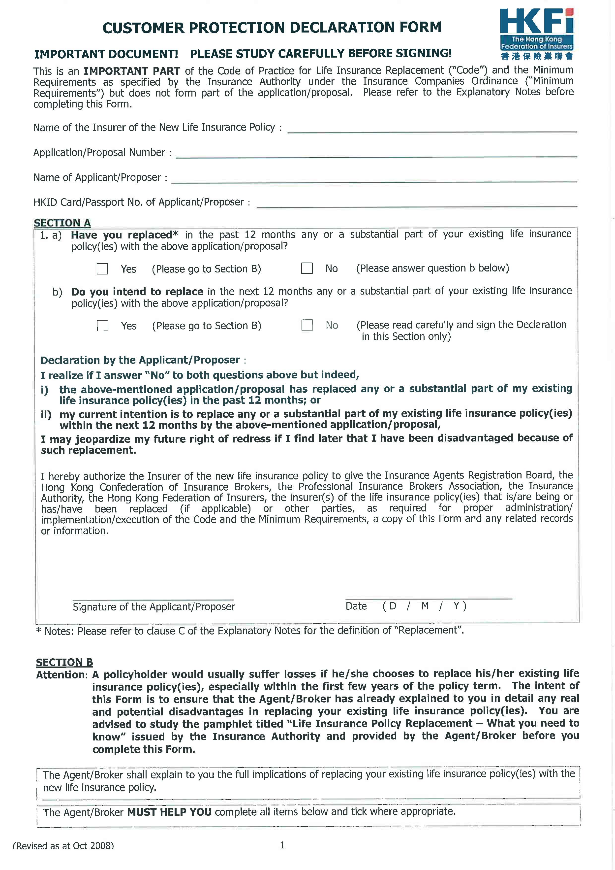

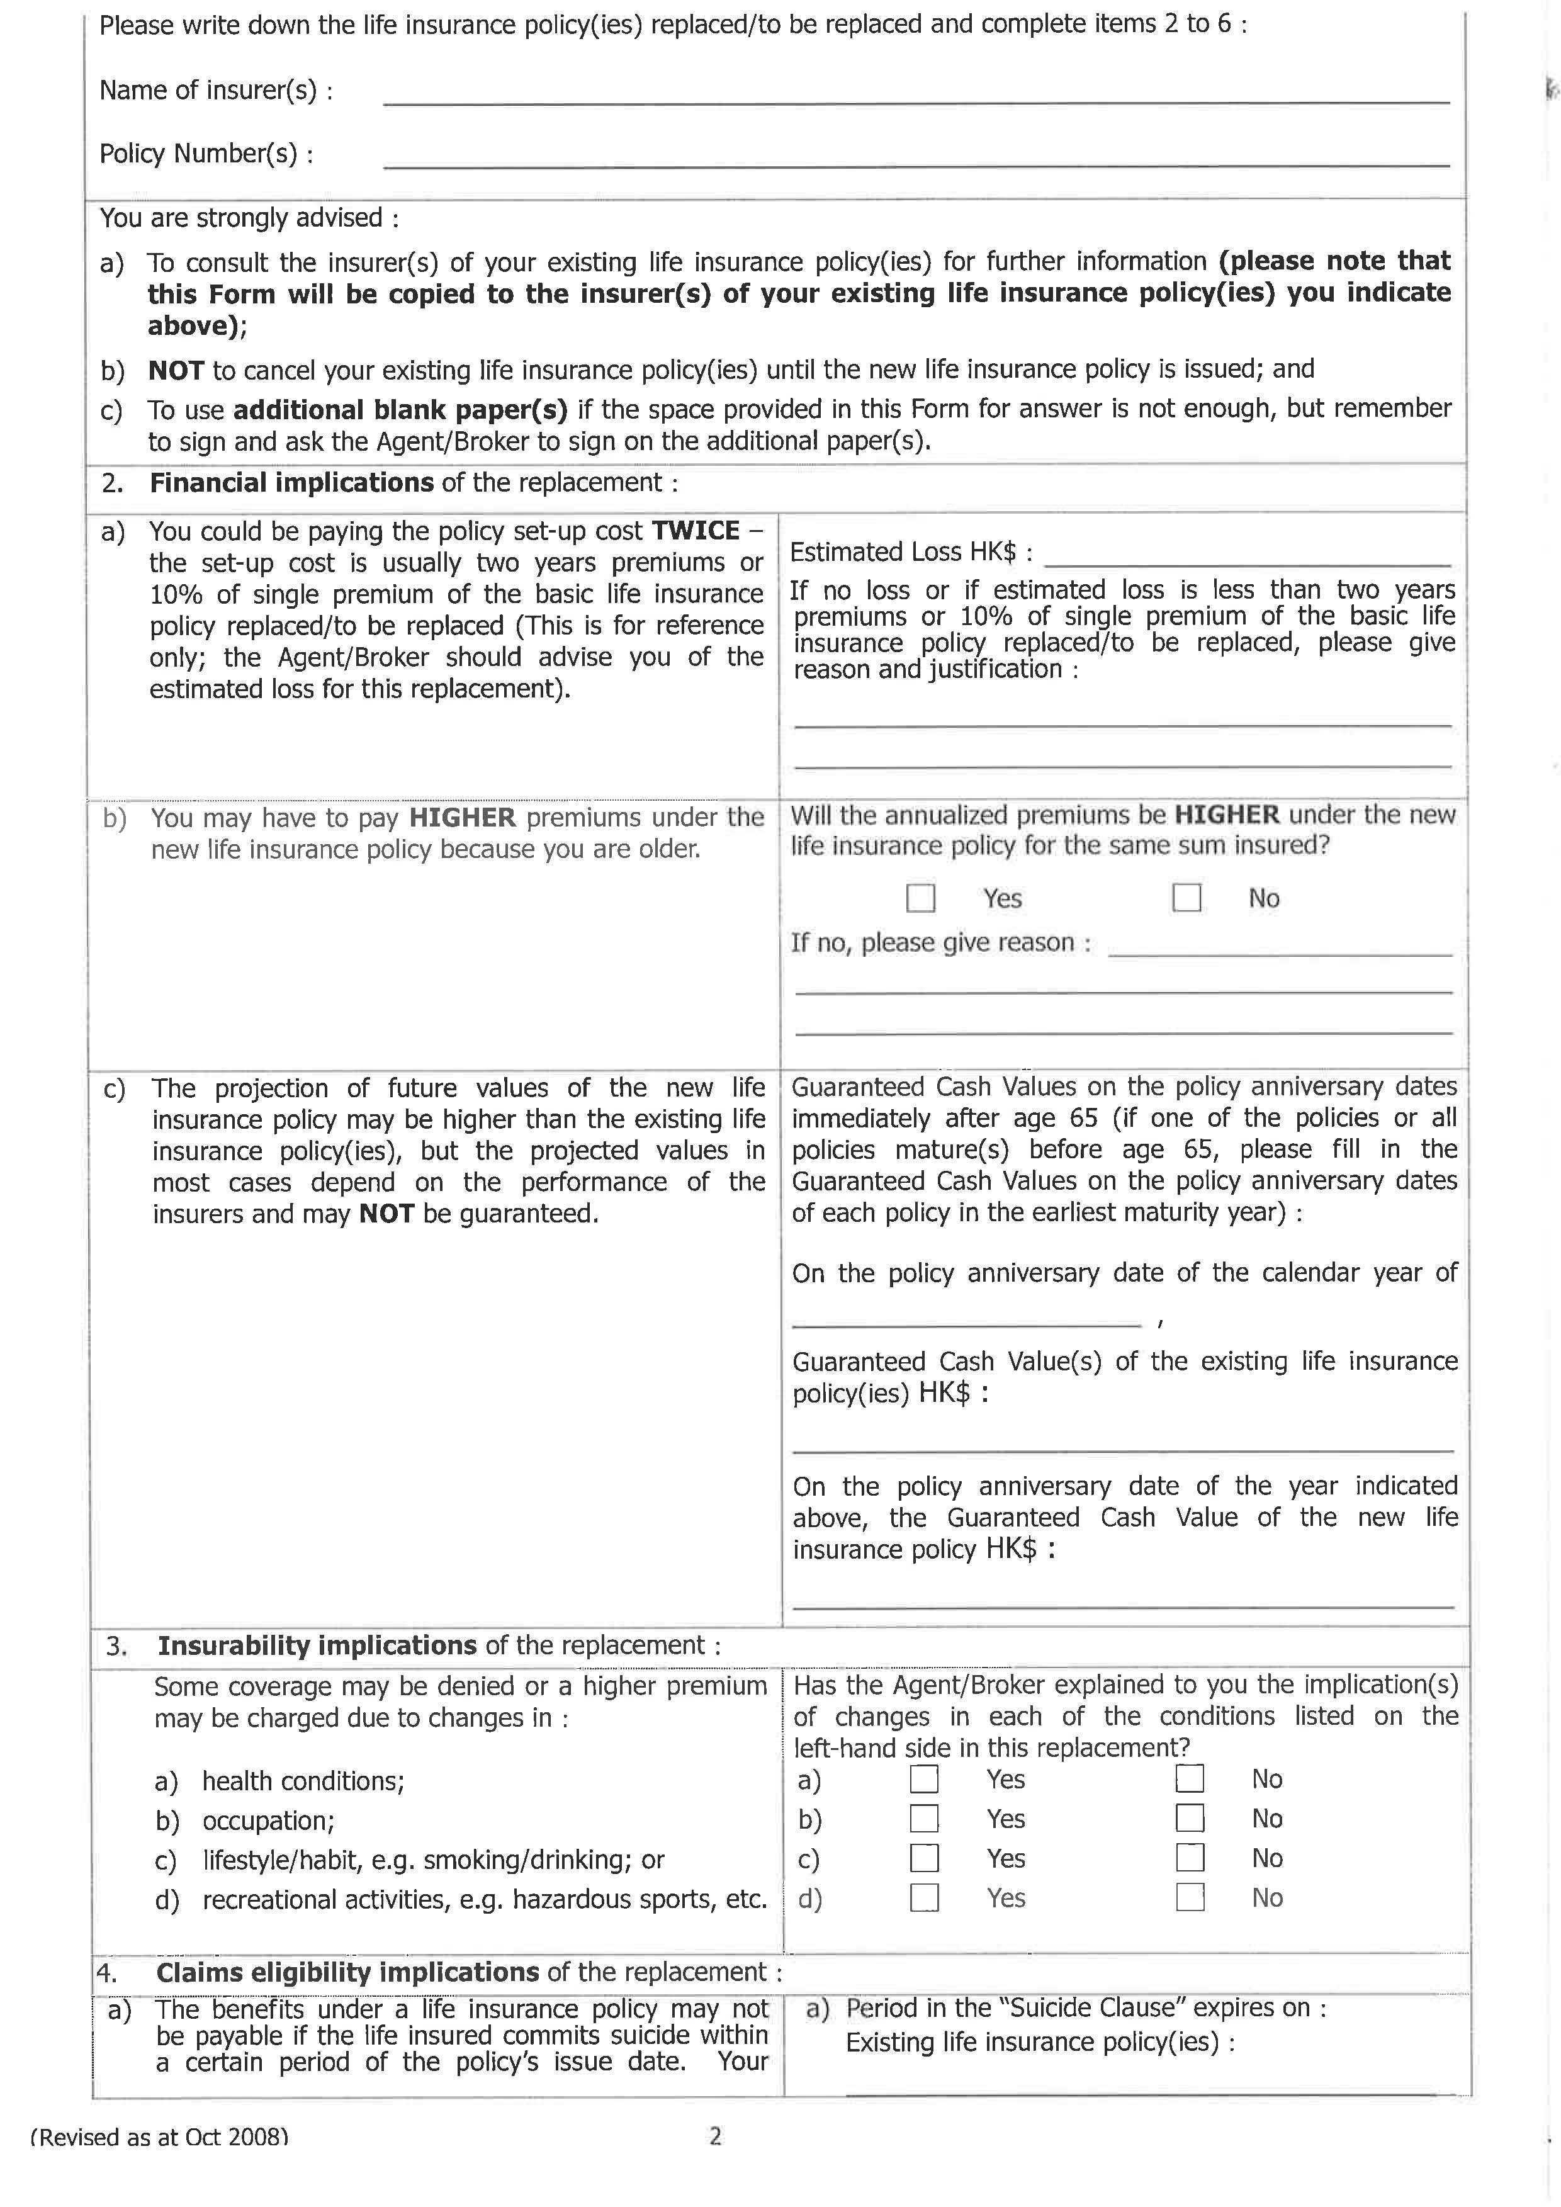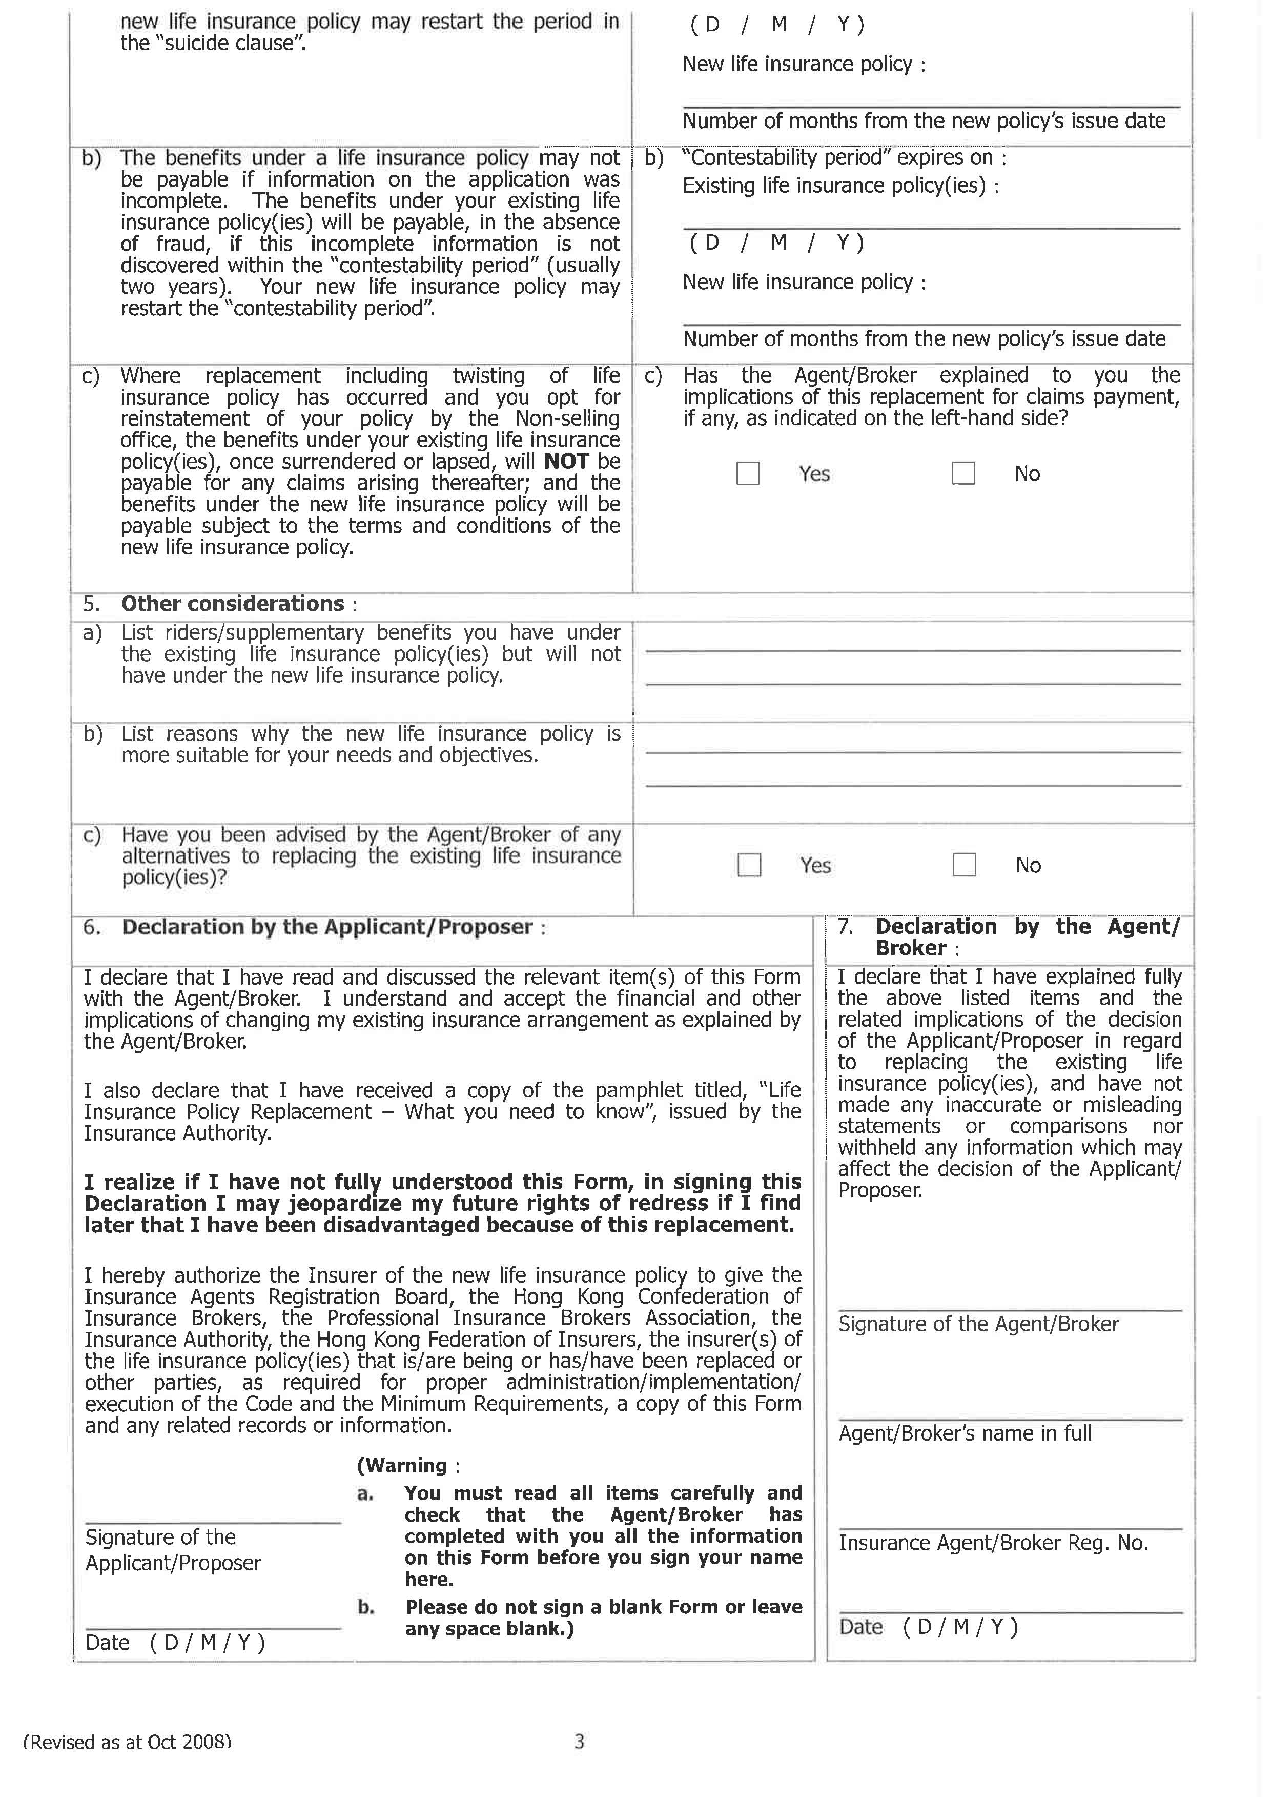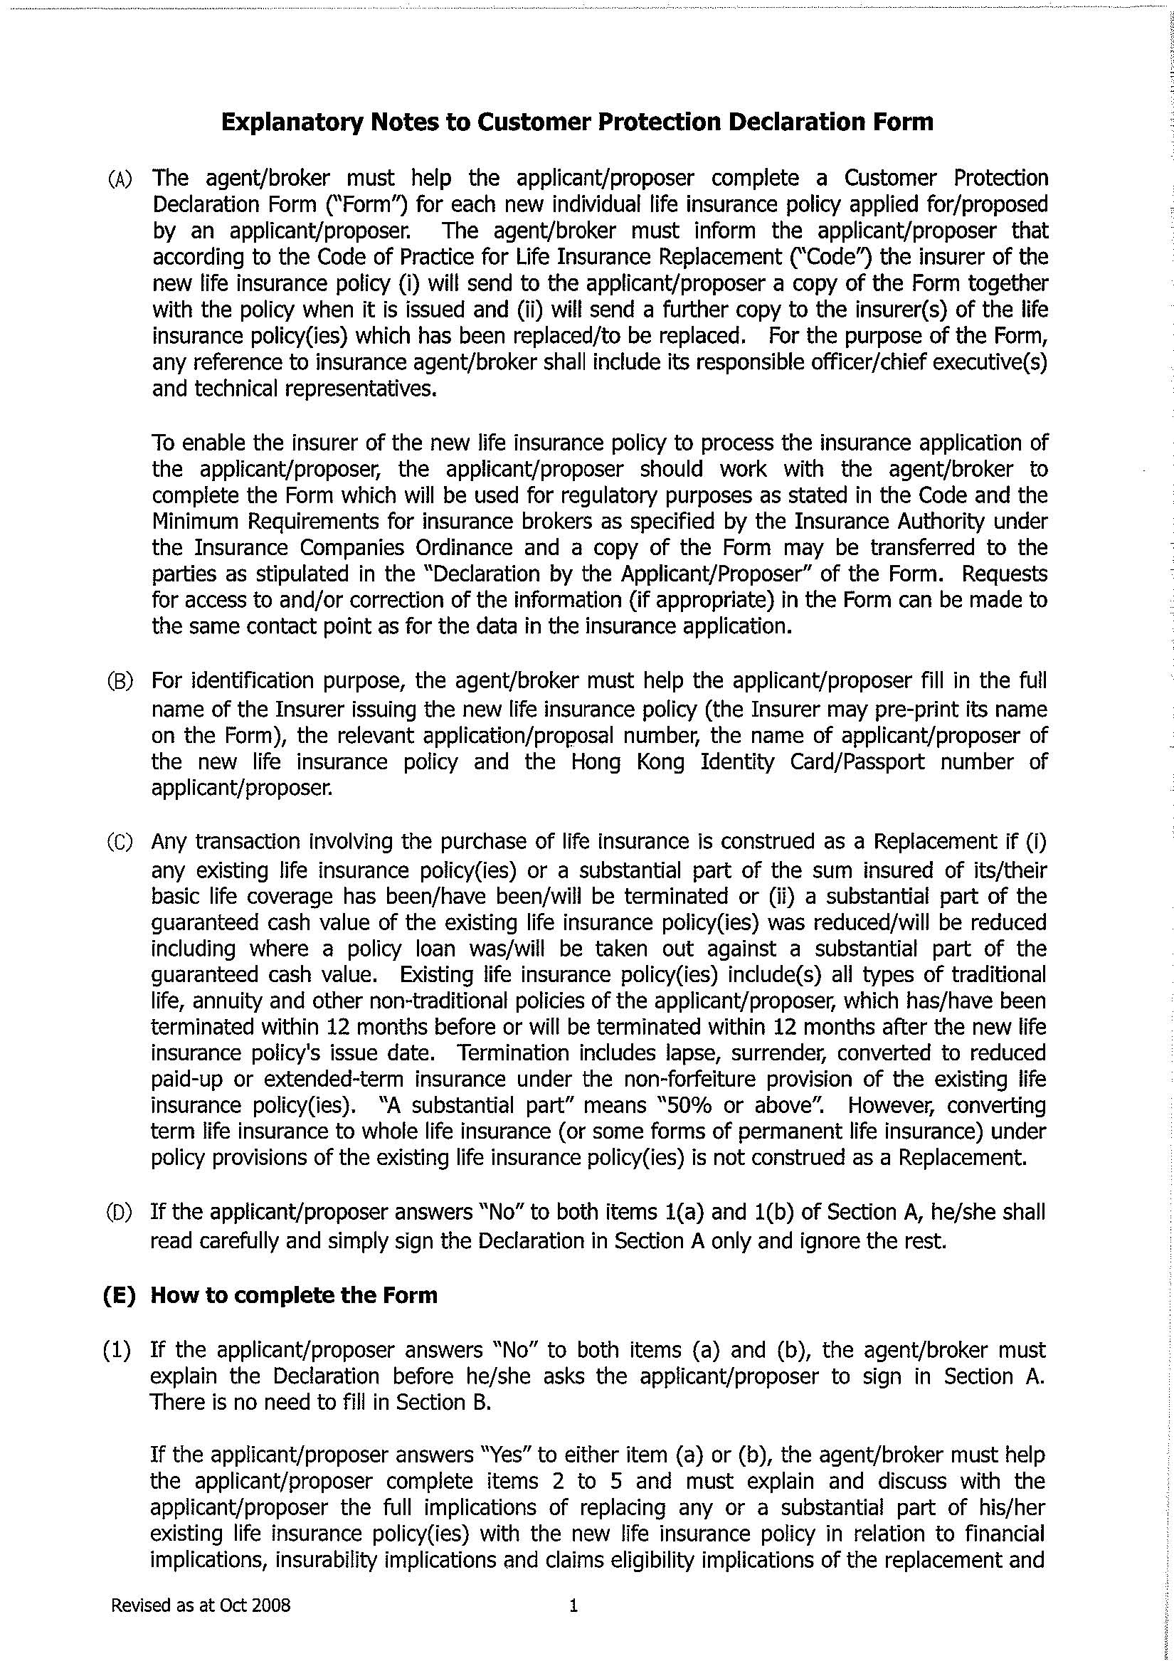
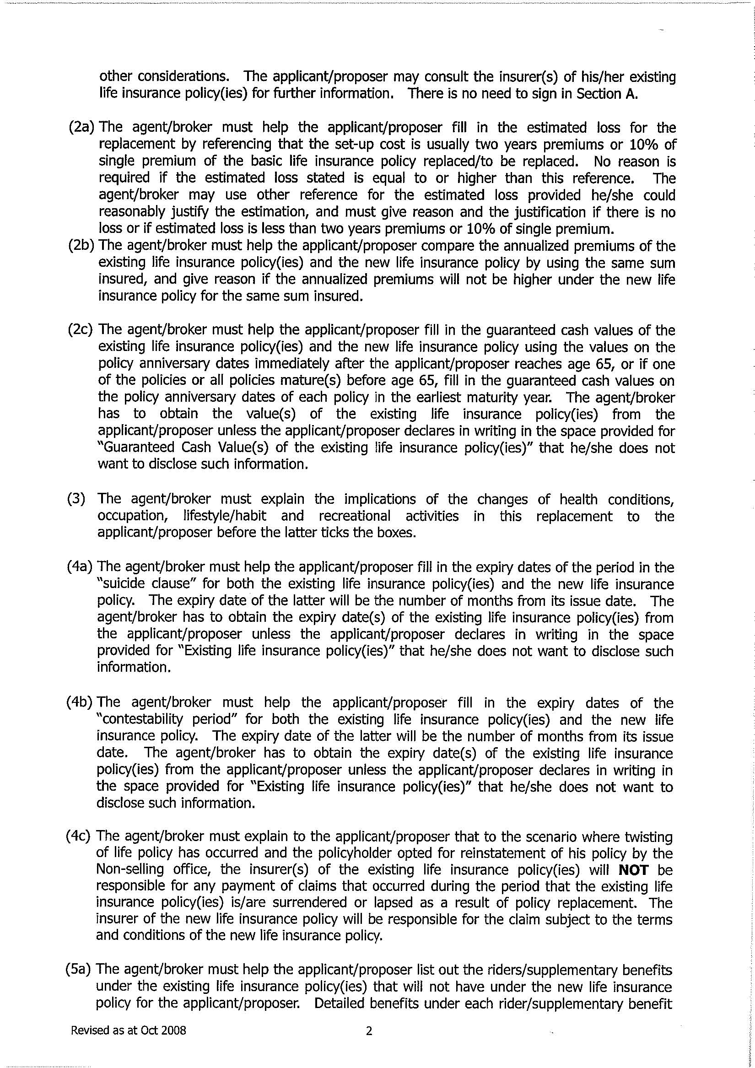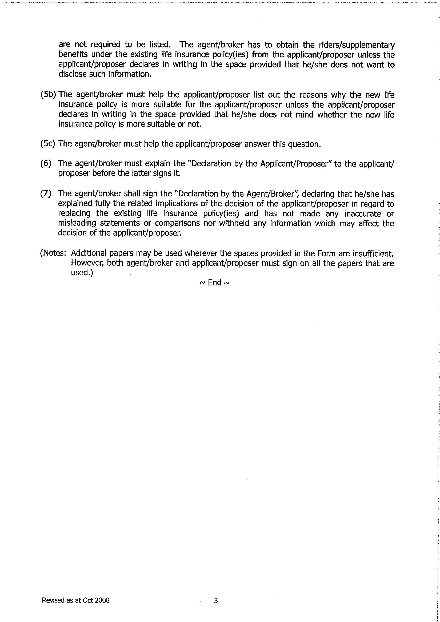

Appendix B
Information to be disclosed in the Illustration Document for Investment-Linked Policies
Illustration Document for Investment-linked Policies (Version 1)
(Source: SFC)
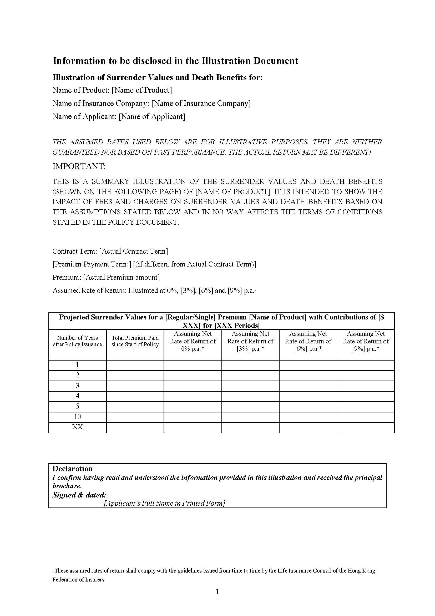
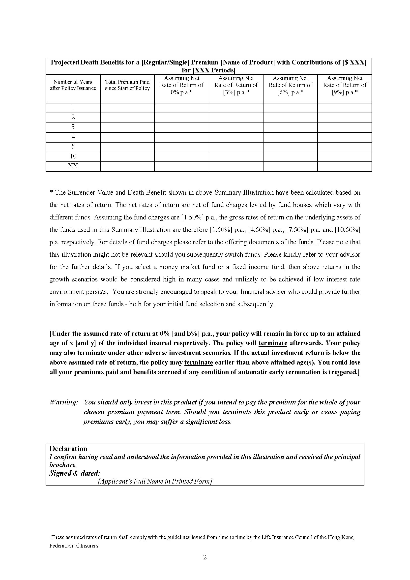
Illustration Document for Investment-linked Policies (Version 2)
(Source: SFC)
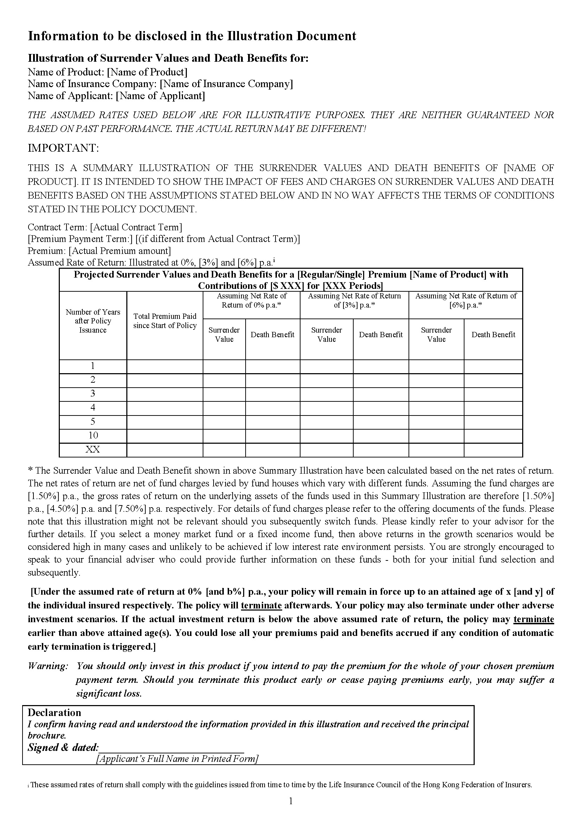

Appendix C

Standard Illustration for Universal Life (Non-Linked) Policies
(Source: HKFI)

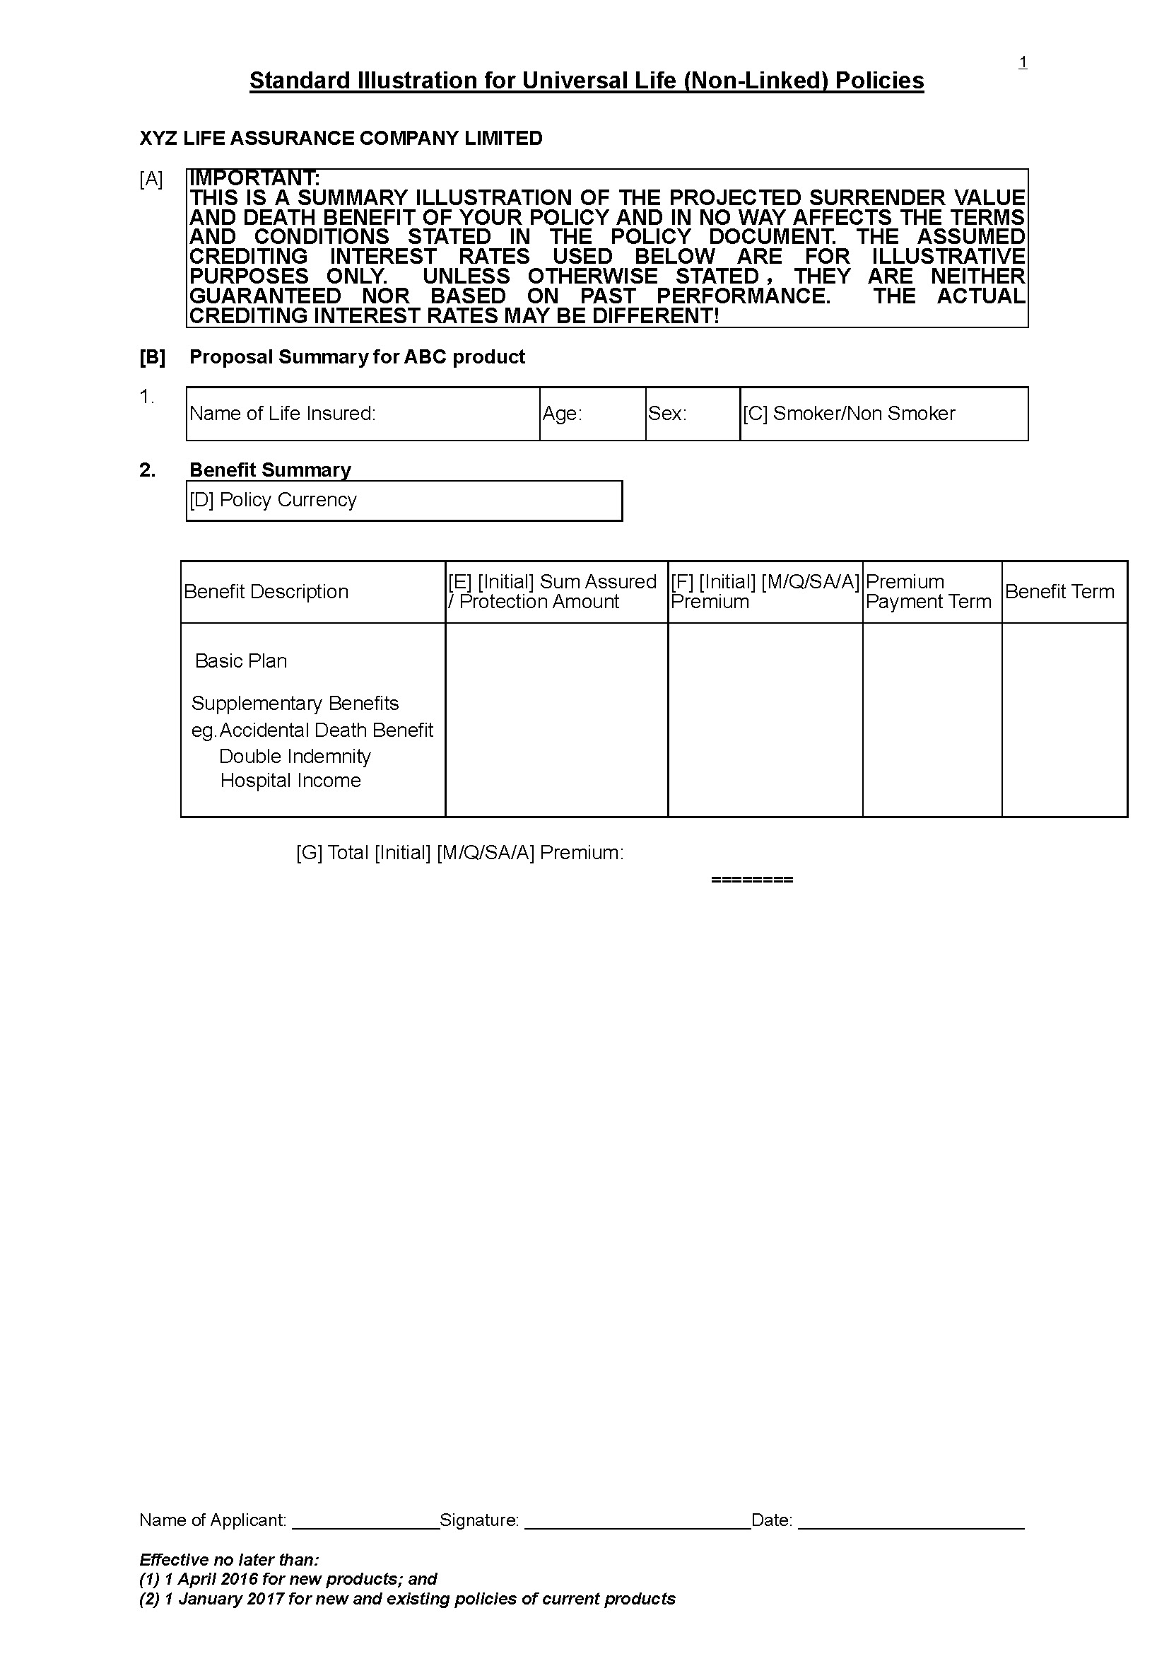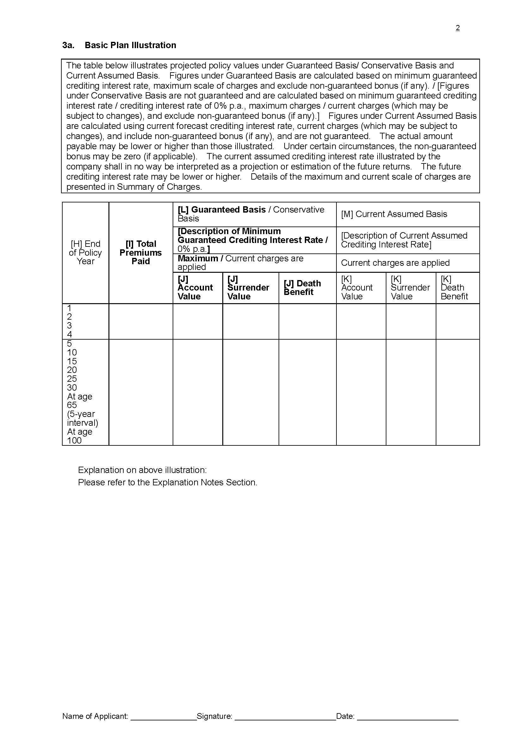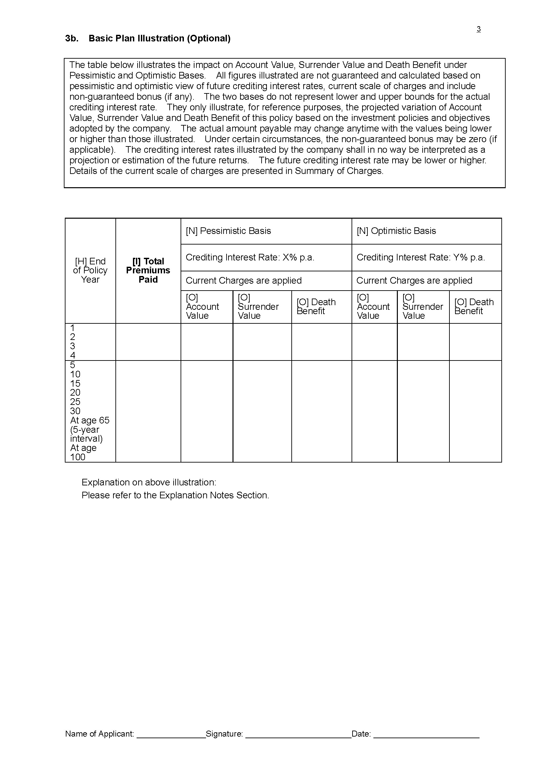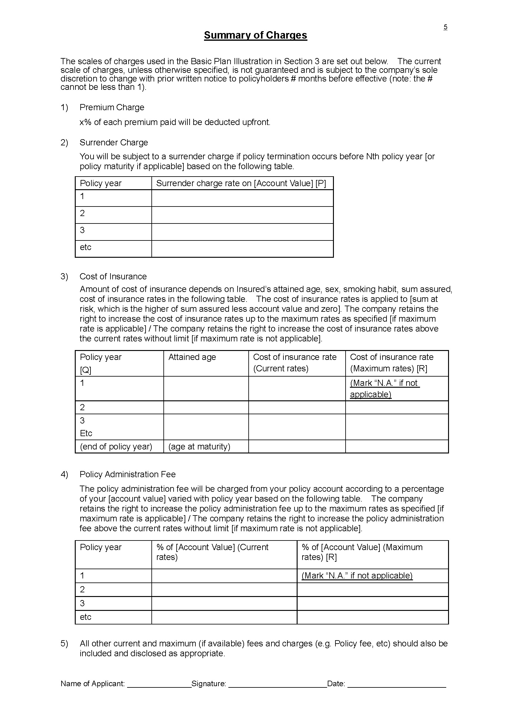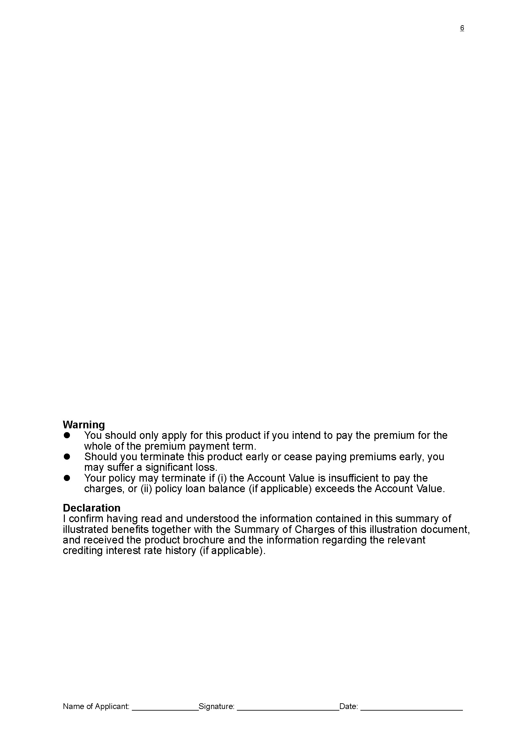

Appendix D

Standard Illustration for Participating Policies
(Source: HKFI)

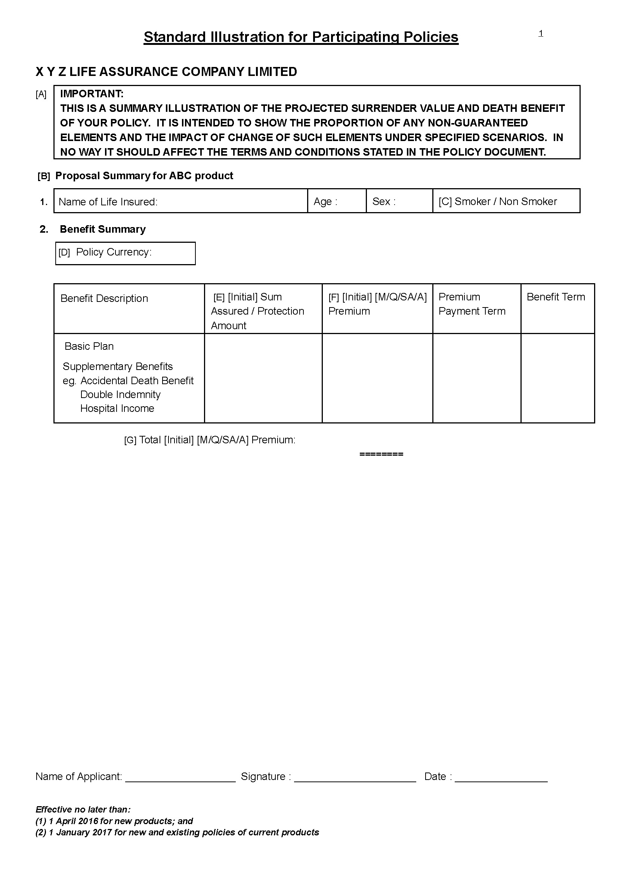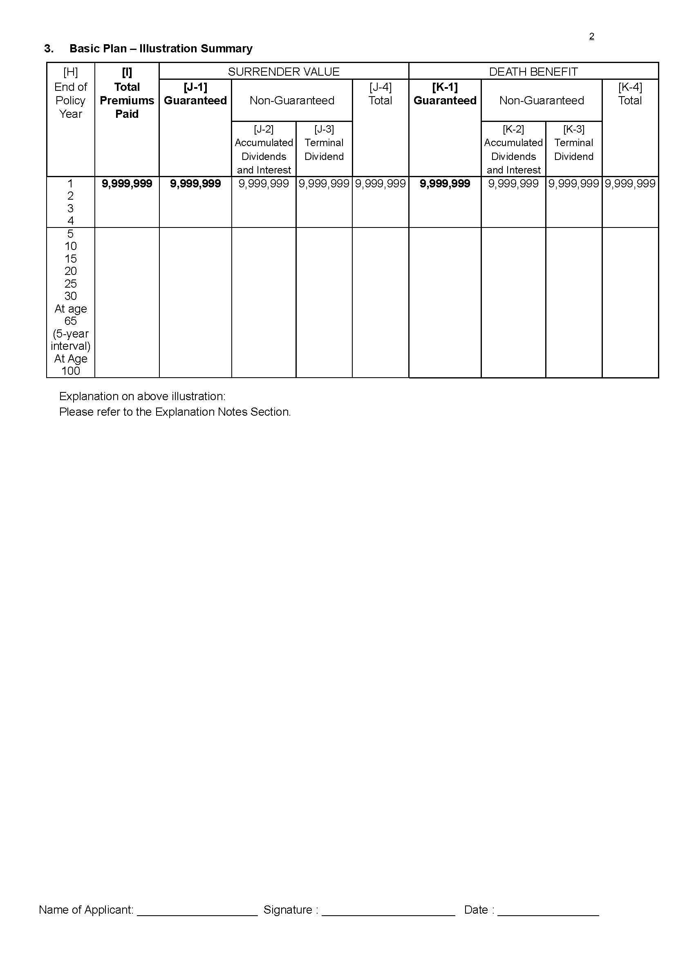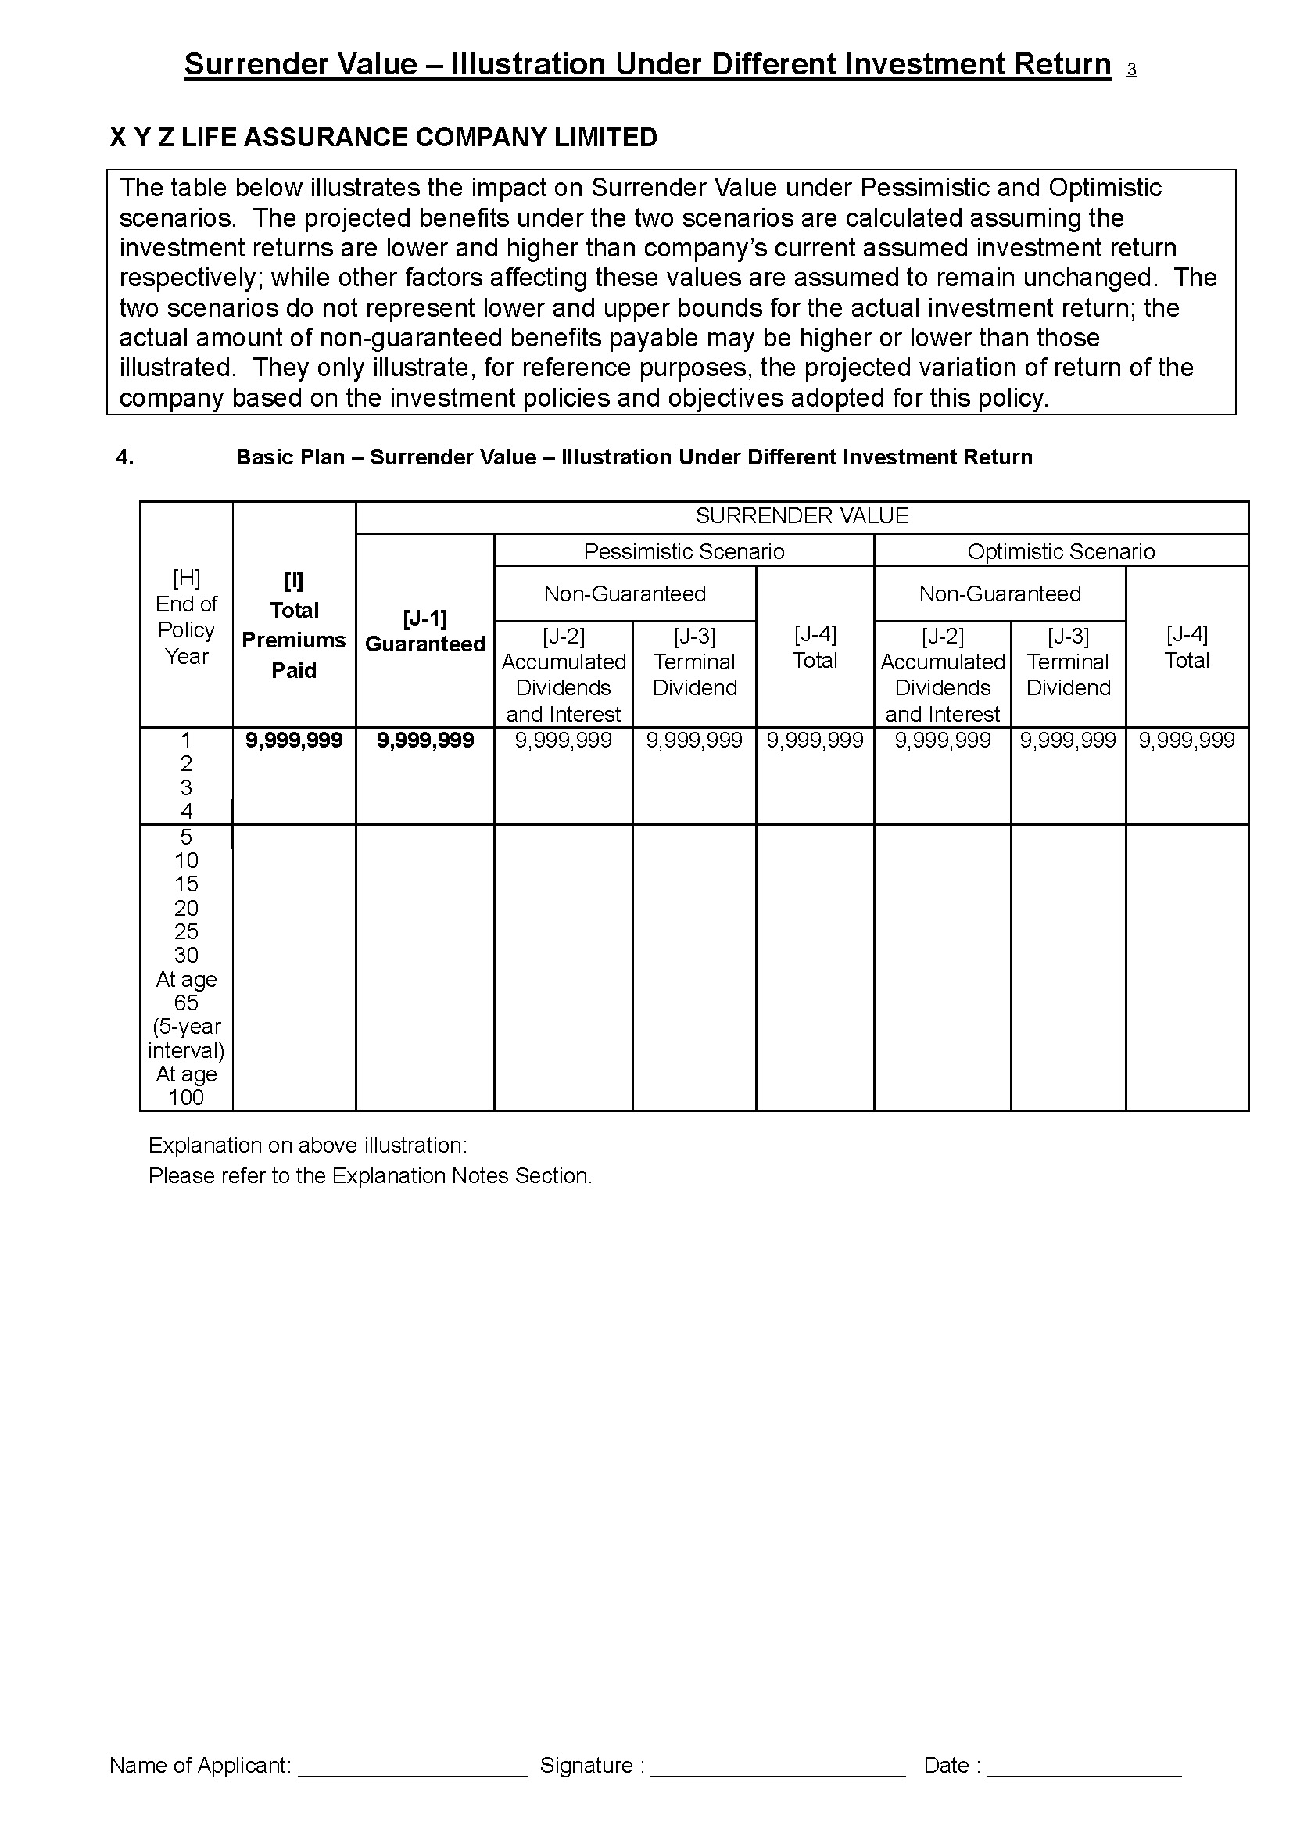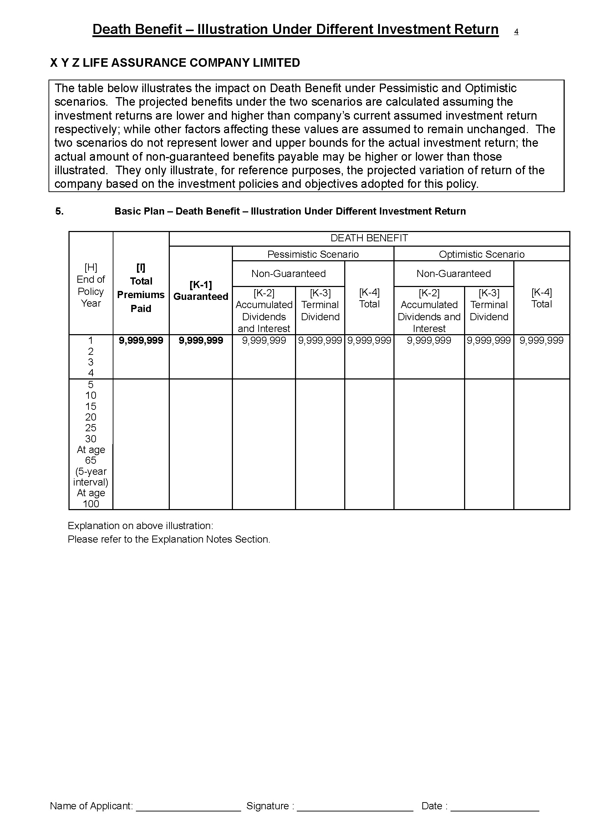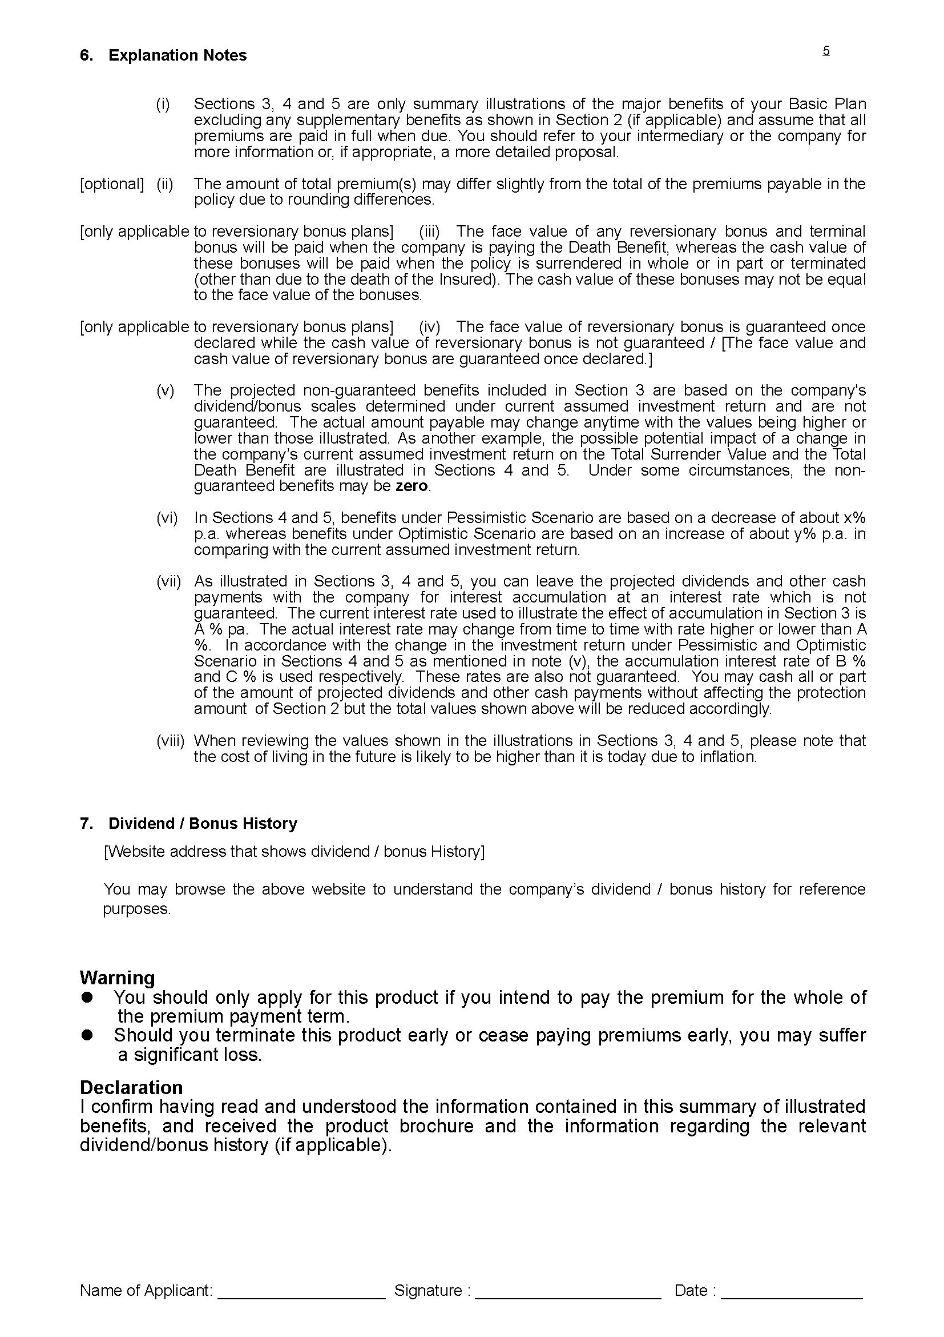

Appendix E

Guidance Note on Underwriting Long Term Insurance Business (Other Than Class C Business) (GN16)
(Source: OCI)

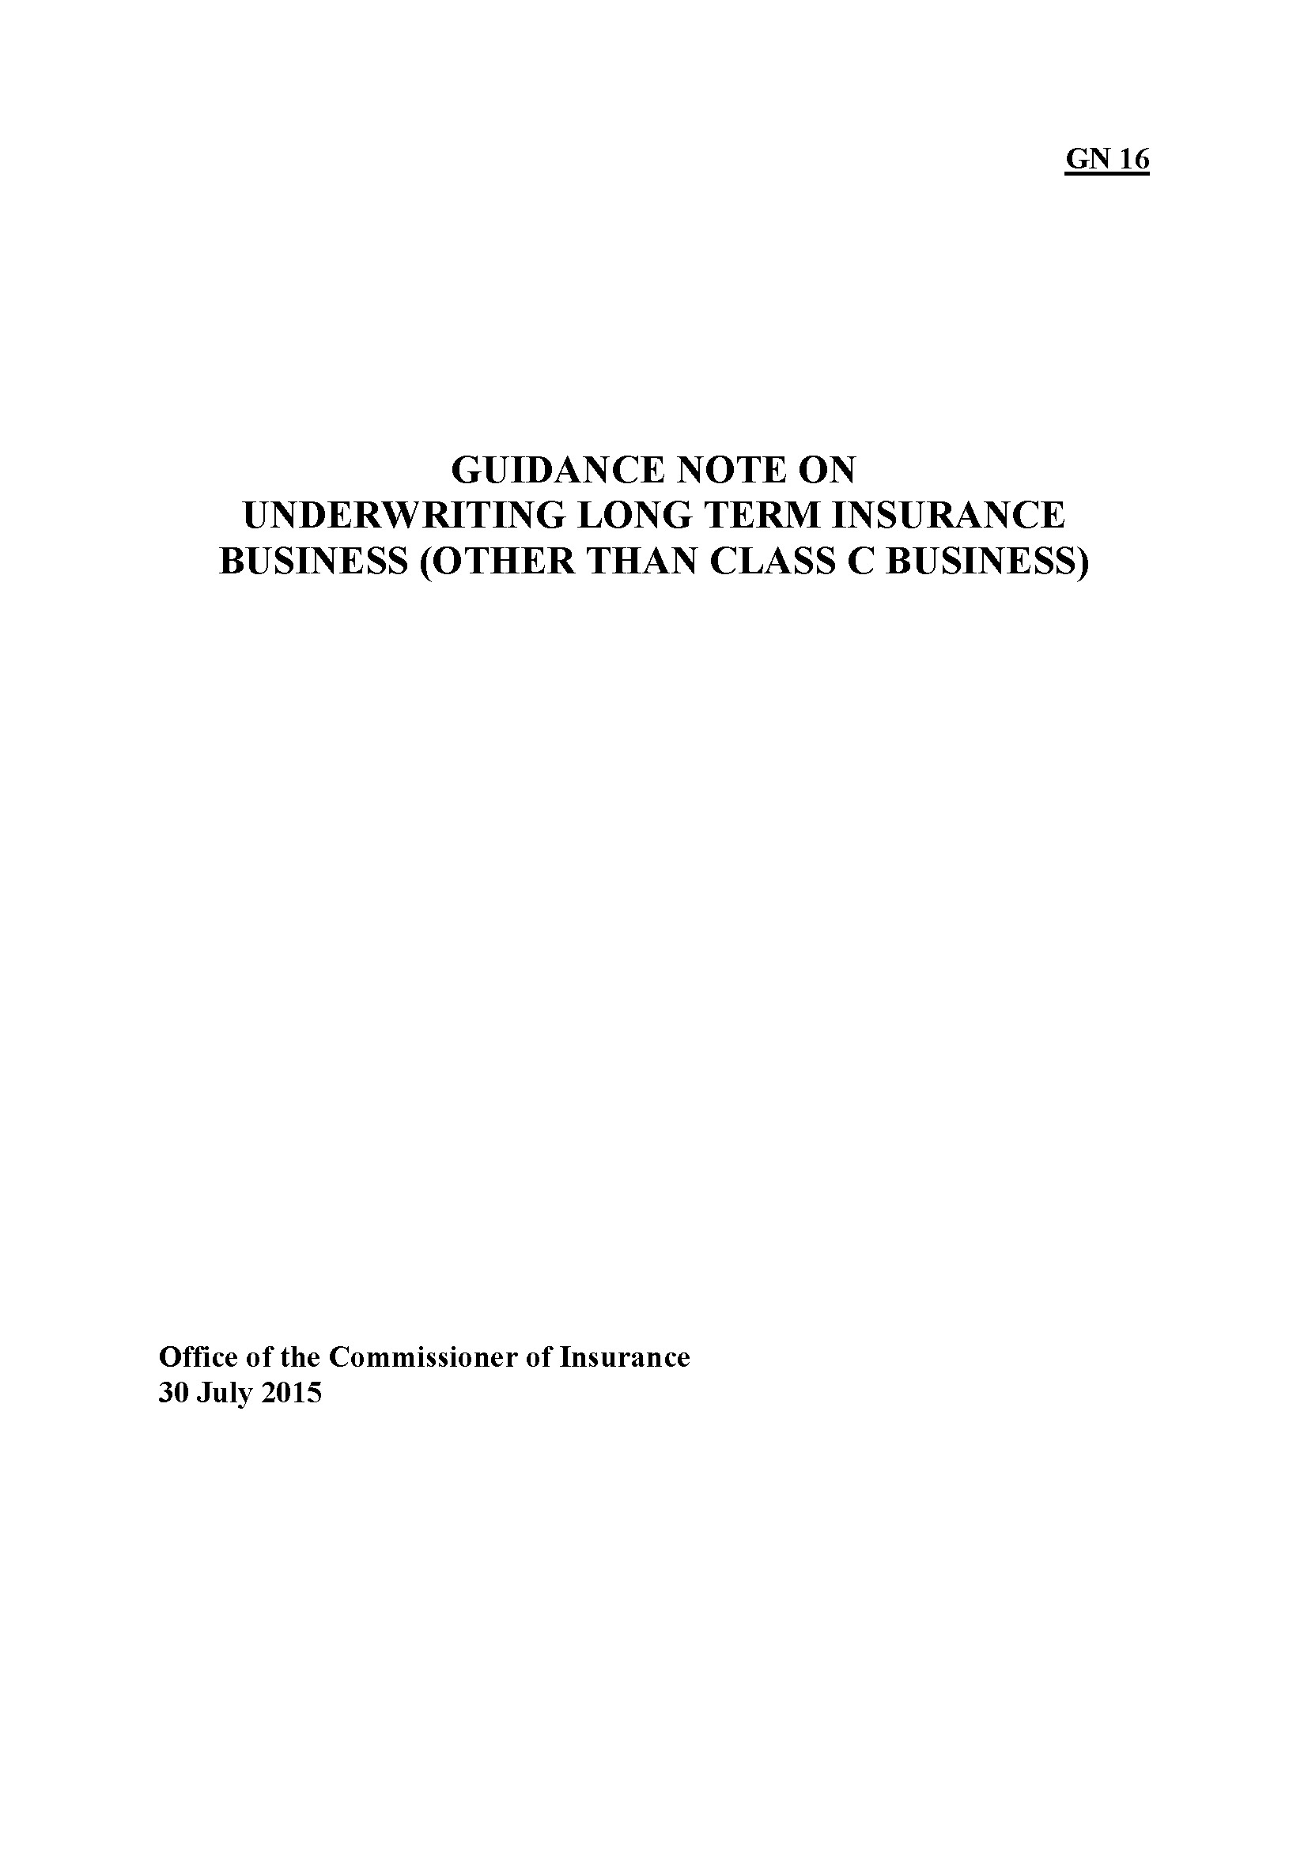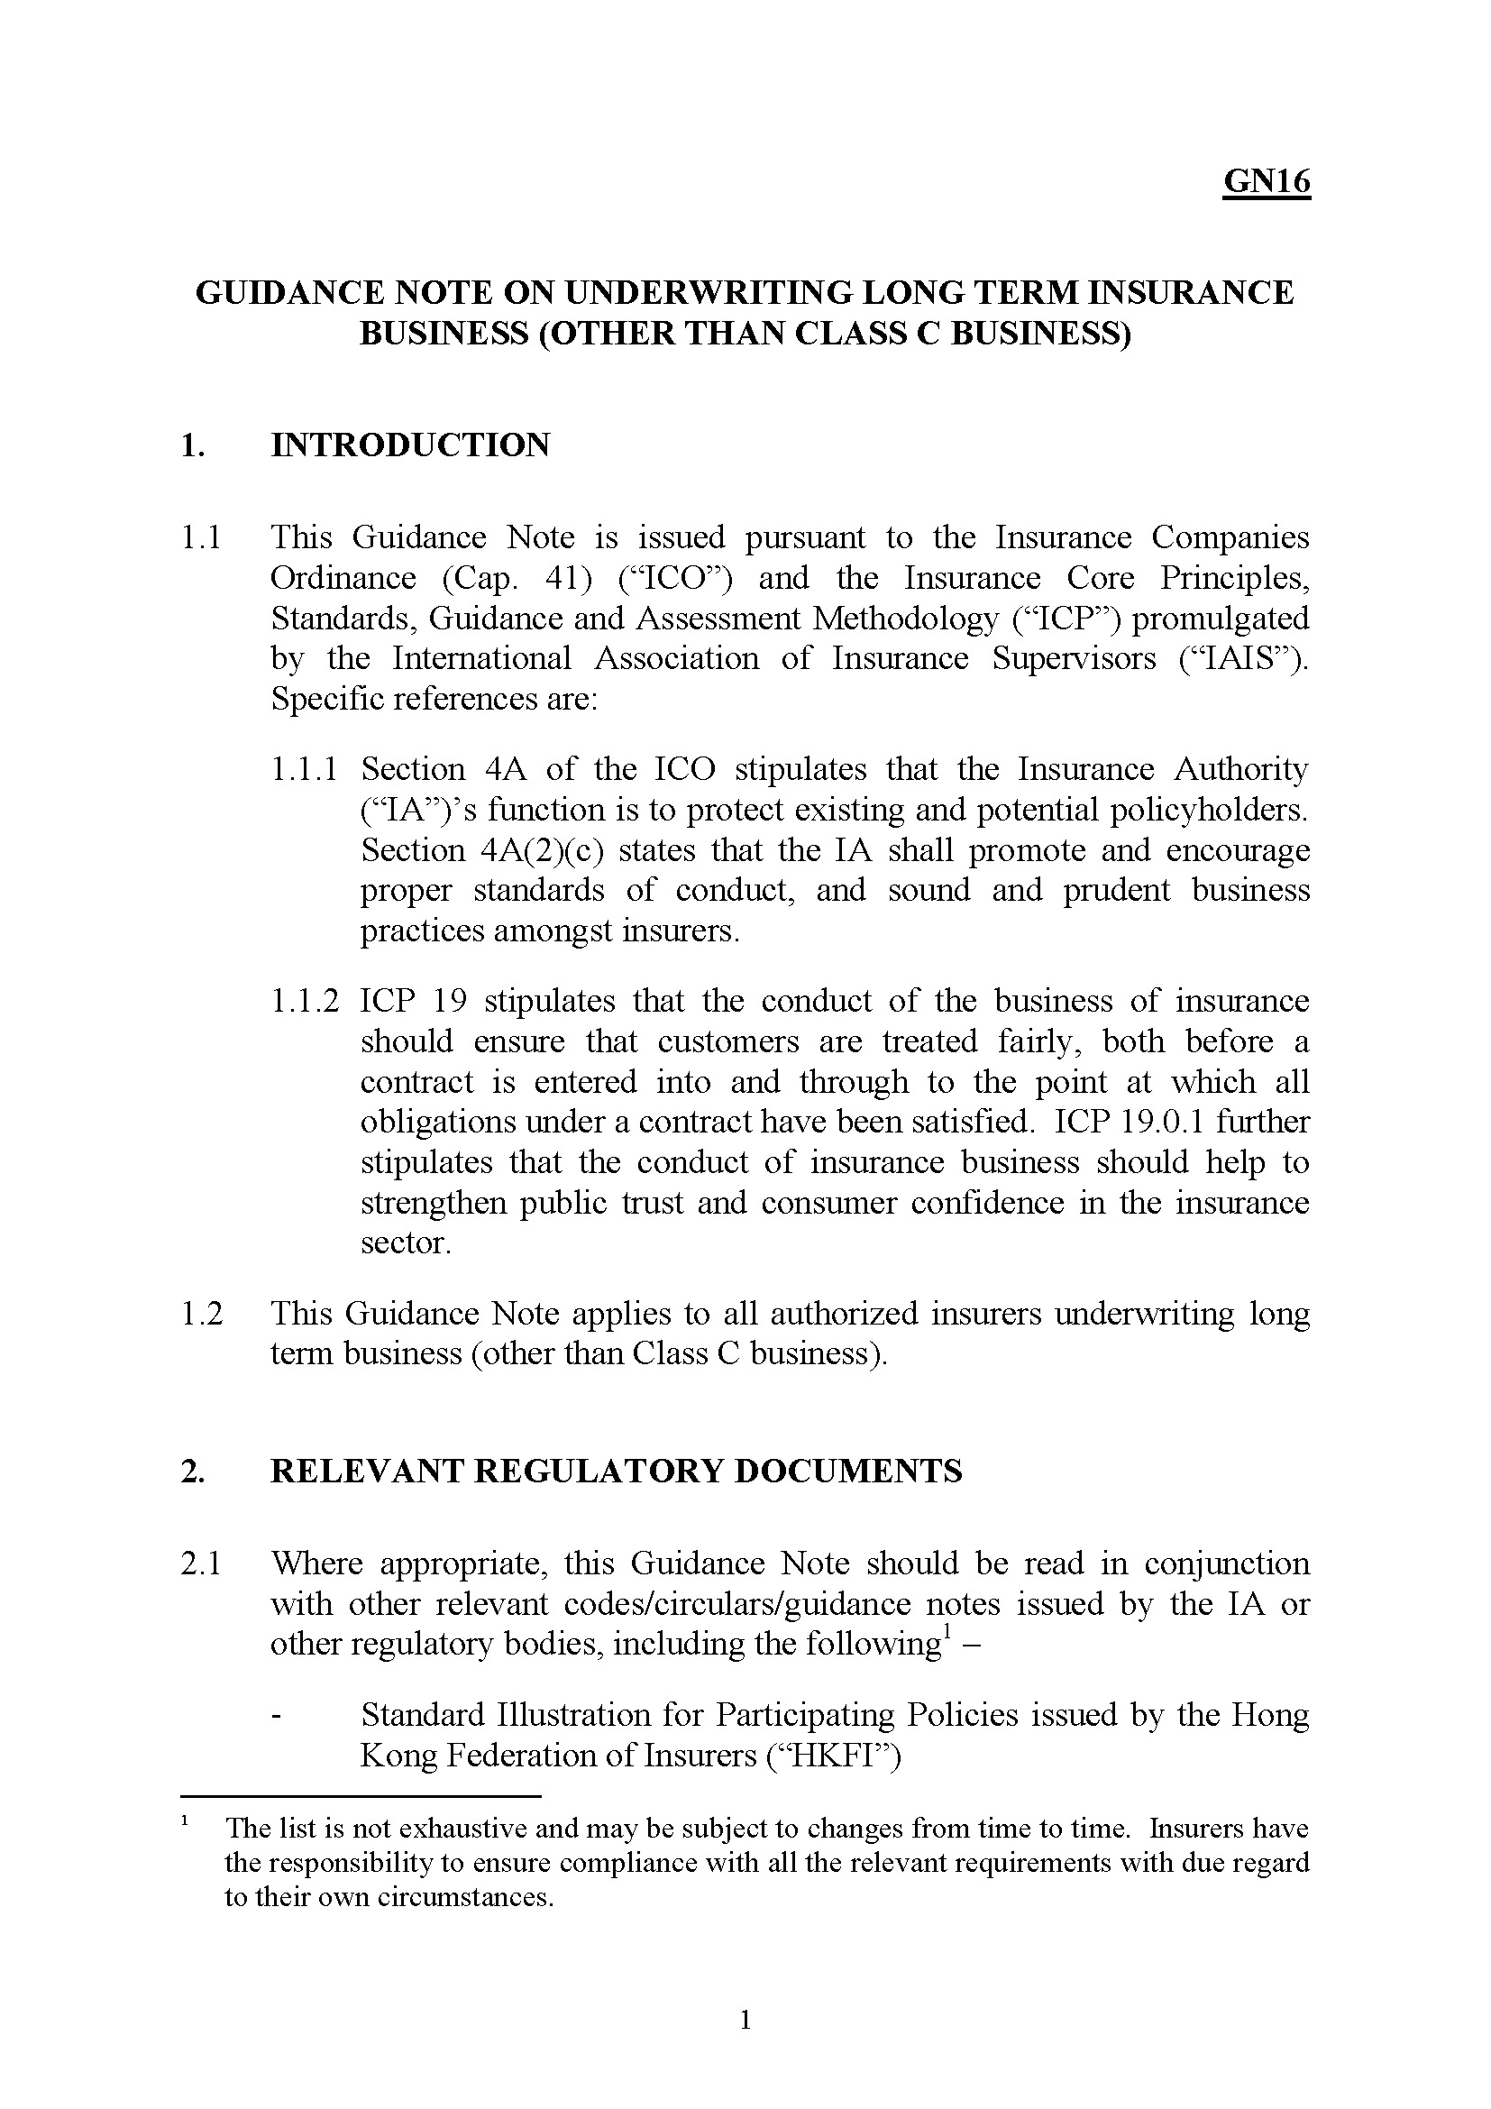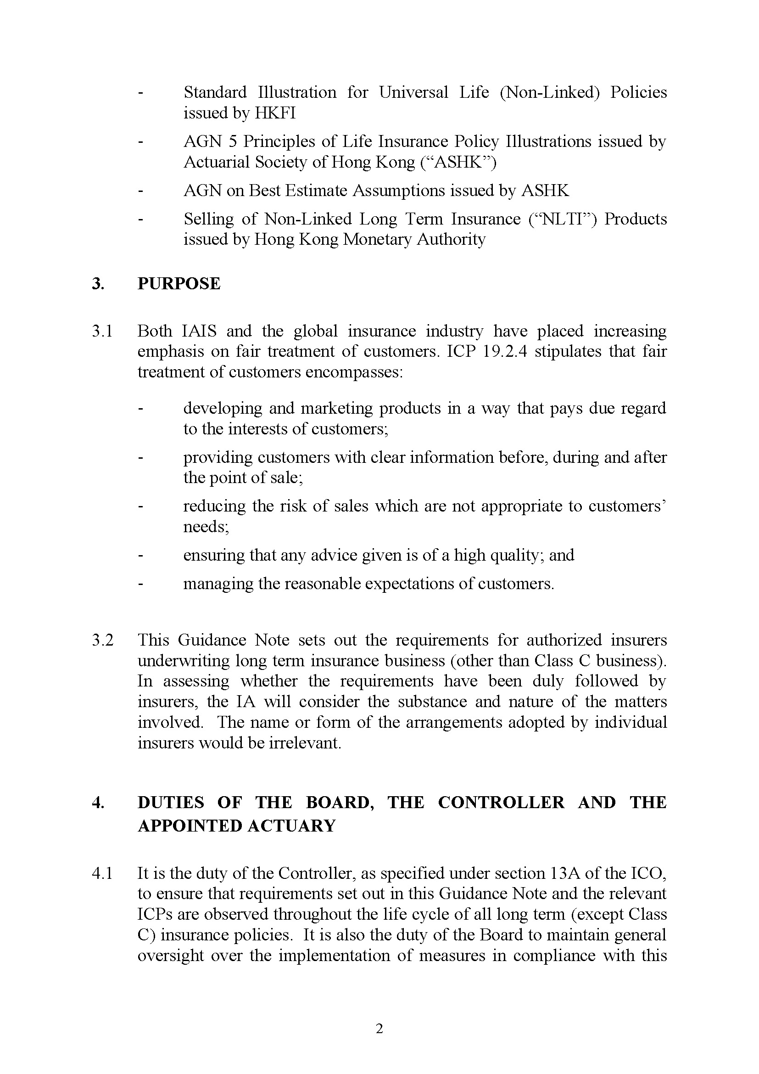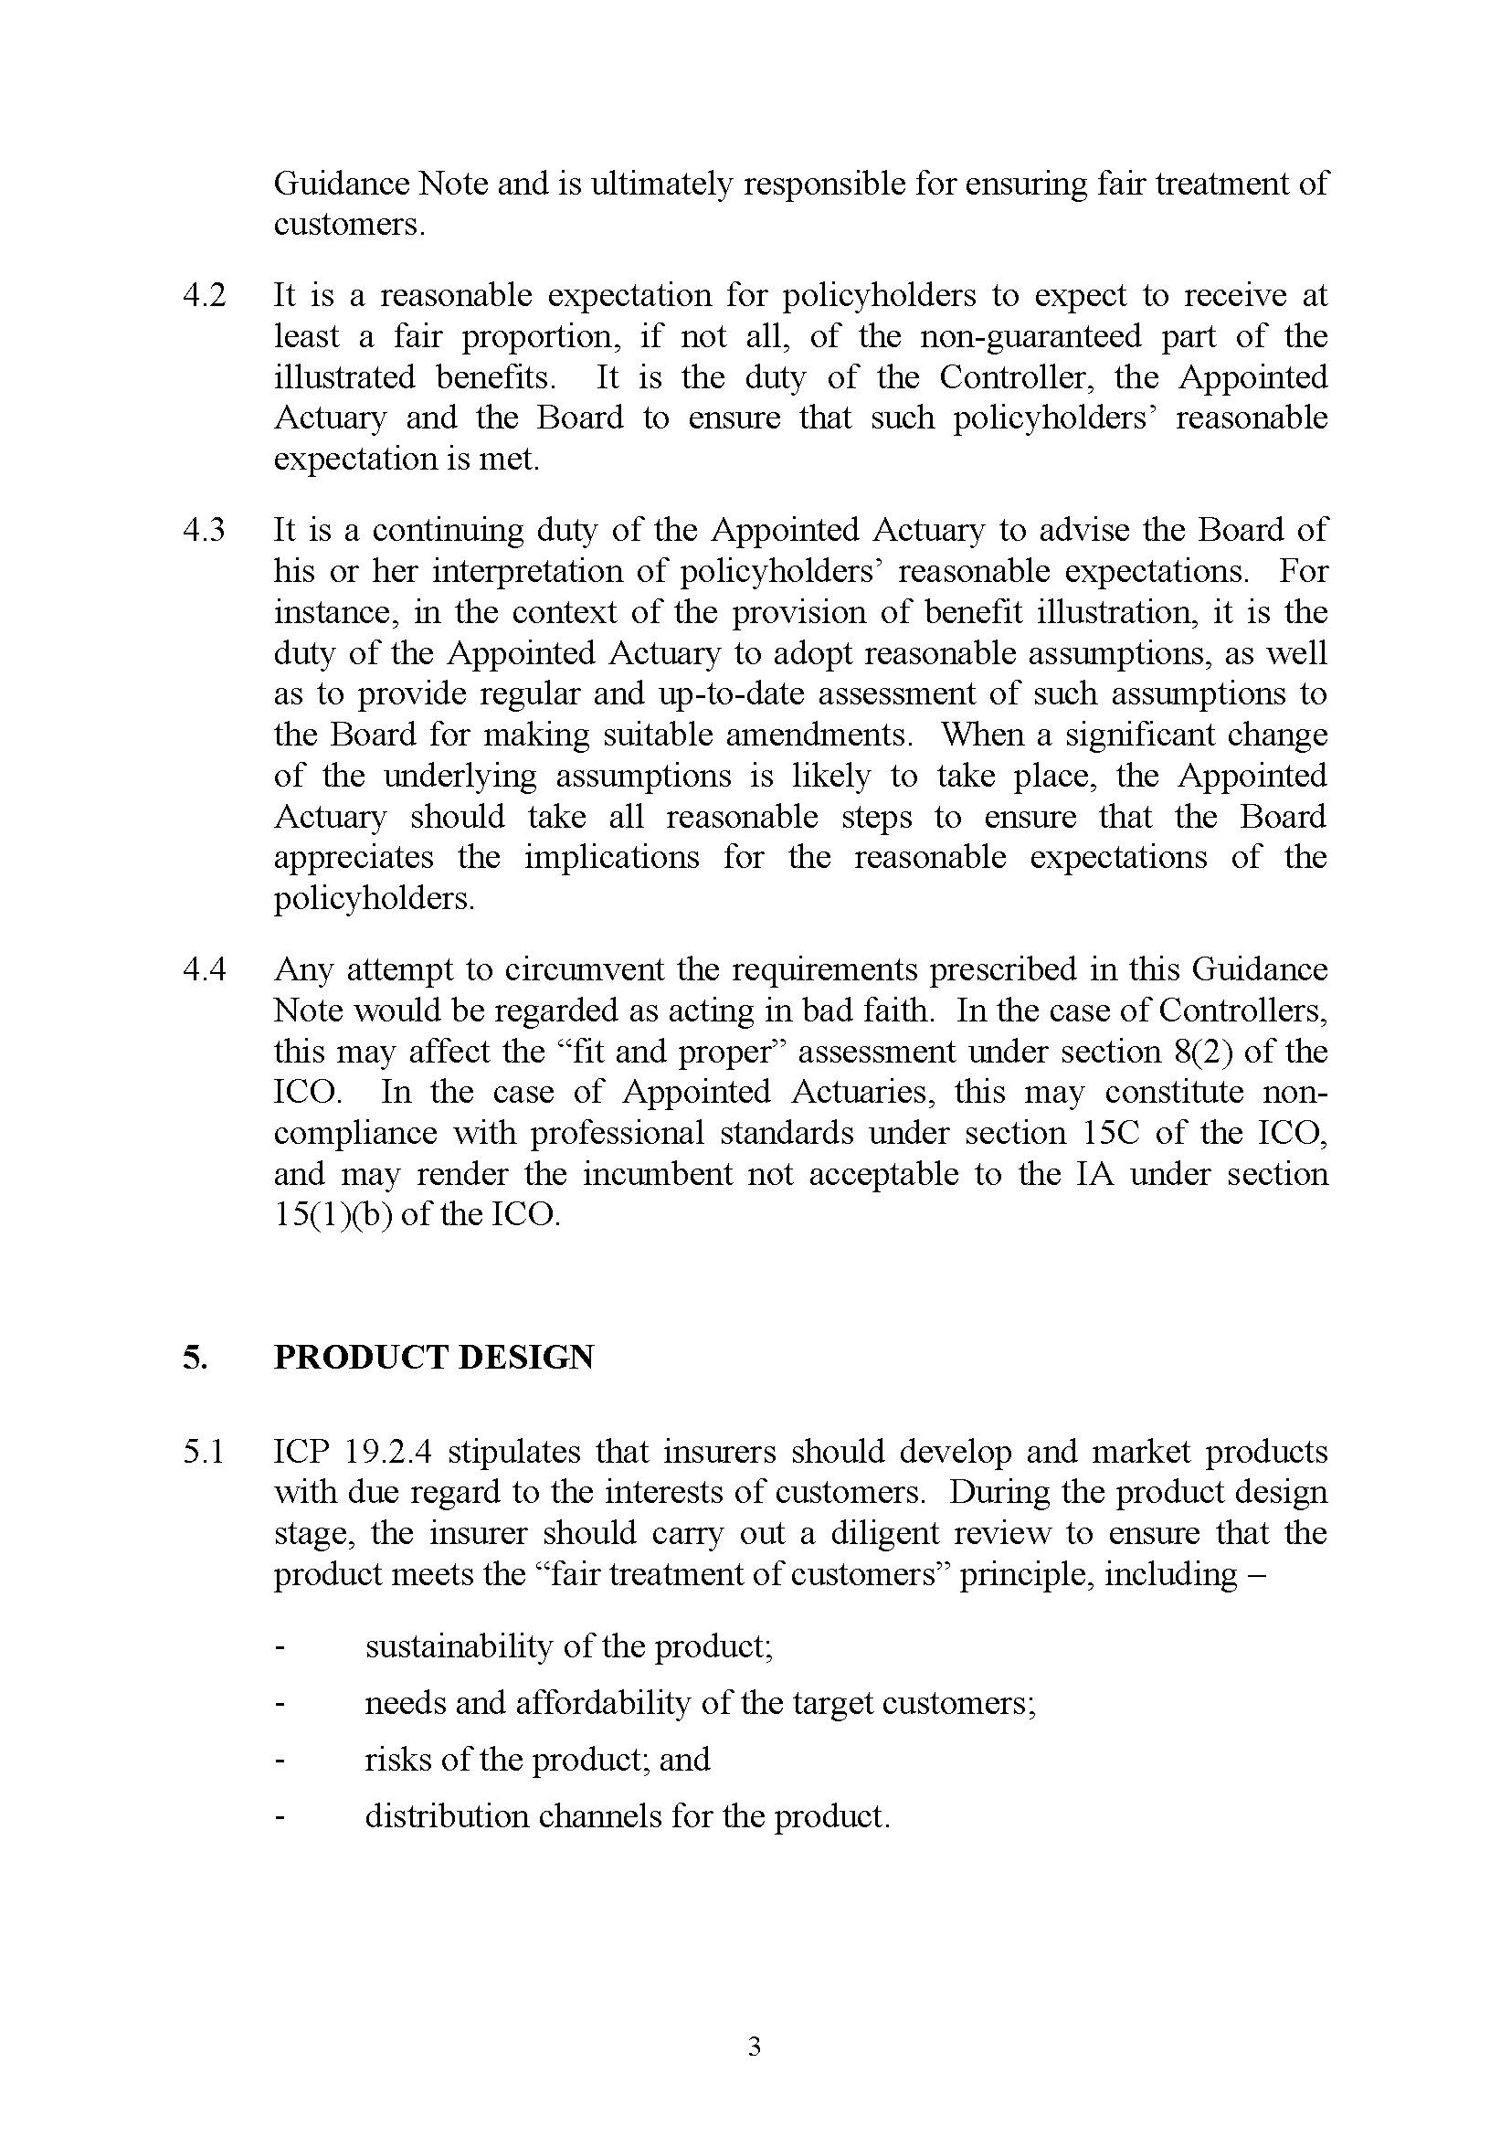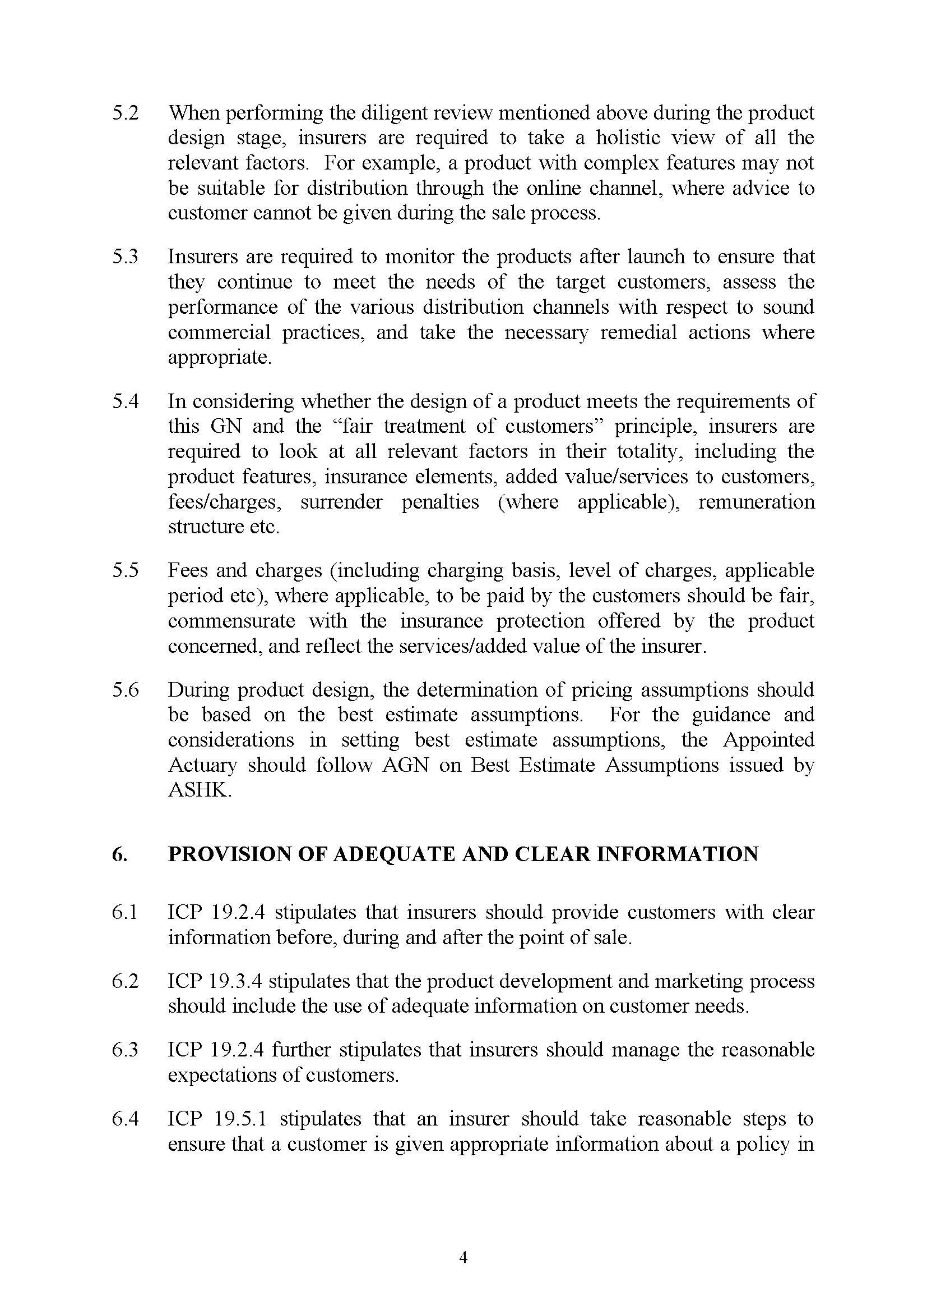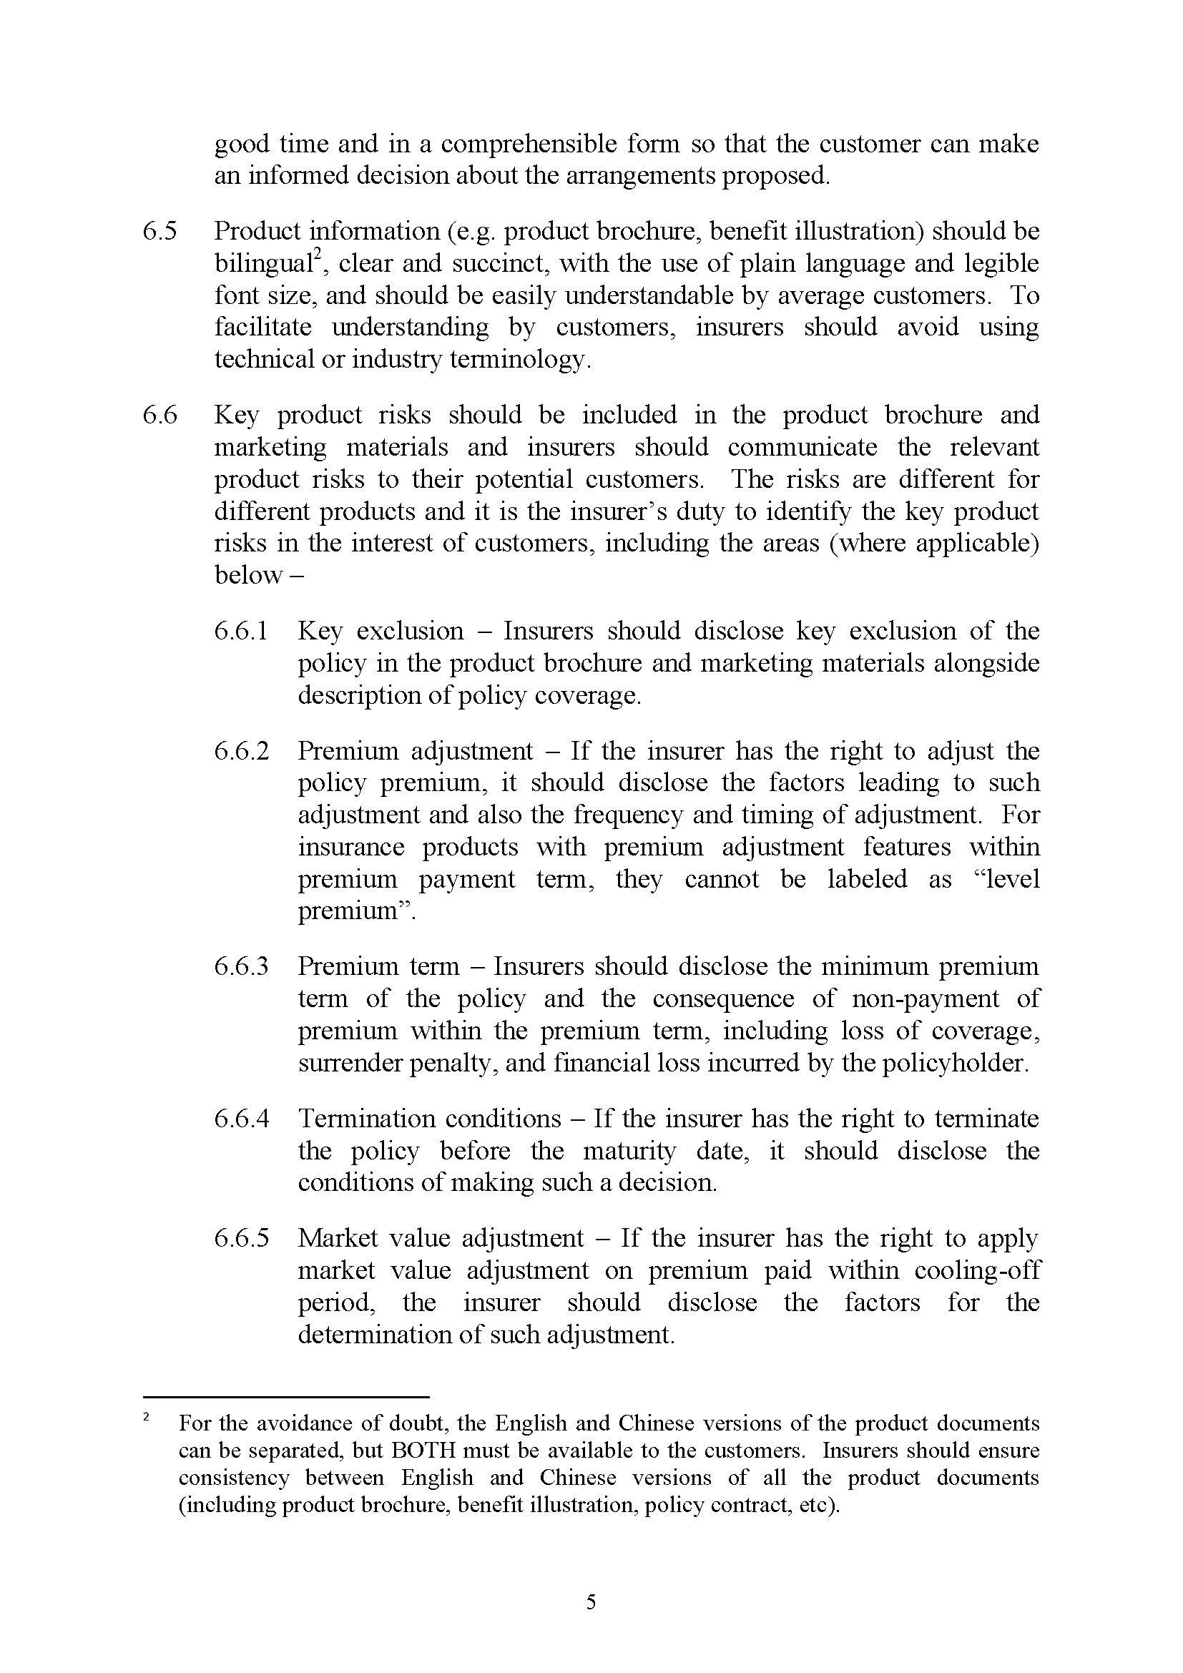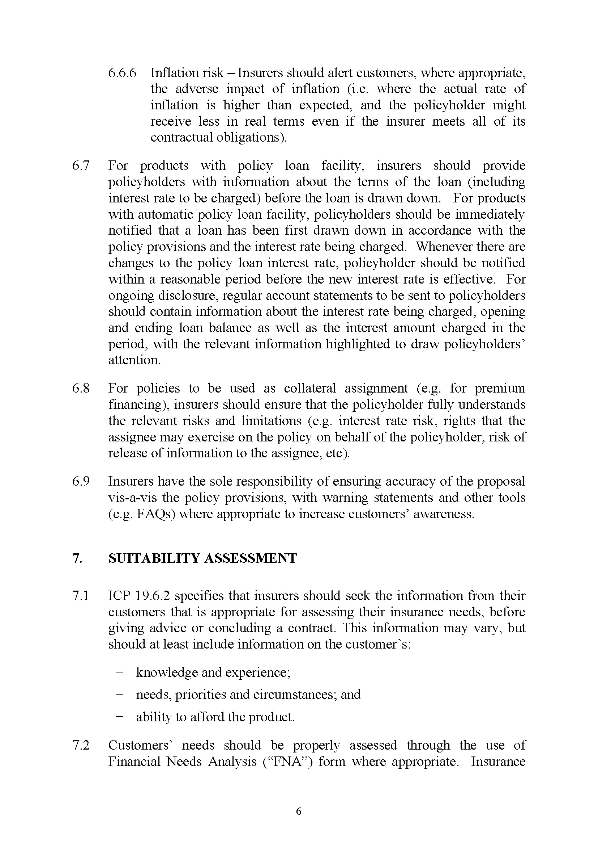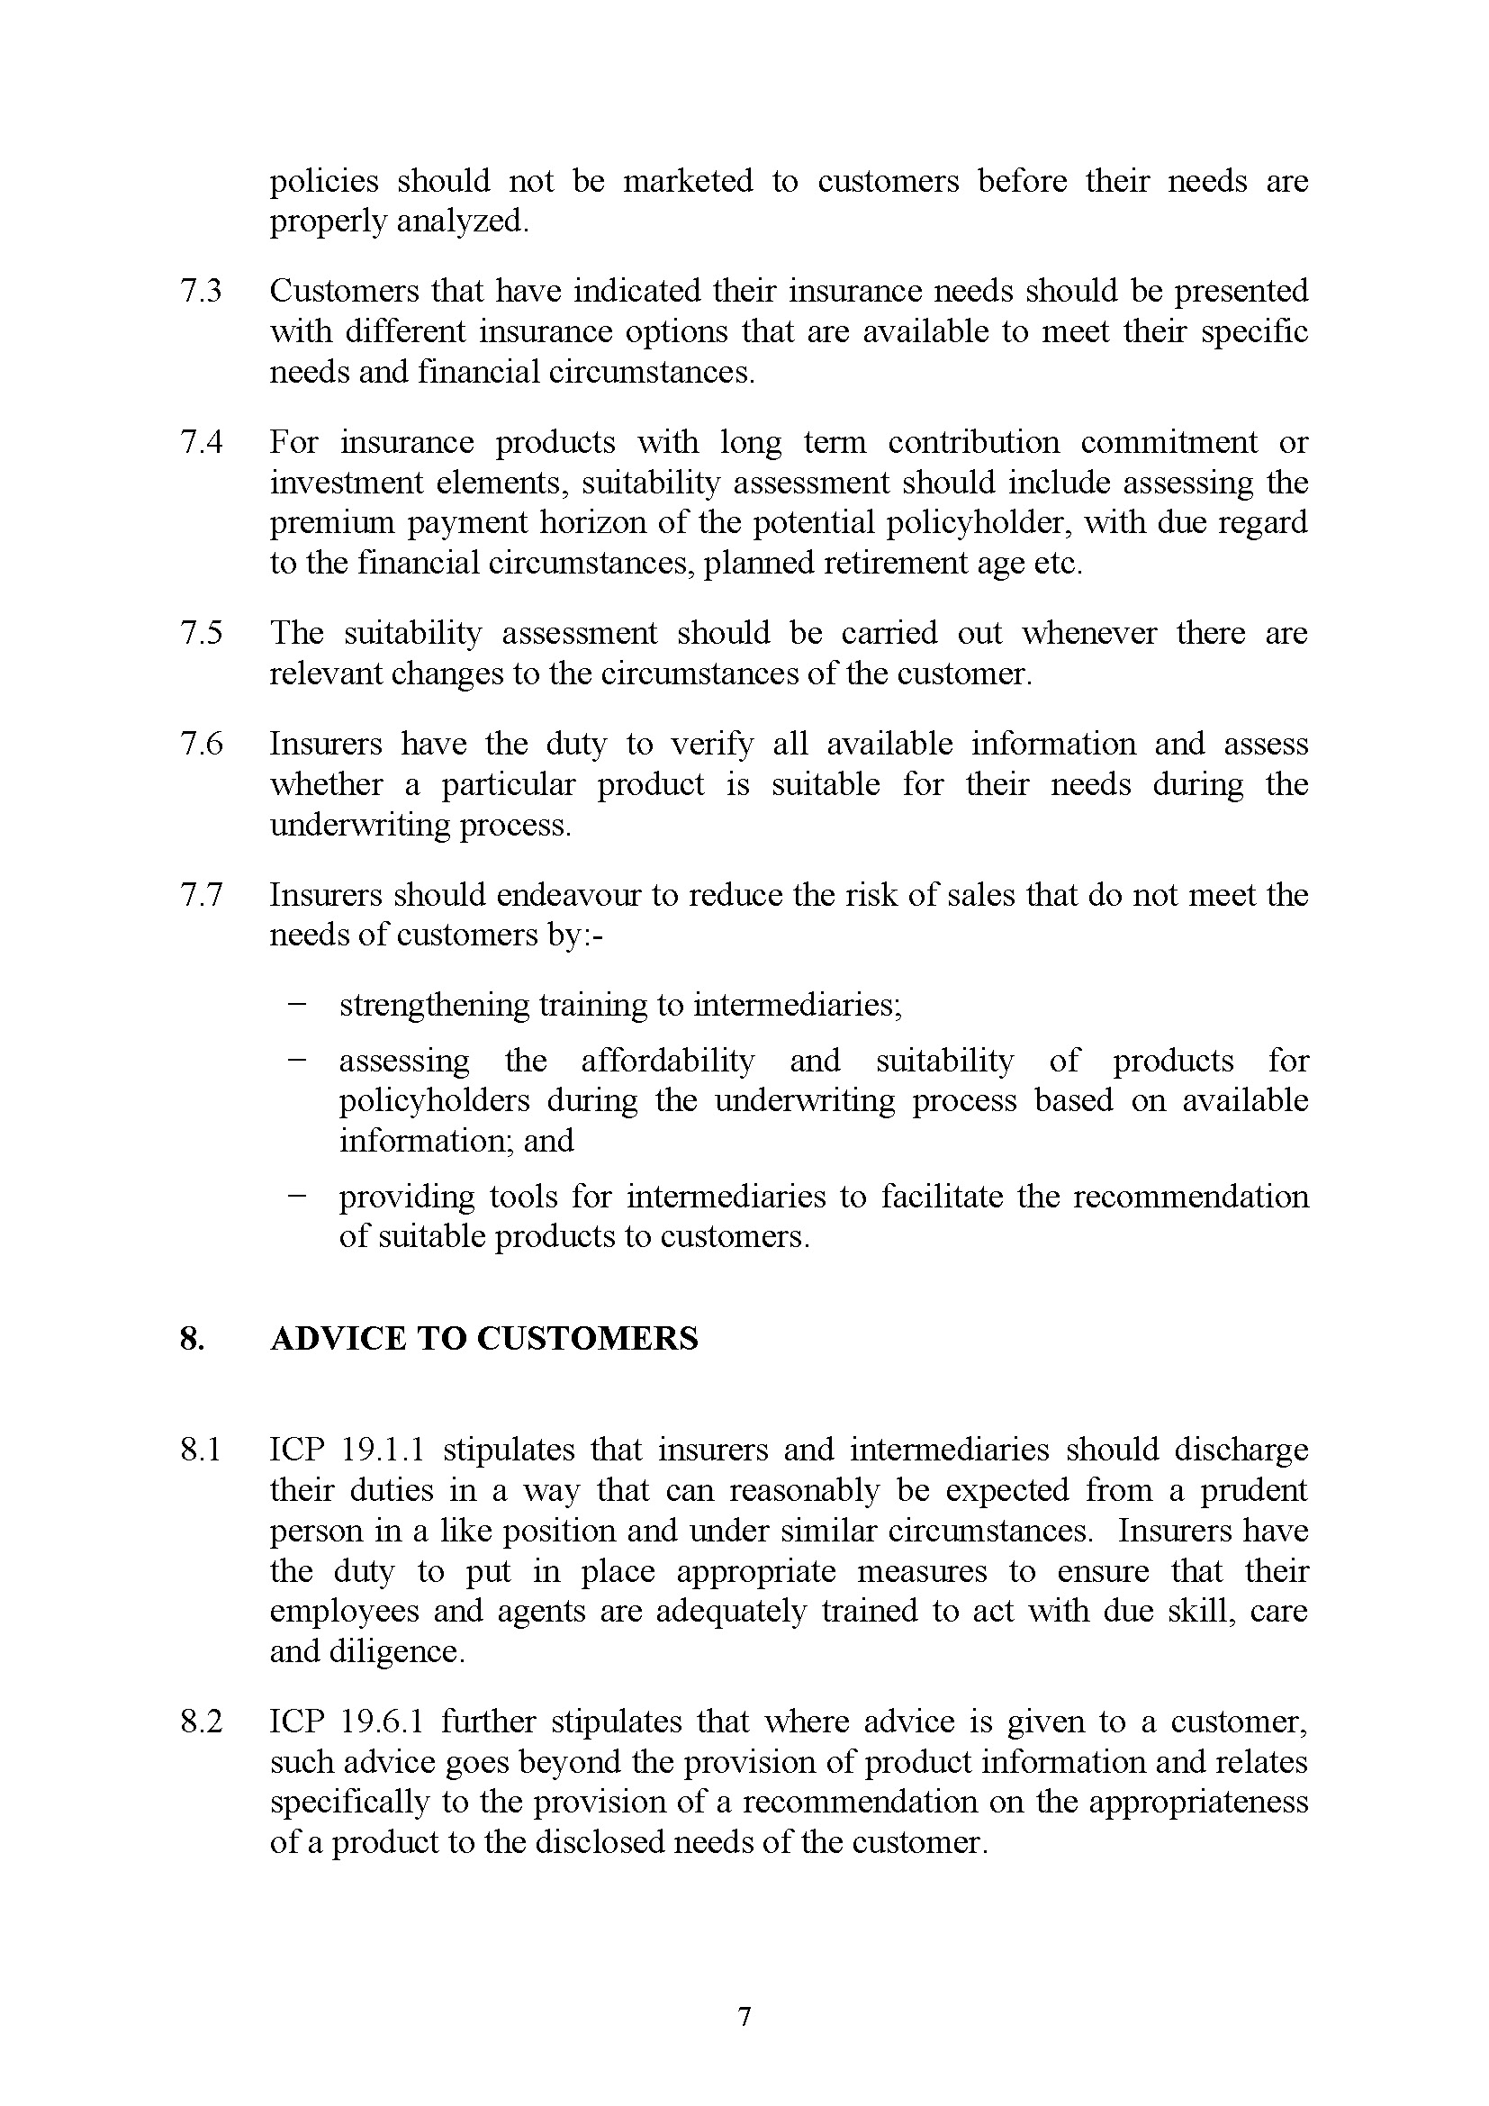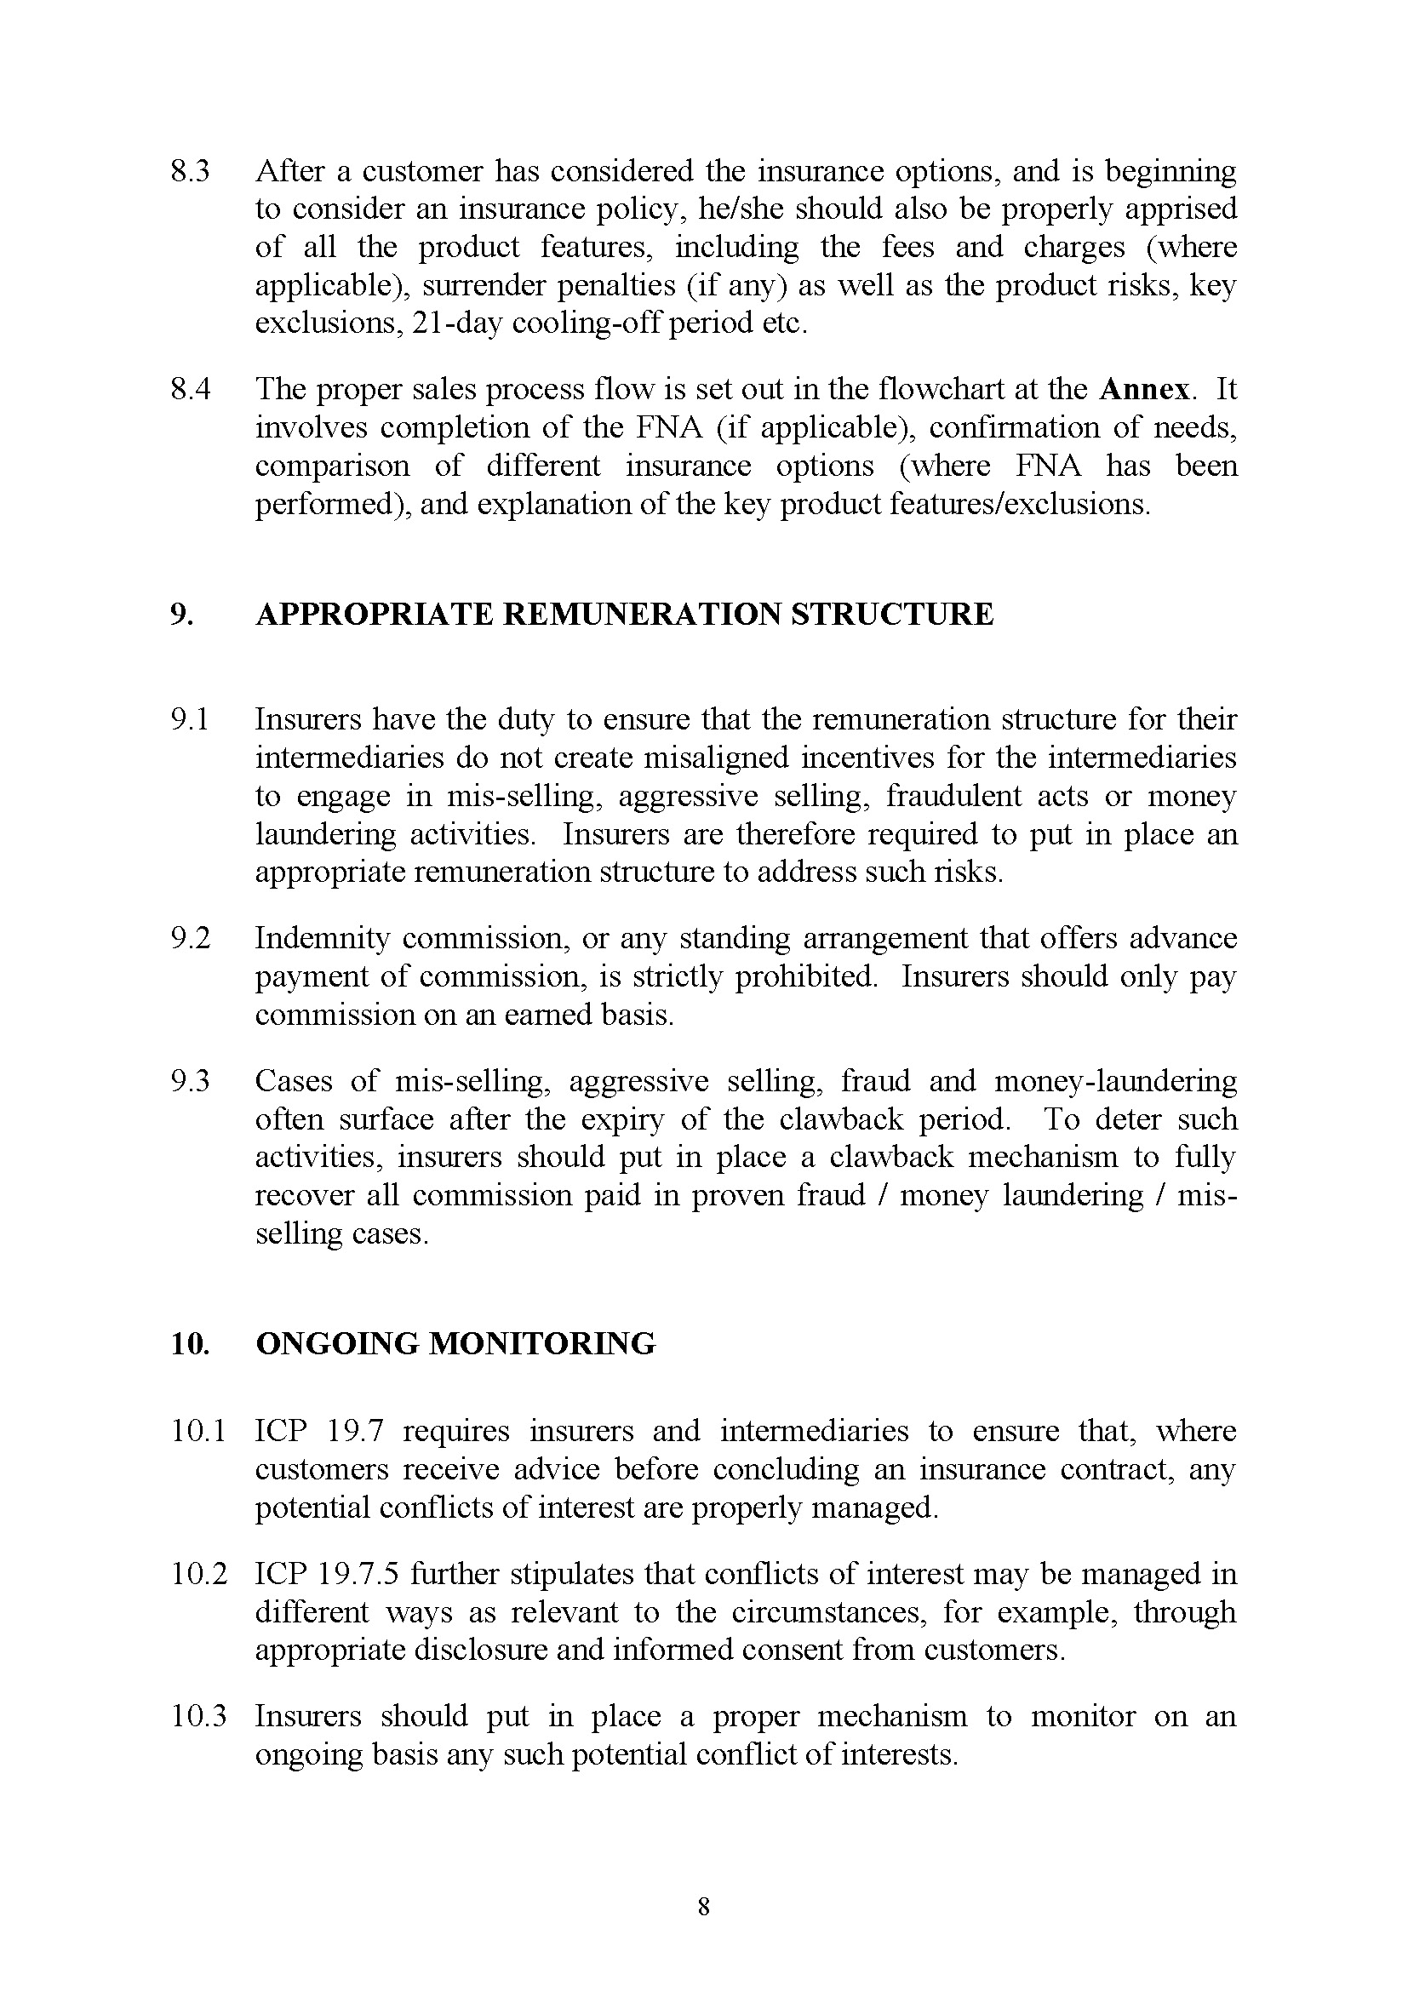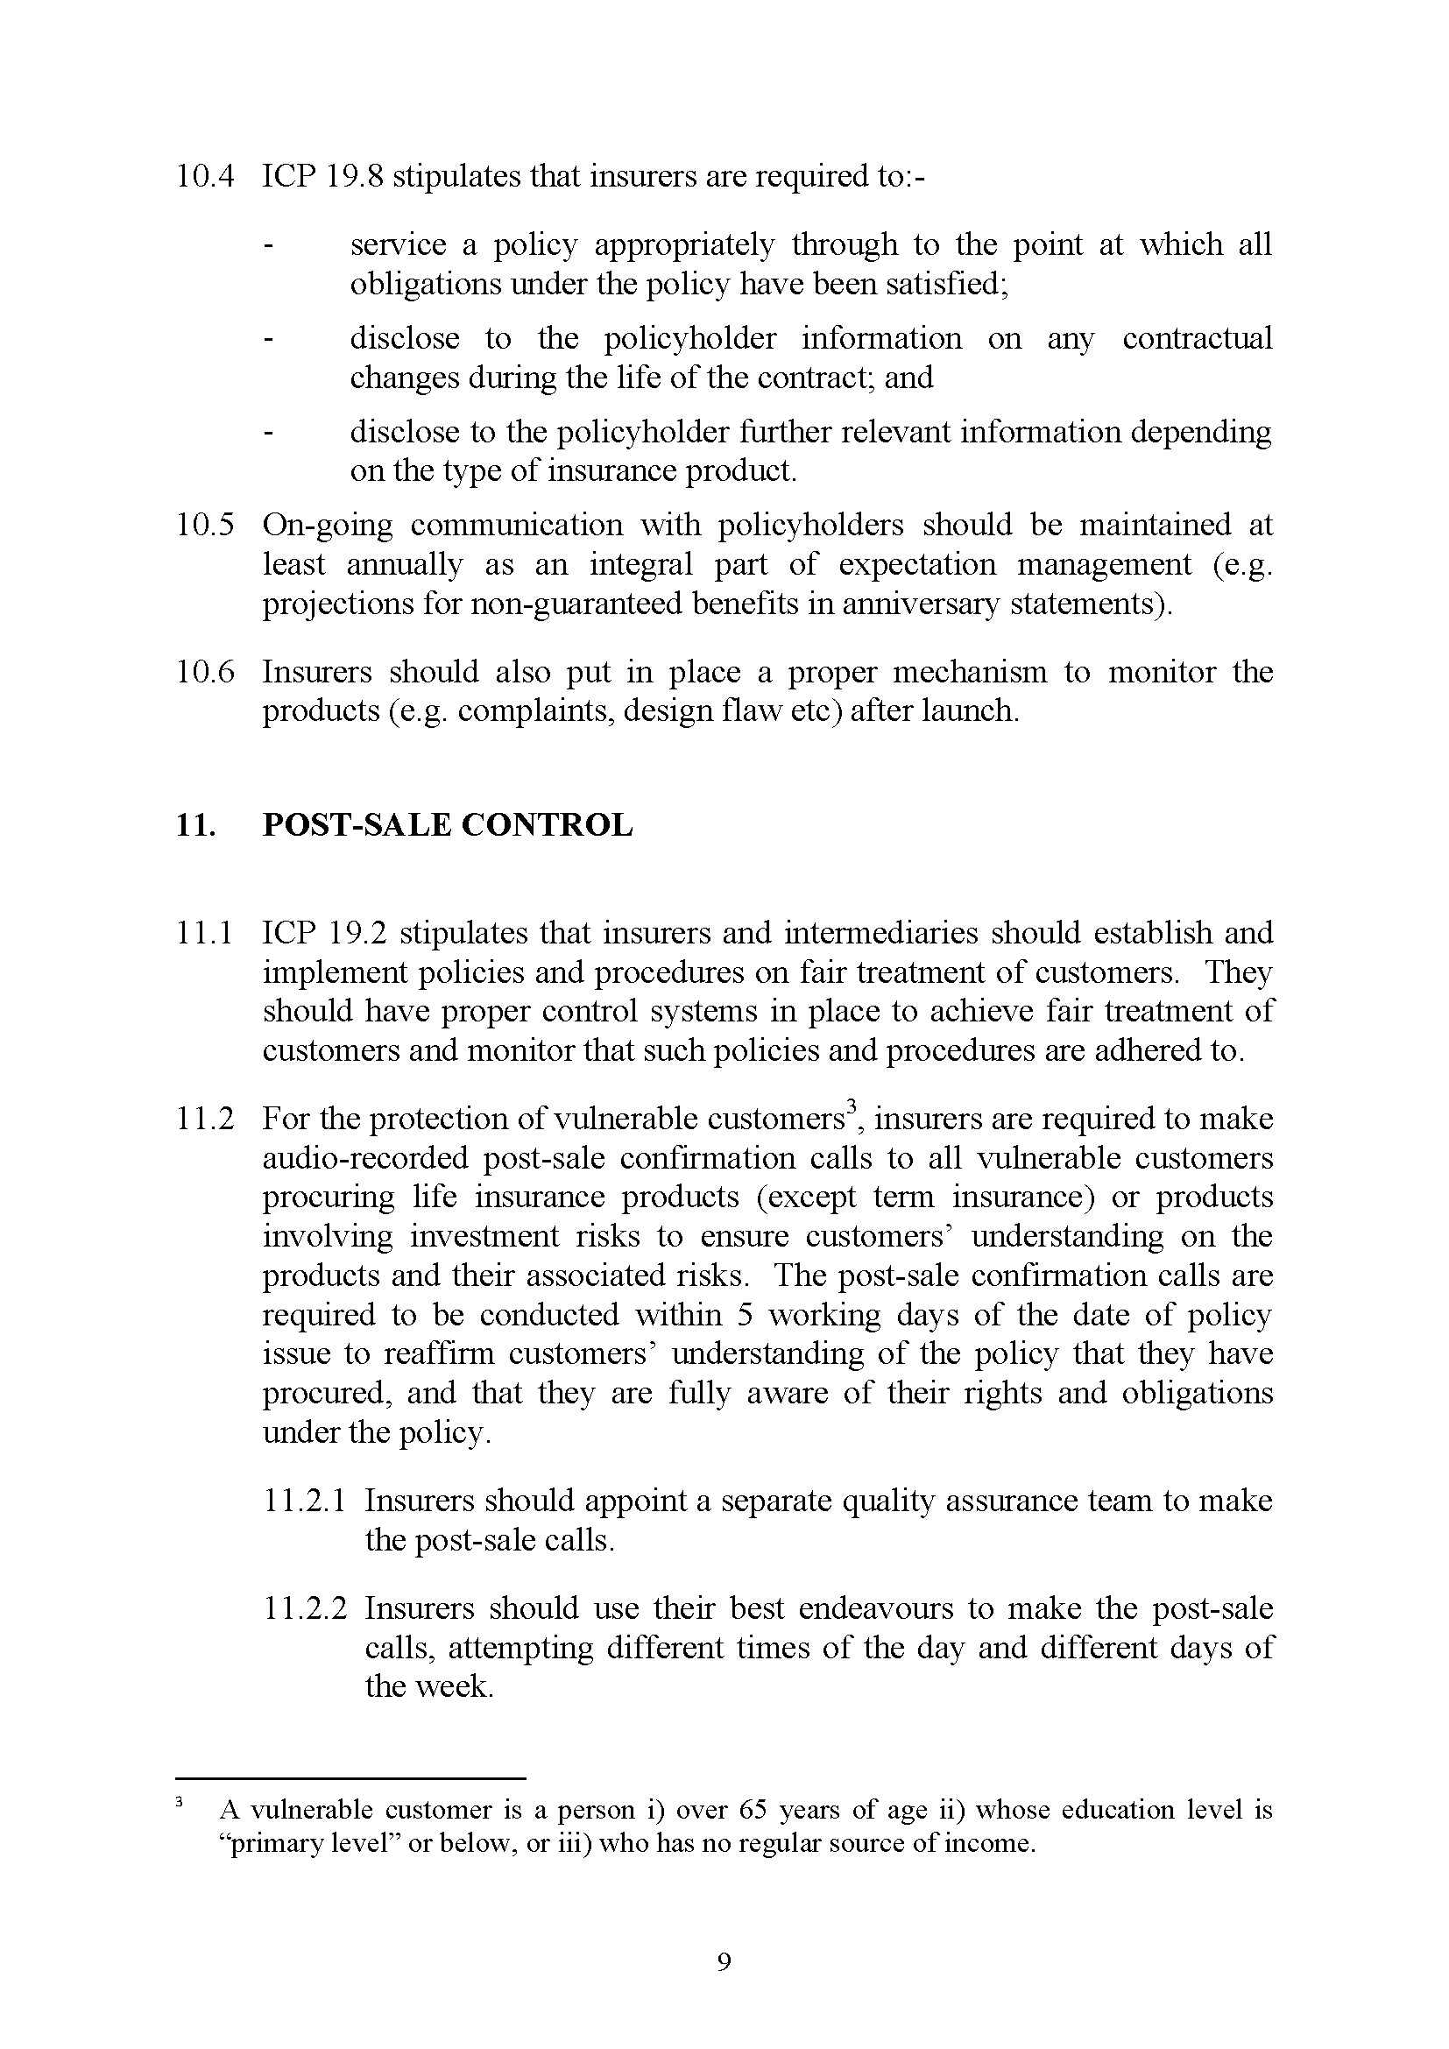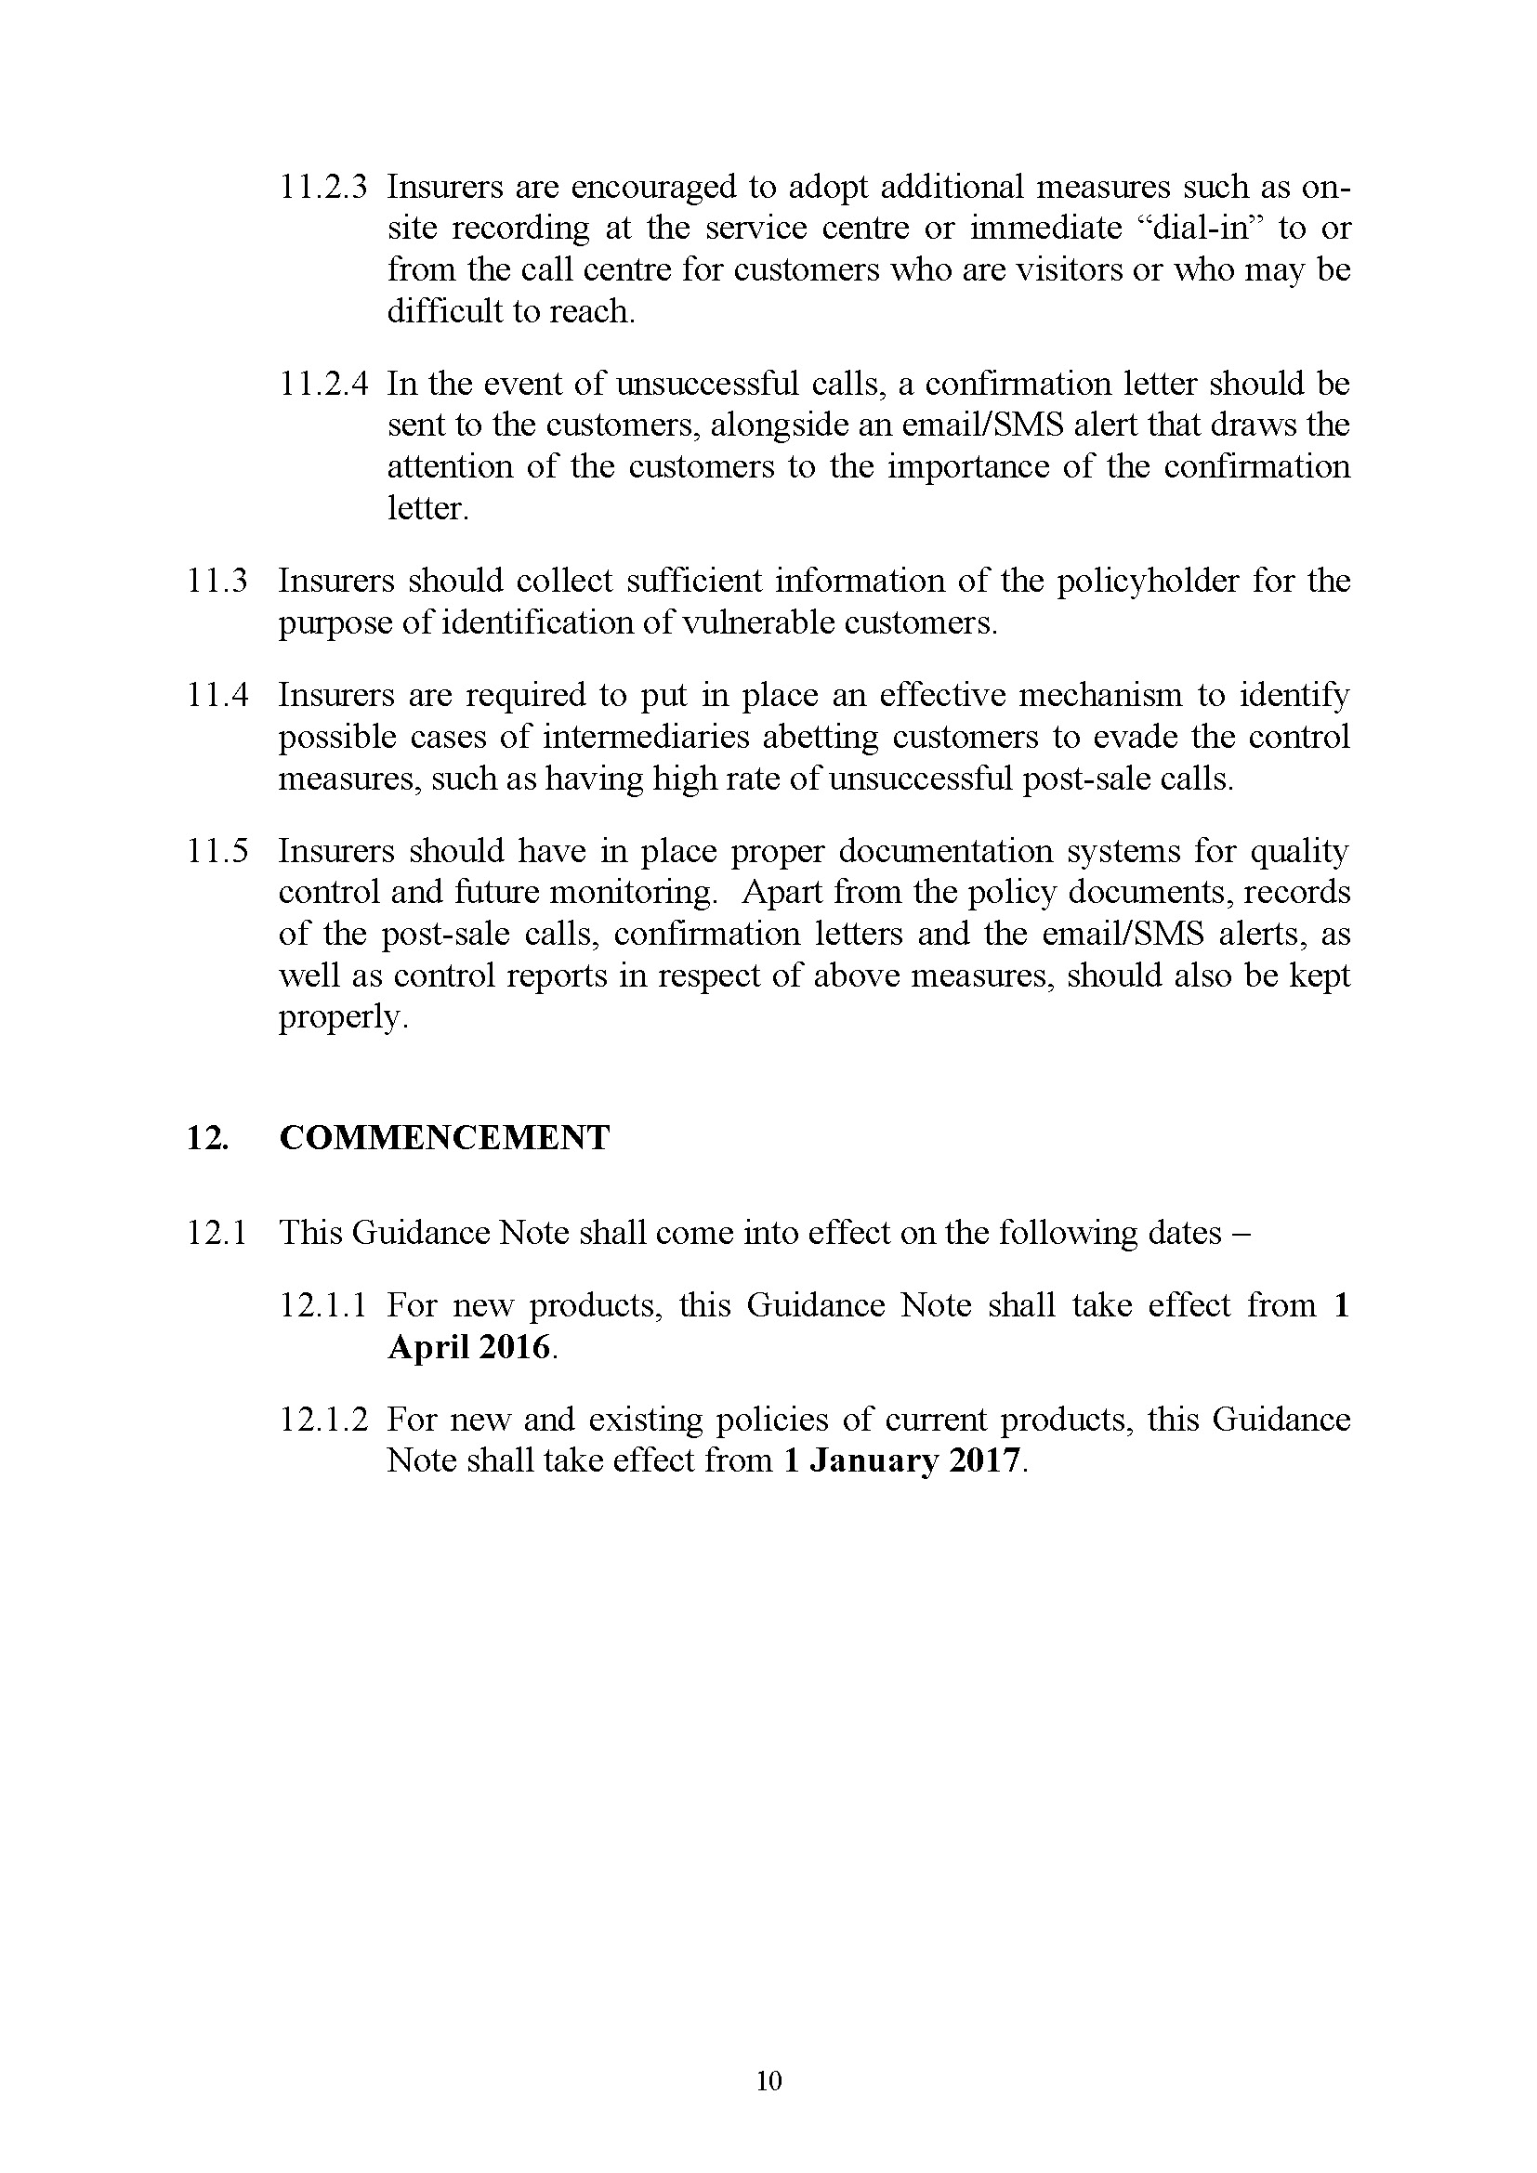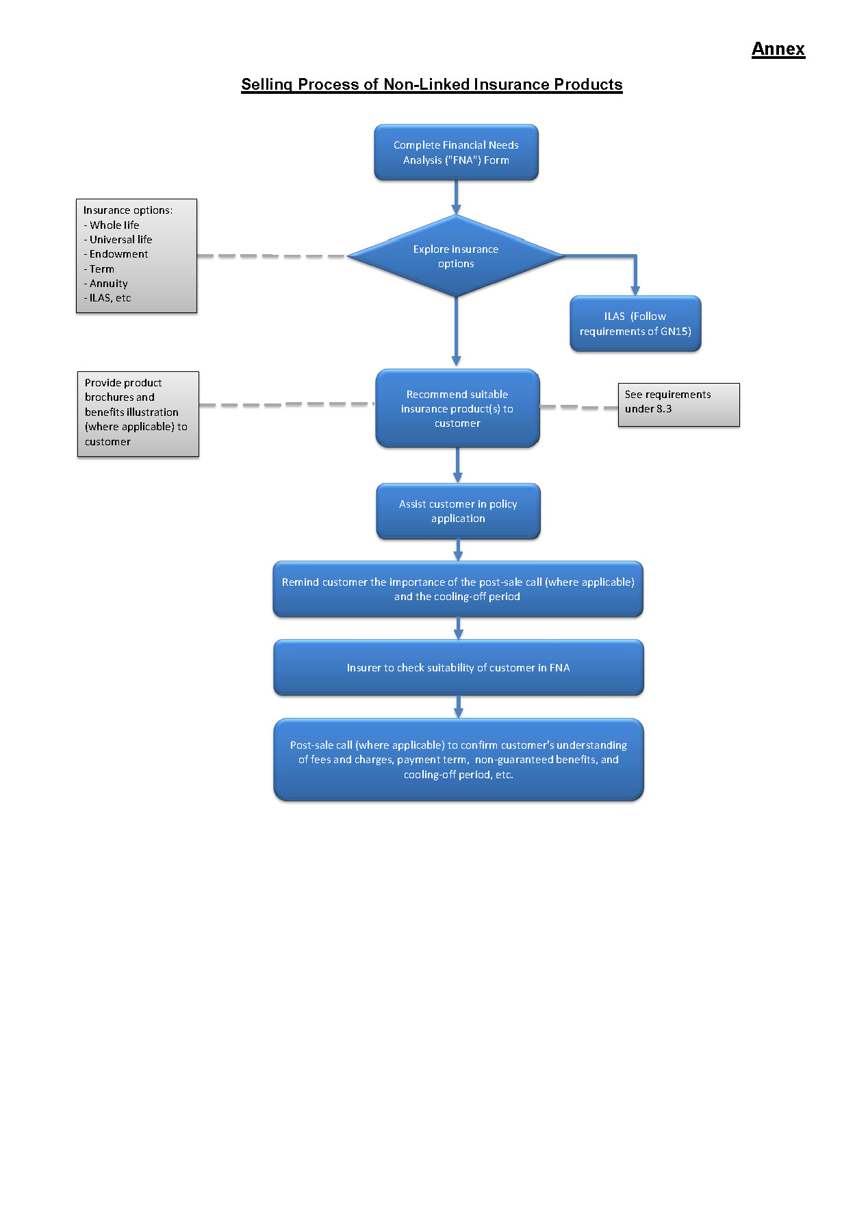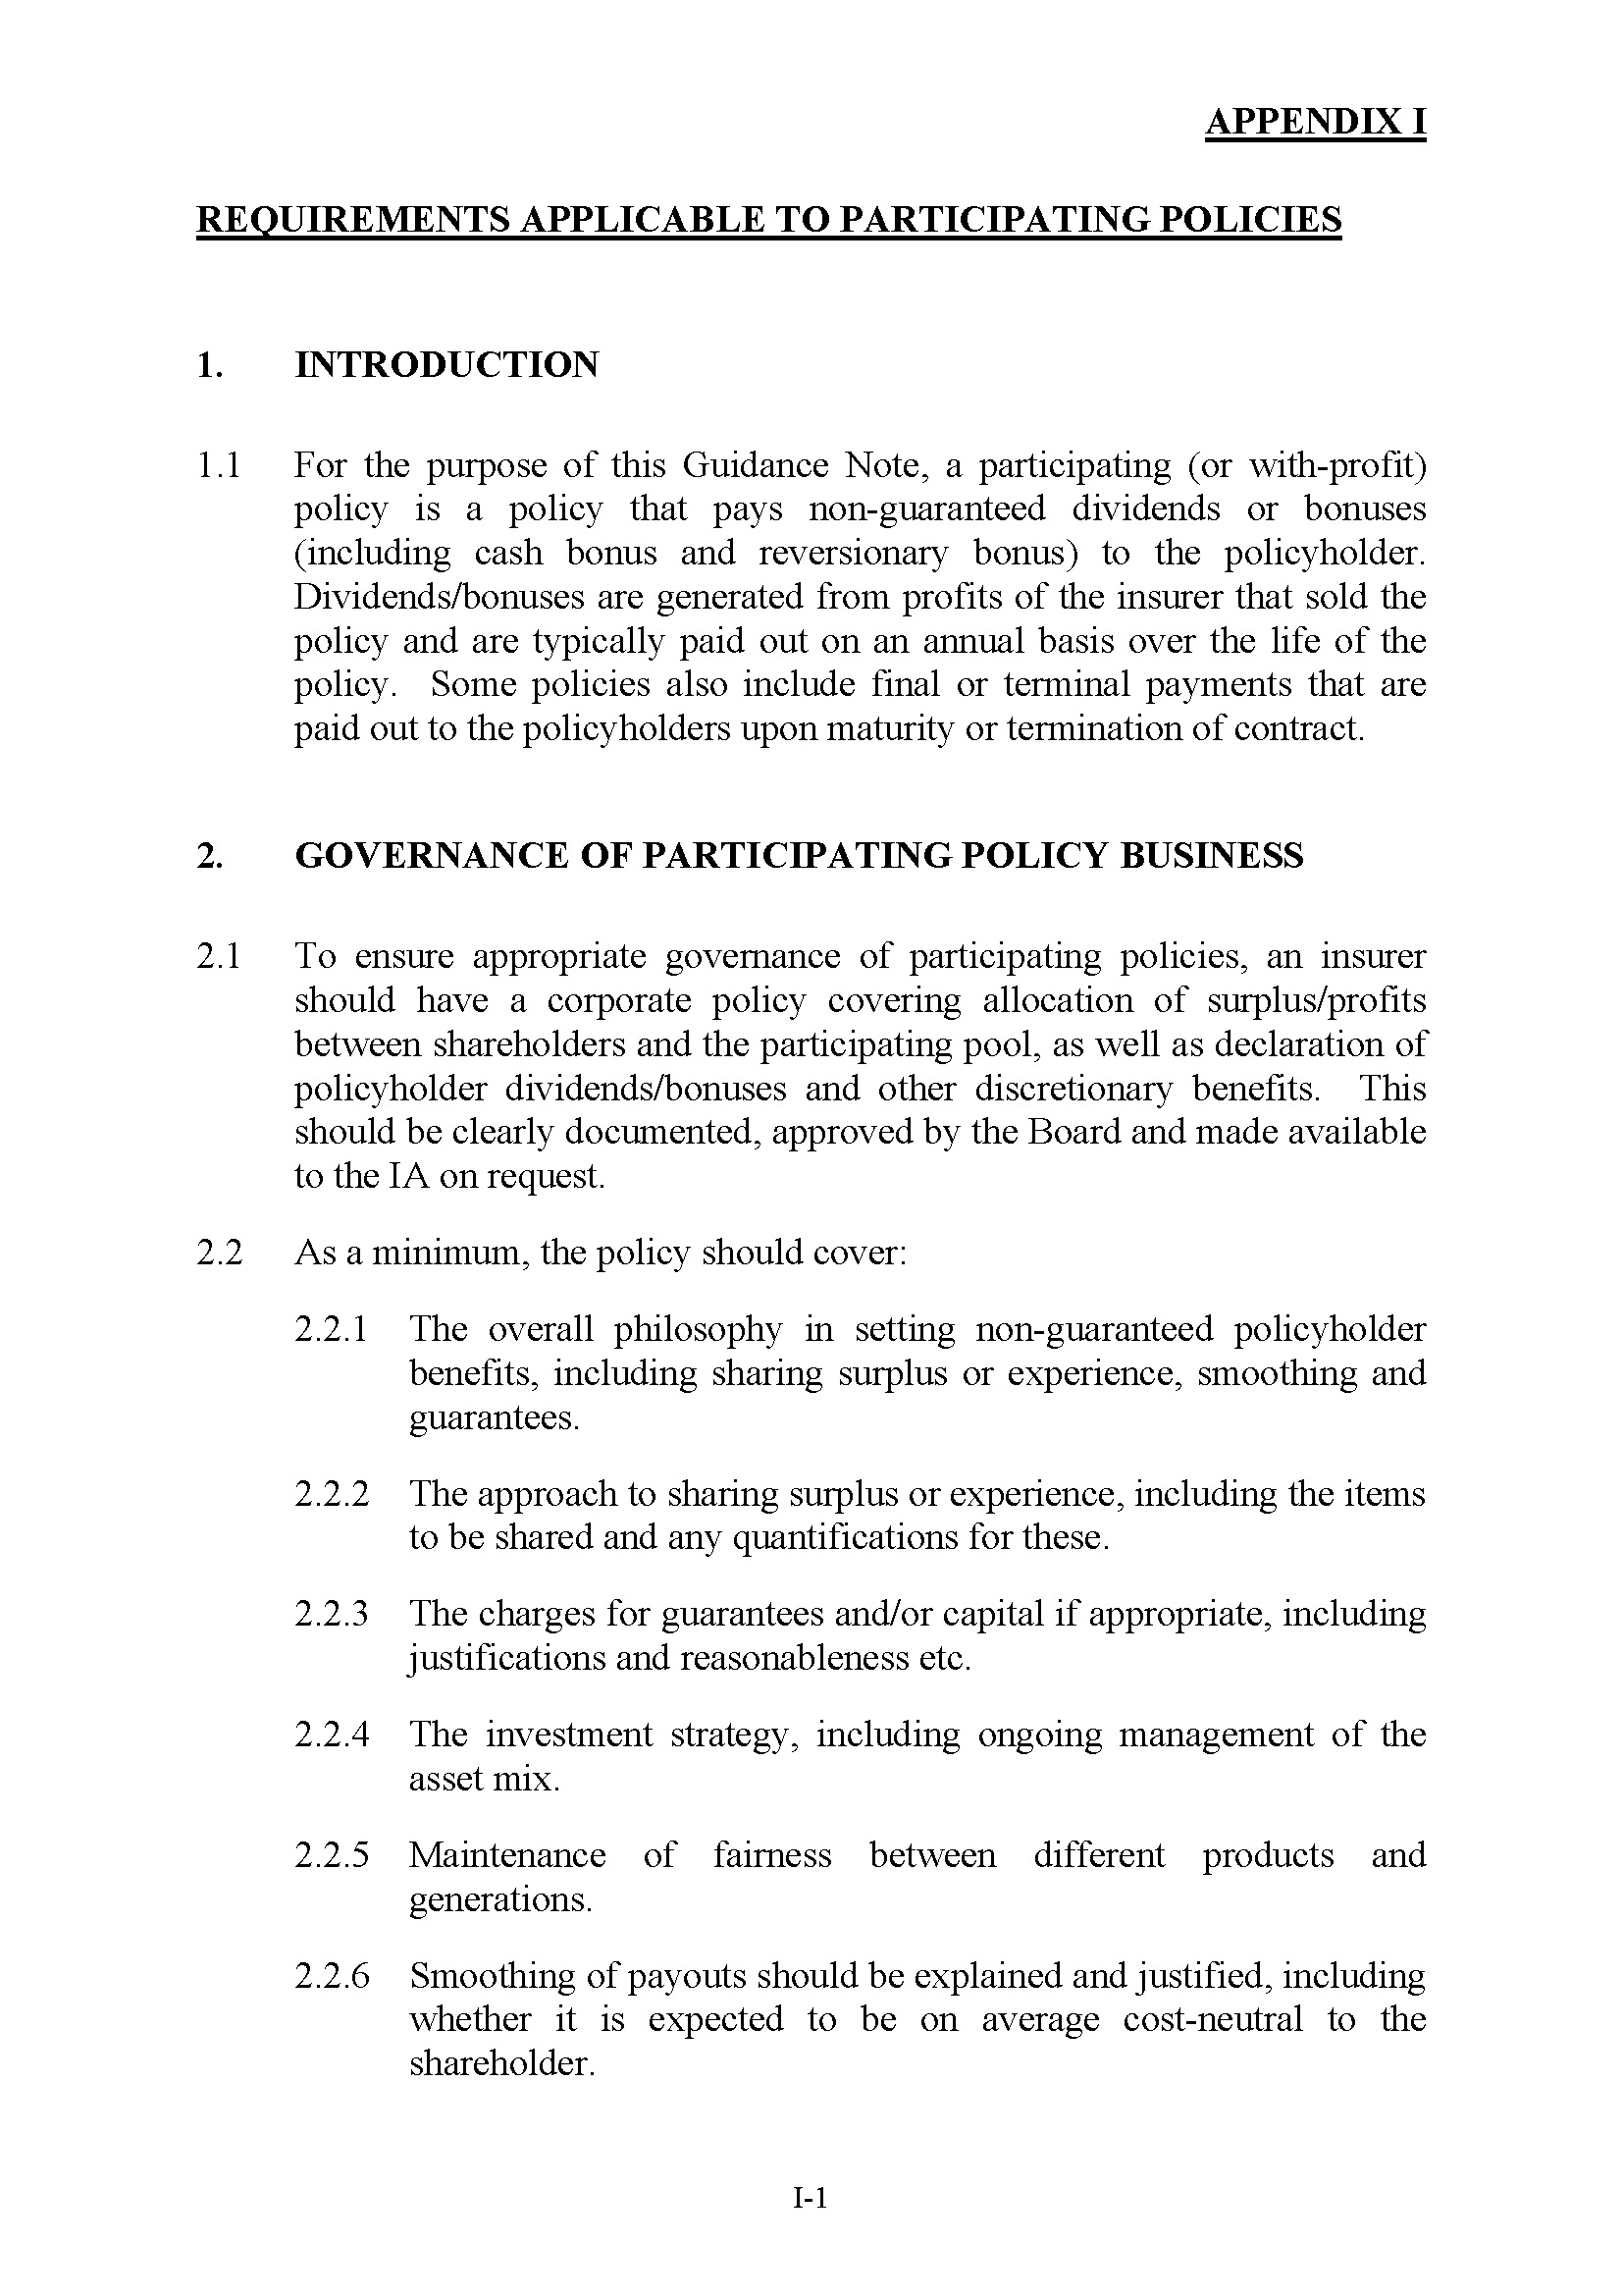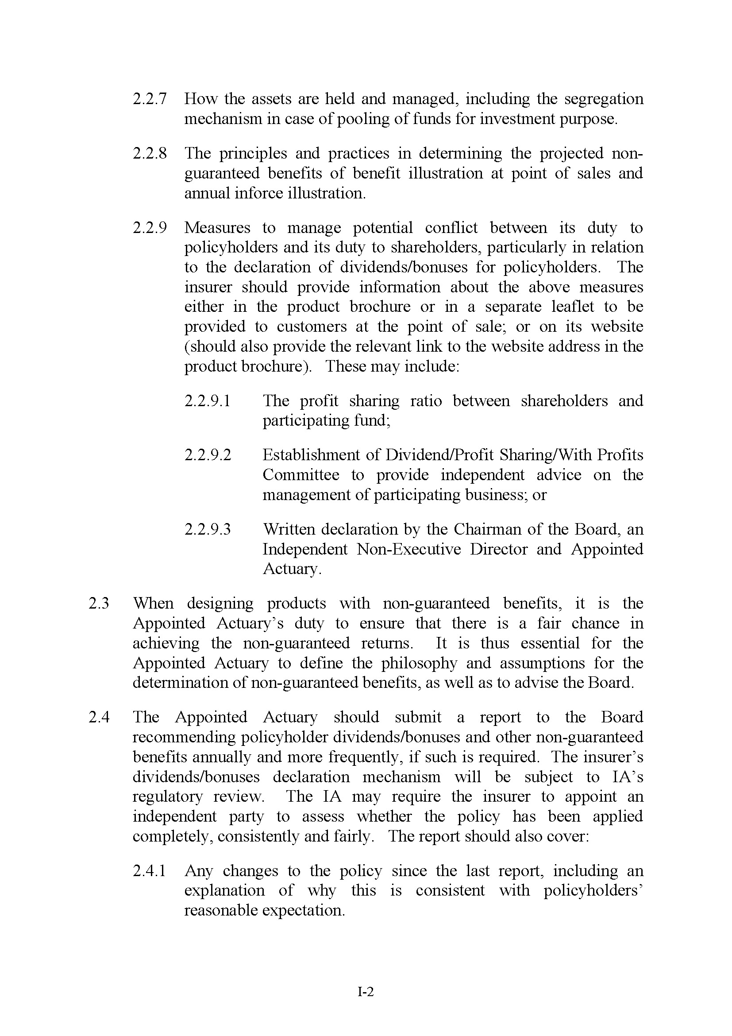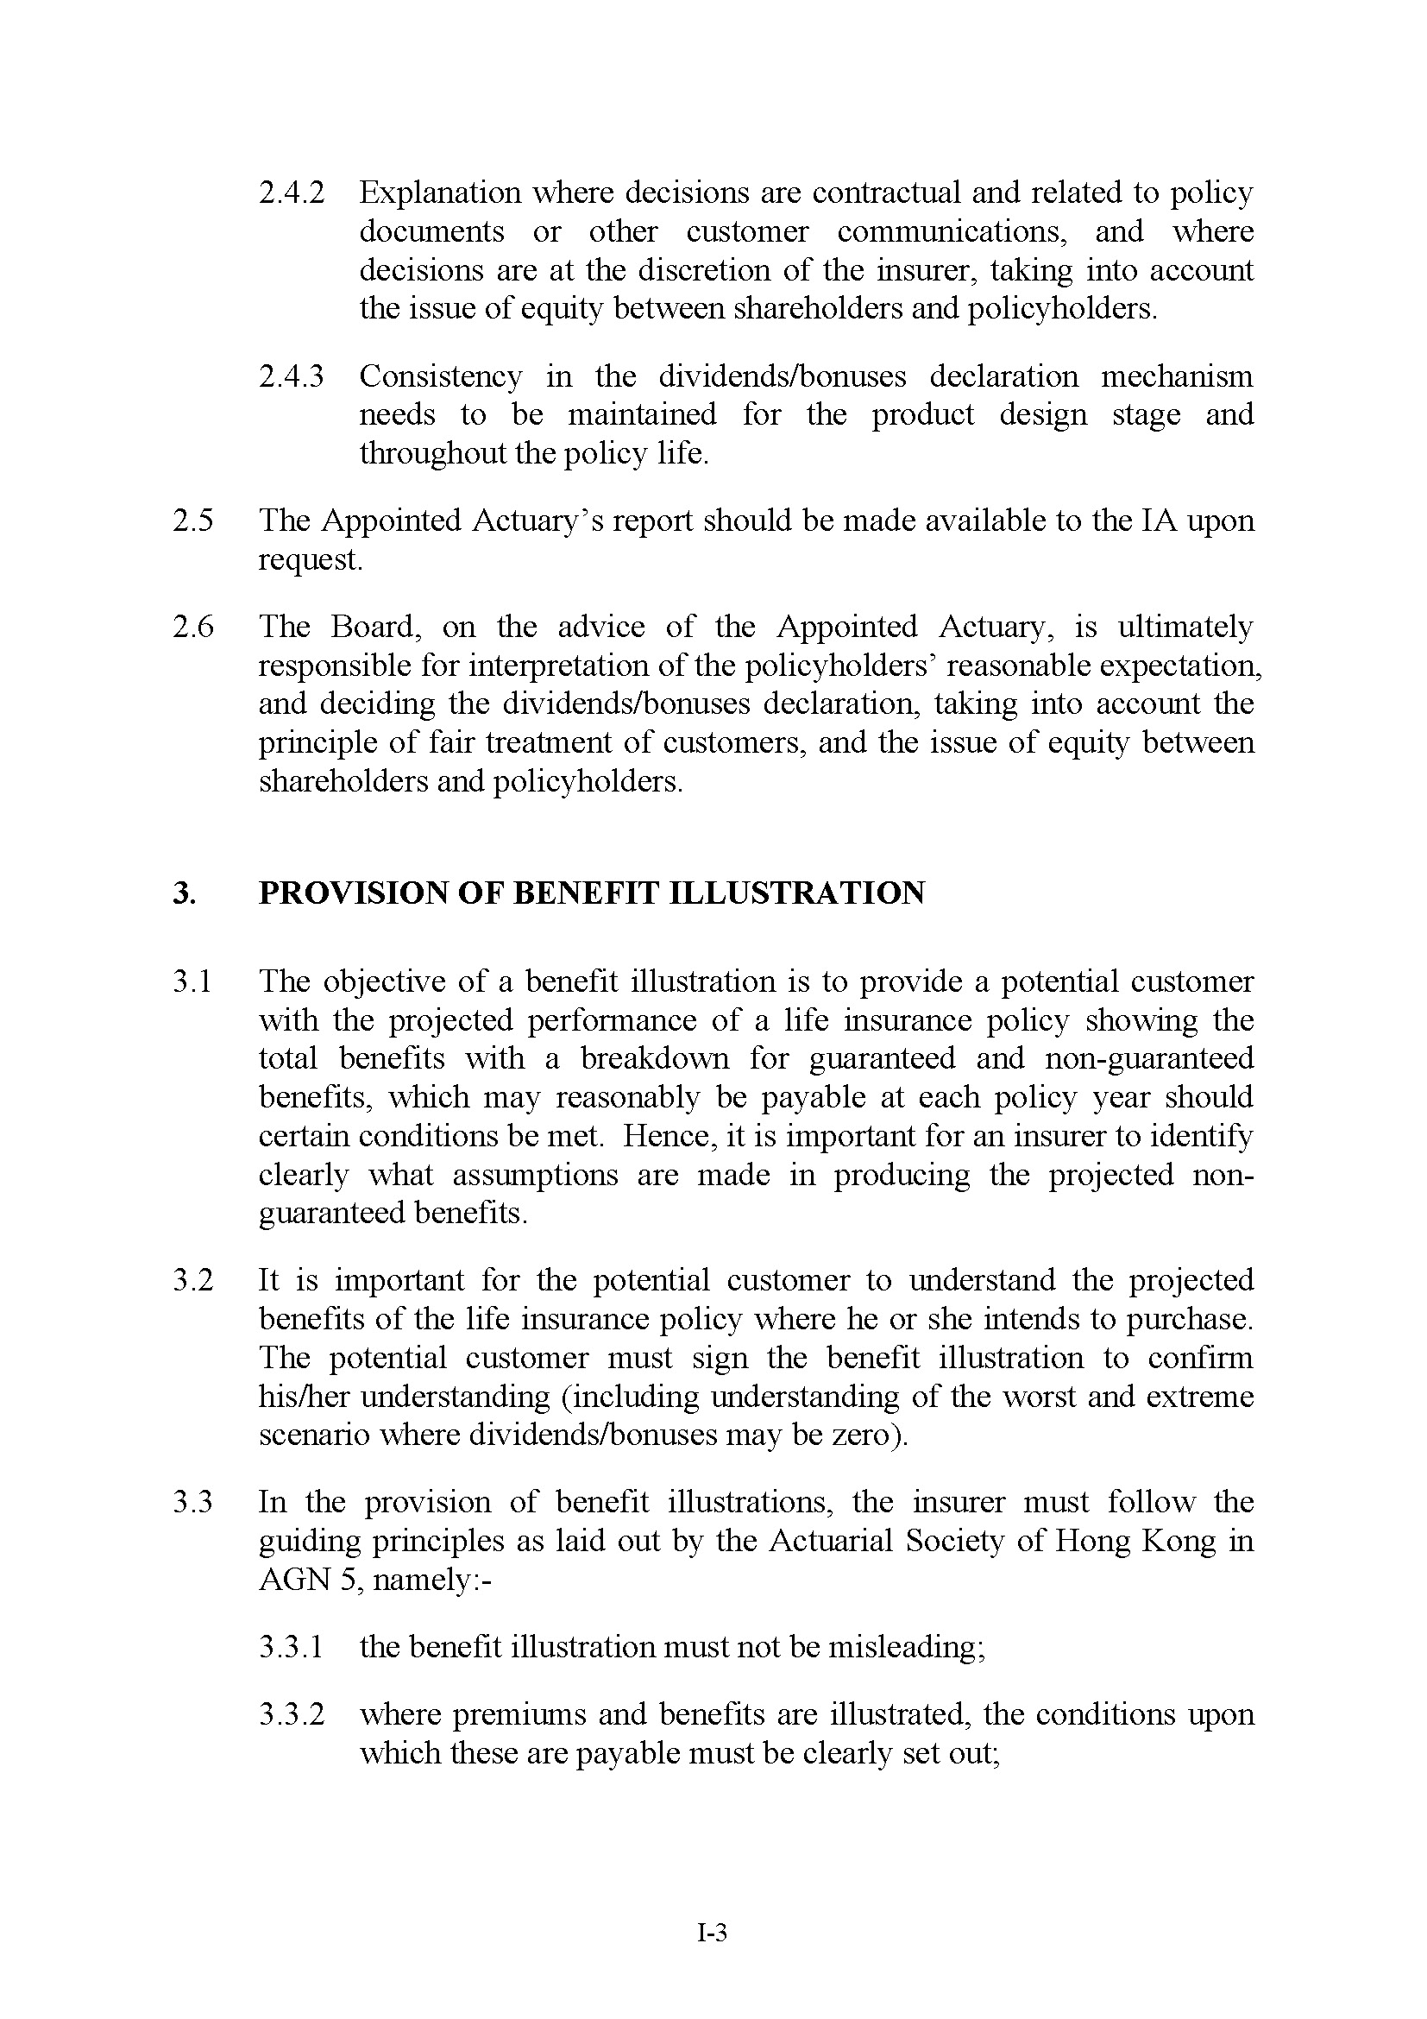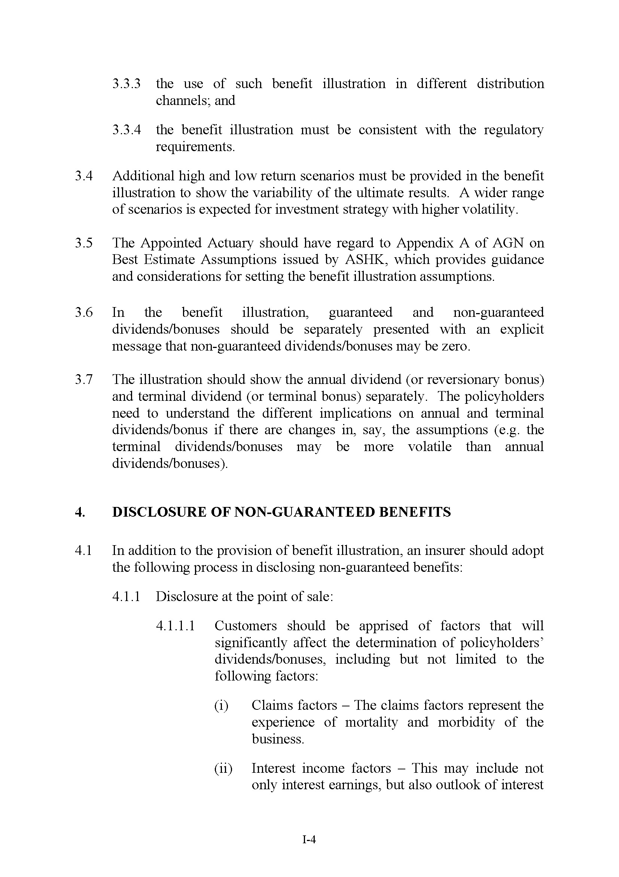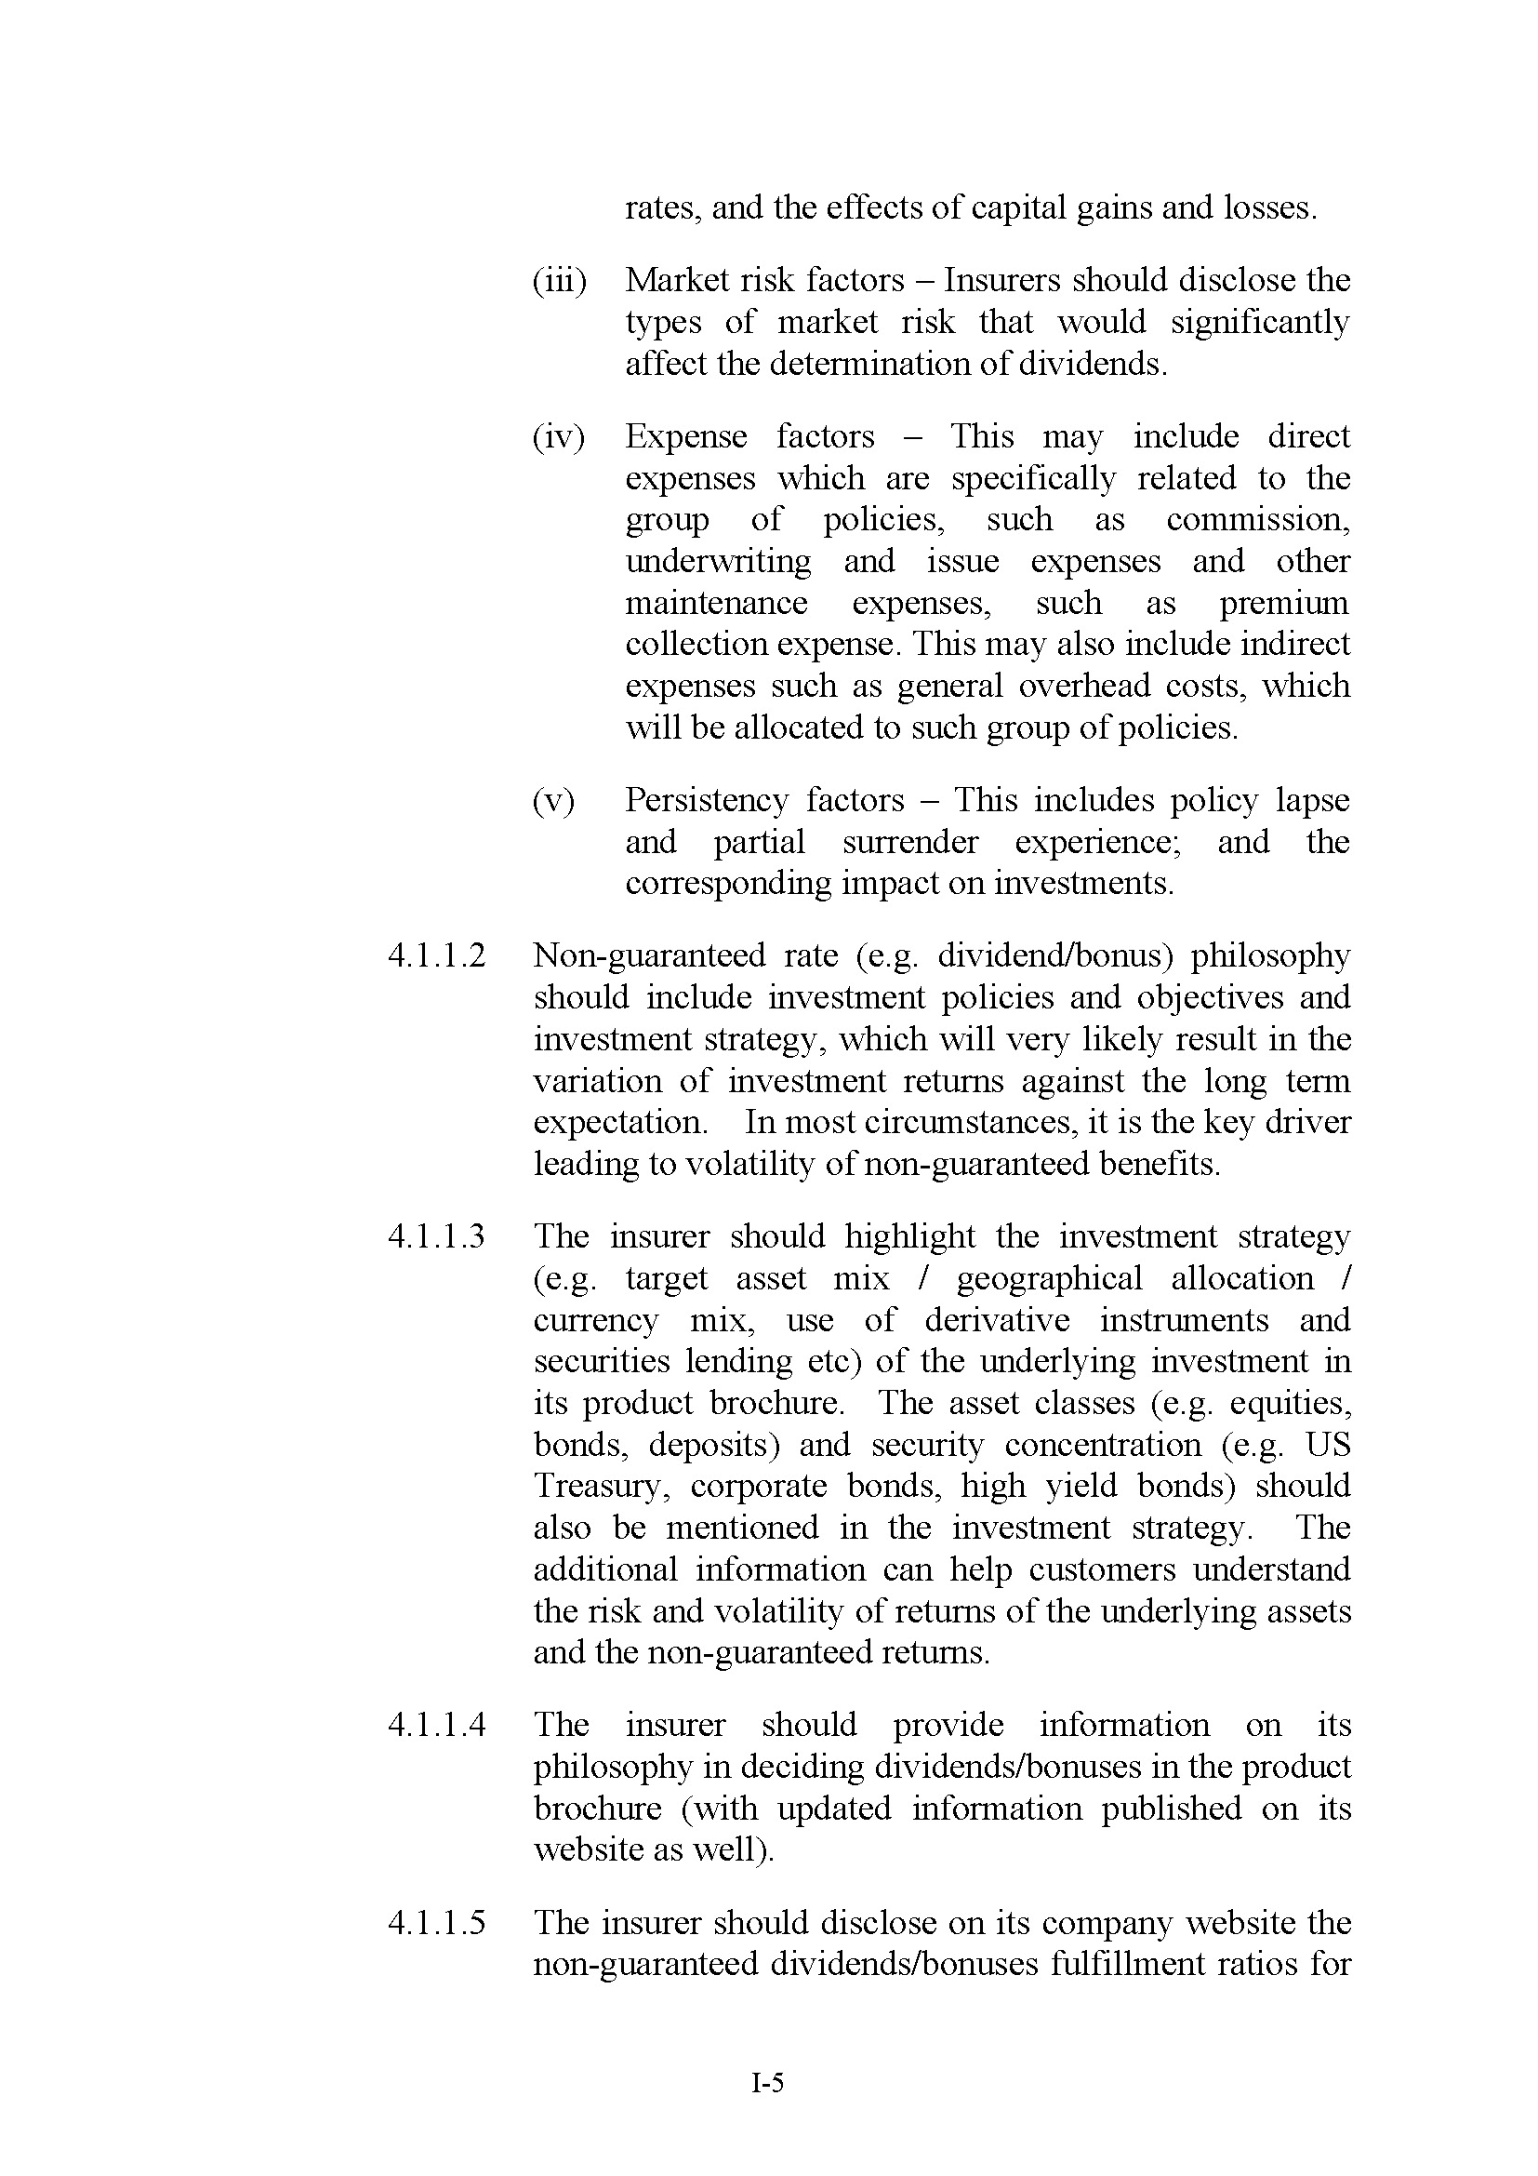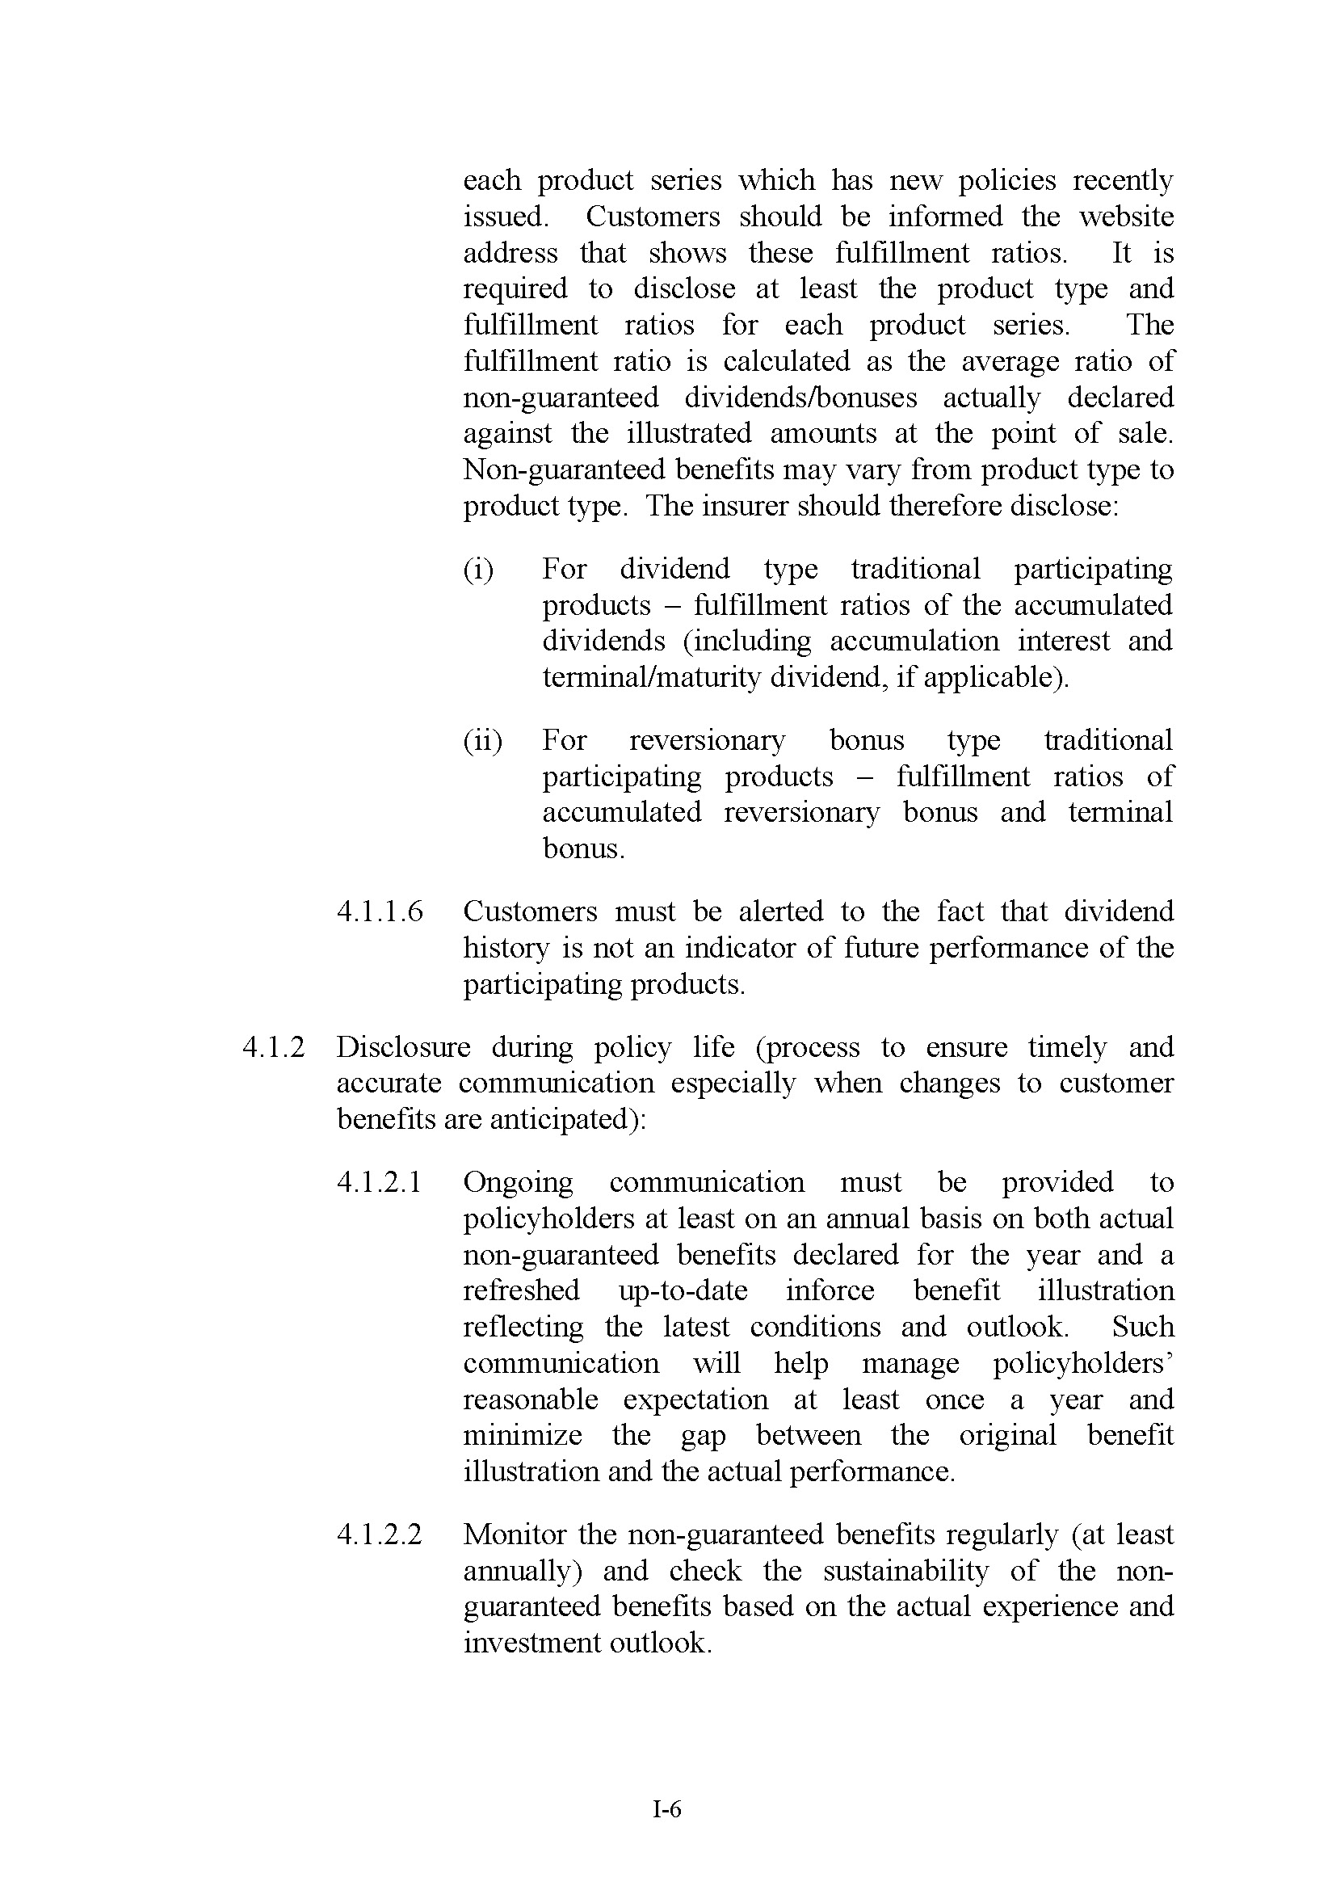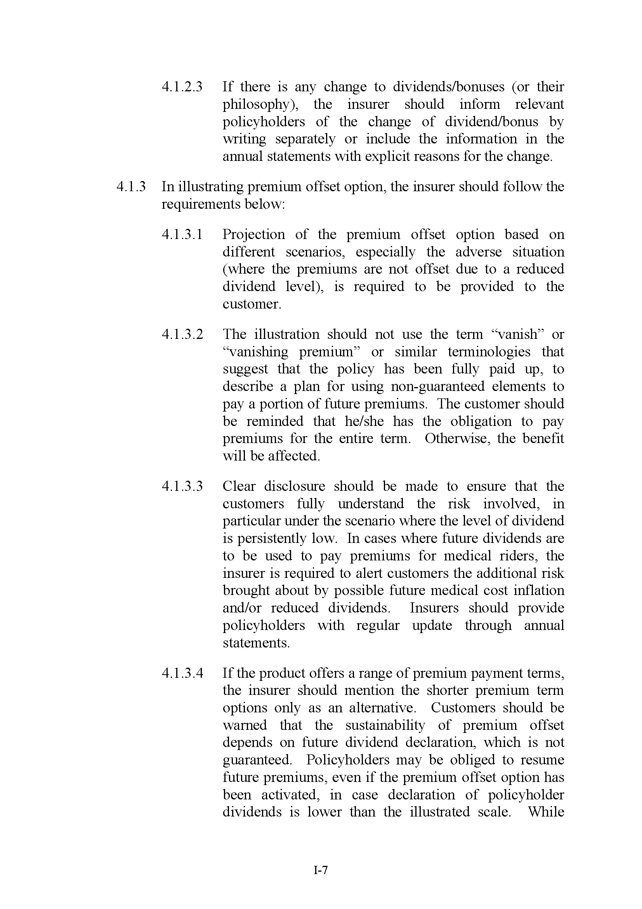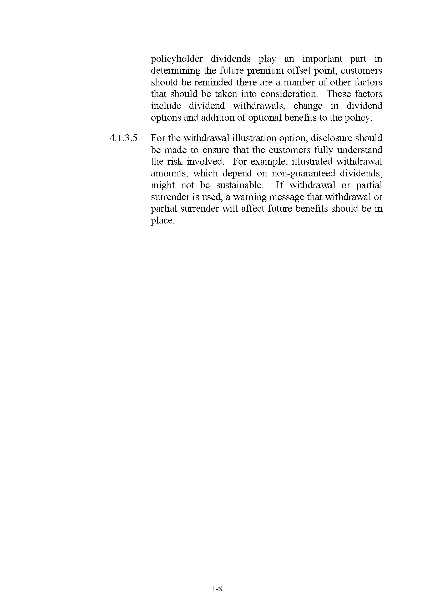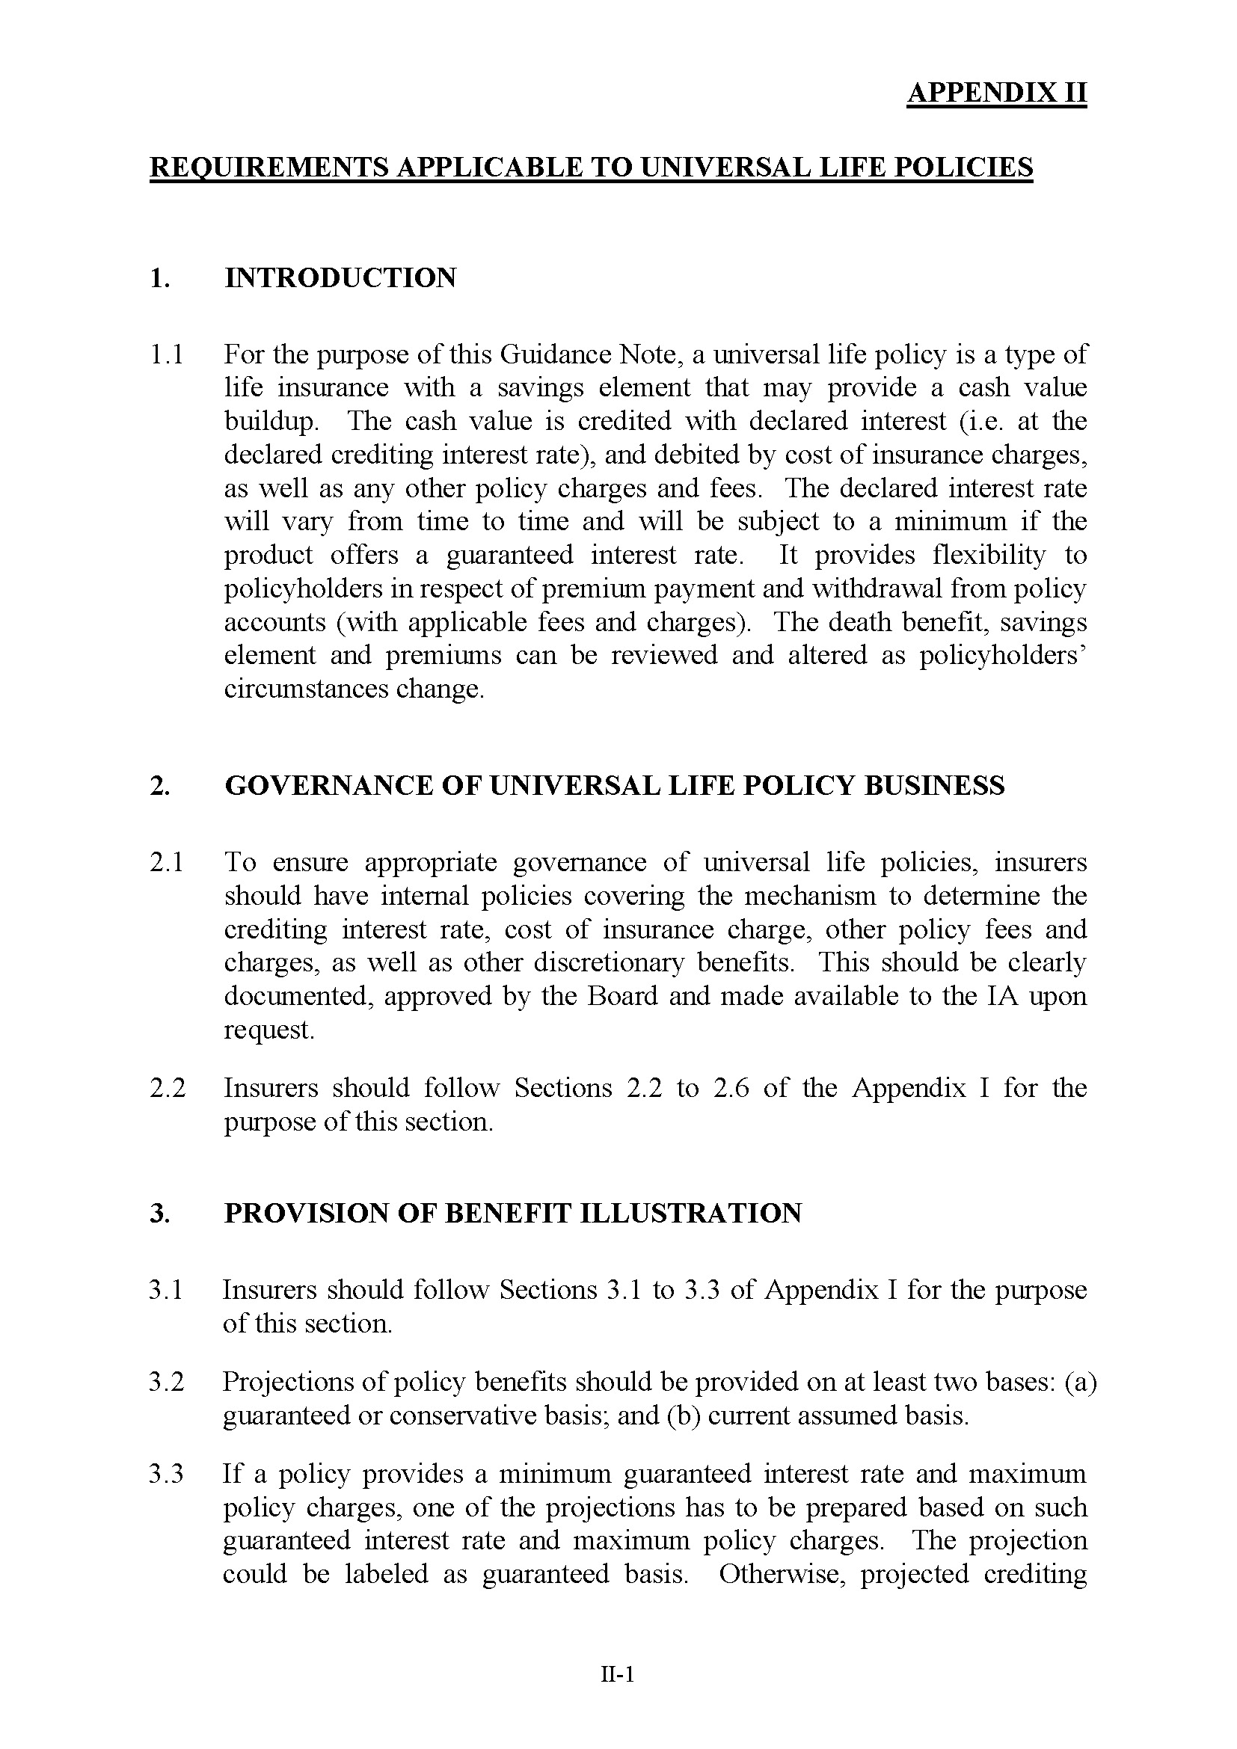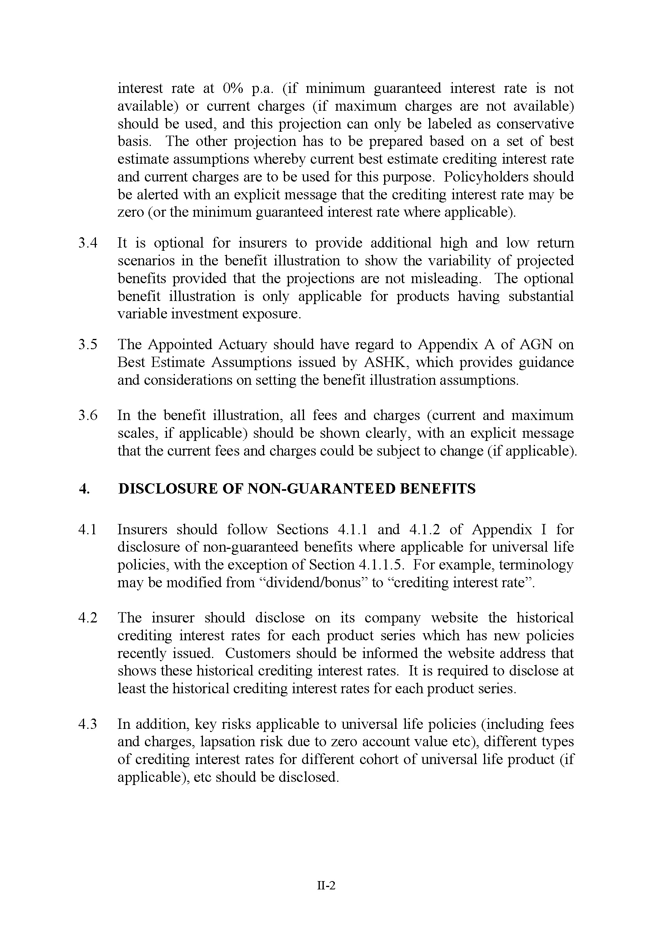

Appendix F

Initiative on Financial Needs Analysis
(Source: HKFI)
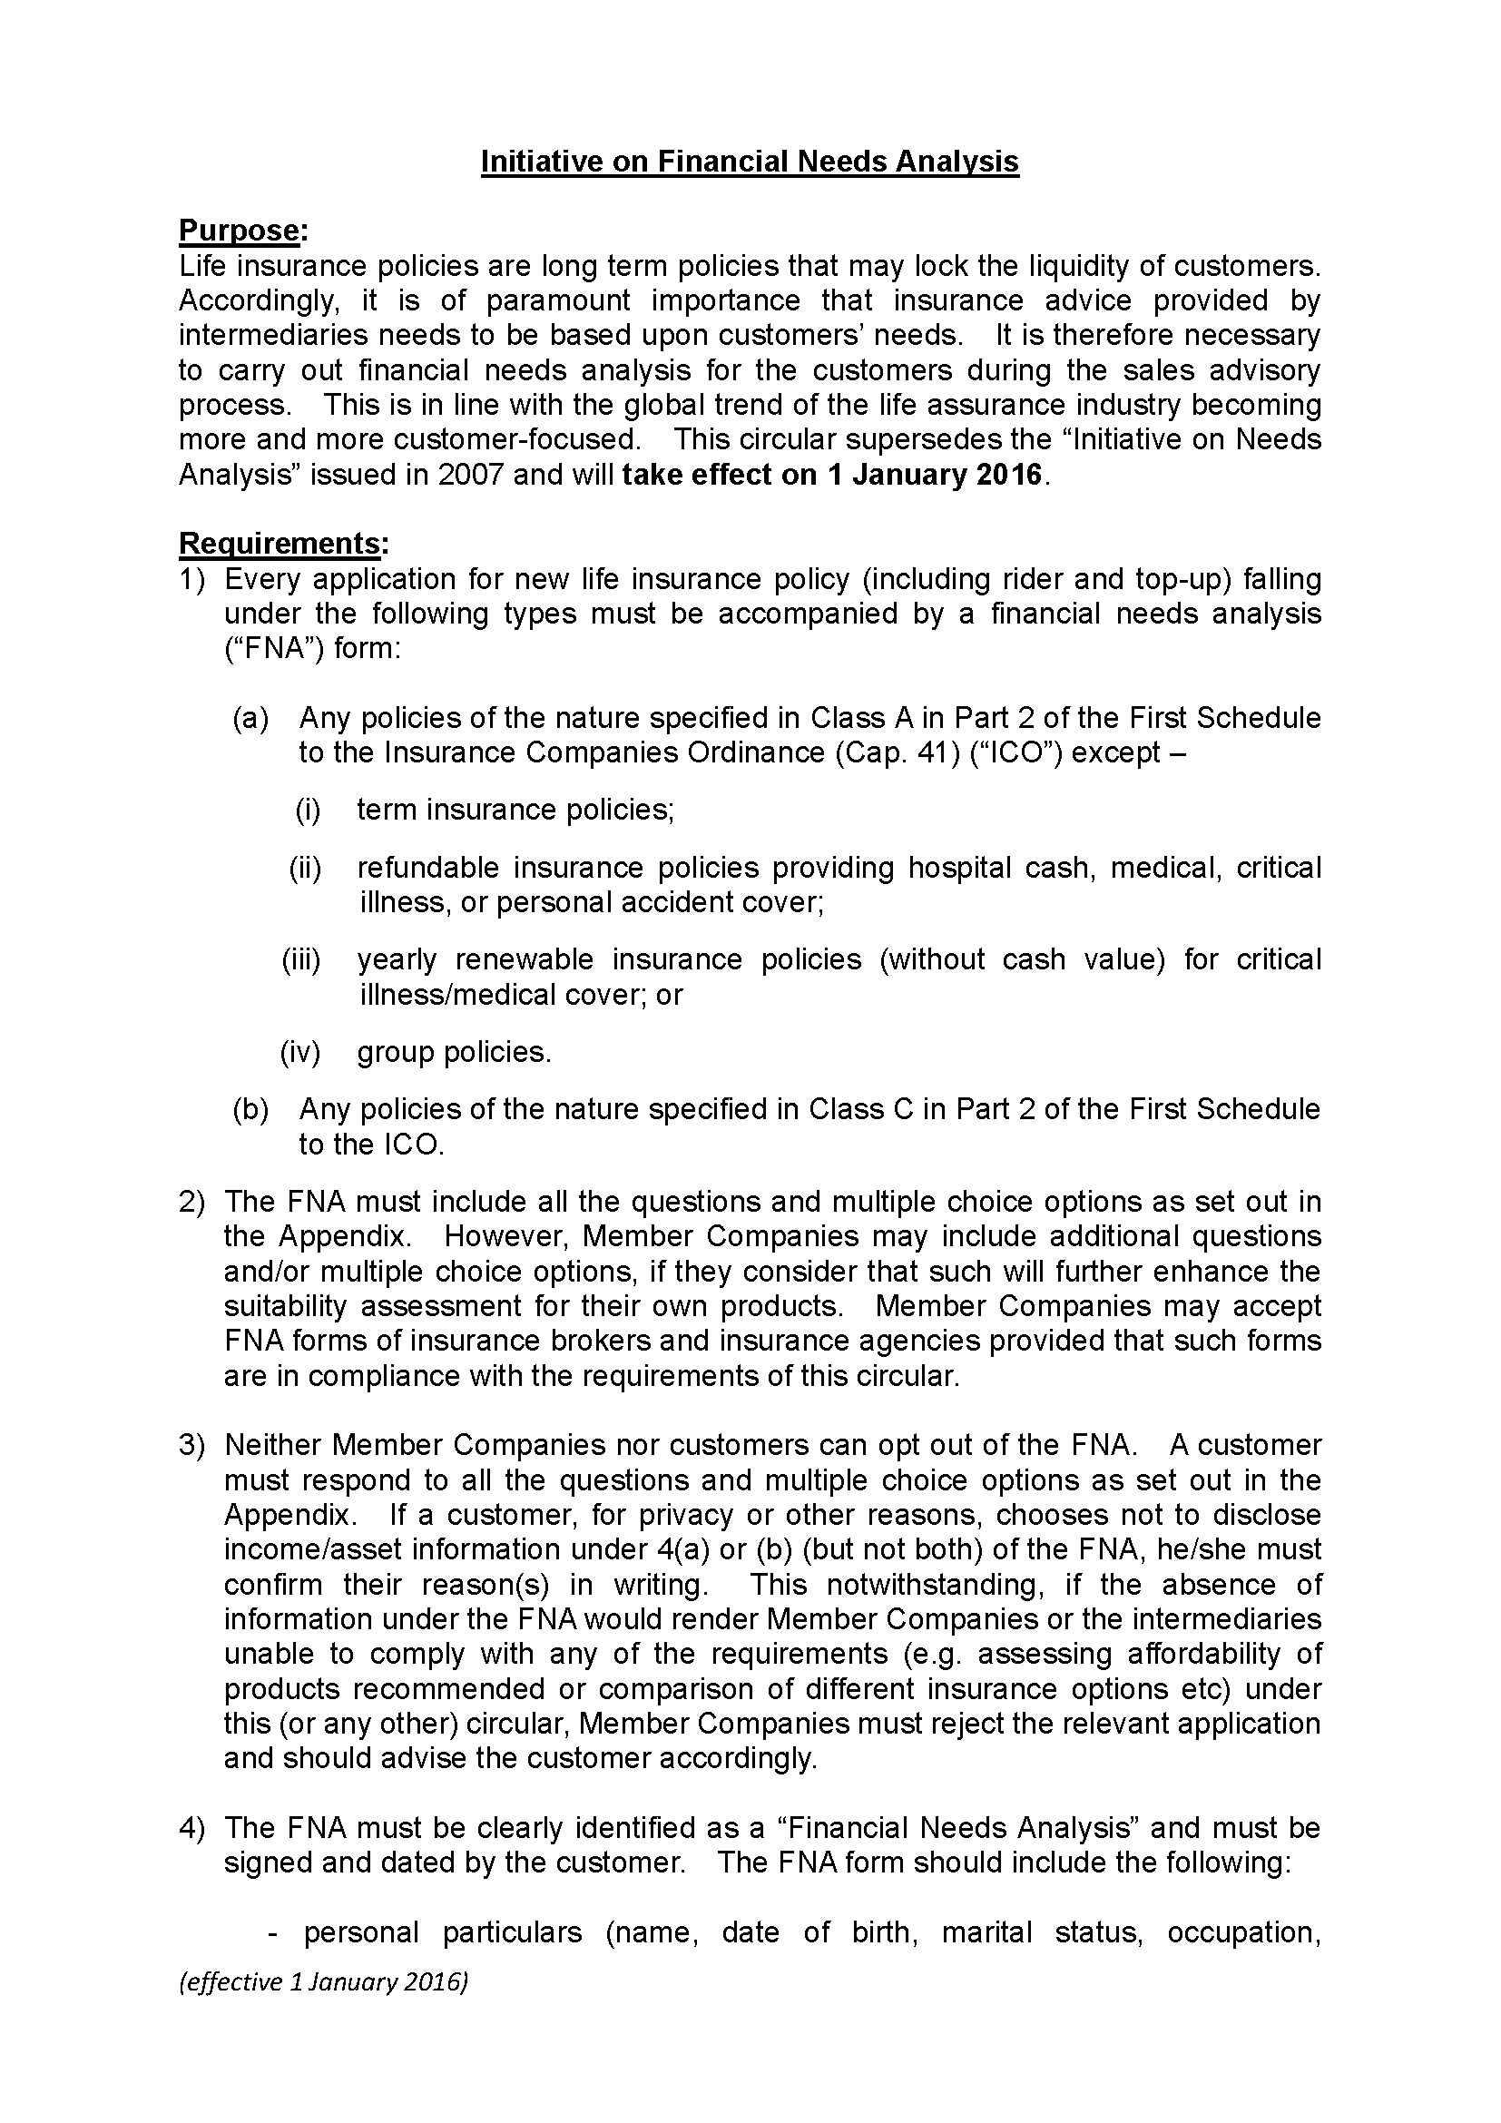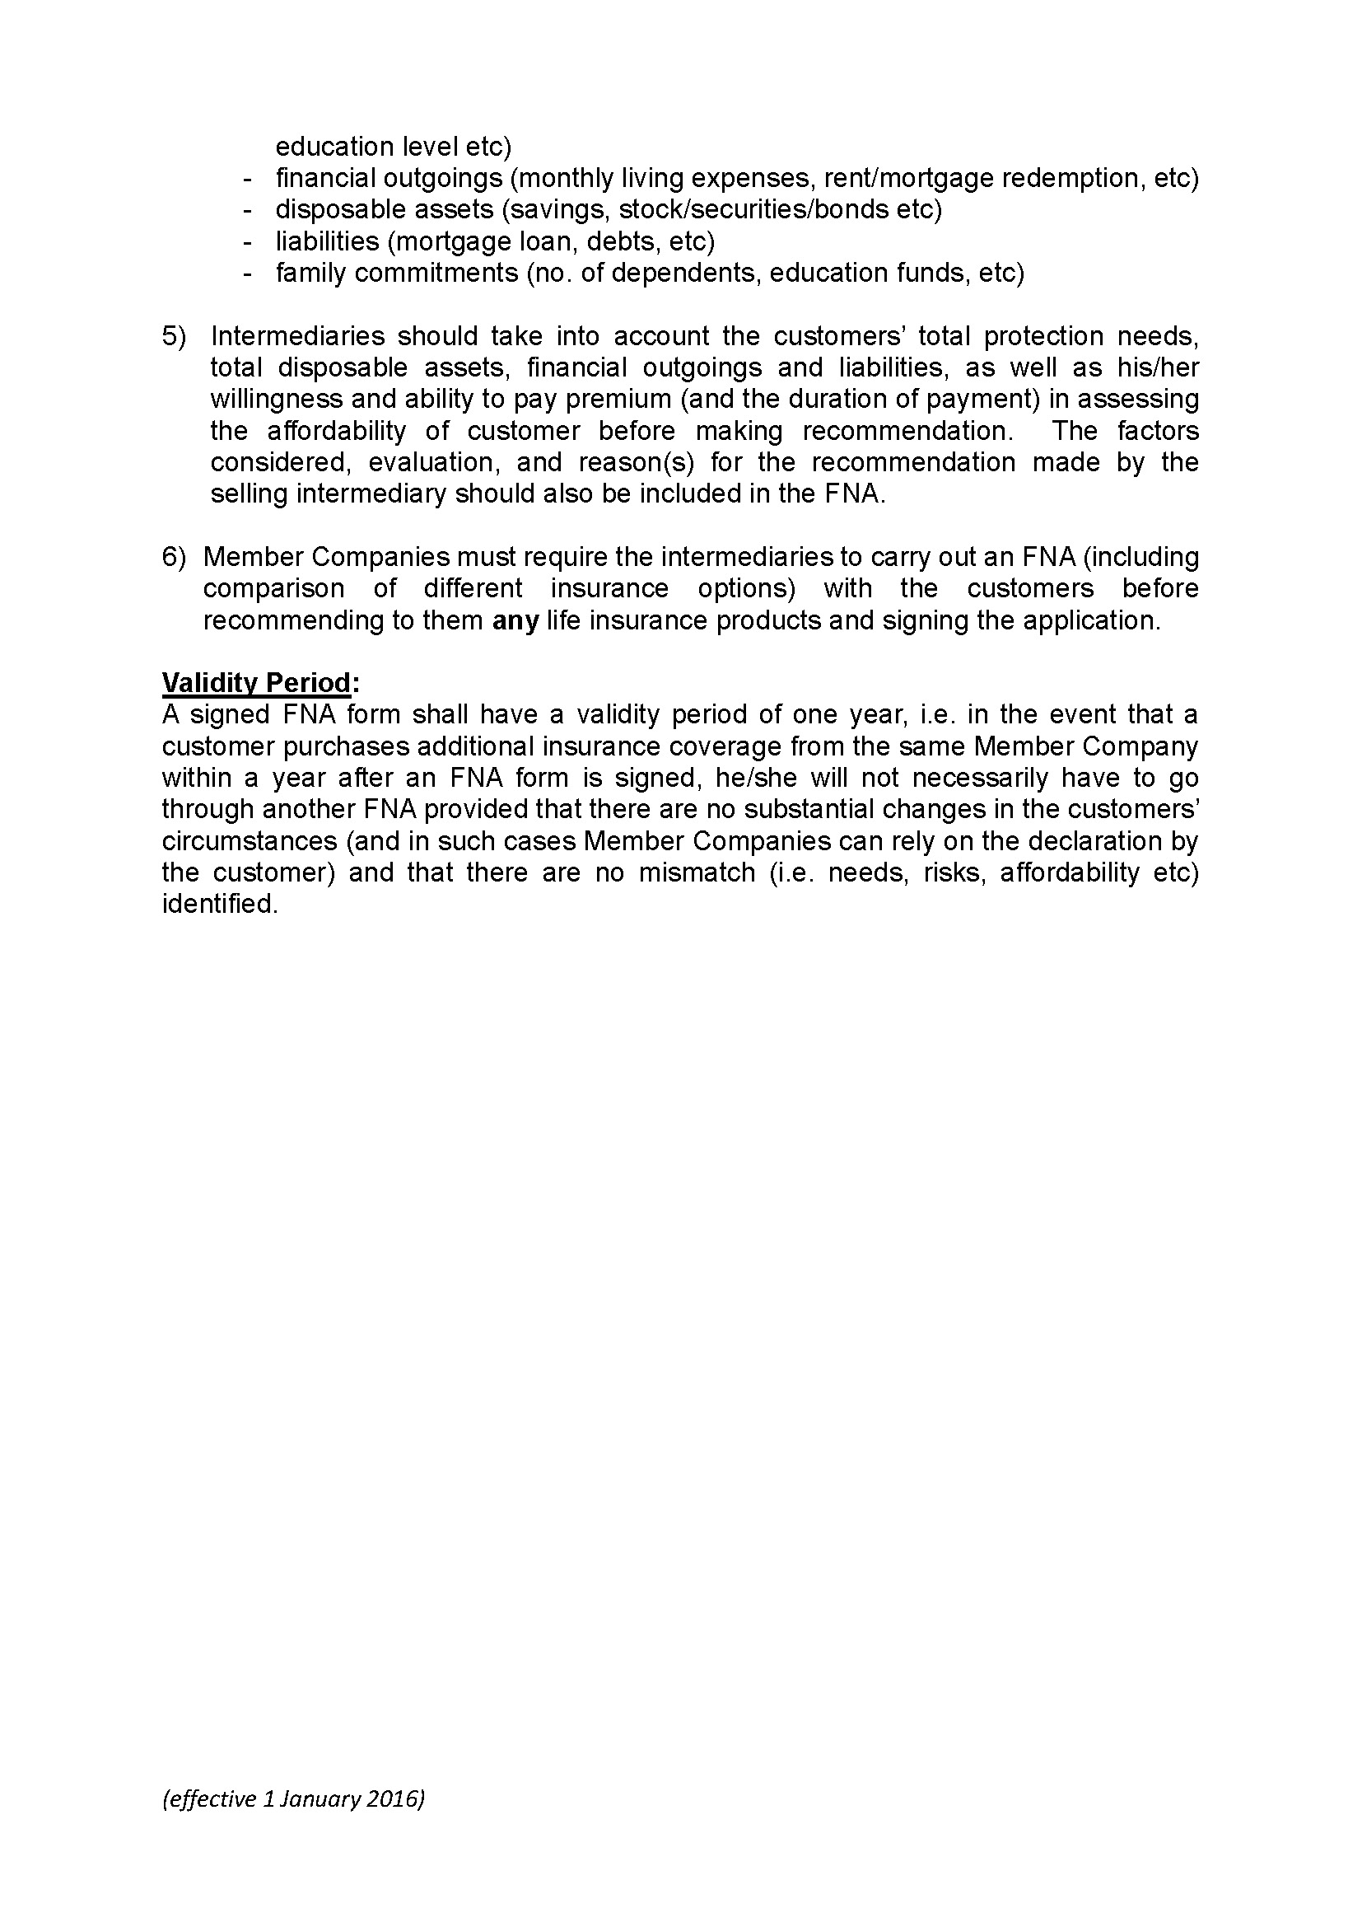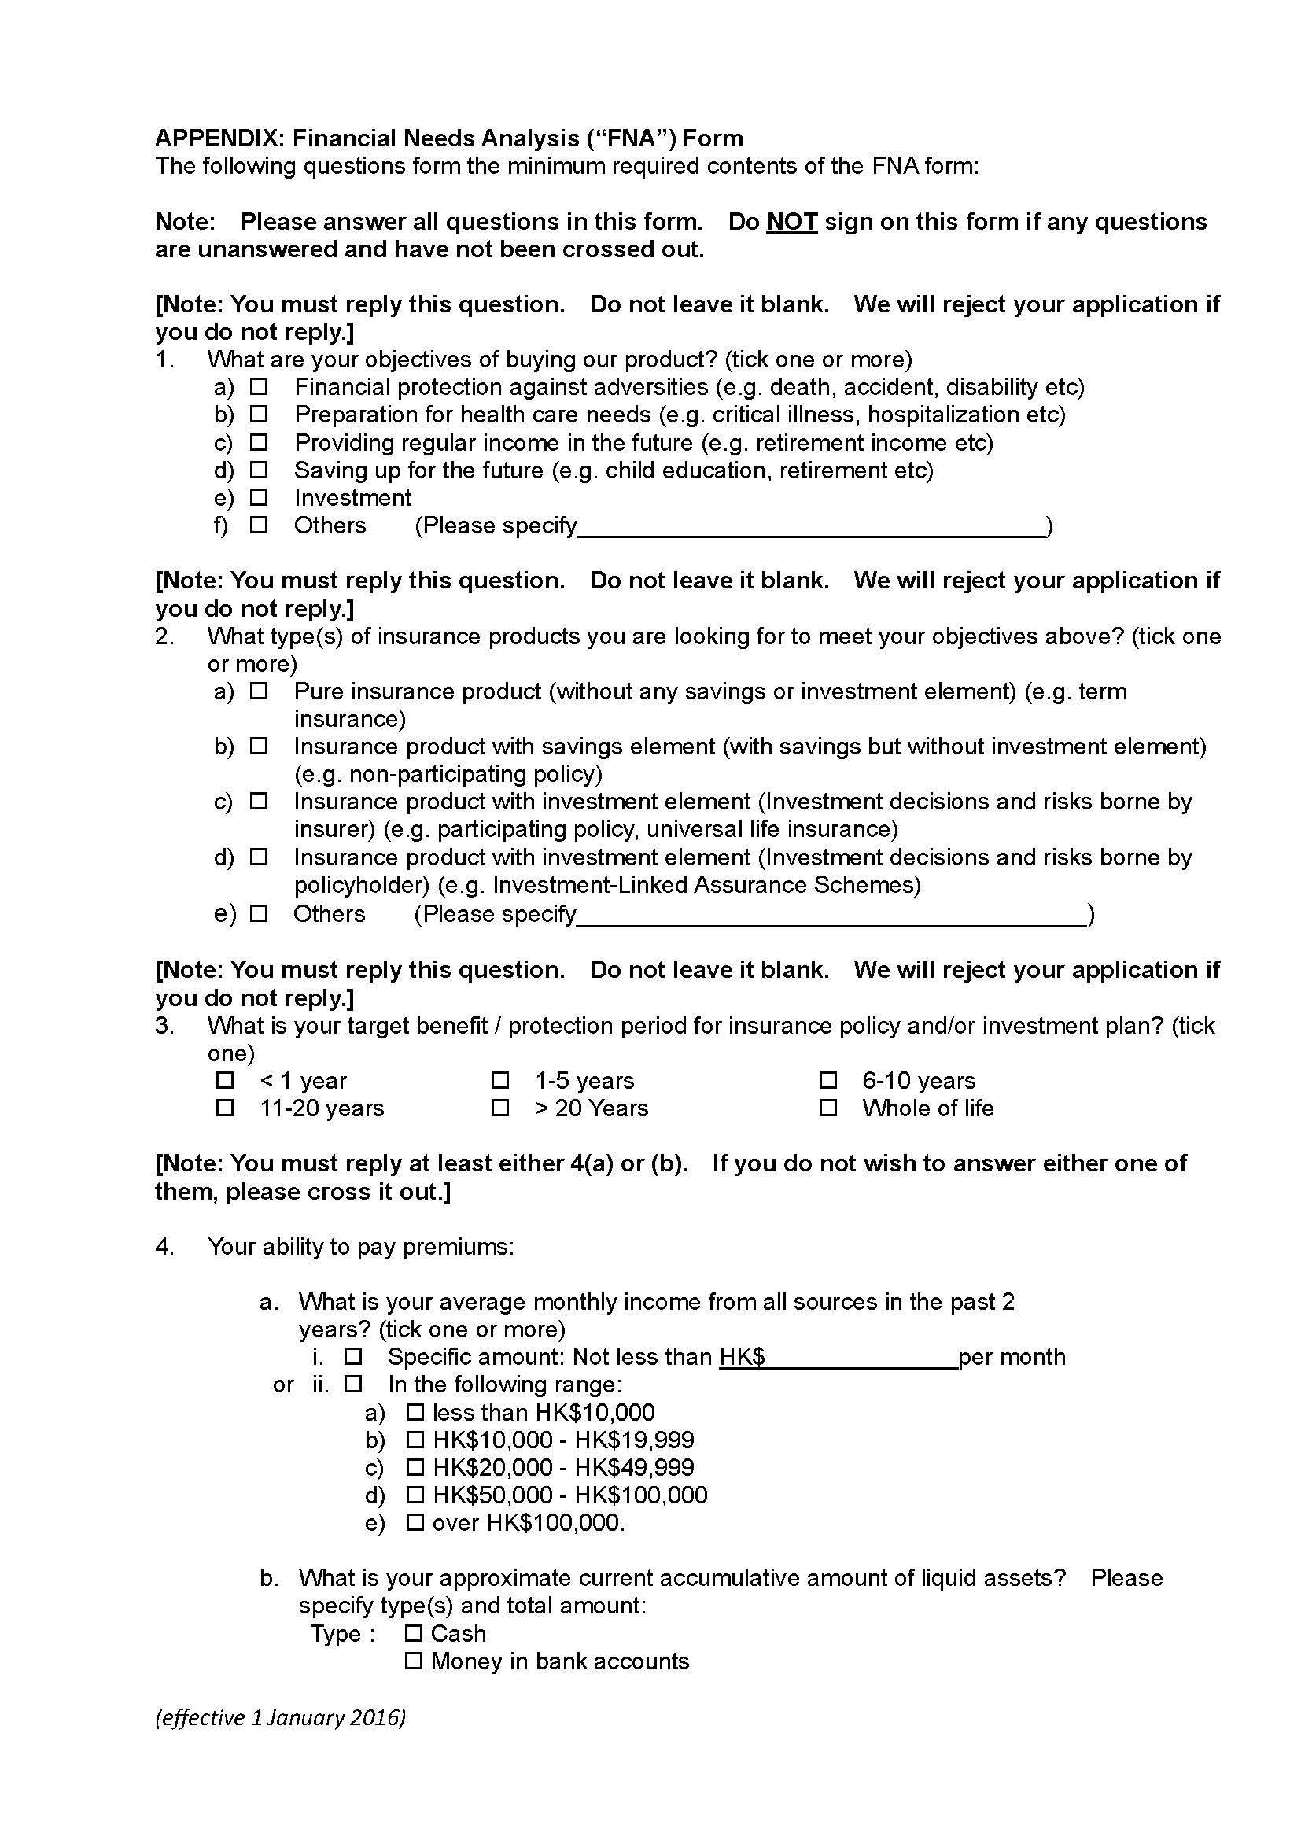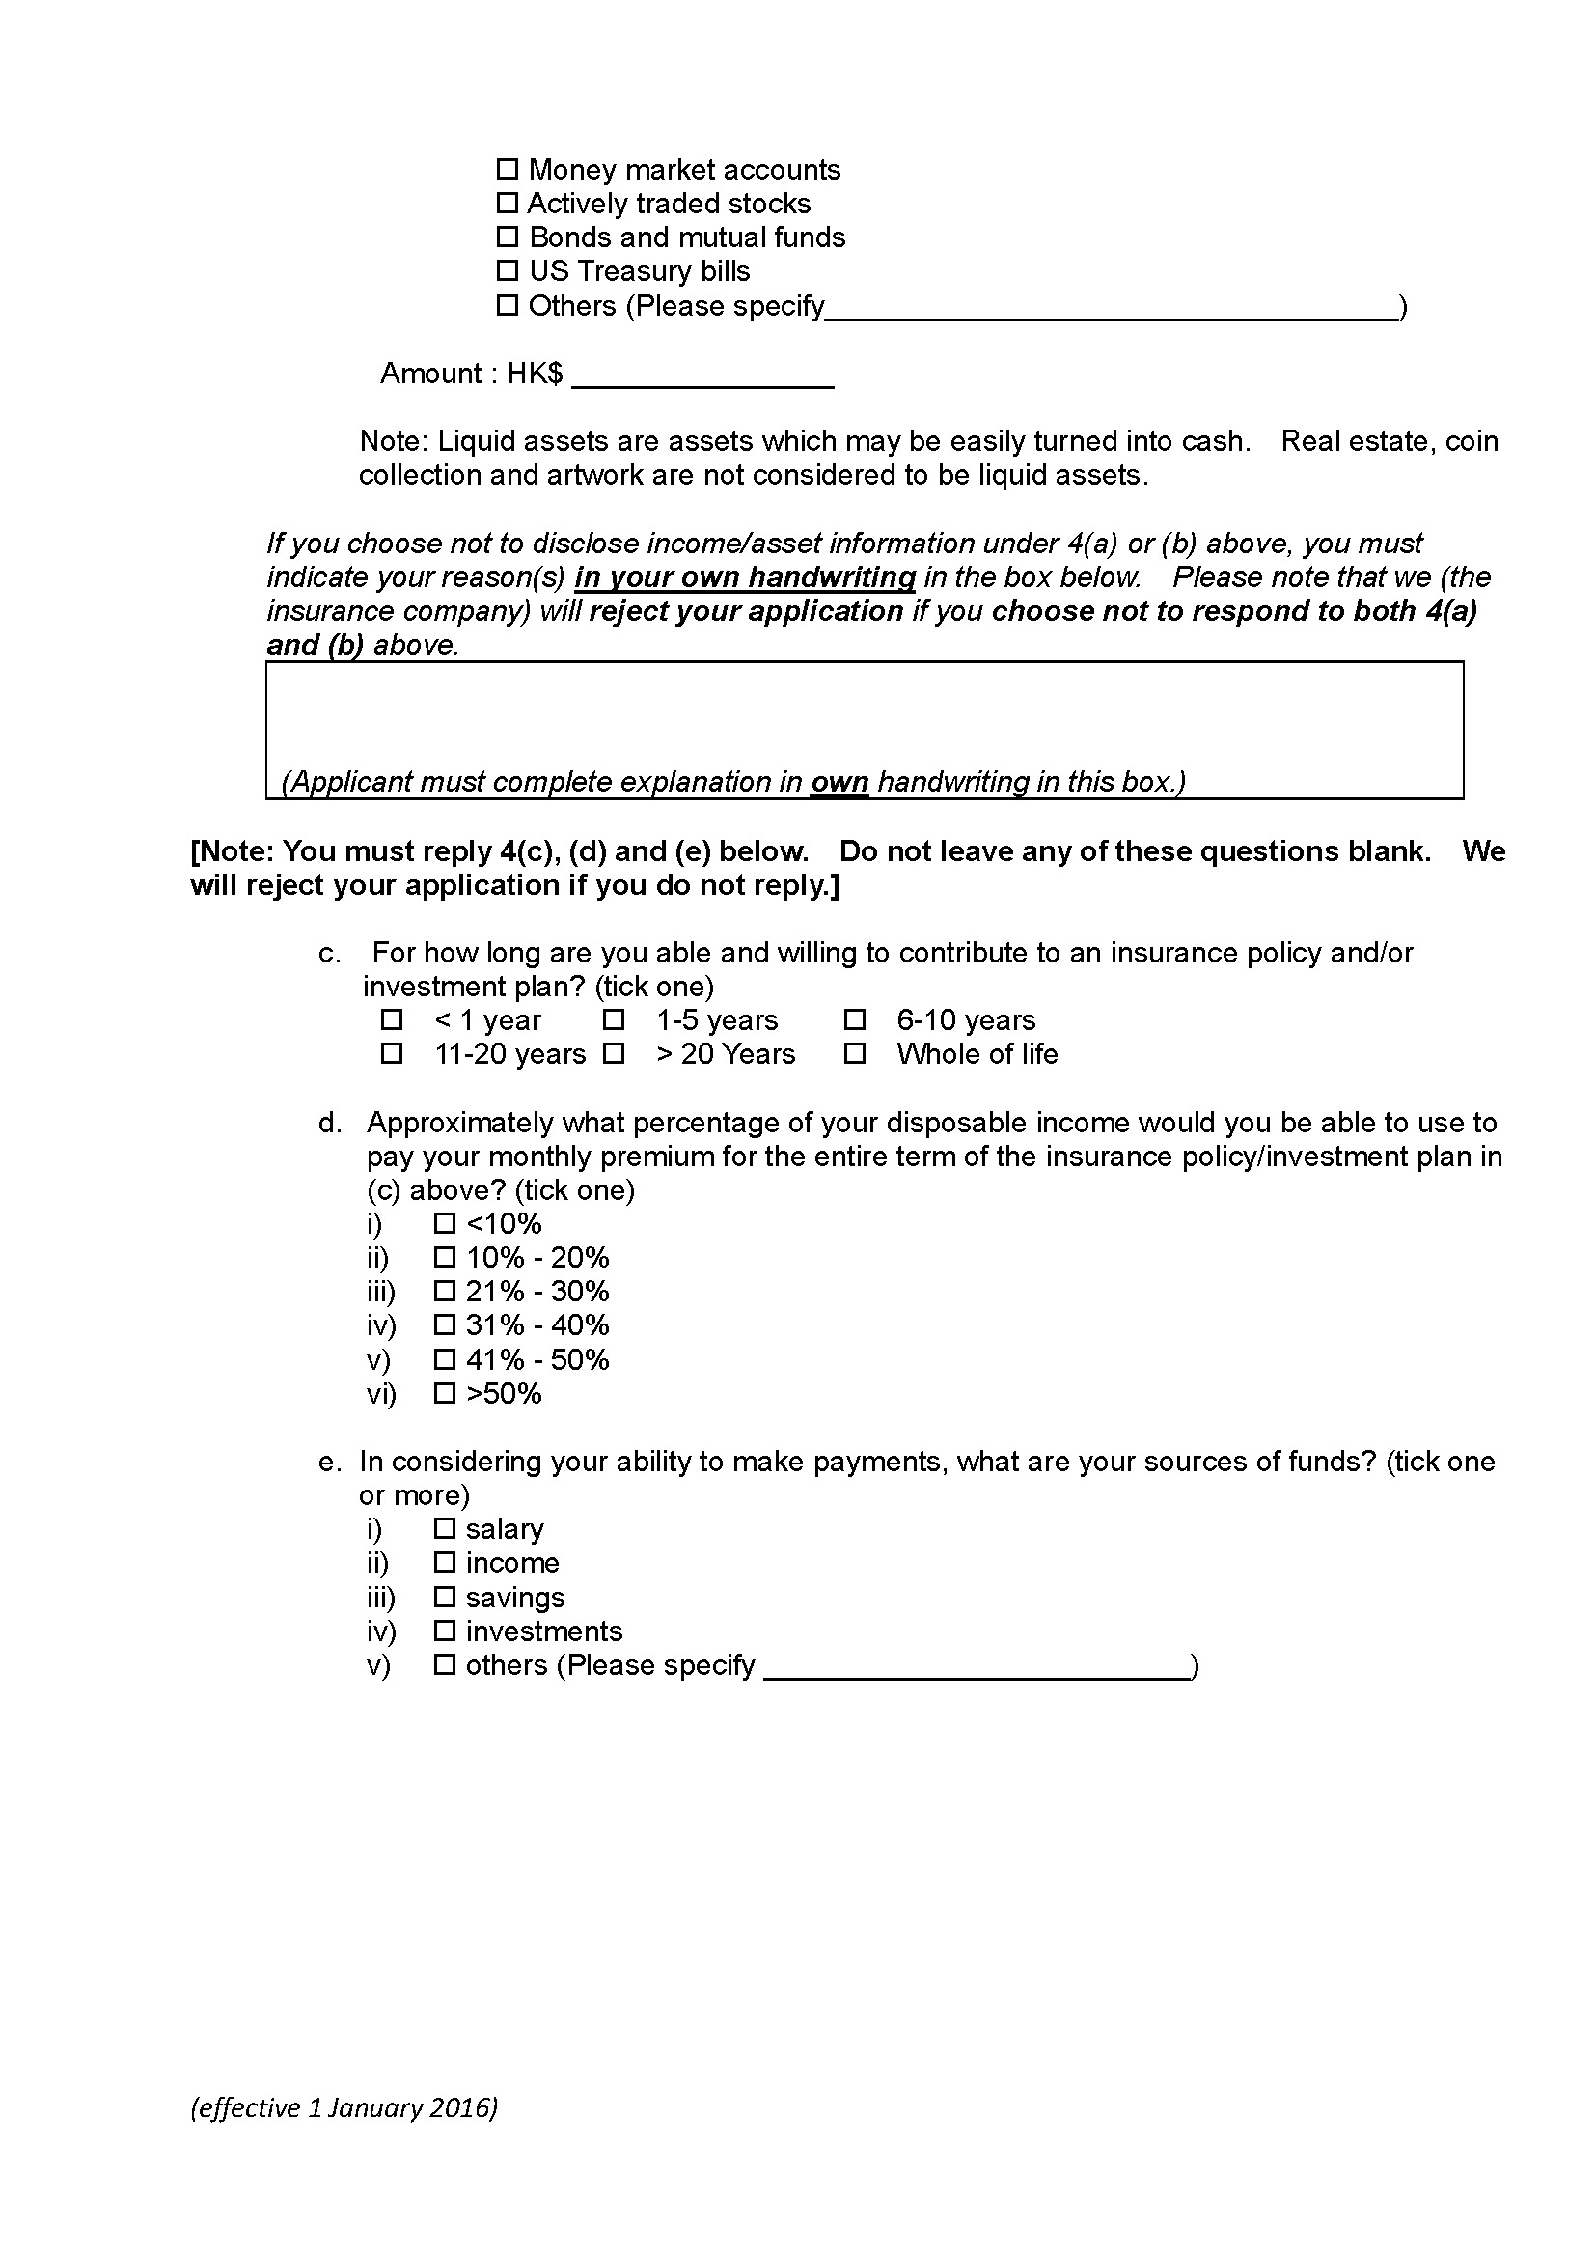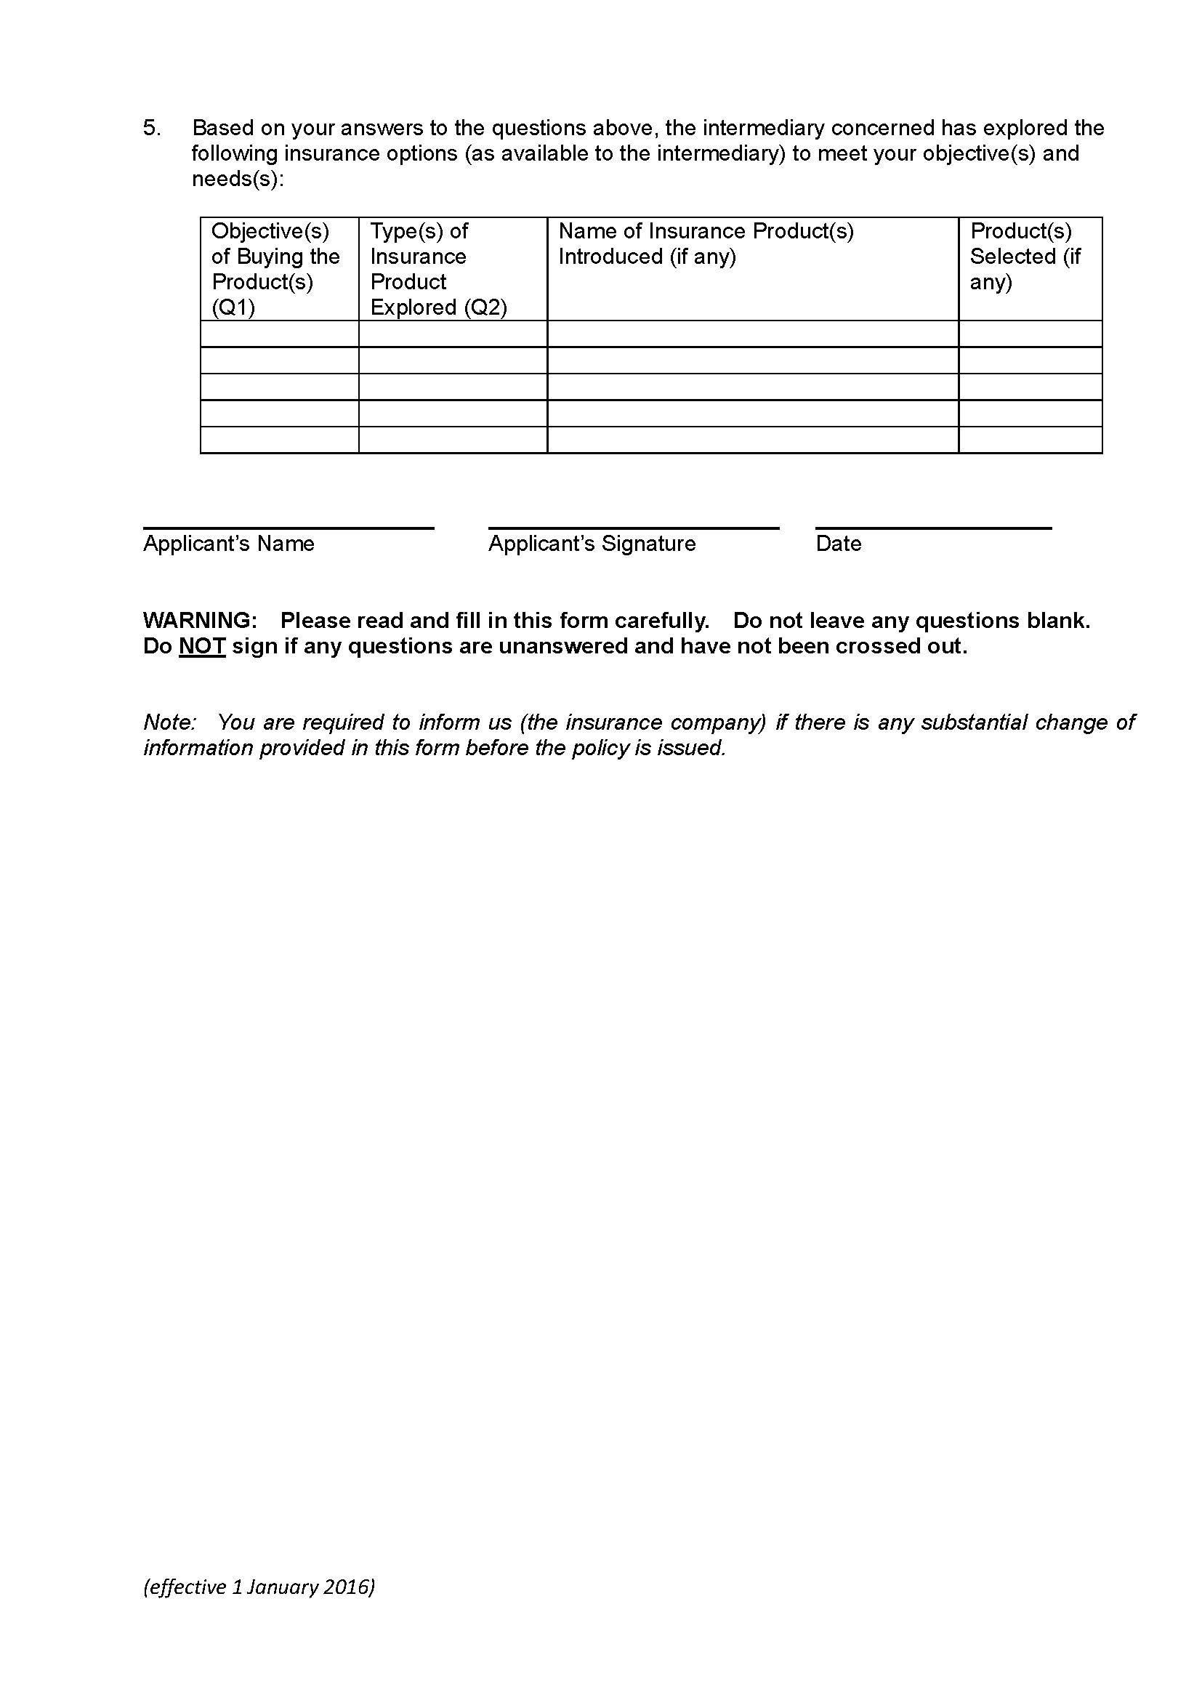

Appendix G

Important Facts Statement for Mainland Policyholder

(Only Chinese version available)

(Source: OCI)

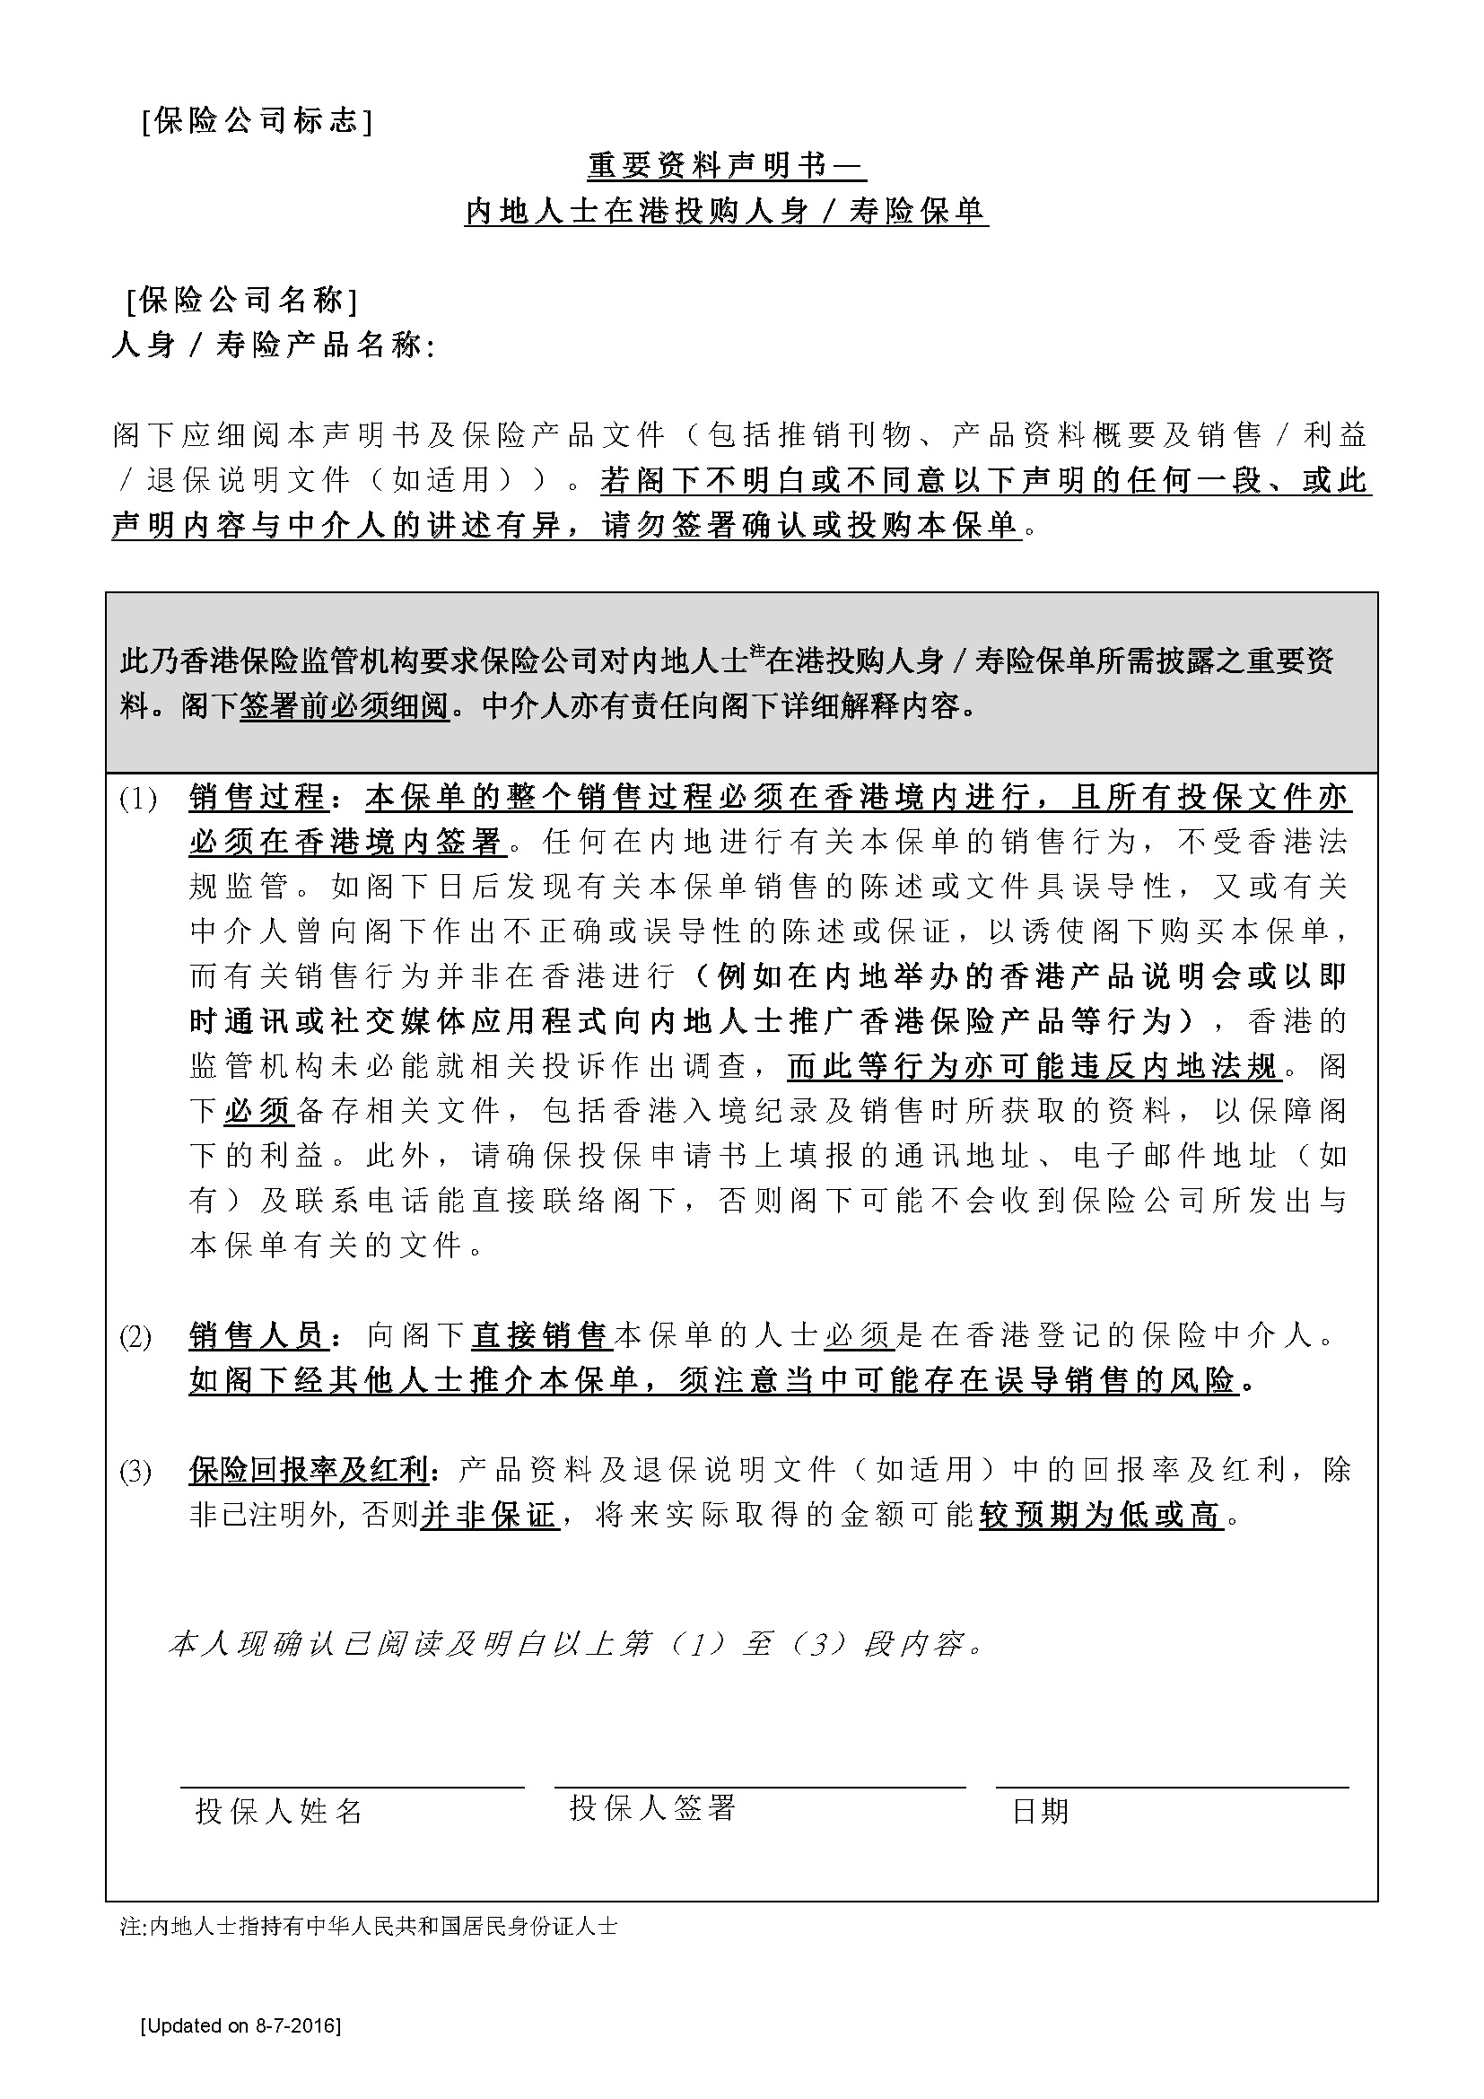

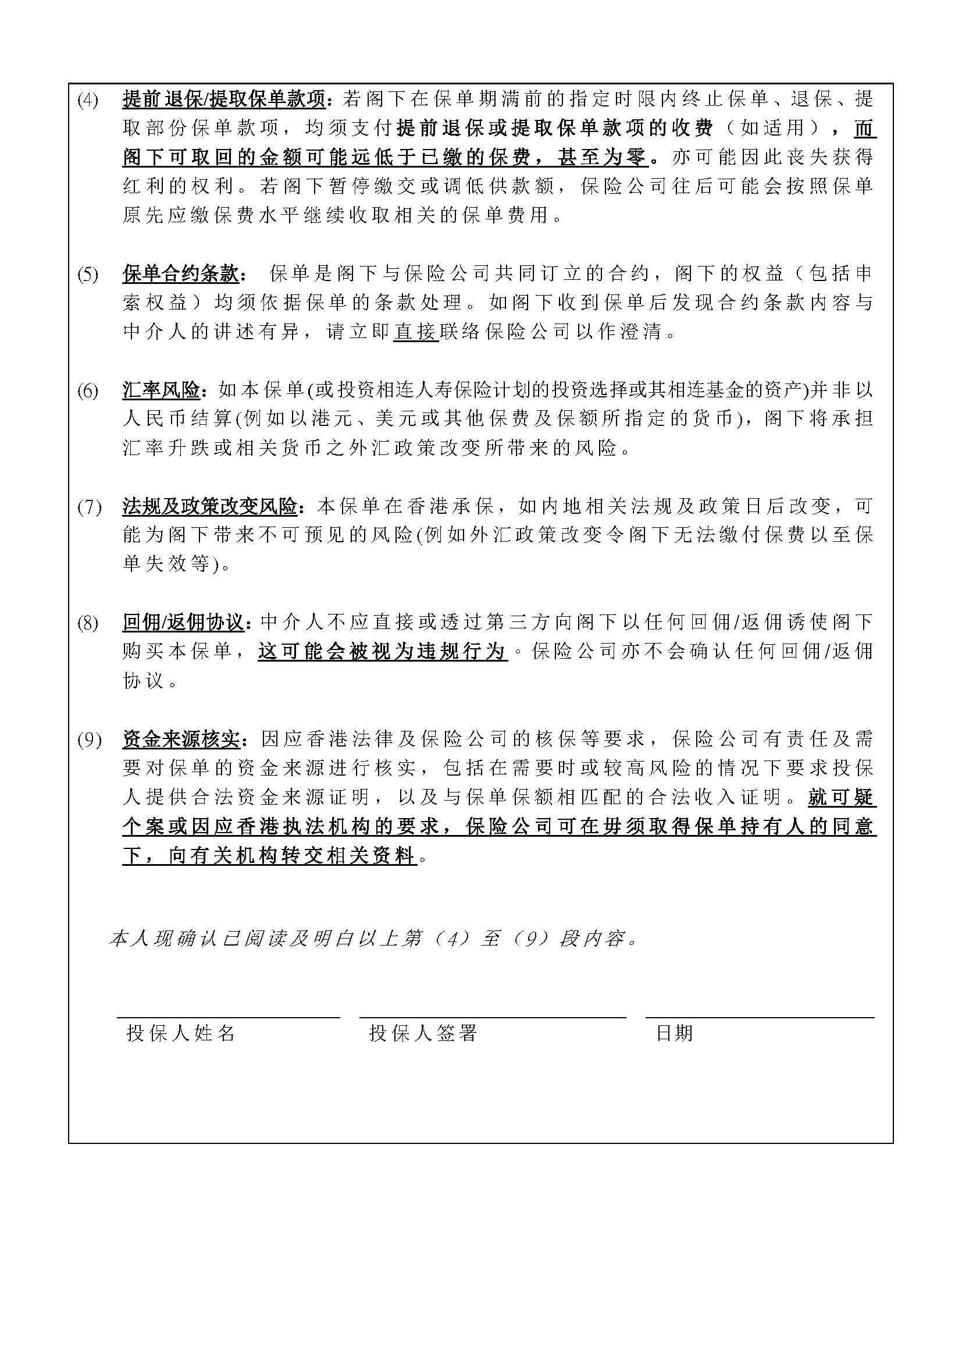

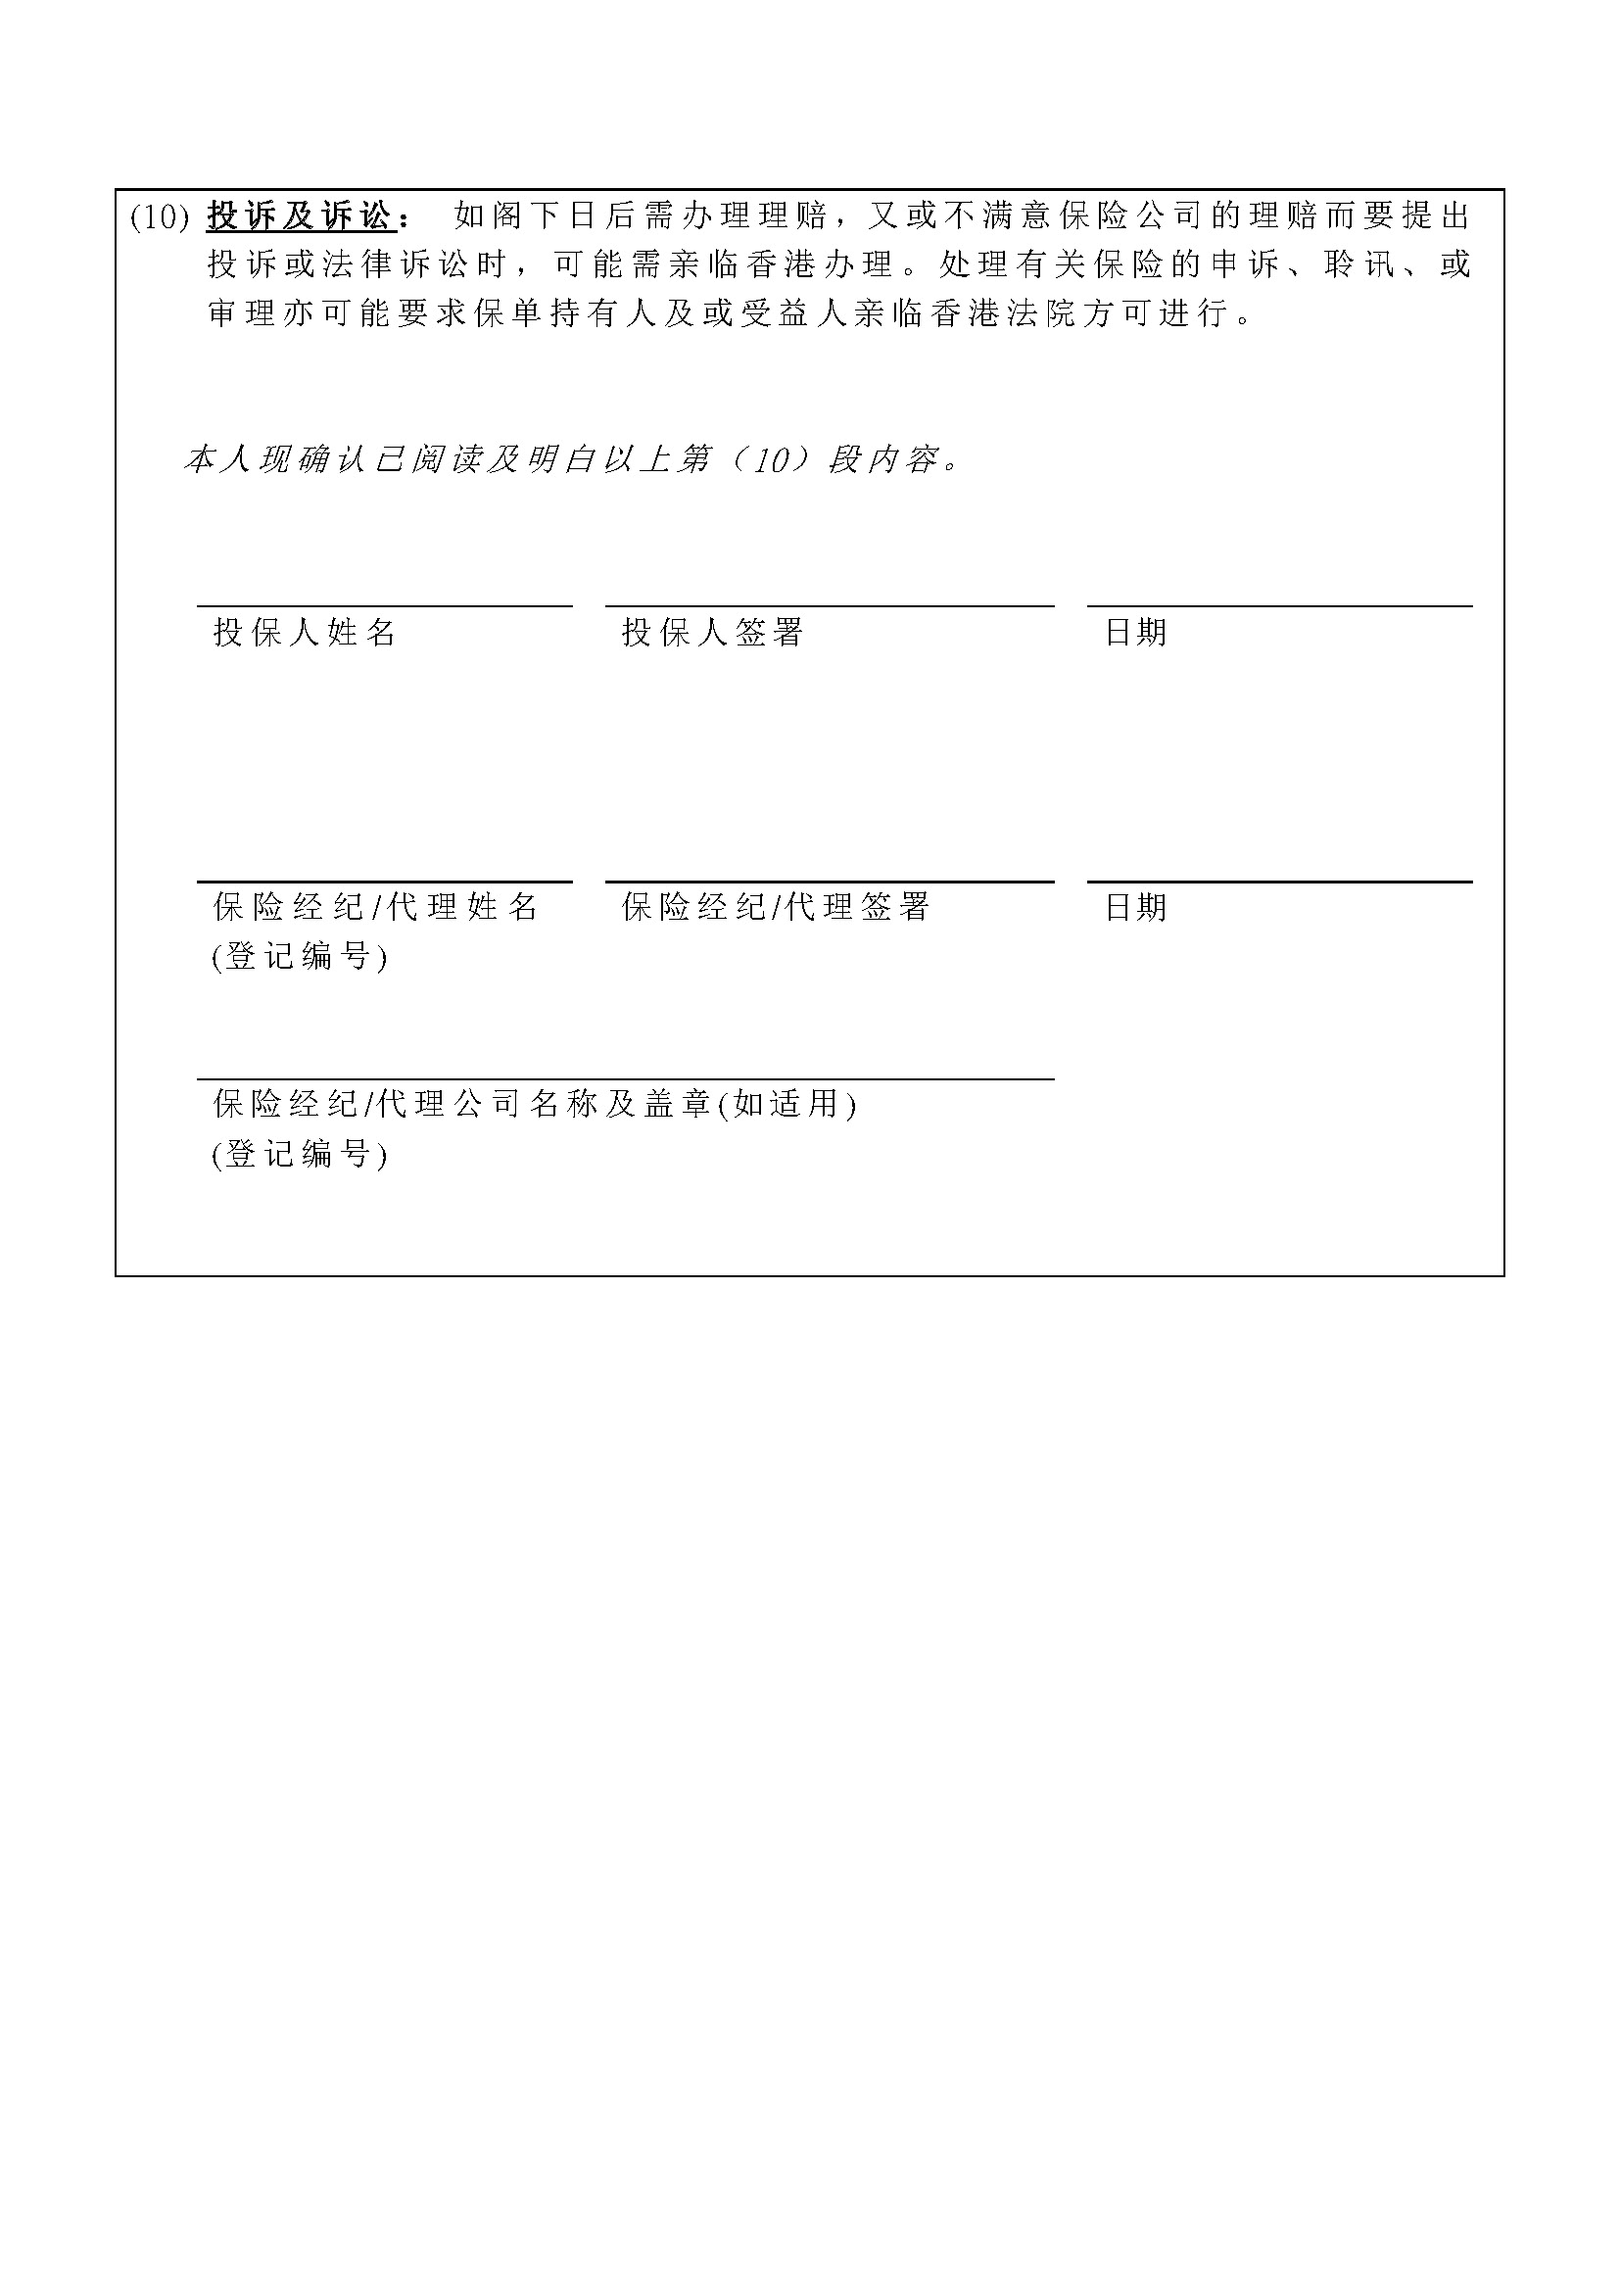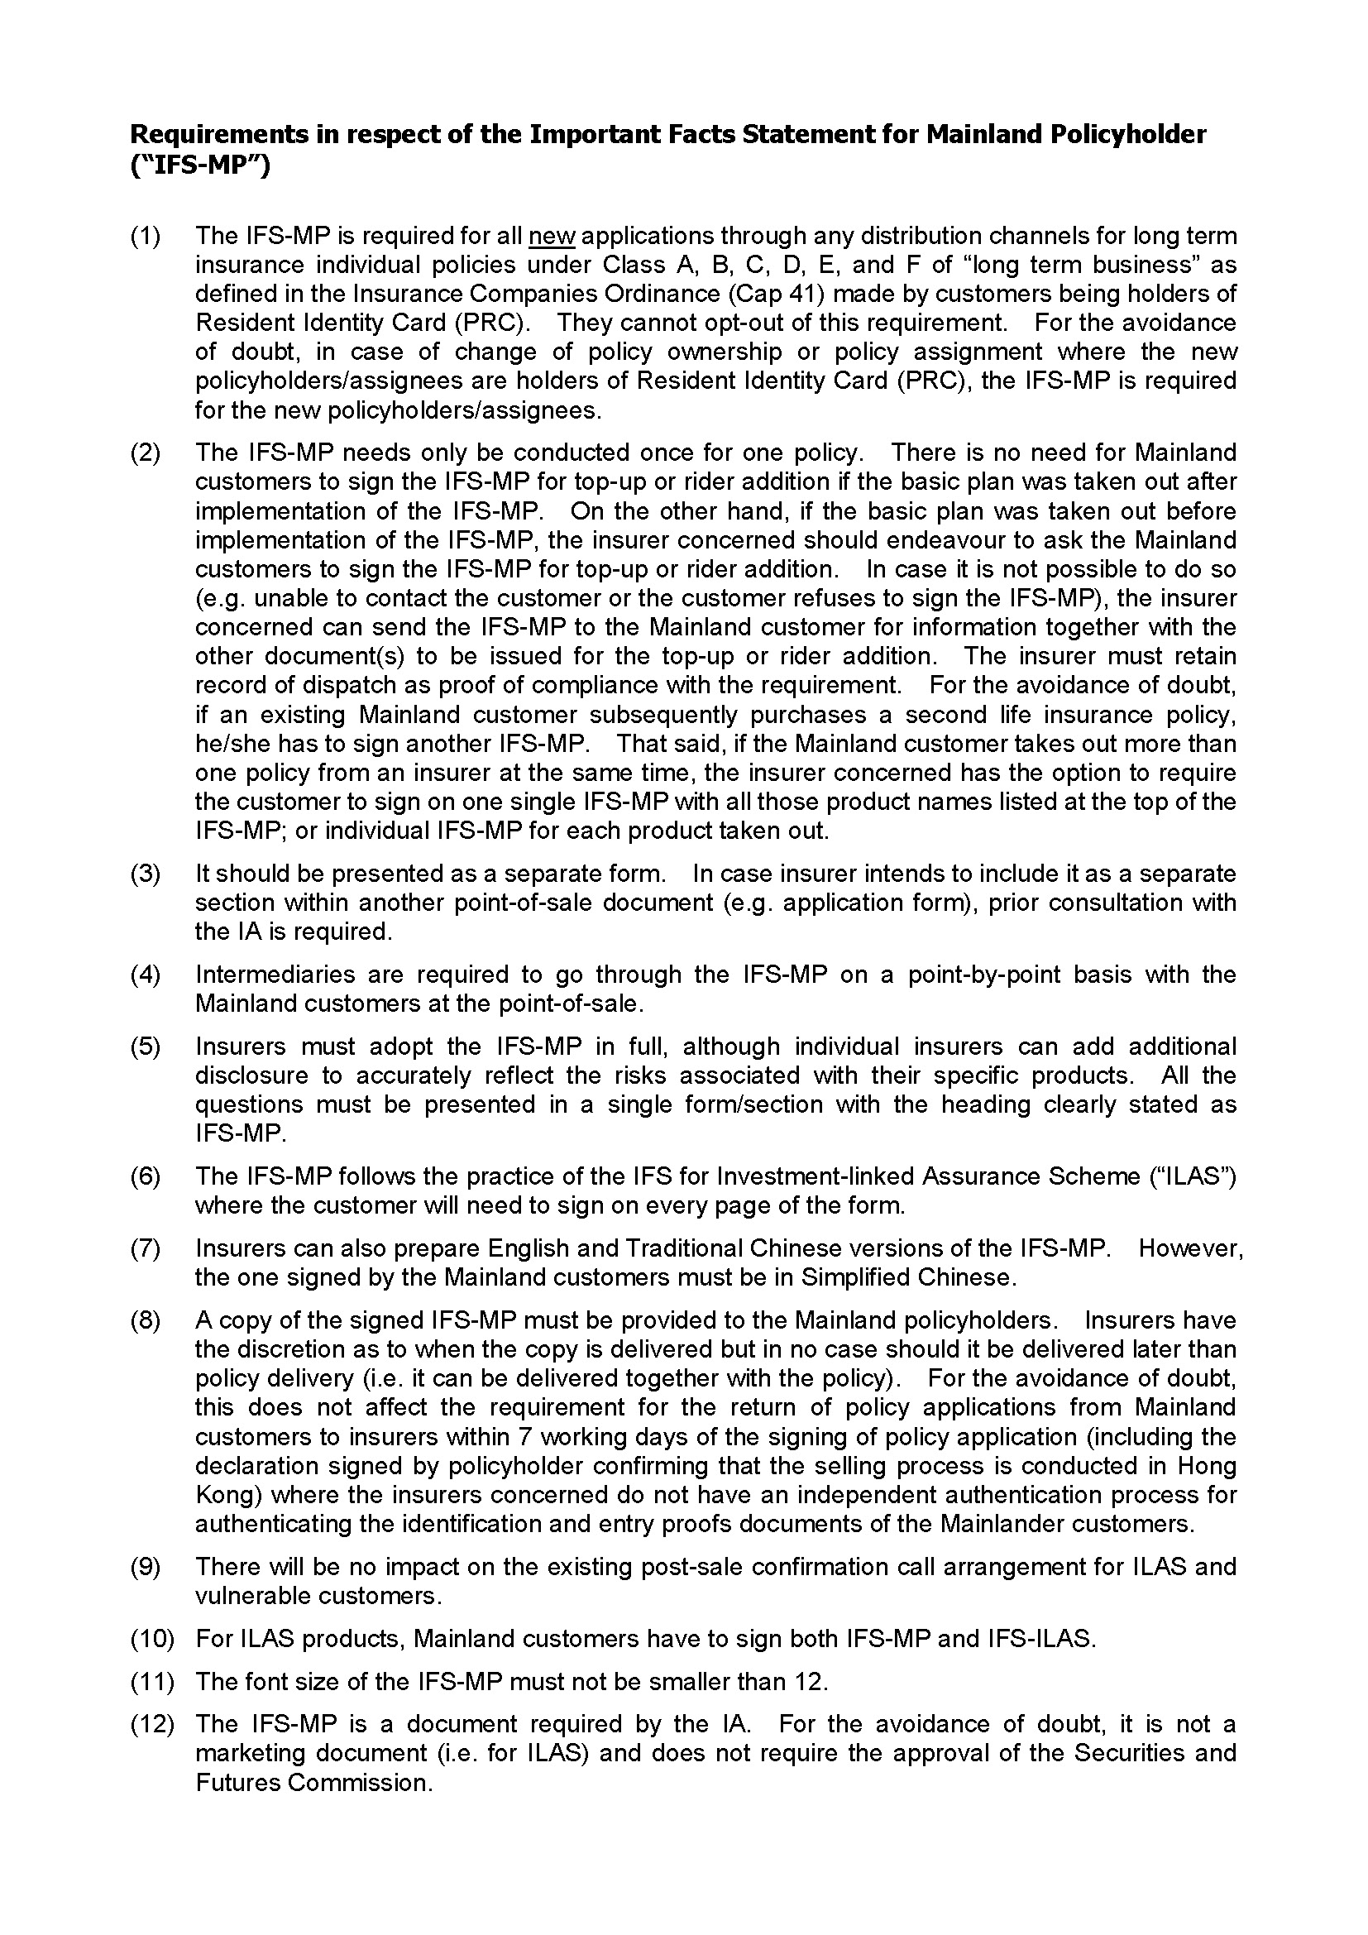

Appendix H

Guidance Note on Conducting “Know Your Client” Procedures for Long Term Insurance Business (CIB-GN(4))

(Source: CIB)

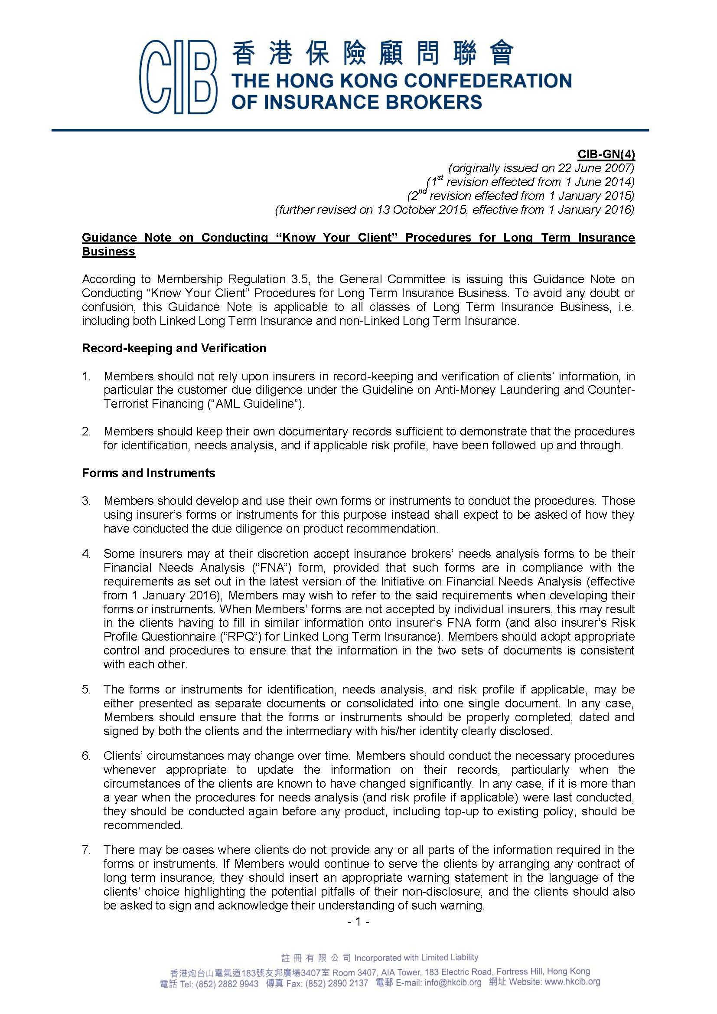
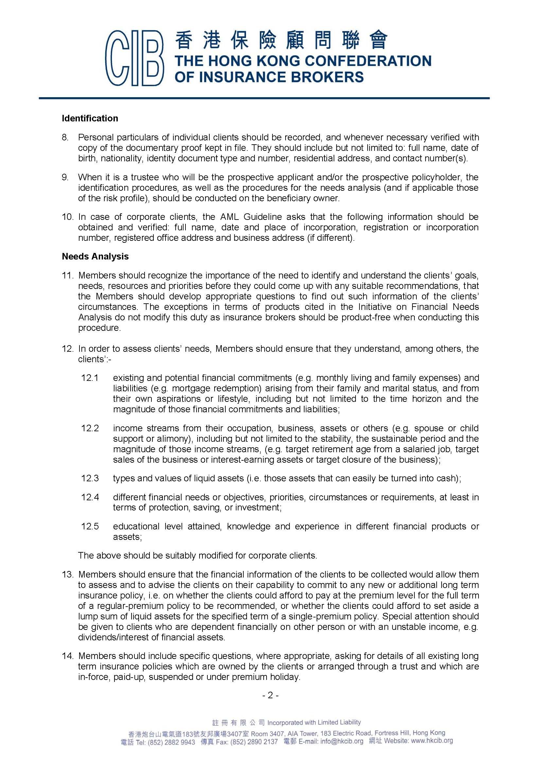
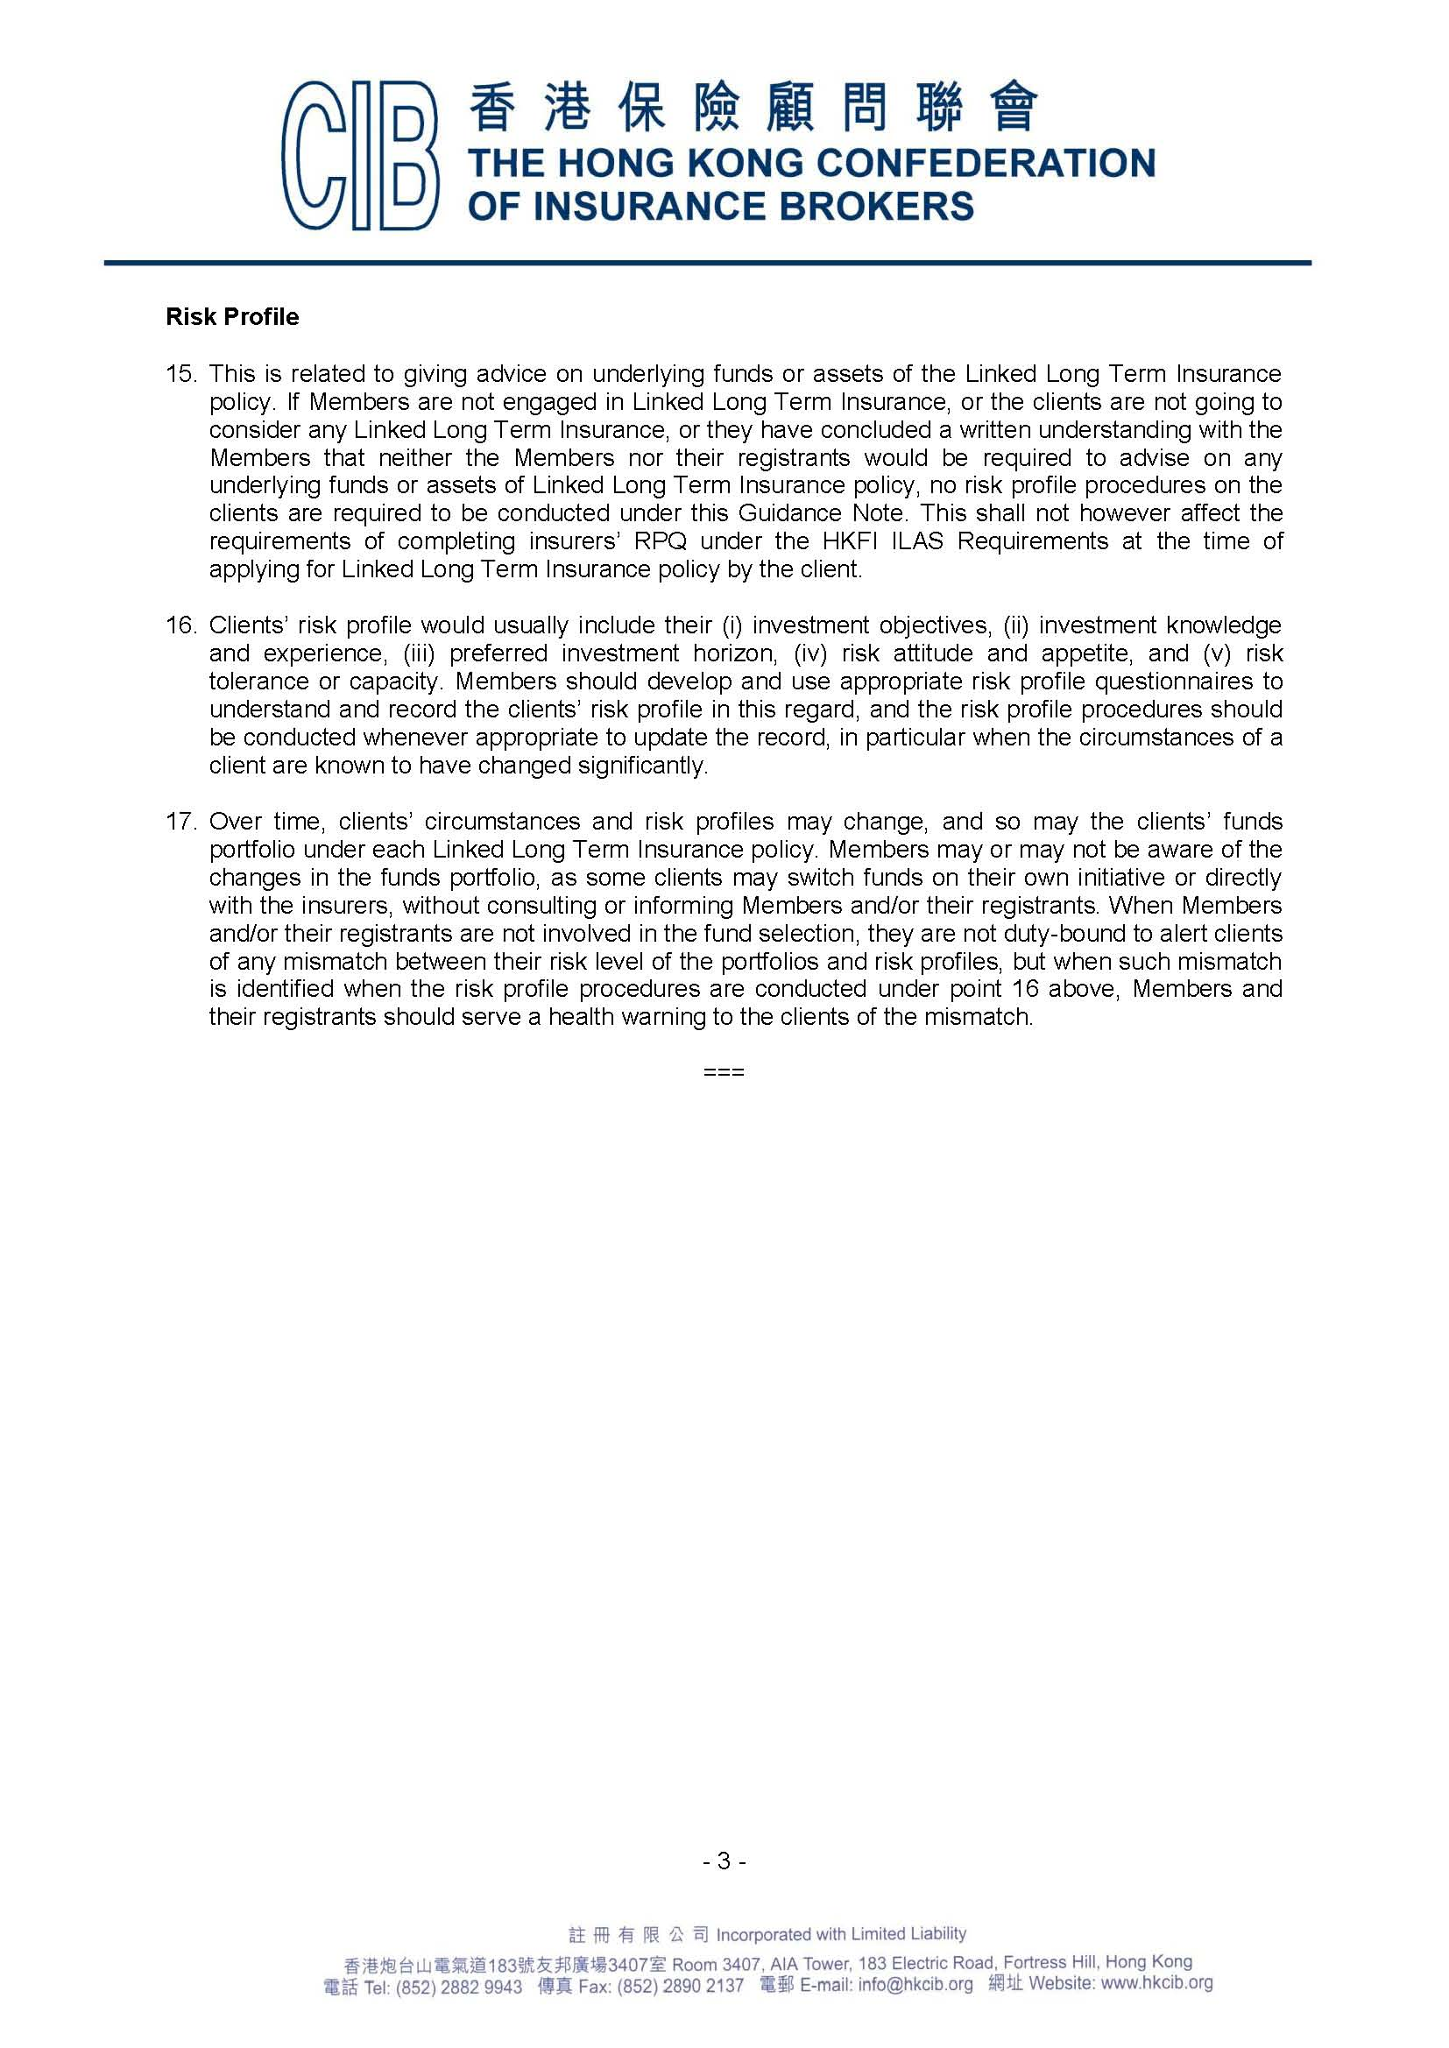

Appendix I

Guidance Note on Product Recommendation for Long Term Insurance Business (CIB-GN(12))

(Source: CIB)
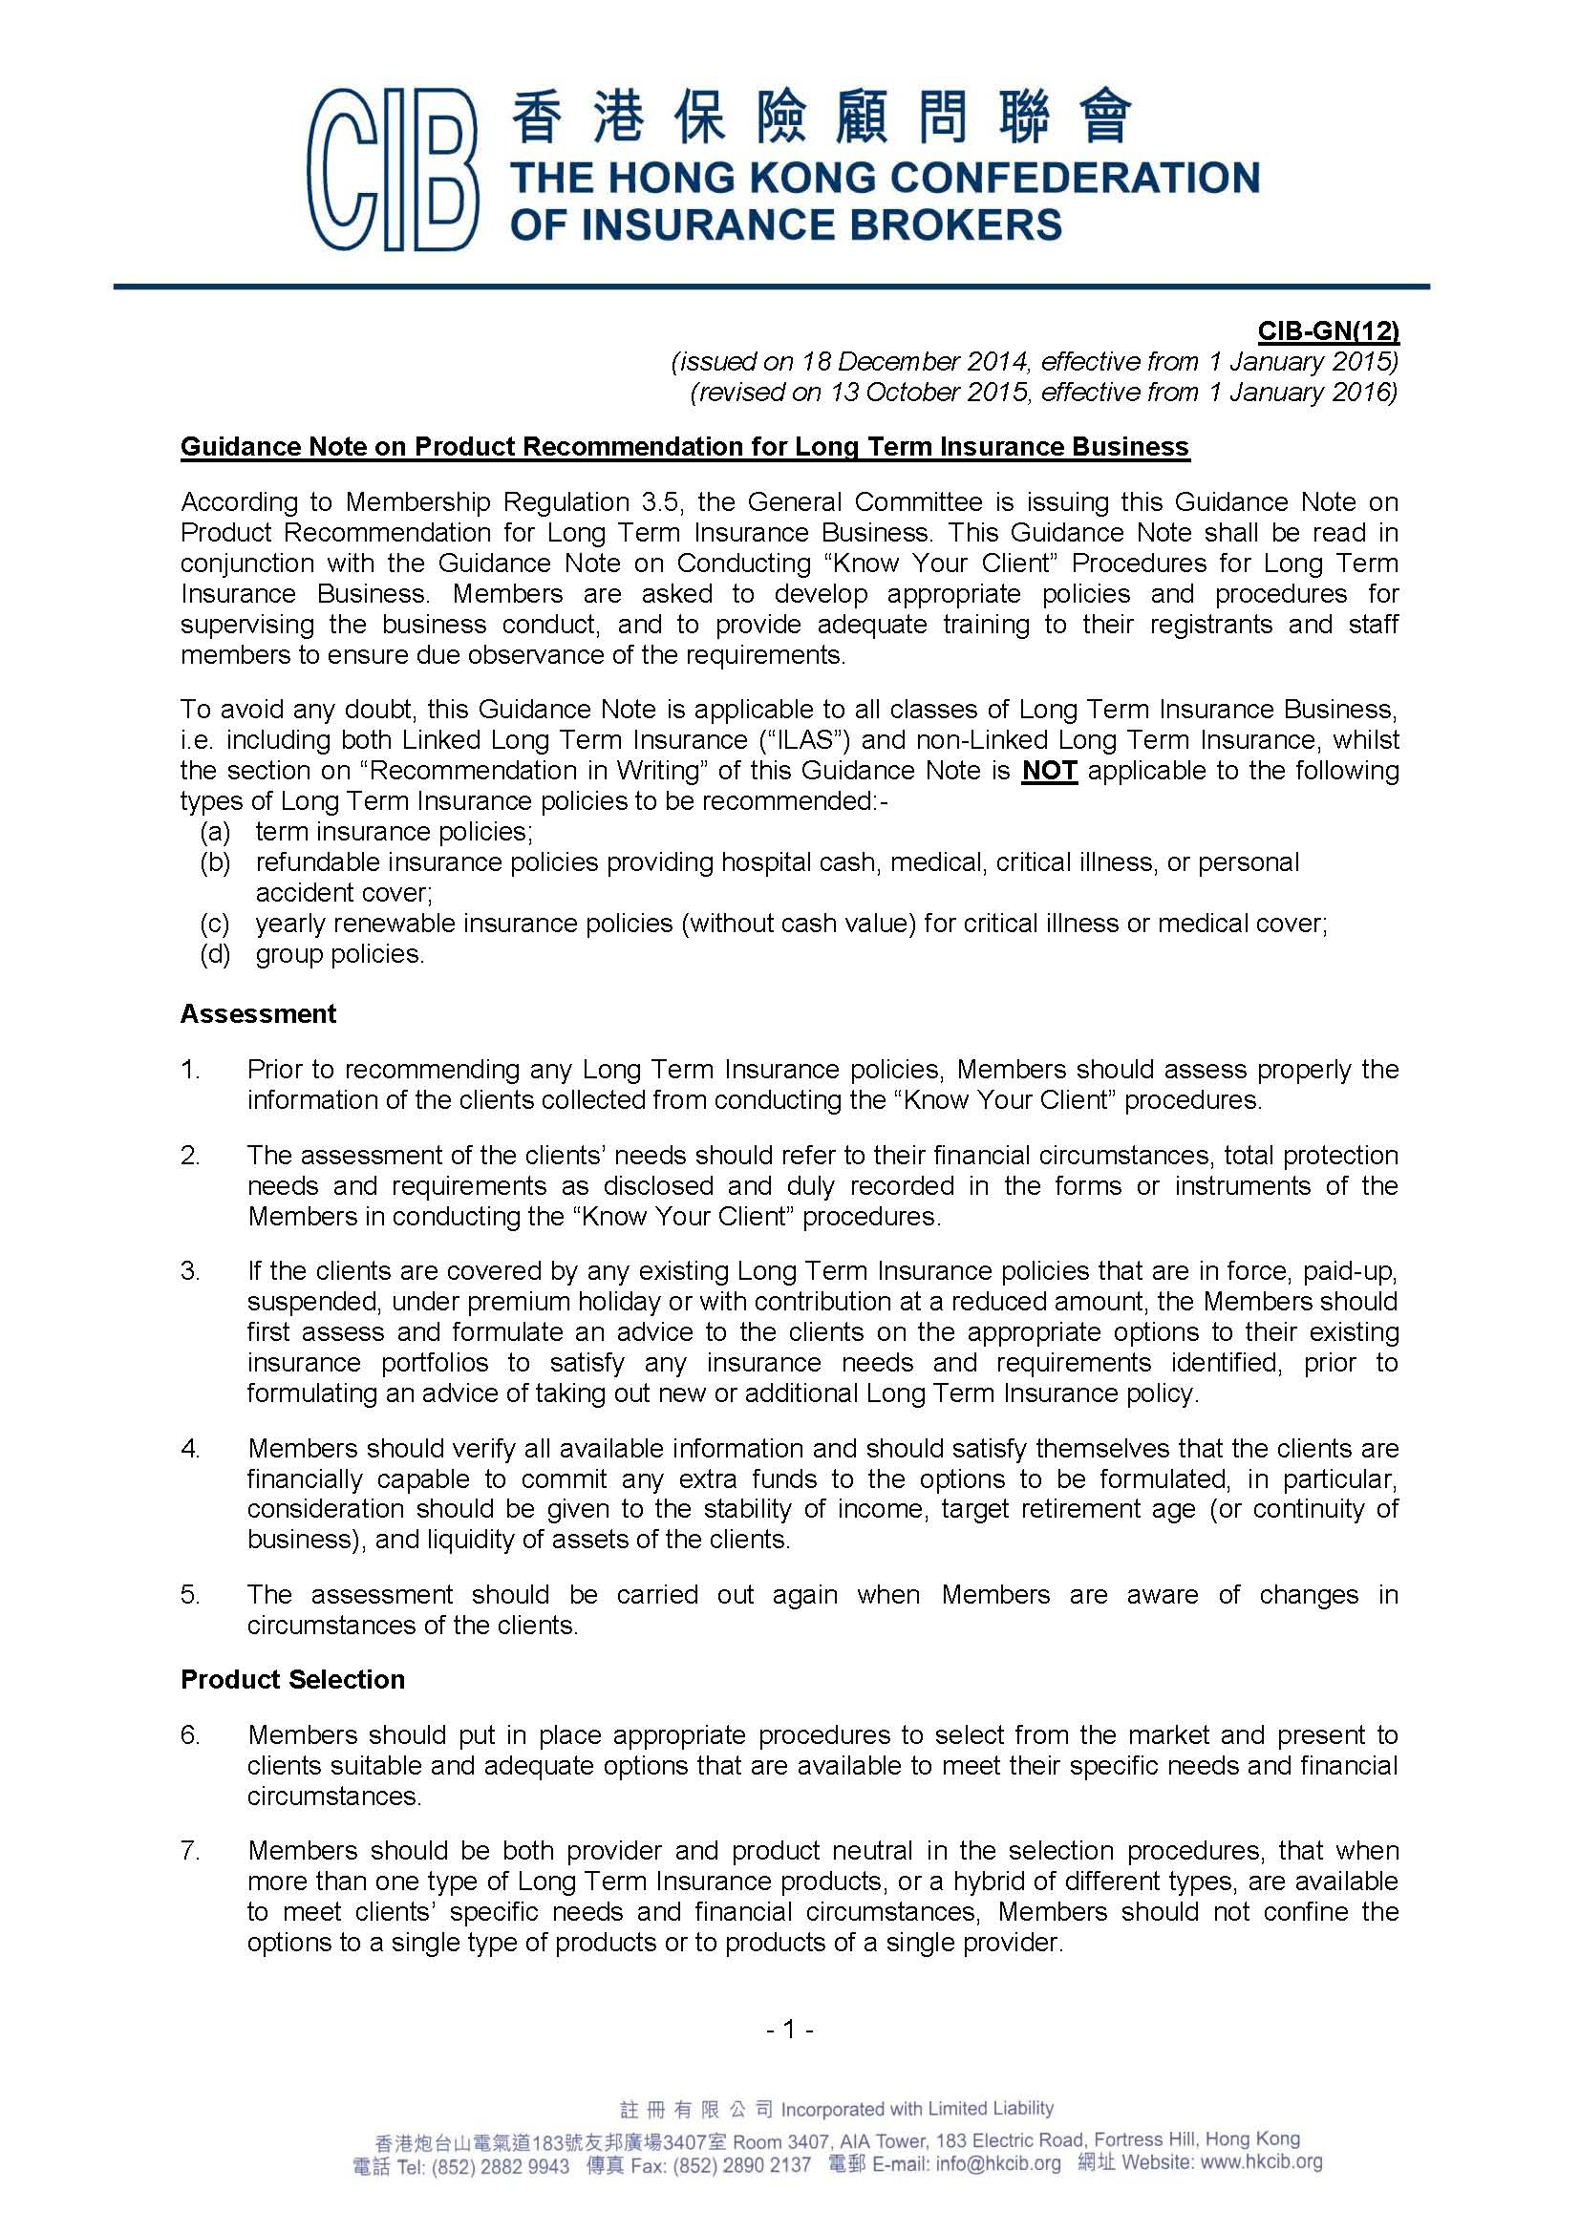
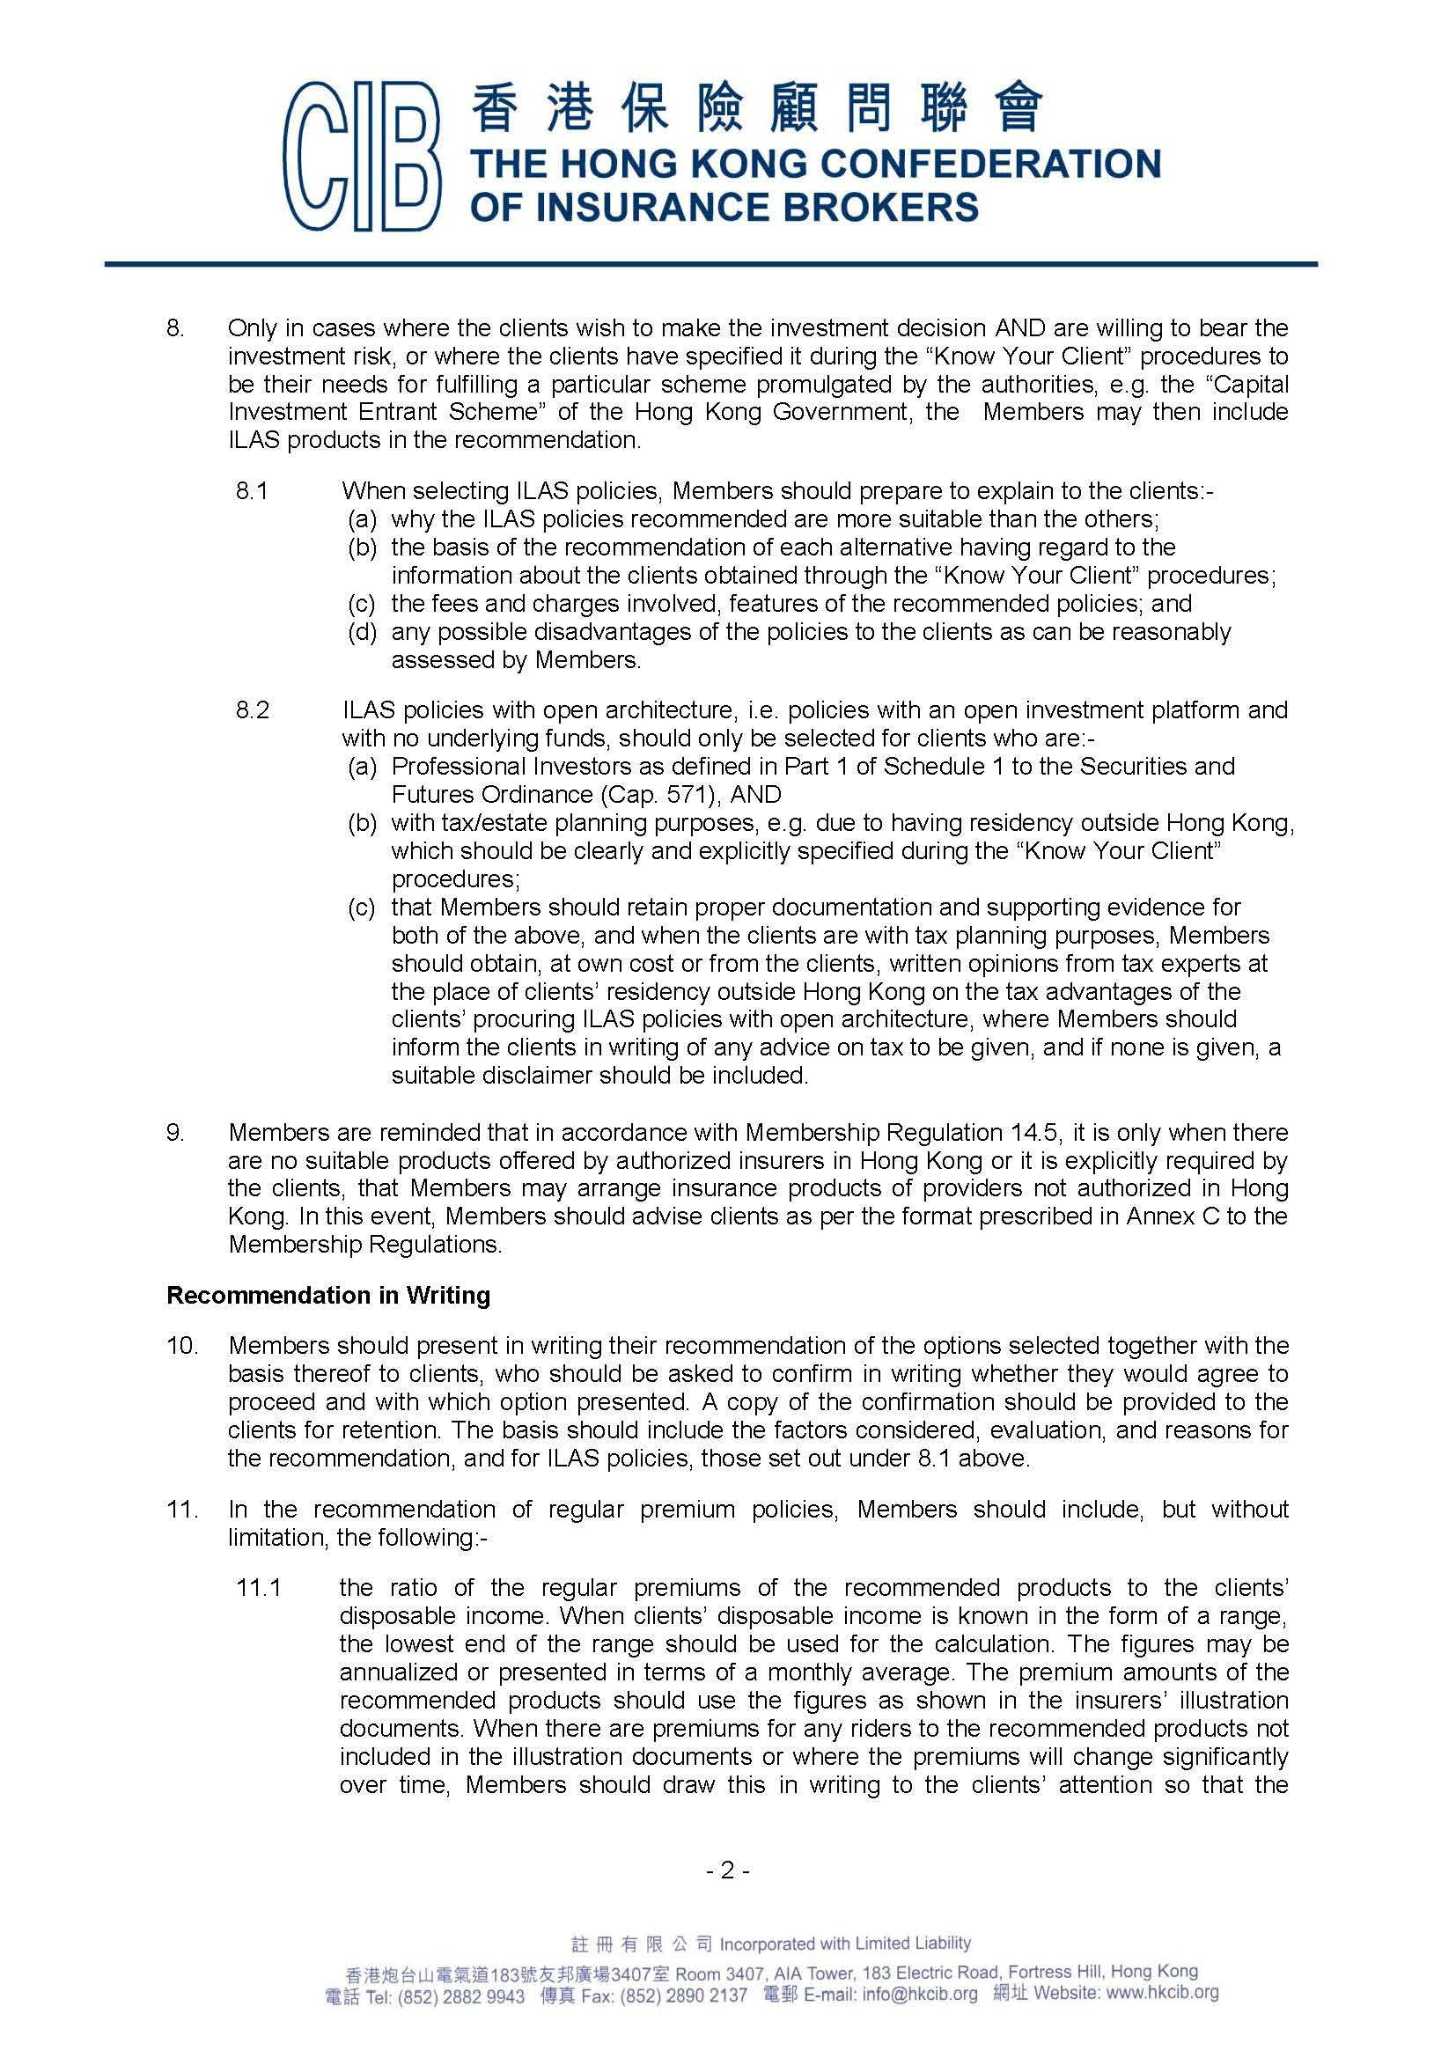
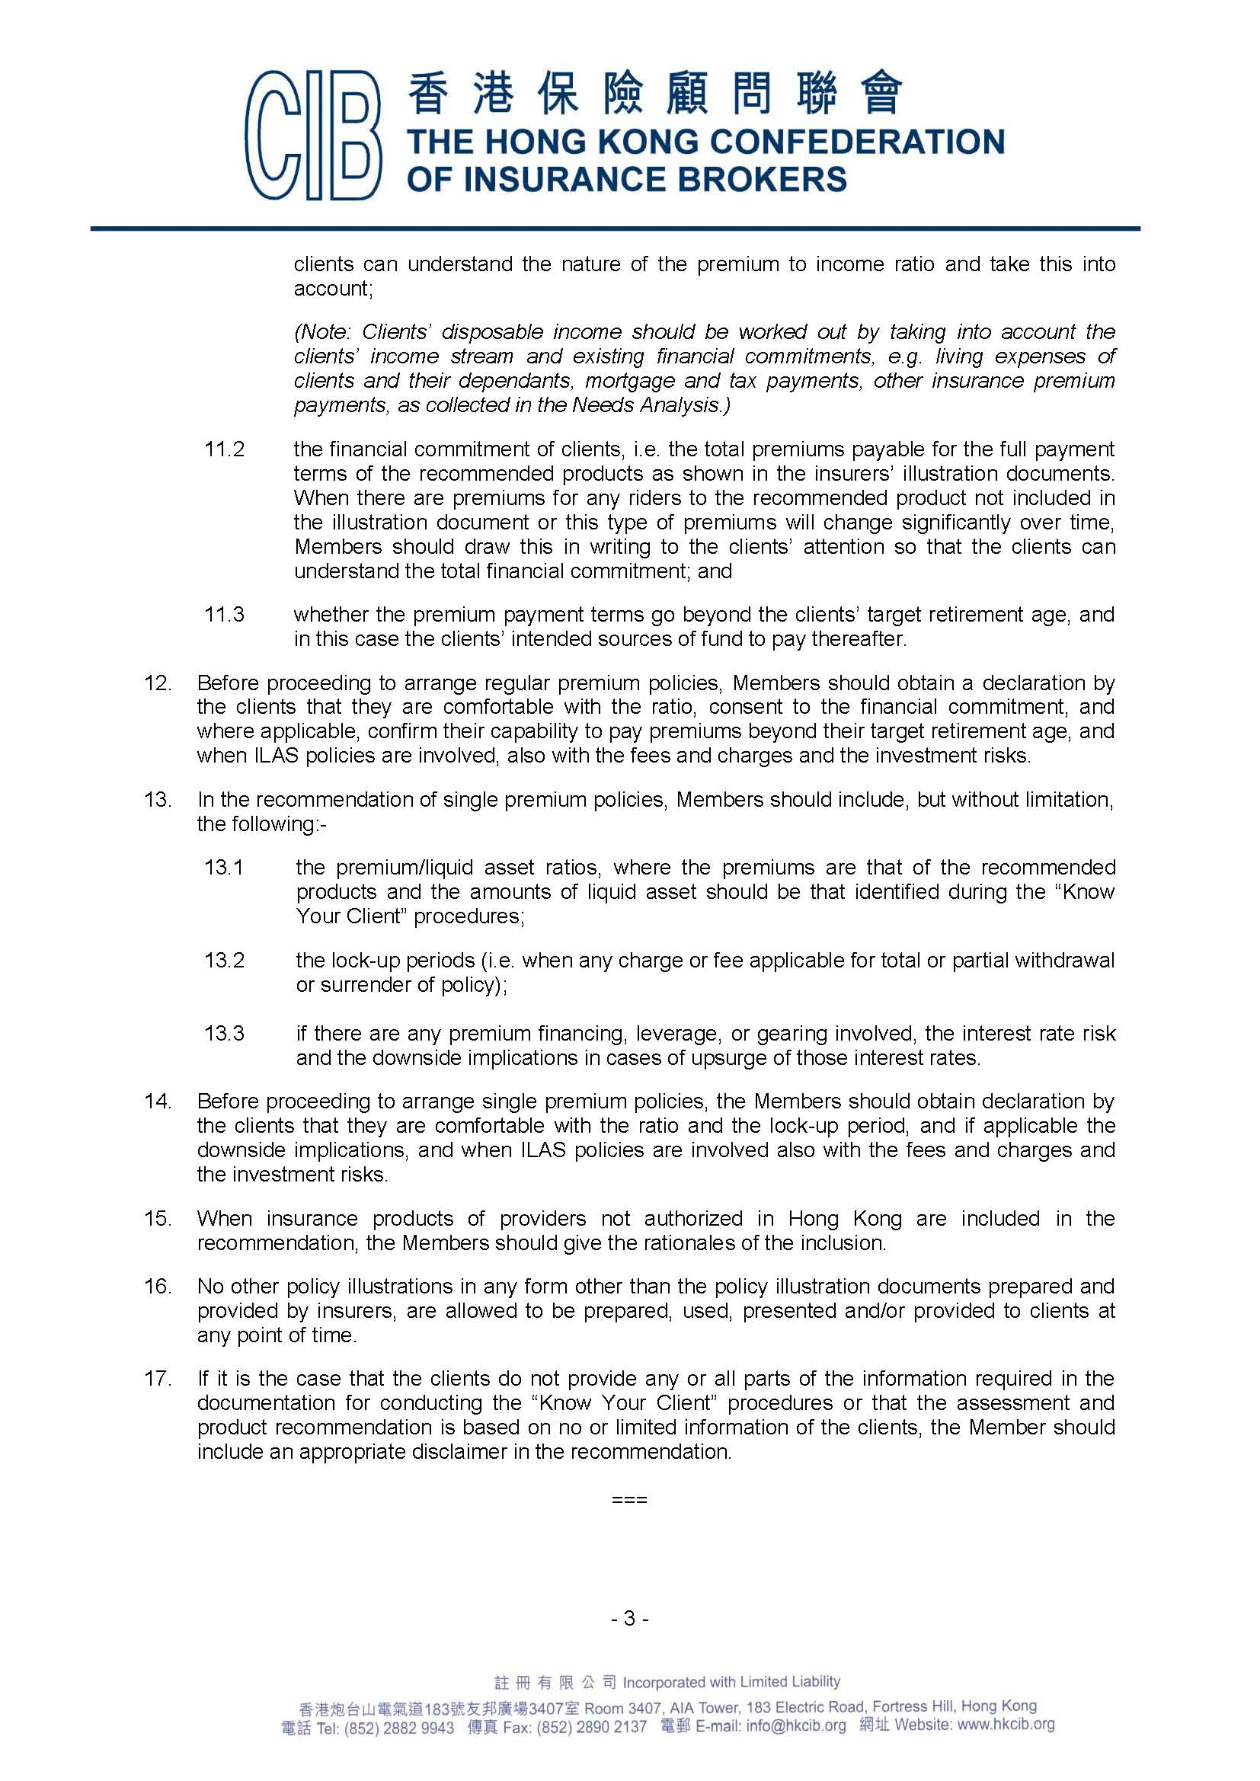

GLOSSARY

Absolute Assignment (絕對轉讓) In life insurance terminology, an Absolute Assignment is an irrevocable assignment of all policy ownership rights to a third party to the contract. |  |  |  | 4.9(f)(i)
Accelerated Death Benefits (提前支付死亡保險利益) These are life insurance death benefits which may, in prescribed circumstances (e.g. life threatening health situations), be payable in part or in full in advance of death of the policyowner-insured. |  |  |  | 3.3
Accident Benefits (意外保險利益) Additional benefits that may be added to a life policy by means of an Accidental Death Benefit (ADB) Rider （意外死亡保險利益附約） or Accidental Death and Dismemberment (AD&D) Rider（意外死亡及喪失肢體附約）. |  |  |  | 3.2
Accidental Death and Dismemberment (AD&D) Rider (意外死亡及喪失肢體附約) Under this rider, an accidental death benefit is payable in a sum equal to the face amount of the basic plan, providing what is termed a "double indemnity"(雙倍賠償), and a dismemberment benefit is payable in the event of, say, loss of any two limbs or loss of sight in both eyes. |  |  |  | 3.2
Accidental Death Benefit (ADB) Rider (意外死亡保險利益附約) An addition to a basic life plan, providing a double benefit should the life insured die from an accident. |  |  |  | 3.2.1(a)
Actively-at-Work Provision (在職工作條款) A group life insurance policy provision that to be admitted to the plan, a prospective member (employee) must have been present at work on the day when coverage became effective. |  |  |  | 2.4(f)
Activities of Daily Living (ADLs) (日常起居活動) A list of basic human needs and functions (washing and dressing oneself, etc.); inability to perform these will satisfy a criterion for payments under a Long Term Care Benefit rider（長期護理附約）. |  |  |  | 3.3.2(c)
Annually Renewable Term (ART) Insurance (每年可續保定期保險)  An alternative title for Yearly Renewable Term (YRT) Insurance. |  |  |  | 2.1.1b(a)
Annuitant (年金標的人) The annuitant of an annuity is the person whose life is the subject matter of that annuity. |  |  |  | 2.3(a)
Annuity (年金) A contract whereby an insurer promises to make a series of periodic payments (called “annuity benefit payments”) to a designated individual (called the “payee”) throughout the lifetime of a person (called the “annuitant”) or for an agreed period, in return for a single payment or series of payments made in advance (called “annuity considerations”) by the other party to the contract called the “contractholder” (or “annuity purchaser”). Very often, the payee, the annuitant and the contractholder are the same person. |  |  |  | 2.3
Annuity Certain (確定年金) A variation of an annuity which paysbenefits for a fixed number of years, whether the annuitant survives or dies during that period. |  | 2.3.1(c)
Anti-Selection (逆選擇) A situation where "bad" risks (lives insured) tend to continue with their insurers, whilst "good" risks tend not to. This is a real danger with the natural premium system. Also known as Selection Against the Insurer (不利於保險人的選擇). |  | 1.3.2a(c)(ii)
Applicant (投保人) A person who is applying for life insurance. |  | 1.2.2
Application (投保單) The more usual term in Hong Kong life insurance for a proposal form, by means of which underwriters obtain preliminary information from applicants. |  | 5.2.1(a)
Assignee (承讓人) In relation to a life insurance contract, it is a third party to whom the policyowner’s interests in the contract have been assigned. |  | 4.9
Assignment (轉讓) In relation to a life insurance contract, it is the transfer of interests in the contract to a third party, with or without consideration. |  | 4.9
Assignor (轉讓人) In relation to a life insurance contract, it is a person who has assigned his interests in the contract to a third party to the contract. |  | 4.9
Attained Age (到達年齡) The current age of a life insured. |  | 2.1.1b(a)
Attending Physician's Statement (APS)(主診醫生報告) In relation to a death claim, an APS might be required from the physician who treated the life insured prior to his death, in support of the claim. |  | 5.3.2b(b)
Automatic Dividend Option (自動紅利選擇) If a policyowner expresses no preference regarding dividend options, this policy provision provides for a particular option to be applied automatically. Often an automatic option means that paid-up additional insurance will be purchased with any declared dividends. An alternative will be to leave the dividends with the insurer to earn interests. |  | 4.10 Note
Automatic Premium Loan (APL) Provision (自動保費貸款條文) A policy provision to the effect that in the event of non-payment of a due premium, and in the absence of an instruction from the policyowner, the cash value of the policy, if any, will be automatically used to pay the premium so as to keep the policy in force. |  | 4.5(a)Note
Beneficial Interest (實益權益) Where a person has an interest of value or use in property which he does not legally own, he is said to have a beneficial interest in that property. |  | 4.4
Beneficiary (受益人) The Beneficiary of a life insurance policy is the person whom a policyowner has nominated to receive benefits under the policy. |  | 4.4
Benefit Policies (利益保單) Policies which do not pay claims on an indemnity basis, but on a stipulated benefit basis (e.g. in life insurance policies). |  | 1.2.3(b)(i)
Benefit Riders (保險利益附約) Endorsements to a life insurance policy, granting additional benefits, e.g. Accidental Death Benefit (ADB) rider (意外死亡附約). |  | 3
Binding Premium Receipt (立約保費收據) A premium receipt which confirms a temporary life insurance cover. It therefore fulfils some of the features found with cover notes in general insurance. Being temporary, the life insurance cover can be terminated by the insurer earlier than the end of the specified maximum period of cover. Also known as an Unconditional Premium Receipt (不附條件保費收據) and Temporary Insurance Agreement (TIA) (臨時保險協議). |  | 5.2.2(b)
Bonuses (英式紅利) The approximate equivalent of dividends with participating policies, bonuses are normally reversionary amounts added to the ultimate benefit payable under a with-profit policy. They are usually declared as a percentage, to be applied to either the sum insured or the sum of the sum insured and the accumulated bonus in arriving at the amount of bonus. |  | 1.3.1b(a) Note 1
Cash Value (現金價值) It is a savings element that results when the premiums received during the early years of level premium life policies have been found to exceed the total payment of death claims occurring in those years. The excess amounts are set aside and collectively referred to as a cash value. The cash value that has been allocated to a policy can be used by the policyowner in a number of ways, e.g. to be withdrawn in the form of surrender value, or used as a pledge for policy loans. |  | 1.3.2b(c)(i)
Chose in Action (據法權產) A personal right which can only be enforced or claimed by action, and not by taking physical possession. Examples include a debt, a cheque and a patent. |  | 4.9
Class Designation (概括式指定) A description of policy beneficiaries by group association rather than by name, e.g. "my children", and "my brothers and sisters". |  | 4.4(a)
Collateral Assignment (抵押轉讓) In life insurance terminology, a Collateral Assignment is a temporary assignment of a policy as collateral security for a loan. The assignee's interest with such an assignment is limited to the amount of the loan plus interests. |  | 4.9(f)(ii)
Comprehensive Cover (綜合保障) In motor insurance, it is the widest form of cover, combining third party liability and "own damage" cover. A Comprehensive private car policy may also give other benefits, such as personal accident and/or medical expenses insurance. |  | 1.2.3(c)(ii)
Conditional Premium Receipt (附條件保費收據) A receipt for premium which confirms that insurance will begin from the time of the application, provided the life insured is subsequently found to have been insurable on standard terms at that time. |  | 5.2.2(a)
Conservation (保留) The retention of existing business, i.e. avoiding policy lapses and surrenders. |  | 5.2.3a(a)
Contestable Period (可異議期) The period of time specified in an Incontestability Provision（不可異議條款）beyond which the insurer will not contest the contract. |  | 4.2(b)
Contingent Beneficiary (次順位受益人) A beneficiary who has been designated to receive the death benefit payable under a life insurance policy if it is he, rather than the primary beneficiary, who survives the life insured. |  | 4.4(b)
Continuous Premium Whole Life Policy (連續繳費終身壽險單) A whole life insurance policy where the premiums continue to be payable throughout the lifetime of the life insured. |  | 2.1.3(a)(i)
Contribution (分擔) An insurance principle which means that two or more insurers covering the same insured for the same loss share that loss rateably. However, this is in providing an indemnity, to which life insurance is not normally subject. Therefore the existence of more than one life insurance policy will not affect the amounts payable by the individual insurers. |  | 1.2(e)
Contributory (Plans) (供款（計劃）) Group life, or employee benefit, schemes where the premium is paid in part by the members of the plans. |  | 2.4(c)
Convert (Conversion) (轉換) A policyowner’s exercise of the right to choose a substitute insurance plan in accordance with a conversion provision, or by mutual consent. |  | 2.1.1b(b)
Convertible Term Insurance (可轉換定期壽險) A term insurance which provides the policyowner with the right to convert the insurance plan into a permanent plan, without evidence of insurability. |  | 2.1.1b(b)
Cooling-Off Initiative (冷靜期規定) A self-regulatory measure initiated by the Hong Kong Federation of Insurers to grant certain privileges to life insurance policyowners regarding the retroactive cancellation of arranged contracts, exercisable within a prescribed period (Cooling-Off Period). |  | 5.2.4
Cooling-Off Period (冷靜期) See Cooling-Off Initiative. |  | 5.2.4
Cost of Living Adjustment (COLA) Benefit Rider (生活指數調整附約) A rider providing for periodic increases in the disability income benefits being paid to a disabled insured, which increases are linked to a prescribed index. |  | 3.6.1
Cover Note (暫保單) A term from general insurance, referring to a document issued to prove the temporary existence of insurance, the approximate equivalent in life insurance being the Binding Premium Receipt（立約保費收據）. |  | 5.2.2(b) Note
Credit Life Insurance (信用壽險) A form of decreasing term insurance normally on a group basis arranged by a lending institution to cover the outstanding balances of loans should the borrowers die without full repayments. The benefit is payable direct to the lending institution. |  | 2.1.1a(b)(i)
Critical Illness Benefit (危疾保險利益) Critical illness insurance, covering a range of specified diseases, is provided either in the form of a rider or a standalone insurance plan. In the former case, the insurer offers to make a lump-sum advance payment from the sum insured of the basic life insurance plan. In the latter case, the lump-sum benefit payment offered will be an advance payment only where the critical illness insurance plan offers death benefit as well as critical illness benefit. |  | 3.3.1
Customer Protection Declaration (CPD) Form 《客戶保障聲明書》 An important document that must be completed and signed before a customer agrees or makes a decision in relation to the purchase of a new life insurance policy. It is part of the concern of the insurance industry to preserve high ethical and professional standards, and to control inappropriate replacement of insurance policies instigated by insurance intermediaries. |  | 5.2.5(c)
Days of Grace (寬限日期) See Grace Period (寬限期). |  | 4.3
Death Benefit (死亡保險金) The basic amount payable under an insurance policy upon the death of the life insured. This may be subject to additional factors, e.g. accidental death benefits. |  | 2.2.1(e)
“Debt” on Policy (保單負債) An underwriting measure with a sub-standard risk, whereby a "debt" is placed against the face amount, possibly reducing to extinguishment as the policy years go by without a claim. |  | 5.3.3(c)(i)
Declinature (拒保) An insurer’s refusal to insure a given risk. |  | 5.3.3(a)
Declined Risk (拒保風險) A given risk which is impaired to such an extent that a particular insurer is refusing to insure it. |  | 5.3.1(b)(iii)
Decreasing Term Insurance (遞減定期壽險) Term insurance whose face amount reduces each year or at specified times. It is the cheapest form of life cover, useful to meet a diminishing temporary need, e.g. a mortgage loan scheduled for repayments over a period of years. |  | 2.1.1a(b)
Defer Decision (延遲決定) An option for the life underwriter where a proposed risk is uninsurable owing to a temporary condition (e.g. accident injuries). The risk is not permanently refused, but it will need reassessment at a later date. |  | 5.3.3(c)(iv)
Deferred Annuity (延期年金) An annuity where annuity benefit payments begin at some specified future time or specified age of the annuitant. |  | 2.3.1(b)
De-mutualised (股份化) A description of a life insurance company which has changed its mutual status, to become a proprietary company, i.e. a limited company owned by its shareholders. |  | 5.1(a) Note
Disability Income rider (殘疾收入附约) A policy rider providing an income during the insured person's period of disability. |  | 3.1.2
Disability Waiver of Premium Rider (殘疾豁免保費附約) An endorsement to a life policy, offering to waive premiums otherwise payable whilst the insured person is totally disabled, keeping the life insurance in full force. |  | 3.1.1
Dismemberment (喪失肢體) The loss of one or more limbs, but within the AD&D Rider provisions the term also applies to loss of sight. |  | 3.2.1(b)
Dividend Options (紅利選擇) The choices available to the policyowner of a participating policy with declared dividends. These choices include: receiving the dividends in cash, applying them towards future premium payments, leaving them to earn interests with the insurer, etc. |  | 4.10
Dividends (紅利) Amounts declared to holders of participating policies on the basis of the experience of the pooled fund to which those policies are connected and which the insurer concerned manages. Usually expressed as a percentage of the premium paid. |  | 4.10
Divisible Surplus (可分配盈餘) That amount of an insurance company’s surplus (i.e. that portion of the owners’ equity which represents the excess of its assets over its liabilities and capital) which is available for distribution to the holders of its participating policies (or with-profit policies) in the form of dividends (or bonuses). |  | 1.3.1b(a)
Double Indemnity Benefit (雙倍賠償利益) An additional benefit to be paid, equal to the policy face amount, should death occur as a result of an accident. An alternative name for Accidental Death Benefit (意外死亡保險利益). |  | 3.2.1(a)Note 1
Duty of Disclosure (披露責任) It requires the parties to a proposed insurance contract to reveal to the other, before contract conclusion, all material facts whether these are requested or not. |  | 1.2.2
Employee Benefit Plans (僱員福利計劃) Group life insurance for employees within the same organisation or industry. |  | 2.4
Endowment Insurance (儲蓄壽險) Life insurance that will pay the face amount when the life insured survives a fixed period of years (at maturity) but upon death in case he dies within the period. |  | 2.1.2
Enrolment Card (and Certificate) (成員登記卡、保險憑證) Documents used with group life insurance, providing evidence of cover to individual insured persons. Separate from the Master Policy (總保單). |  | 5.4.1(b)
Entire Contract Provision (完整合約條款) A life policy provision that defines the whole set of documents constituting the insurance contract. |  | 4.1
Equities (股票) Ordinary shares in a proprietary company. As an investment vehicle, they carry a higher risk than some types of investment, but usually offer long-term growth prospects. |  | 2.2.2(b)
Equity（衡平法） Equity is a set of rules originally established by the Chancery Court of England to mitigate the rigour of common law so as to achieve enhanced fairness. Equity prevails over common law. |  | 1.2.1
Estate (財產) All the property which is owned by an individual, especially someone who has died recently. |  | 4.4(c)
Estate Planning (財產策劃) The making of a plan when one is alive, for the disposal of one’s estate after one’s death or upon his becoming incapacitated. |  | 1.1(a)
Ex Gratia Payment (通融賠付) A payment, usually of a claim, which is made "out of grace or favour", i.e. where there is no legal liability to make such a payment. |  | 4.12 Note 2
Examining Physician (體檢醫生) A qualified medical professional conducting a medical examination on behalf of an insurer. |  | 5.3.2b
Excepted/Excluded Perils (除外危險) A cause of loss excluded from an insurance cover. |  | 1.2.3(a)(ii)
Excess Interest (額外利息) Interest earned over and above the guaranteed interest. Must be notified in the Annual Report with universal life insurance. |  | 2.2.1(f)(v)
Exclusions (除外責任) Risks or losses removed from an insurance cover. These are relatively rare with life insurance, but may more commonly be found with rider benefits, e.g. suicide with accidental death benefits. |  | 5.3.3(c)(ii)
Extended Term Insurance (展期保險) An option under a non-forfeiture benefits provision of a permanent life insurance policy, whereby the net cash value is used as a single premium to purchase a substitute term insurance cover for the same amount as the original face amount, and for such period as the amount of cash value can provide. |  | 4.5(b)(iii)
Face Amount (保額) Specified on the first page of a life insurance policy, it is the amount the policy promises to pay upon death of the life insured. Equivalent to “sum insured” and “sum assured”. |  | 5.2.5(b)
Family Income Insurance (家庭收入壽險) A variation of decreasing term insurance which pays the life insured’s surviving spouse or dependant a stated monthly benefit in the event of death, for the remainder of a specified period of time. |  | 2.1.1a(b)(ii)
Financial Underwriting (財務性核保) Underwriting concentrating more on the implications arising from the amount of insurance requested, e.g. whether the policyowner can meet premium obligations, whether reinsurance may be required, and whether the amount seems excessive by normal criteria with such class of risks. |  | 5.3.1Note
First Beneficiary (第一受益人) See Primary Beneficiary (第一順位受益人). |  | 4.4(b)
Fulfilment Ratio (實現比率) When a participating (or with-profit) policy that offers non-guaranteed dividends/bonuses is being recommended to a prospective customer, projected values are normally presented to him for reference purposes. He may, before making a purchase decision, want to know how likely these values or amounts will come true. It will help to be shown Fulfilment Ratios that are relevant to the recommended insurance product. Relating to a particular insurance product and to a definite period of its existence in the past, the Fulfilment Ratio is substantially the average proportion that the non-guaranteed dividends/bonuses actually declared bear to the amounts projected at the points of sale. |  | 5.2.8
Fully Earned (已完全賺取的) When an amount of premium for a particular period in the past is said to be fully earned, that amount is taken as corresponding to the risk run by the insurer during that period, so it (the earned or fully earned premium) contains no "surplus" to provide for a cash value or other benefit common with the level premium system in many types of life insurance. |  | 1.3.2b(b)
Fully Paid Up (完全清繳) Once a policy has been fully paid up, no more premiums have to be paid but it will continue to provide cover. It is one of the  non-forfeiture options (see Reduced Paid-Up Insurance (減額清繳保險)) . |  | 5.2.7d(c)
Fully Paid-Up Shares (完全清繳的股票) Shares in a proprietary company (or stock company), for which the subscription price has been wholly paid by the shareholders. |  | 5.1(b)
Grace Period (寬限期) A period of time after a premium is due, during which the premium may be paid and cover kept continuous, without penalty. Also known as Days of Grace (寬限日期) . |  | 4.3
Graded-Premium Policy (等級保費保險單) A variation of whole life policy, where the premium increases on a regular basis, e.g. every three years, but the face amount remains unchanged. |  | 2.1.3(c)
Gross Premium (毛保費) The premium for a life insurance policy after taking into account the three rating factors of mortality, interest and expenses. |  | 1.3.1a Note
Group Insurance (團體保險) Life insurance of a number of persons forming a recognisable group, e.g. employees of a particular employer. |  | 2.4
Guaranteed Annuity (保證年金) An annuity which guarantees that annuity benefits will be paid until the annuitant dies and will be paid for at least a certain period, even if he does not survive that period. Also known as a Life Income With Period Certain. |  | 2.3.1(c)
Guaranteed Insurability Option (GIO) (保證可保選擇) Under this rider, the policyowner has the right to purchase additional insurance of the same type as the basic life insurance plan either on specified option dates, at specified ages, or when a specified event happens, without having to supply evidence of insurability. |  | 3.5.1
Immediate Annuity (即期年金) An annuity where the annuity benefit payments commence one annuity period (i.e. the time span between one scheduled payment and the next in the series) immediately following the purchase of the annuity. |  | 2.3.1(a)
Incontestability Provision (不可異議條款) A provision in a life insurance or annuity policy whereby after an initial period the insurer may not contest the policy. |  | 4.2
Increasing Term Insurance (遞增定期壽險) Term insurance that provides a death benefit that increases automatically at specified intervals over the period of insurance. The increases may be linked to an agreed index (e.g. the Composite Consumer Price Index). |  | 2.1.1a(c)
Indemnity (彌償) Restricting insurance payment to an exact financial compensation, the principle of indemnity is not normally applicable to life and personal accident insurance. |  | 1.2(d)
Indemnity Corollaries (彌償引伸) Sub-principles of the parent principle of indemnity, i.e. contribution and subrogation. As with indemnity, neither is likely to have any application with life insurance. |  | 1.2.3(c)
Insurability Benefits (可保權利益) Two types of insurability benefits are offered as riders to life insurance policies, i.e. Paid-up Additional Insurance （清繳增額保險）and Guaranteed Insurability Option (保證可保選擇). |  | 3.5
Insurable Interest (可保權益) In the context of life insurance, it is the legal right to insure an individual's life, which is required at the commencement of insurance, although it is not needed when the insured event happens. |  | 1.2.1
Insured Perils (受保危險) Causes of loss covered by a particular policy. |  | 1.2.3(a)(i)
Irrevocable Beneficiary (不可撤換受益人) A beneficiary who cannot be changed without his/her consent. |  | 4.9(e)(i)
Joint-Life Basis (聯合壽險方式) A life insurance policy that grants cover on a joint-life basis insures the lives of two (or more) persons. Such a policy will pay either on the first or last death, as specified. |  | 2.1.1a(b)(iii)
Key Person Life Insurance (關鍵人物人壽保險) A type of insurance that a business may purchase for insuring the life of an individual whose death might cause a significant financial loss to the business. |  | 1.2.1(d)(iii)  Note
Lapse (失效) It is the kind of termination of a life insurance policy that will result from the non-payment of a due premium within the permitted time period (including the Grace Period(寬限期) ). |  | 1.3.2b(c)  (iii)
Level Premium System (均衡保費制度) The normal method of life insurance pricing, whereby (for the same face amount) the annual premium is established at inception and does not vary throughout the term of the policy. |  | 1.3.2b
Level Term Insurance (定額定期壽險) Term insurance that offers a death benefit that does not change during the term of the policy. |  | 2.1.1a(a)
Life Income Annuity With Period Certain (確定期間終身年金) See Guaranteed Annuity (保證年金). 2.3.1(c)  Living Benefit Rider (生前支付保險利益附約) Another name for Accelerated Death Benefit Rider(提前支付死亡保險利益附約). |  | 2.3.1(c)
 |  | 3.3
Loading (附加保費) A sum added to a life insurance policy’s net premium to cover all of the insurer’s costs of doing business (commissions, etc.). |  | 1.3.1a(c)
Long Term Care (LTC) (長期護理) A rider allowing a stated portion of the death benefit to be advanced to the policyowner-insured when he requires constant care for a medical condition. |  | 3.3.2
Market Value Adjustment (MVA) (市值調整) A permitted right of insurers under the cooling-off initiative to make an adjustment with the refund of premiums, in relation to linked policies and non-linked single premium life policies. |  | 5.2.4 (g)(ii)
Master Policy (總保單) The primary insurance document with a group life insurance plan. |  | 5.4.1(b)
Material Fact (重要事實) A fact that would influence the judgment of a prudent insurer in determining whether to accept a risk or at what premium to accept it. |  | 1.2.2
Mature (Maturity) (期滿) In relation to an endowment insurance policy, it means the policy becomes payable upon the life insured’s survival of the period of insurance. |  | 2.1.2
Maturity Claims (期滿索償) Claims under endowment type insurance, where the full number of years specified have been completed and the life insured is still living. |  | 5.6.1
Medical Application (要體檢投保) A proposal for life insurance where a physical medical examination of the life to be insured is required. |  | 1.2.2(c)
Money Laundering (洗黑錢) The illegal practice of "cleansing" money obtained illegally (e.g. through drug trafficking) by the use of business or financial instruments such as life insurance. Insurers and insurance intermediaries must take great care in trying to detect and eliminate such practices. |  | 5.5.1Note
Moral Hazards (道德危險) Rather more subjective features concerning human attitudes, behaviour and conduct which may have a bearing on the risk. |  | 5.3.1(a)(ii)
Mortality (死亡率) An important consideration in determining life insurance premium rates. It refers to the rate at which insured lives may be expected to die at a given age. The term, therefore, may more accurately be described as Rate of Mortality(死亡比率). |  | 1.3.1a(a)
Mortality Tables (死亡表／生命表) Published statistics on mortality, indicating the expected rates of mortality at given ages. |  | 1.3.1a(a)
Mortgage Indemnity Insurance (按揭彌償保險) A ​type of ​insurance that ​protects a mortgagee against ​the risk of the value of the mortgaged property falling beneath, say, 75% of the original valuation for any reason. |  | 2.1.1a(b)(iii) Note
Mortgage Redemption Insurance (抵押贖回保險) A form of decreasing term insurance, with the benefit linked to the outstanding balance of a mortgage loan that the policyowner has raised. It often grants cover on a joint-life basis, paying on the first death. |  | 2.1.1a(b)  (iii)
Multiple-Employer Groups (Insurance) (多個僱主的團體(保險) ) Group life insurance where different employers participate in a single plan covering their respective employees. |  | 2.4(d)
Mutual Insurance Company (相互保險公司) An insurance company with no shareholders, technically owned by its participating policyholders (i.e. owners of participating policies). |  | 5.1(a)
Natural Premium System (自然保費制度) A system of life insurance premium pricing, whereby the premium for any one policy changes each year according to the prevailing age of the life insured and other features. This is unworkable from a practical point of view and may be considered an academic concept. |  | 1.3.2a
Natural Risk (自然風險) The intrinsic risk presented by the life insured at a particular point in time, related to the person's age, health and other factors. |  | 1.3.2a(a)
Net Cash Value (淨現金價值) Although a policy with cash value may allow the policyowner to cancel the policy in return for a surrender value, or to buy a substitute insurance cover using the cash value as a single premium, the amount actually available for any one of these purposes (i.e. the Net Cash Value) may not equal the cash value for a couple of reasons. The Net Cash Value is calculated by making adjustments for amounts such as paid-up additions, outstanding policy loans and interests, and advance premium payments. |  | 1.3.2b(c)(iv)
Net Policy Proceeds (淨保單收益) The entitlement of an assignee under a life insurance policy, his interests being subordinate to those of the insurer regarding overdue premiums, outstanding policy loans and accrued interests. |  | 4.9(c)
Net Premium (淨保費) Sometimes called the Pure Premium (純保費), this, in the context of life insurance pricing, may be described as the basic premium to be charged exactly to cover the cost of death claims arising under normal statistical expectations, with no allowances for expenses and profit. |  | 1.3.1a Note
Non-Contributory (Plans) (非供款（計劃）) Group life, or employee benefit, plans where the members do not contribute premiums. |  | 2.4(c)
Nonforfeiture (不能作廢) A consequence of the level premium system and policies having a cash value. In the event that future premiums are not paid, the policy does not lapse (become forfeit), because the cash value may be used to keep the policy in force. |  | 4.5
Nonforfeiture (Options) (不能作廢（選擇權）) These are the choices available to the policyowner who does not wish to continue payment of premiums under a policy with a cash value, that will prevent the policy from lapsing. These options include: taking a surrender value in cash, accepting reduced paid-up insurance and accepting extended term insurance in substitution of the original plan. |  | 4.5(b)
Nonforfeiture Provisions (不能作廢條款) Policy provisions that provide Nonforfeiture Options. |  | 4.5
Non-Medical Application (免體檢投保) A request for life insurance which (subject to certain stipulations) does not have to be accompanied by a physical medical examination of the life to be insured. |  | 1.2.2(b)
Option Dates (備擇日期／行權日期) Dates specified under a Guaranteed Insurability Option (保證可保選擇) on which additional insurance may be purchased without evidence of insurability. |  | 3.5.1(a)
Package Policy (一籃子保單) Put simply, it is a single policy containing different types of cover (e.g. a personal accident and sickness policy). |  | 3.3.1 Note
Paid-Up Additional Insurance (清繳增額保險) A participating policy normally allows the policyowner to use any declared dividend as a net single premium to purchase Paid-Up Additional Insurance for the same plan and in whatever face amount the dividend can provide at the attained age of the life insured. |  | 4.10(d)
Paid-Up Insurance (清繳保險) Insurance that a policyowner opts in substitution of the original insurance, with a reduced amount of insurance, without liability to pay further premiums, but otherwise on the same terms as the original insurance. |  | 1.3.2b(c)(iv)
PAR/NON-PAR (分紅／不分紅) The customary abbreviation for policies that are participating or non-participating. |  | 1.3.1b(a)
Participating/Non-Participating (分紅／不分紅) Also known as With-Profit (有利潤) or Without-Profit (無利潤), the terms indicate whether the policyowners can expect to share in the divisible surplus of the insurer or not. |  | 1.3.1b(a)
Participating Policyholders (分紅保單持有人) Those policyholders whose policies are participating (or with-profit). |  | 5.1(a)
Pension (退休金) A monthly or other periodic payment to a person in retirement, until death. |  | 2.3
Permanent Plan (永久計劃) A life insurance plan which is effective throughout the life insured’s lifetime provided premiums continue to be paid, and which contains a savings element. |  | 2.1.1b(b)(iii)
Personal Data (Privacy) Ordinance（《個人資料（私隱）條例》） This is a piece of legislation that is to safeguard the privacy of personal data. When seeking sensitive information about health condition in the course of processing life insurance applications, practitioners should take great care not to breach the Ordinance. |  | 1.2.2(d)
Personal Needs （個人需要） Life insurance fulfils a vital function of satisfying an individual’s various needs in everyday life, such as the needs to make provision for the education of one’s children, for one’s own retirement and for dependents’ living expenses in case of one’s premature death. |  | 1.1.1(a)
Personal Representative (遺產代理人) The executor of a will or the administrator of the estate of a deceased person. |  | 5.6.2(a)
Physical Hazards (實質危險) The objective measurable factors that are very likely to increase the risk of the insured event happening, such as obviously known health dangers (e.g. heavy smoking and serious overweight). |  | 5.3.1(a)(i)
Policy Loan (保單抵押貸款) A policy that generates a cash value usually allows the policyowner to borrow money (Policy Loan) from the insurer against the security of the cash value. |  | 1.3.2b(c)(ii), 4.6
Policy Revival (保單復效) See Reinstatement. |  | 4.7
Policyowner-insured (受保保單所有人) Where the life insured and the policyowner are the same person, this person can be referred to as a policyowner-insured. |  | 3 Note
POS (Policyowner Service)(保單所有人服務部) The Client Service Department, responsible for such matters as documentation, correspondence, premium payments, etc. |  | 5.1.1(e), 5.5
Pre-Existing Conditions (保險生效前已患的疾病) It is common for medical benefit policies to exclude expenses relating to medical problems that existed before the insurance commenced. |  | 3.4(c)(i)
Preferred Risks (優良風險) Above average risks, constituting highly desirable types of business for the insurer (e.g. confirmed non-smokers in excellent health). |  | 5.3.1(b)(iv)
Premium Holiday（保費免繳期） A facility which allows a policyholder of a regular premium plan to skip premium payments for a period of time provided that the policy value is sufficient to cover the mortality charges and fees. No penalty or debit interest will be incurred. |  | 5.2.6b
Premium Waiver (保費豁免) A policy provision whereby premiums otherwise payable are not required by the insurer under prescribed circumstances, e.g. when the life insured has become disabled. |  | 3.3.1(f)
Presumption of Death (推定死亡) Where a person has not been seen for several years, an application can be made to the court to presume him to be legally dead. |  | 5.6.2(e)
Primary Beneficiary (or First Beneficiary)(第一順位受益人／第一受益人) Where a policy has two or more policy beneficiaries, the one who is stated as having priority in receiving the policy proceeds is called the Primary Beneficiary. There could be more than one Primary Beneficiary. |  | 4.4(b)
Principal Brochure (主要推銷刊物) A document required with all investment-linked assurance schemes, containing the information necessary for prospective scheme participants to make an informed judgment of the investment proposed to them. |  | 5.2.4(g)
Proprietary (or Stock) Company (營利(或股份) 公司) A company having shareholders, who have their liability towards the company's debts limited to the extent of any amounts unpaid in respect of their company shares. |  | 5.1(b)
Provident Fund Scheme (公積金計劃) A retirement provision, but unlike with a pension, the benefit is in the form of a lump-sum amount payable at retirement or other specified time. |  | 2.3.2
Proximate Cause (近因) It is the principle which seeks to establish the dominant or effective reason for a loss occurring. The cause of death may sometimes be important in life insurance, for example, if the policy provides additional benefits for accidental death (or if death happens within the contestable period or suicide exclusion period). |  | 1.2(c)
Public Policy (公共政策) It is a principle of law that enables the court to set aside, or deny effect to, acts or transactions that tend to injure the public good or public order. |  | 5.6.2(d)(iv)
Pure Endowment (純生存保險) A rare form of life insurance where the benefit is only payable if death does not occur during the period (term) specified. |  | 2.1.2(b)
Pure Premium or Pure Cost of Protection (純保費／保障的純成本) See Net Premium (淨保費). |  | 1.3.1a Note
Reduced Paid-Up Insurance (減額清繳保險) A non-forfeiture option that allows the policyowner to use the net cash value as a single premium to purchase substitute insurance with a lower sum insured than the original one. |  | 4.5(b)(ii)
Reinstatement (復效) The restoration of a lapsed policy into full force. Also known, with UK style policies, as Policy Revival (保單復效). This is provided for under policy conditions, but is subject to certain limitations, e.g. a specified time period (perhaps five years for exercising the option), repayment of back premiums and interest, and perhaps other measures. |  | 4.7
Reinsurance (再保險) Insurance that transfers all or part of the risk assumed by an insurer under one or more insurance contracts to another insurer. |  | 5.1.1(g)(iii)
Release (or Release Form) (棄權聲明／解除責任憑證)  Documentary confirmation from a beneficiary that the policy's death benefit stands reduced by the amount of any accelerated death benefit payment. Alternatively, a discharge given by a benefit recipient, e.g. with a policy surrender and death claim. |  | 3.3(c), 5.6.3(c)
Renewable Term Insurance (可續保定期壽險) Term insurance that offers the right of renewal for further period(s) without evidence of insurability. |  | 2.1.1b(a)
Renewal Premiums (續保費) Premiums paid or payable for life insurance after payment of the initial premium. |  | 1.3.2b(c)(iii)
Replacement (轉保活動) Under the Code of Practice for Life Insurance Replacement, replacement also involves any policy which has lapsed, been surrendered or converted to paid-up insurance. |  | 5.2.5(b)
Reserve (儲備金) That part of the premium collected which is considered to be unearned will be used to build policy reserve for the purposes of paying policy benefits in the future. |  | 1.3.2b(b)
Reversionary (Interest/Bonus)(復歸(權益/紅利)) A financial interest which exists now, but where full enjoyment and privileges of ownership is deferred until some future time or event, e.g. reversionary bonuses under with-profits policies. |  | 4.9, 4.10
Rider(附約) Such an amendment to a policy that becomes part of the insurance contract and that either expands or limits the benefits payable under the contract. |  | 3.1
Settlement Options (賠付選擇) The choices available to the policyowner when the policy proceeds become available. These options include: lump sum single payment, proceeds left to earn interest with the insurer and proceeds paid in instalments over a fixed period, etc. |  | 4.11
Single-Employer Plans (單一僱主計劃) Group life insurance where all insured persons are employees of the same employer. |  | 2.4(d)
Special Class Risks (特殊風險) See Sub-Standard Risks (次標準風險). |  | 5.3.1(b)(ii)
Standard Risks (標準風險) Risks presenting no abnormal features and insurable on normal terms. |  | 5.3.1(b)(i)
Straight Life Insurance (純粹壽險) Whole life insurance for which premiums are payable for as long as the life insured lives. |  | 2.1.3(a)(i)
Subrogation (代位權) A legal principle which allows an insurer who has provided an indemnity to take over for his own benefit rights the policyholder has against third parties. As indemnity does not apply to life insurance, so this corollary of indemnity – subrogation - does not apply to it either. |  | 1.2(f)
Sub-Standard Risks (次標準風險) Proposed risks which are more likely to result in a loss that the average, so that they are either rejected or insurable with special terms. Sometimes called Special Class Risks. |  | 5.3.1(b)(ii)
Sum Assured (保額) See Face Amount. |  | 5.3.3(c)(i)
Sum Insured (保額) See Face Amount. |  | 5.2.5(b)
Surrender (退保) Termination of an insurance policy by the policyowner for a Surrender Value. |  | 5.6.3
Surrender Value (退保價值) Payable in cash, a policy’s surrender value equals the cash value minus a surrender charge, a charge that is applicable when a policy is surrendered for its cash value or when a policy, under some plans, is adjusted to provide a lower level of death benefit. Also see Cash Value (現金價值). |  | 1.3.2b(c)(i)

Switching (Policy Switching)(轉保) Changing an existing life insurance policy for a replacement one. The term, however, has an undesirable implication whereby policyholders are persuaded to make the change which may be more for the benefit of the insurance intermediary or the new insurer than the policyholder. The latter practice is known as Twisting (誘導轉保) (i.e. an inappropriate replacement of a life insurance policy). |  | 5.2.5
Technical Underwriting (技術性核保) Assessment of the intrinsic and perceived hazards of given risks, as to their insurability and terms. |  | 5.3.1 Note
Temporary Insurance Agreement (TIA)(臨時保險協議) See Binding Premium Receipt (立約保費收據). |  | 5.2.2(b)
Term Insurance (定期壽險) Life insurance which will pay benefit only if the life insured dies during the period (term) specified. Also known as Temporary Life Insurance (短期人壽保險). |  | 2.1.1
Third Degree Burns (三級燒傷或燙傷) Can be defined as full thickness skin destruction due to burns. |  | 3.2.2(b)(i)
Third Party Policy (第三者保單) A policy where the insurance is on the life of a person other than the applicant. |  | 3
Title (所有權) It is a legal term meaning the right to hold goods or property (e.g. policy proceeds). |  | 5.6.3(a)
Total Disability (完全殘疾) As defined under the Disability Income Rider, this means that the insured person is unable to perform the essential acts of his own occupation, or any occupation for which he is reasonably fitted by education, training or experience. |  | 3.1.2(a)
Twisting (誘導轉保) See Switching (轉保). |  | 5.2.5(a)
"Unbundled" Pricing Structure (「分別列示各定價因素」定價結構) A feature of universal life insurance, whereby the insurer separately discloses the three pricing factors: mortality (or pure cost of protection), interest and expenses. |  | 2.2.1(c)
Unconditional Premium Receipt (不附條件保費收據) See Binding Premium Receipt (立約保費收據). |  | 5.2.2(b)
Underwriting (核保) The process of identifying and classifying the degree of risk represented by an application, and of determining its insurability and the contract terms to be adopted. |  | 1.3.1a(a), 5.1.1(g), 5.3

Uninsured Perils (不保危險) These are causes of loss neither specifically covered nor specifically excluded by a policy. An important consideration with non-life insurance and the principle of proximate cause, but unlikely to have any significant application to life insurance. |  | 1.2.3(a)(iii)
Unit-Linked Long Term Policy (單位相連長期保單) Also known as an ‘Investment-Linked Long Term Policy’ (投資相連長期保單), it is an insurance policy with its policy value generally linked to the performance of its underlying investments. |  | 2.2.2
Universal Life Insurance (萬用壽險) Life insurance which is subject to a flexible premium, has an adjustable benefit and an ‘unbundled’ pricing structure, and accumulates a cash value. |  | 2.2.1
Utmost Good Faith (最高誠信) A common law principle whereby each party to an insurance contract must, prior to contract conclusion, reveal to the other all Material Facts whether these are requested or not. At law, a breach of this principle makes the contract voidable, subject to such contract terms as the Incontestability Provision. |  | 1.2(b)
Waiting Period – in relation to Critical Illness Rider (等候期—與危疾附約有關的) Where diagnosis is a defining element of an insured event of the Critical Illness Rider, the diagnosis has to be one done when the rider has already been in effect for a specified number of days. |  | 3.3.1(e)(iv)
Waiting Period – in relation to Disability Waiver of Premium Rider (等候期—與殘疾豁免保費附約有關的) A qualification to the Disability Waiver of Premium Rider, whereby premiums are not waived until the insured person has been disabled for a specified number of months. Some insurers refund premiums paid during the waiting period if the disability lasts longer, so that premiums begin to be waived. |  | 3.1.1(a)
Whole (of) Life Insurance (終身壽險) Life insurance where the benefit is payable only on death, whenever that occurs. |  | 2.1.3
With-Profit Policy) (有利潤保單) The equivalent term in U.K. insurance terminology of a participating policy. |  | 1.3.1b(a) Note 1
Without-Profit (Policy) (無利潤保單) The equivalent term in U.K. insurance terminology of a non-participating policy. |  | 1.3.1b(a) Note 1
Yearly Renewable Term (YRT) Insurance (每年可續保定期壽險) One year term insurance with guaranteed insurability renewal provisions. Also known as Annually Renewable Term (ART) Insurance. |  | 2.1.1b(a)

INDEX

Absolute assignment | 絕對轉讓 |  |  |  |  |  | 4.9(f)(i)
Accelerated death benefits | 提前支付死亡保險利益 |  |  |  |  |  | 3.3
Accident benefits | 意外保險利益 |  |  |  |  |  | 3.2
Accidental death and dismemberment rider | 意外死亡及喪失肢體附約 |  |  |  |  |  | 3.2
Accidental death benefit | 意外死亡保險利益 |  |  |  |  |  | 3.2.1(a)
Accounts department | 會計部 |  |  |  |  |  | 5.1.1(a)
Actively-at-work provision | 在職工作條款 |  |  |  |  |  | 2.4(f)
Activities of daily living | 日常起居活動 |  |  |  |  |  | 3.3.2(c)
Actuarial department | 精算部 |  |  |  |  |  | 5.1.1(b)
Adjustable benefit | 可調整的保險利益 |  |  |  |  |  | 2.2.1(b)
Age not admitted | 年齡未獲承認 |  |  |  |  |  | 5.6.1(d)
Annually renewable term | 每年可續保定期保險 |  |  |  |  |  | 2.1.1b(a)
Annuitant | 年金標的人 |  |  |  |  |  | 2.3(a)
Annuity | 年金 |  |  |  |  |  | 2.3
Annuity certain | 確定年金 |  |  |  |  |  | 2.3.1(c)
Annuity period | 年金期 |  |  |  |  |  | 2.3.1(a)
Anti-selection | 逆選擇 |  |  |  |  |  | 1.3.2a(c)(ii)
Applicant | 投保人 |  |  |  |  |  | 1.2.2
Application | 投保單（投保申請書） |  |  |  |  |  | 5.2.1(a)
Application procedure | 投保手續 |  |  |  |  |  | 5.2.1
Appointed actuary | 獲委任的精算師 |  |  |  |  |  | 5.2.6b(c)
Assignee | 承讓人 |  |  |  |  |  | 4.9
Assignment | 轉讓 |  |  |  |  |  | 4.9
Assignor | 轉讓人 |  |  |  |  |  | 4.9
Attained age | 到達年齡 |  |  |  |  |  | 2.1.1b(a)
Attending physician’s statement (APS) | 主診醫生報告 |  |  |  |  |  | 5.3.2b(b)
Automatic dividend option | 自動紅利選擇 |  |  |  |  |  | 4.10Note
Automatic premium loan | 自動保費貸款 |  |  |  |  |  | 4.5(a)Note
Beneficial interest | 實益權益 |  |  |  |  |  | 4.4
Beneficiary | 受益人 |  |  |  |  |  | 4.4
Beneficiary designation | 受益人的指定 |  |  |  |  |  | 4.4
Benefit policies | 利益保單 |  |  |  |  | 1.2.3(b)(i)
Benefit riders | 保險利益附約 |  |  |  |  | 3
Binding premium receipt | 立約保費收據 |  |  |  |  | 5.2.2(b)
Bonuses | 英式紅利／紅利 |  |  |  |  | 1.3.1b(a)Note1
Cash surrender value | 退保現金價值 |  |  |  |  | 4.5(b)(i)
Cash value | 現金價值 |  |  |  |  | 1.3.2b(c)(i)
Chose in Action | 據法權產 |  |  |  |  | 4.9
Claims | 理賠 |  |  |  |  | 5.1.1(d)
Class designation | 概括式指定 |  |  |  |  | 4.4(a)
Code of Practice for Life Insurance Replacement | 《壽險轉保守則》 |  |  |  |  | 5.2.5
Collateral assignment | 抵押轉讓 |  |  |  |  | 4.9(f)(ii)
Collateral security | 質押擔保 |  |  |  |  | 1.3.2b(c)(ii)
Complaints or disputes | 投訴／爭議 |  |  |  |  | 5.2.4(f)(iii)
Comprehensive cover | 綜合保障 |  |  |  |  | 1.2.3(c)(ii)
Conditional premium receipt | 附條件保費收據 |  |  |  |  | 5.2.2(a)
Conservation | 保留 |  |  |  |  | 5.2.3a(a)
Contestable period | 可異議期 |  |  |  |  | 4.2(b)
Contingent beneficiary | 次順位受益人 |  |  |  |  | 4.4(b)
Continuous premium whole life policy | 連續繳費終身壽險單 |  |  |  |  | 2.1.3(a)(i)
Contribution | 分擔 |  |  |  |  | 1.2(e)
Contributory (plans) | 供款（計劃） |  |  |  |  | 2.4(c)
Conversion privilege | 轉換特權 |  |  |  |  | 2.1.1b(b)
Convert (conversion) | 轉換 |  |  |  |  | 2.1.1b(b)
Convertible term insurance | 可轉換定期壽險 |  |  |  |  | 2.1.1b(b)
Cooling-off initiative | 冷靜期規定 |  |  |  |  | 5.2.4
Cooling-off period | 冷靜期 |  |  |  |  | 5.2.4
Cost of living adjustment benefit | 生活指數調整 |  |  |  |  | 3.6.1
Cover note | 暫保單 |  |  |  |  | 5.2.2(b)Note
Credit life insurance | 信用壽險 |  |  |  |  | 2.1.1a(b)(i)
Critical illness benefit | 危疾保險利益 |  |  |  |  | 3.3.1
Customer loyalty | 客戶忠誠度 |  |  |  |  | 5.2.3a(a)
Customer protection declaration form | 客戶保障聲明書 |  |  |  |  | 5.2.5(c)
Days of grace | 寬限日期 |  |  |  |  | 4.3
Death benefit | 死亡保險金 |  |  |  |  | 2.2.1(f)
Death claims | 死亡索償 |  |  |  |  | 5.6.2
“Debt” on policy | 保單負債 |  |  |  |  | 5.3.3(c)(i)
Declinature | 拒保 |  |  |  |  | 5.3.3(a)
Declined risk | 拒保風險 |  |  |  |  | 5.3.1(b)(iii)
Decreasing term insurance | 遞減定期壽險 |  |  |  |  | 2.1.1a(b)
Defer decision | 延遲決定 |  |  |  |  | 5.3.3(c)(iv)
Deferred annuity | 延期年金 |  |  |  |  | 2.3.1(b)
De-mutualised | 股份化 |  |  |  |  | 5.1(a)Note
Disability income | 殘疾收入 |  |  |  |  | 3.1.2
Disability waiver of premium rider | 殘疾豁免保費附約 |  |  |  |  | 3.1.1
Dismemberment | 喪失肢體 |  |  |  |  | 3.2.1(b)
Dividend options | 紅利選擇 |  |  |  |  | 4.10
Dividends | 紅利 |  |  |  |  | 4.10
Divisible surplus | 可分配盈餘 |  |  |  |  | 1.3.1b(a)
Double indemnity benefit | 雙倍賠償利益 |  |  |  |  | 3.2.1(a)Note1
Duty of disclosure | 披露責任／申報實情責任 |  |  |  |  | 1.2.2
Employee benefit plans | 僱員福利計劃 |  |  |  |  | 2.4
Endorsements | 批單 |  |  |  |  | 2(b)(iv)
Endowment insurance | 儲蓄壽險 |  |  |  |  | 2.1.2
Enrolment card and Certificate | 成員登記卡、保險憑證 |  |  |  |  | 5.4.1(b)
Entire contract provision | 完整合約條款 |  |  |  |  | 4.1
Equitable (premiums) | 公平的（保費） |  |  |  |  | 1.3.1(b)
Equities | 股票 |  |  |  |  | 2.2.2(b)
Equity | 衡平法 |  |  |  |  | 1.2.1
Estate | 財產 |  |  |  |  | 4.4(c)
Estate planning | 財產規劃 |  |  |  |  | 1.1(a)
Ex gratia payment | 通融賠付 |  |  |  |  | 4.12Note2
Examining physician | 體檢醫生 |  |  |  |  | 5.3.2b
Excepted/excluded perils | 除外危險 |  |  |  |  | 1.2.3(a)(ii)
Excess interest | 額外利息 |  |  |  |  | 2.2.1(f)(v)
Exclusions | 除外責任 |  |  |  |  | 5.3.3(c)(ii)
Expenses | 開支 |  |  |  |  | 1.3.1a(c)
Extended term insurance | 展期保險 |  |  |  |  | 4.5(b)(iii)
Face amount | 保額 |  |  |  |  | 5.2.5(b)
Family income insurance | 家庭收入壽險 |  |  |  |  | 2.1.1a(b)(ii)
Financial underwriting | 財務性核保 |  |  |  |  | 5.3.1Note
First (or primary) beneficiary | 第一受益人／第一順位受益人 |  |  |  |  |  |  | 4.4(b)
Fixed interest investments | 固定利息投資 |  |  |  |  | 2.2.2(b)
Flexible premium | 靈活保費 |  |  |  |  | 2.2.1(a)
Fraud | 欺詐行為 |  |  |  |  | 4.2(b)
Fulfilment ratio | 實現比率 |  |  |  |  | 5.2.8
Fully earned | 已完全賺取的 |  |  |  |  | 1.3.2b(b)
Fully paid up | 完全清繳 |  |  |  |  | 5.2.7d (c)
Fully paid-up shares | 完全清繳的股票 |  |  |  |  | 5.1(b)
Grace period | 寬限期 |  |  |  |  | 4.3
Graded-premium policy | 等級保費保險單 |  |  |  |  | 2.1.3(c)
Gross premium | 毛保費 |  |  |  |  | 1.3.1aNote
Group insurance | 團體保險 |  |  |  |  | 2.4
Guaranteed annuity | 保證年金 |  |  |  |  | 2.3.1(c)
Guaranteed insurability option | 保證可保選擇 |  |  |  |  | 3.5.1
Hospital charges | 住院費用 |  |  |  |  | 3.4(a)(i)
Illustration Document | 說明文件 |  |  |  |  | 5.2.6a
Immediate annuity | 即期年金 |  |  |  |  | 2.3.1(a)
Important Facts Statement | 重要資料聲明書 |  |  |  |  | 5.2.10
Inception date | 起保日期 |  |  |  |  | 5.2.2
Incontestability provision | 不可異議條款 |  |  |  |  | 4.2
Increasing term insurance | 遞增定期壽險 |  |  |  |  | 2.1.1a(c)
Indemnity | 彌償 |  |  |  |  | 1.2(d)
Indemnity corollaries | 彌償的引伸 |  |  |  |  | 1.2.3(c)
Inflation | 通貨膨脹 |  |  |  |  | 3.6
Initiative on Financial Needs Analysis | 財務需要分析的規定 |  |  |  |  | 5.2.9
Insurability benefits | 可保權利益 |  |  |  |  | 3.5
Insurable interest | 可保權益 |  |  |  |  | 1.2.1
Insurable interest (in oneself) | 可保權益（就自己而言） |  |  |  |  | 1.2.1(c)
Insurable interest (in others) | 可保權益（就其他人而言） |  |  |  |  |  |  | 1.2.1(d)
Insurable interest (when needed) | 可保權益（何時需要） |  |  |  |  | 1.2.1(h)
Insurance Company Ordinance | 《保險公司條例》 |  |  |  |  | 1.2.1(a)
Insurance intermediaries | 保險中介人 |  |  |  |  | 2
Insured event | 受保事件 |  |  |  |  | 1.2.3(c)(i)
Insured perils | 受保危險 |  |  |  |  | 1.2.3(a)(i)
Interest | 利息 |  |  |  |  | 1.3.1a(b)
Investment | 投資 |  |  |  |  | 1.3.1a(b)
Irrevocable beneficiary | 不可撤換受益人 |  |  |  |  | 4.9(e)(i)
Joint-life basis | 聯合壽險方式 |  |  |  |  | 2.1.1a(b)(iii)
Key person life insurance | 關鍵人物人壽保險 |  |  | 1.2.1(d)(iii)Note
Lapse | 失效 |  |  |  |  | 1.3.2b(c)(iii)
Law of averages/ law of large numbers | 平均法則／大數法則 |  |  |  |  | 1.3.1a(a)
Level premium system | 均衡保費制度 |  |  |  |  | 1.3.2b
Level term insurance | 定額定期壽險 |  |  |  |  | 2.1.1a(a)
Life annuity | 終身年金 |  |  |  |  | 2.3.1(c)
Life income annuity with period certain | 確定期間終身年金 |  |  |  |  | 2.3.1(c)
Life insurance | 人壽保險 |  |  |  |  | 1.1
Life Insurance Council | 壽險總會 |  |  |  |  | 5.2.4
Life insured | 受保生命 |  |  |  |  | 1.2.1(b)
Life underwriter’s report | 壽險代理人報告 |  |  |  |  | 5.2.1(c)(i)
Linked policy illustration document | 相連保單退保說明文件 |  |  |  |  | 5.2.6a
Living benefit rider | 生前支付保險利益附約 |  |  |  |  | 3.3
Loading | 附加保費 |  |  |  |  | 1.3.1a(c)
Long term business | 長期業務 |  |  |  |  | 1.3.1b
Long term care | 長期護理 |  |  |  |  | 3.3.2
Lump sum | 一整筆款項 |  |  |  |  | 2.1.1a(b)(ii)
Mandatory Provident Fund System | 強制性公積金制度 |  |  |  |  | 2.3.2
Market value adjustment | 市值調整 |  |  |  |  | 5.2.4(g)(ii)
Master policy | 總保單 |  |  |  |  | 5.4.1(b)
Material fact | 重要事實 |  |  |  |  | 1.2.2
Mature (maturity) | 期滿 |  |  |  |  | 2.1.2
Maturity claims | 期滿索償 |  |  |  |  | 5.6.1
Medical application | 要體檢投保 |  |  |  |  | 1.2.2(c)
Medical benefits | 醫療保險利益 |  |  |  |  | 3.4
Misstatement of age/sex | 誤報年齡／性別 |  |  |  |  | 4.8
Money laundering | 洗黑錢 |  |  |  |  | 5.5.1Note
Moral hazards | 道德危險 |  |  |  |  | 5.3.1(a)(ii)
Mortality | 死亡率 |  |  |  |  | 1.3.1a(a)
Mortality tables | 死亡表／生命表 |  |  |  |  | 1.3.1a(a)
Mortgage indemnity insurance | 按揭彌償保險 |  | 2.1.1a(b)(iii)Note
Mortgage redemption insurance | 抵押贖回保險 |  |  |  |  | 2.1.1a(b)(iii)
Multiple-employer groups | 多個僱主的團體 |  |  |  |  | 2.4(d)
Mutual insurance company | 相互保險公司 |  |  |  |  | 5.1(a)
Natural premium system | 自然保費制度 |  |  |  |  | 1.3.2a
Natural risk | 自然風險 |  |  |  |  | 1.3.2a(a)
Net cash value | 淨現金價值 |  |  |  |  | 1.3.2b(c)(iv)
Net policy proceeds | 淨保單收益 |  |  |  |  | 4.9(c)
Net premium | 淨保費 |  |  |  |  | 1.3.1aNote
Non-contributory (plans) | 非供款（計劃） |  |  |  |  | 2.4(c)
Nonforfeiture | 不能作廢 |  |  |  |  | 4.5
Nonforfeiture (options) | 不能作廢（選擇） |  |  |  |  | 4.5(b)
Nonforfeiture provisions | 不能作廢條款 |  |  |  |  | 4.5
Non-medical application | 免體檢投保 |  |  |  |  | 1.2.2(b)
Non-participating policy | 不分紅保單 |  |  |  |  | 1.3.1b(a)
Non-traditional types of life insurance | 非傳統的人壽保險類別 |  |  |  |  | 2.2
Notice of assignment | 轉讓通知 |  |  |  |  | 4.9(a)
Option dates | 備擇／行權日期 |  |  |  |  | 3.5.1(d)
Optional medical plan | 自選醫療計劃 |  |  |  |  | 3.4(b)
Package Policy | 一籃子保單 |  |  |  |  | 3.3.1 Note
Paid-up additional insurance | 清繳增額保險 |  |  |  |  | 4.10(d)
Paid-up insurance | 清繳保險 |  |  |  |  | 1.3.2b(c)(iv)
Par/non-par | 分紅／不分紅 |  |  |  |  | 1.3.1b(a)
Participating/non-participating | 分紅／不分紅 |  |  |  |  | 1.3.1b(a)
Participating policyholders | 分紅保單持有人 |  |  |  |  | 5.1(a)
Pension | 退休金 |  |  |  |  | 2.3
Permanent plan | 永久計劃 |  |  |  |  | 2.1.1b(b)(iii)
Personal Data (Privacy) Ordinance | 《個人資料（私隱）條例》 |  |  |  |  |  |  |  | 1.2.2(d)
Personal representative | 遺產代理人 |  |  |  |  | 5.6.2(a)
Physical hazards | 實質危險 |  |  |  |  | 5.3.1(a)(i)
Policy loan | 保單抵押貸款 |  |  |  | 1.3.2b(c)(ii),4.6
Policy revival | 保單復效 |  |  |  |  | 4.7
Policy switching | 轉保 |  |  |  |  | 5.2.5
Policyowner-insured | 受保保單所有人 |  |  |  |  | 3Note
Policyowner Service | 保單所有人服務部 |  |  |  |  | 5.1.1(e),5.5
Pre-existing conditions | 保險生效前已患的疾病 |  |  |  |  | 3.4(c)(i)
Preferred risks | 優良風險 |  |  |  |  | 5.3.1(b)(iv)
Premium | 保費 |  |  |  |  | 1.3
Premium holiday | 保費免繳期 |  |  |  |  | 5.2.6b
Premium waiver | 保費豁免 |  |  |  |  | 3.3.1(f)
Presumption of death | 推定死亡 |  |  |  |  | 5.6.2(e)
Primary (or first) beneficiary | 第一順位受益人／第一受益人 |  |  |  |  |  |  | 4.4(b)
Principal brochure | 主要推銷刊物 |  |  |  |  | 5.2.4(g)
Private nursing | 私人護理 |  |  |  |  | 3.4(a)(ii)
Proof of age | 年齡證明 |  |  |  |  | 5.6.1(d)
Proof of death | 死亡證明 |  |  |  |  | 5.6.2(c)
Proposal | 投保 |  |  |  |  | 5.2
Proprietary (or stock) company | 營利（或股份）公司 |  |  |  |  | 5.1(b)
Provident fund scheme | 公積金計劃 |  |  |  |  | 2.3.2
Proximate cause | 近因 |  |  |  |  | 1.2(c)
Public policy | 公共政策 |  |  |  |  | 5.6.2(d)(iv)
Pure cost of protection | 保障的純成本 |  |  |  |  | 2.2.1(c)(i)
Pure endowment | 純生存保險 |  |  |  |  | 2.1.2(b)
Pure premium | 純保費 |  |  |  |  | 1.3.1aNote
Rate of mortality | 死亡比率 |  |  |  |  | 1.3.1a(a)
Rates (life insurance) | 費率（人壽保險） |  |  |  |  | 1.3
Reduced paid-up insurance | 減額清繳保險 |  |  |  |  | 4.5(b)(ii)
Reinstatement | 復效 |  |  |  |  | 4.7
Reinsurance | 再保險 |  |  |  |  | 5.1.1(g)(iii)
Release (or Release form) | 棄權聲明／解除責任憑證 |  |  |  |  | 3.3(c),5.6.3(c)
Renewable term insurance | 可續保定期壽險 |  |  |  |  | 2.1.1b(a)
Renewal premiums | 續保保費 |  |  |  |  | 1.3.2b(c)(iii)
Replacement | 轉保 |  |  |  |  | 5.2.5(b)
Reserve | 儲備 |  |  |  |  | 1.3.2b(b)
Reversionary (interest/bonus) | 復歸（權益/紅利） |  |  |  |  | 4.9
Rider | 附約／附加條款 |  |  |  |  | 3.1
Risk assessment | 風險評估 |  |  |  |  | 5.1.1(g)(i)
Sales illustrations | 銷售說明書 |  |  |  |  | 5.2.6
Savings | 儲蓄 |  |  |  |  | 1.1(b)
Selection against the insurer | 不利於保險人的選擇 |  |  |  |  | 1.3.2a(c)(ii)
Settlement options | 賠付選擇 |  |  |  |  | 4.11
Single employer (plans) | 單一僱主（計劃） |  |  |  |  | 2.4(d)
Single premium endowments | 整付保費儲蓄壽險 |  |  |  |  | 2.1.2(a)
Special class risks | 特殊風險 |  |  |  |  | 5.3.1(b)(ii)
Standard Illustration for Universal Life (Non-Linked) Policies | 萬用壽險（非投資相連）銷售說明文件 |  |  |  |  | 5.2.6b
Standard risks | 標準風險 |  |  |  |  | 5.3.1(b)(i)
Standard terms | 標準條款 |  |  |  |  | 5.2.2(a)
Statutory requirement (insurable interest) | 法定要求（可保權益） |  |  |  |  | 1.2.1(a)
Stock company | 股份公司 |  |  |  |  | 5.1(b)
Straight life insurance | 純粹壽險 |  |  |  |  | 2.1.3(a)(i)
Subrogation | 代位權 |  |  |  |  | 1.2(f)
Sub-standard risks | 次標準風險 |  |  |  |  | 5.3.1(b)(ii)
Suicide exclusion | 自殺除外責任 |  |  |  |  | 4.12
Suicide exclusion period | 自殺免責期 |  |  |  |  | 1.2.3(a)Note1
Sum assured | 保額 |  |  |  |  | 5.3.3(c)(i)
Sum insured | 保額 |  |  |  |  | 5.2.5(b)
Surrender | 退保 |  |  |  |  | 5.6.3
Surrender value | 退保價值 |  |  |  |  | 1.3.2b(c)(i)
Switching | 轉保 |  |  |  |  | 5.2.5
Technical underwriting | 技術性核保 |  |  |  |  | 5.3.1Note
Temporary insurance agreement | 臨時保險協議 |  |  |  |  | 5.2.2(b)
Temporary life insurance | 短期人壽保險 |  |  |  |  | 2.1.1
Term insurance | 定期壽險 |  |  |  |  | 2.1.1
Third degree burns | 三級燒傷或燙傷 |  |  |  |  | 3.2.2(b)(i)
Third party policy | 第三者保單 |  |  |  |  | 3
Time franchise | 起賠期限／/起賠期間 |  |  |  |  | 3.1.1(a)
Title | 所有權 |  |  |  |  | 5.6.3(a)
Total disability | 完全殘疾 |  |  |  |  | 3.1.2(a)
Traditional types of life insurance | 傳統的人壽保險類別 |  |  |  |  | 2.1
Twisting | 誘導轉保 |  |  |  |  | 5.2.5(a)
“Unbundled” pricing structure | 「分別列示各定價因素」的定價結構 |  |  |  |  | 2.2.1(c)
Unconditional premium receipt | 不附條件保費收據 |  |  |  |  | 5.2.2(b)
Underwriting | 核保 | 1.3.1a(a), 5.1.1(g),5.3
Unearned (premium) | 還未賺取的（保費） |  |  |  |  | 1.3.2b(c)(i)
Uninsured perils | 不保危險 |  |  |  |  | 1.2.3(a)(iii)
Unit-linked long term policy | 單位相連長期保單 |  |  |  |  | 2.2.2
Universal life insurance | 萬用壽險 |  |  |  |  | 2.2.1
Utmost good faith | 最高誠信 |  |  |  |  | 1.2(b)
Valuation | 估值 |  |  |  |  | 5.1.1(a)(ii)
Waiting Period –  in relation to Critical Illness Rider | 等候期——  與危疾附約有關的 |  |  |  |  | 3.3.1(e)(iv)
Waiting period –  in relation to Disability Waiver of Premium Rider | 等候期——  與殘疾豁免保費附約有關的 |  |  |  |  |  |  |  | 3.1.1(a)
Whole (of) life insurance | 終身壽險 |  |  |  |  | 2.1.3
With-profit policy | 有利潤保單 |  |  |  |  | 1.3.1b(a)Note1
Without-profit policy | 無利潤保單 |  |  |  |  | 1.3.1b(a)Note1
Yearly renewable term insurance | 每年可續保定期壽險 |  |  |  |  | 2.1.1b(a)

Representative Examination Questions

Answers

QUESTIONS

CHAPTER 1 2 3 4

1 (c) (d) (d) (a)

2 (d) (a) (b) (c)

3 (d) (a) (c) (b)

4 (b) (a) (c) (d)

5 (d) (c) (c) (b)

ACKNOWLEDGEMENTS

Gratitude is given to the representatives of the following organisations for their contributions towards these Study Notes:

- Office of the Commissioner of Insurance
- The Hong Kong Federation of Insurers
- The Insurance Institute of Hong Kong
- Vocational Training Council
- Insurance Training Board
- The Hong Kong Confederation of Insurance Brokers
- Professional Insurance Brokers Association
- The Hong Kong General Insurance Agents Association Limited
- The Life Underwriters Association of Hong Kong
- General Agents & Managers Association of Hong Kong

Appreciation also goes to the Institute of Professional Education And Knowledge of the Vocational Training Council for the original writing and development of the Study Notes.

