User Guide

TO

INPUT TEMPLATE

Table of Contents

Page
I. Layout and convention of the electronic input templates (“e-templates”) 1
II. How to fill in the e-templates 3
III. How to save the Returns for amendments/ updates 12
IV. How to retrieve the saved Returns for amendments/ updates 14
V. How to print a hard copy of the Returns 16
VI. How to submit the Returns to the Insurance Authority by electronic means 17

I. Layout and convention of the electronic input templates (“e-templates”)

1. Color Convention
- The fields in green color denote input fields for entering particulars such as the name of insurer, the period covered and the class of business reported.
- The fields in white color denote input fields for entering numeric data. These input fields are default to have a zero value
- The fields in blue color denote protected fields with pre-defined formula for calculating the totals of data in specific columns/row. The totals will be automatically calculated when the relevant data are inputted. You may view a formula by placing the cursor to any of these fields.
- The fields in gray color denote protected fields and data input is not allowed.

2. Date Format
- For annual returns (“Returns”), the date may be inputted as DD MON YYYY (e.g. 01 JAN 2015 or 1 Jan 2015) or DD/MM/YYYY (e.g. 01/01/2015 or 1/1/2015). In any cases, the date will be represented in the e-templates as DD MON YYYY.
- For quarterly returns (“Returns”), “Reporting Quarter” should be inputted as 1, 2, 3, or 4, and the “Reporting Year” should be inputted in the form of “YYYY” (4 digits must be entered).

3. Numeric Fields
- Only integers are acceptable. Decimal point or decimal digits will not be admitted.
- A comma would be automatically inserted for every 3 digits. You may or may not include commas when inputting the figures
- Negative figures may be inputted with a negative sign “-“ or a pair of brackets. In any cases, the negative figures will be represented on the e-templates with a pair of brackets.
- The maximum length is 15 digits.

4. Customized Buttons
- Save as XML File for Submission to IA
This button enables you to save the e-templates in XML format to be ready for submission to the IA.
- Import XML File
This button enables you to import the e-templates saved in XML format for updates/amendments.
- Clear All Sheets Data
This button enables you to clear all input fields on all the worksheets of the e-templates.
- Clear This Sheet Data
This button enables you to clear all input fields on the worksheet displayed on screen.
- Add Separate Form
This button enables you to create a new blank form for data input of different classes of business.
- Delete Form
This button enables you to delete the form displayed on screen that is created using the “Add Separate Form” button.

5. Form ID
Some forms, such as Forms 6 to 9 in HKGBAR and Form HKL1 in HKLTBAR, provide the “Add Separate Form” button to enable you to create a new blank form for data input of another business class. A unique system-defined form ID will be assigned to each of these new forms. Form ID should not be changed otherwise our system will not be able to recognize the input. (Please refer to step 7 in section II below.)

II. How to fill in the e-templates

The operations of all e-templates are similar. For illustration purpose, Hong Kong General Business Returns (“HKGBAR”) running under Microsoft Excel 2007 would be used as an example below. Other input templates may also be used for illustration where appropriate.

- To fill in e-templates, you should download the corresponding input templates from the website of the Insurance Authority (“IA”) and save them as separate Excel files.

- Open an e-template saved in step 1 via Excel application. As the e-templates are developed using Microsoft Excel Macro, a standard security warning will appear when the file is opened.

- Click Options (選項) when the security alert message appears as below
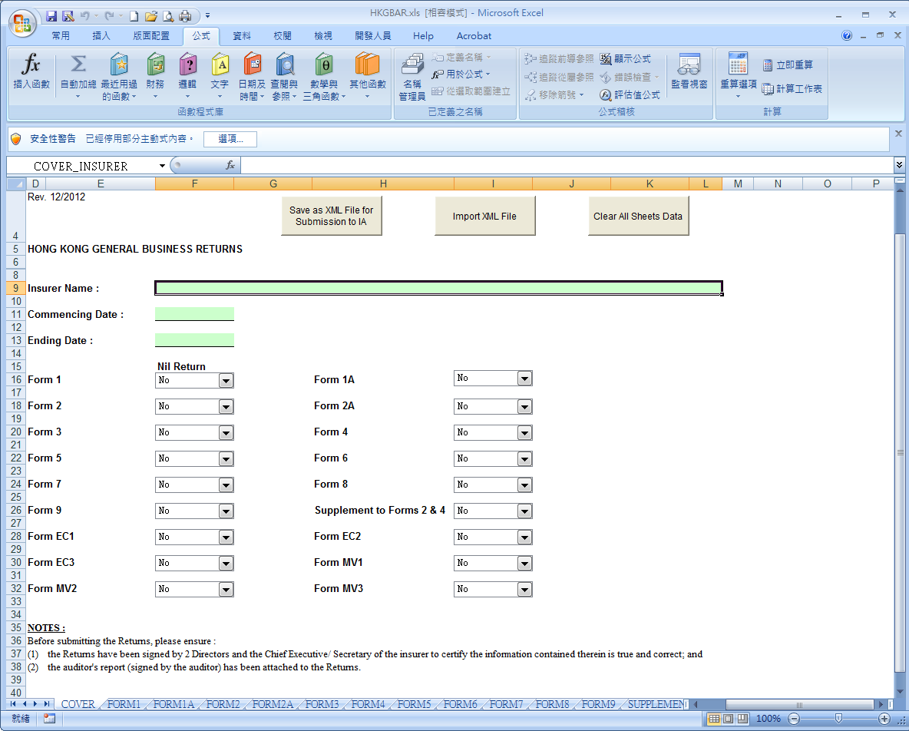

Select the following option to enable macros
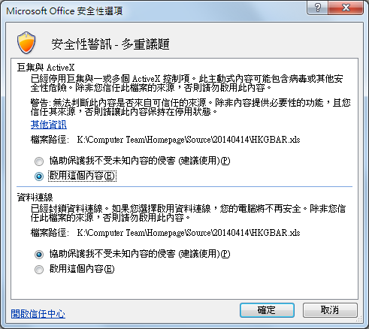

- The Cover Page of the return will appear. You should fill in the Insurer Name, the Commencing Date and the Ending Date. These particulars will be automatically displayed on each worksheet of the e-template. There is also a checkbox against each form of the return. If a particular form has nil return, please click “Yes” in the box against that form.
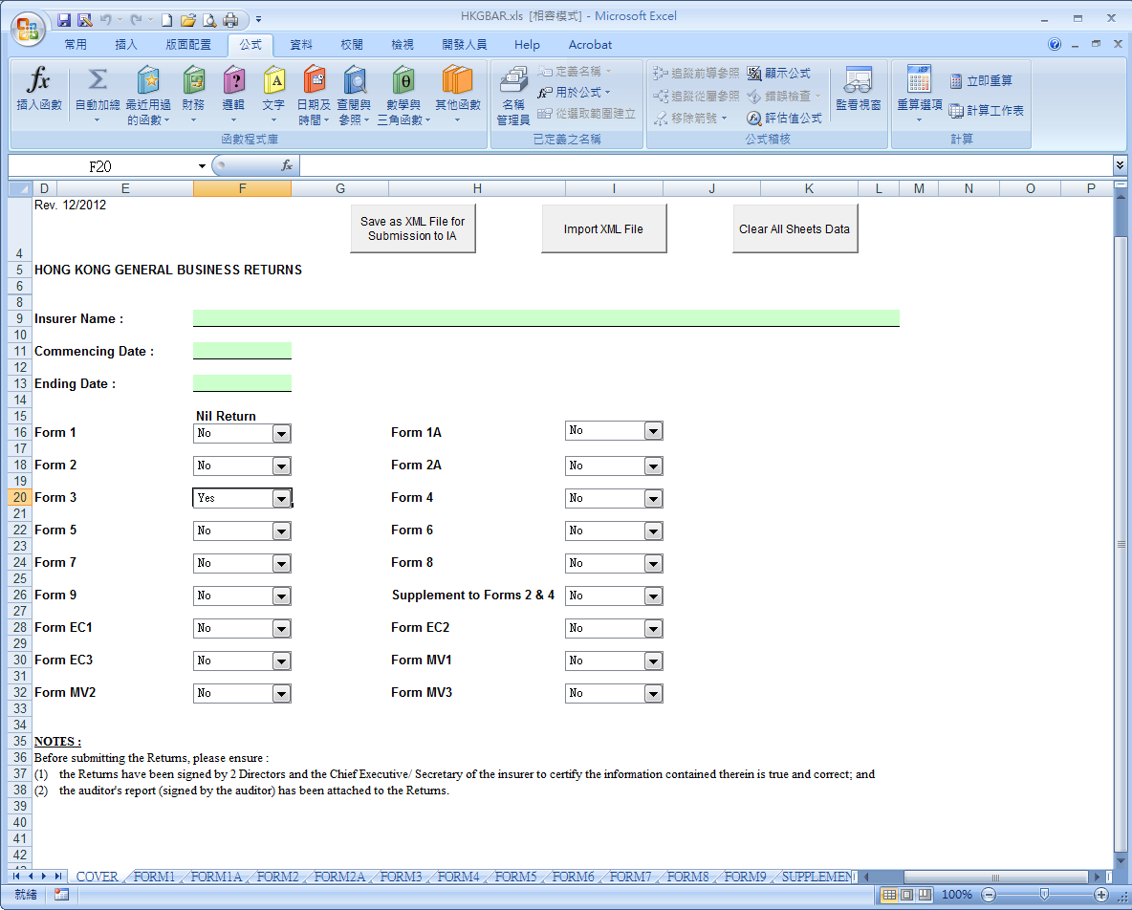
Click this button and select “Yes” if a particular form has nil return

- Click the tab at the bottom of the window to select the form to be inputted. Remember to input integer figures (decimal point and decimal digits are not acceptable) or an error message will be prompted (as below).

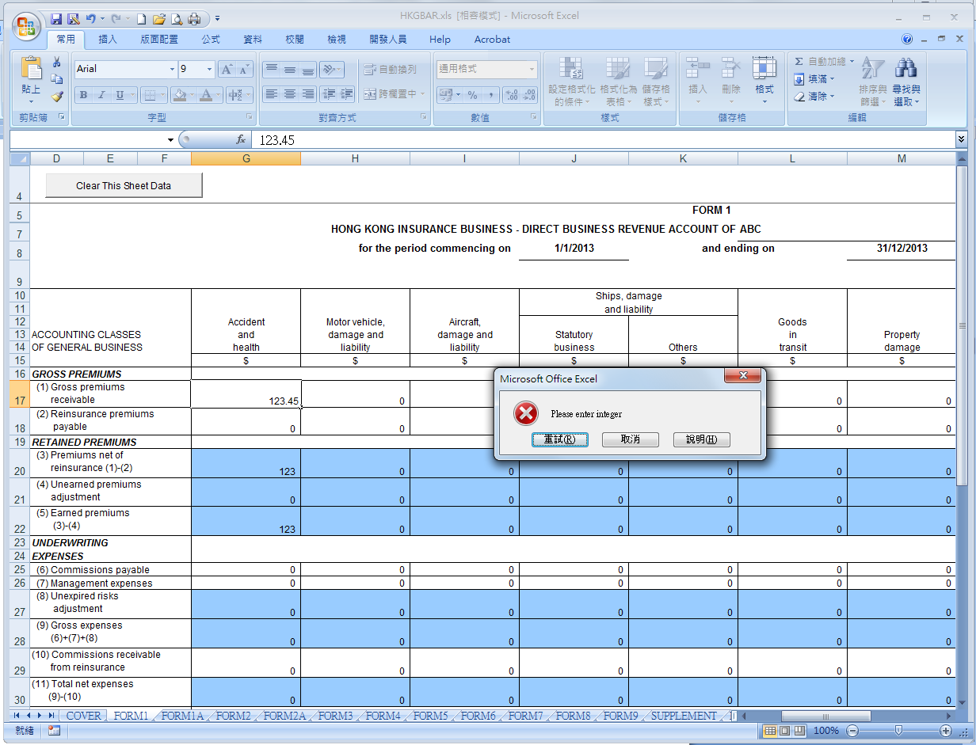
This error message will be prompted if non-integers are input

- Some forms, such as Forms 6 to 9 in HKGBAR and Form HKL1 in Hong Kong Long Term Business Returns (“HKLTBAR”), require you to select an item from the list before inputting the figures.
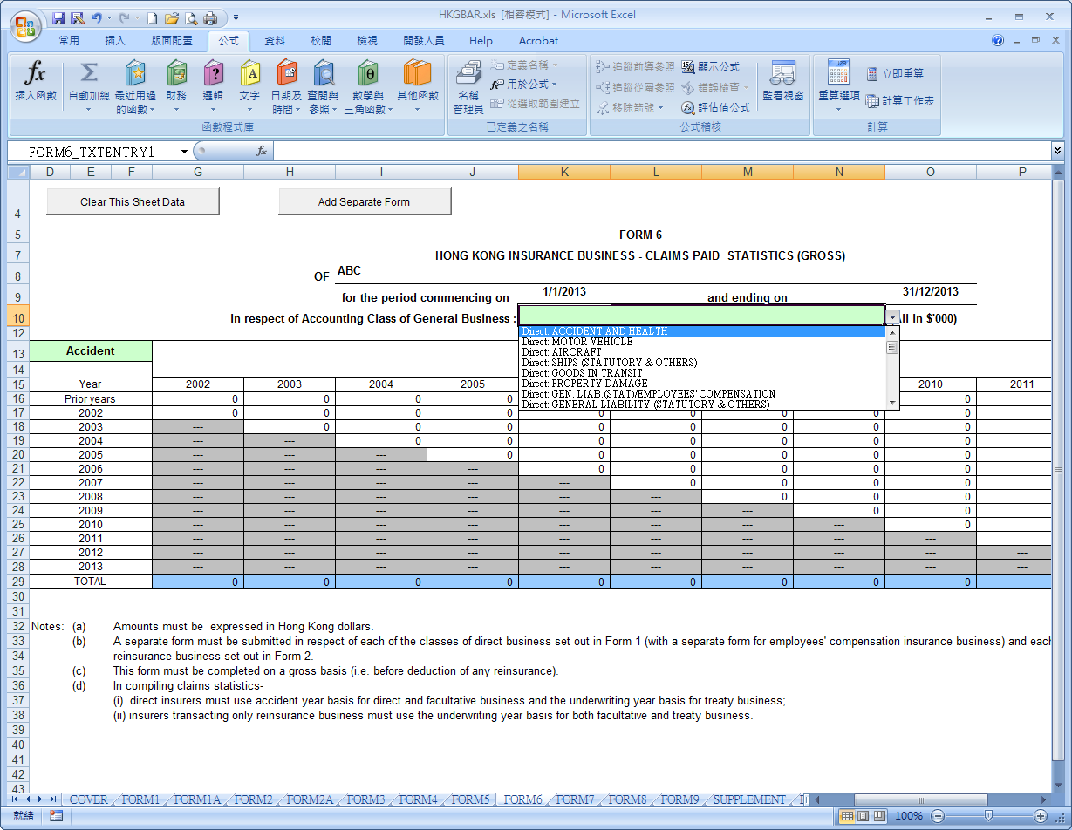
Click at end of this field and select the appropriate business class from the list

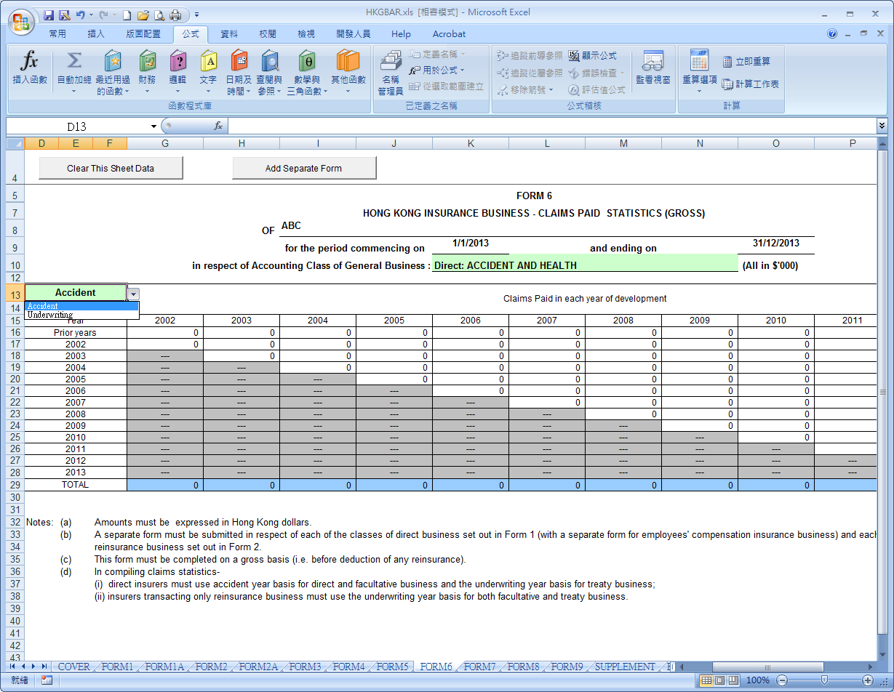
Click at end of this field and select the appropriate basis from the list

- Some forms, such as Forms 6 to 9 in HKGBAR and Form HKL1 in HKLTBAR, provide the “Add Separate Form” button to enable you to create a new blank form for data input of another business class.
Click this button to create a new blank form for data input of another business class

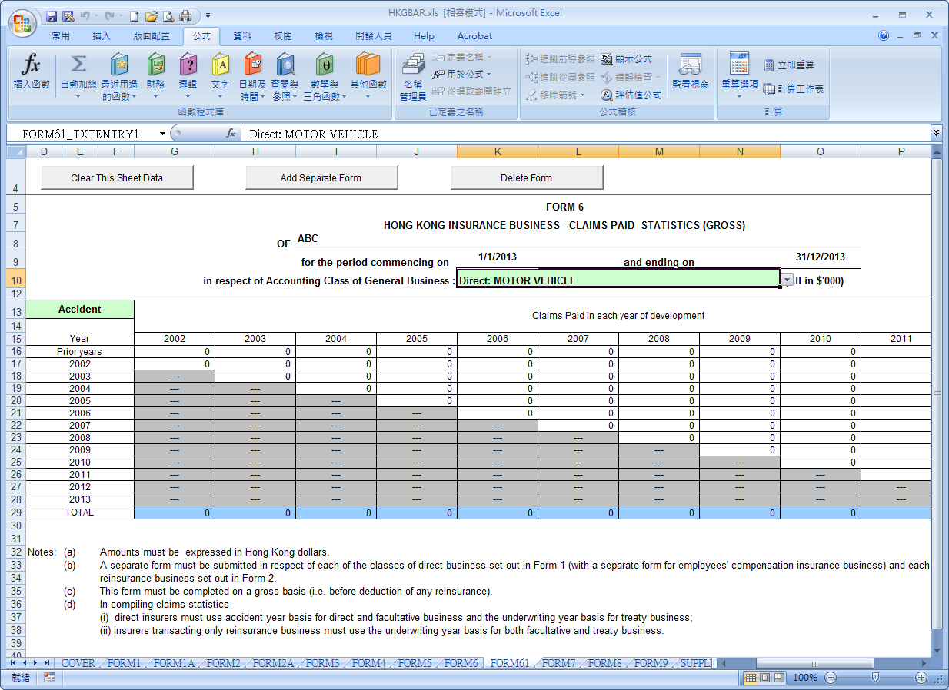
Click at end of this field and select another business class from the list
A new form with a unique system-defined form ID will be created; this form ID should not be changed

- Some forms, such as Forms 6 to 9 in HKGBAR and Form HKL1 in HKLTBAR, provide the “Delete Form” button to enable you to delete the current form that is created by “Add Separate Form” button.

Click this button to delete this form

- Some forms, such as Form HKL2, Forms M2 and M3 in HKLTBAR, provide the button to enable you to expand or compress certain detailed fields. A click on the button will display/hide the unused fields in a particular area.

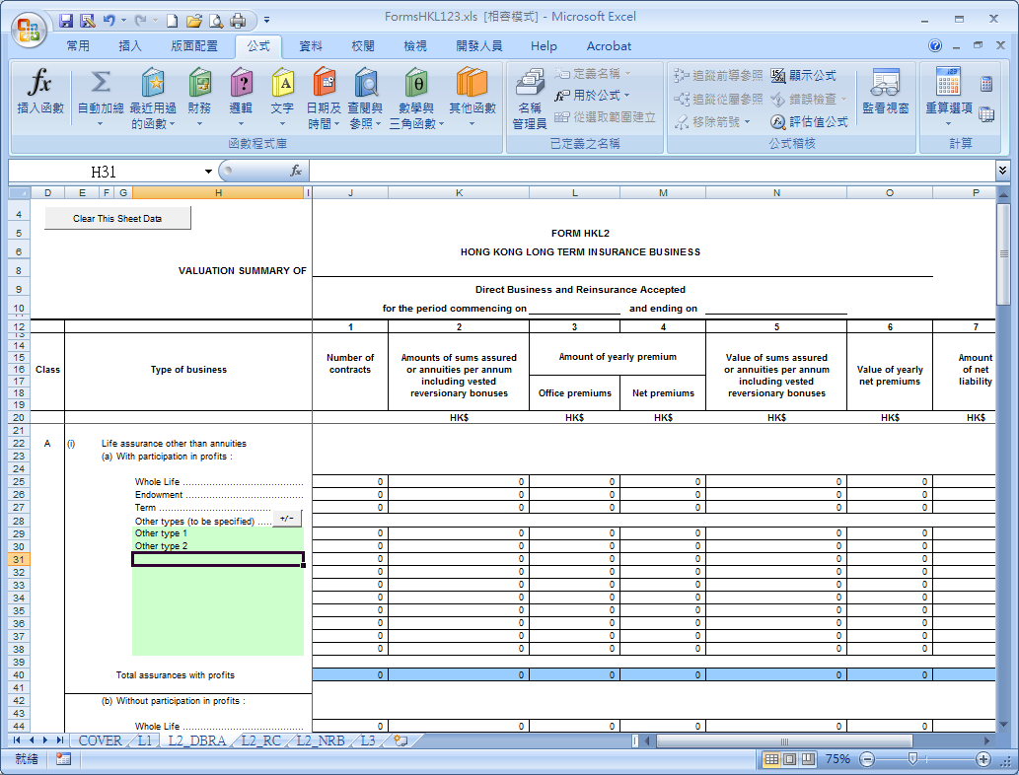
The system by default will display all fields (including the unused fields) in this area

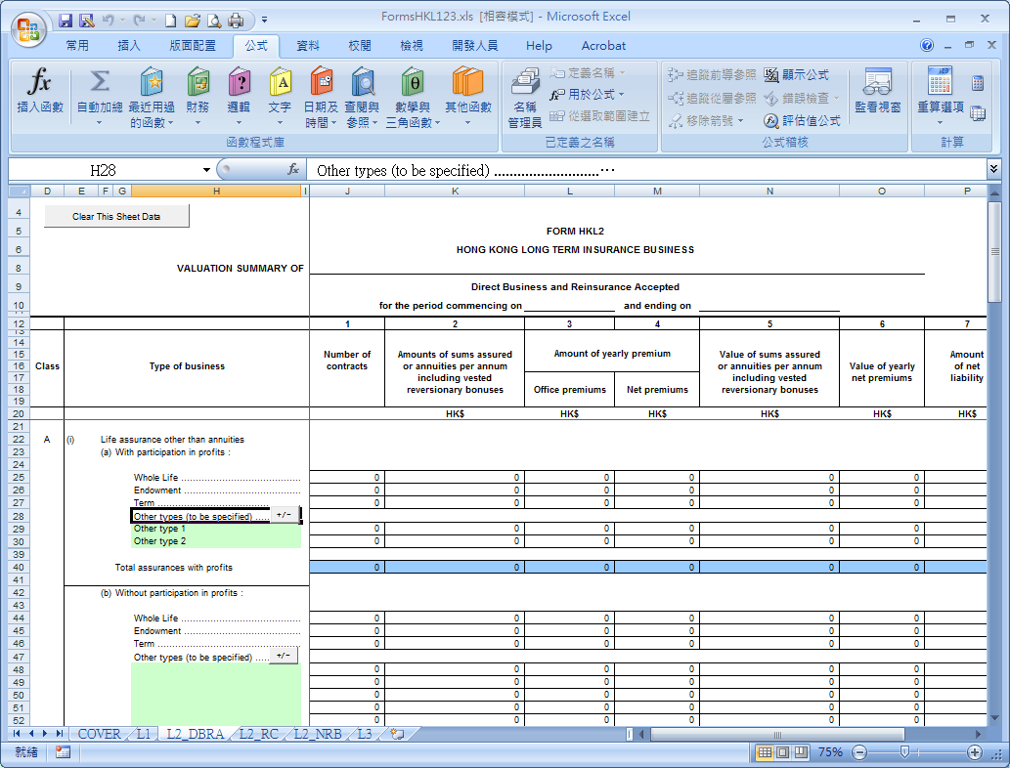
Click this button to hide the unused fields in this area. Click once more to expand the area in full size again.

- If you want to clear all input fields on a particular worksheet for amendments, you may click the “Clear This Sheet Data” button at the top left corner.

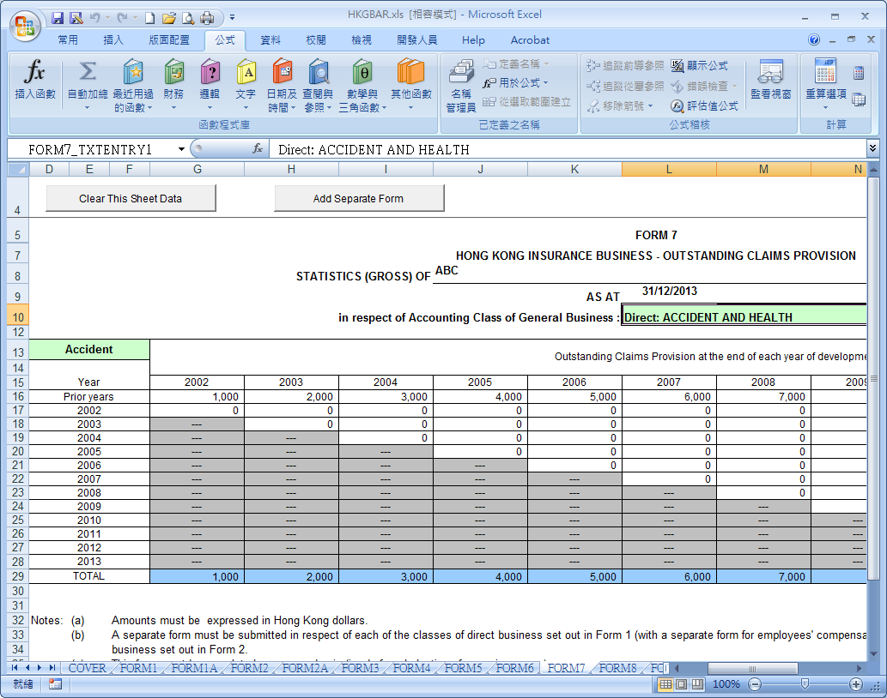
Click this button to clear all fields on this worksheet

- If you want to clear all input fields on all the worksheets, you may click the “Clear All Sheets Data” button at the top right corner of the Cover Page.

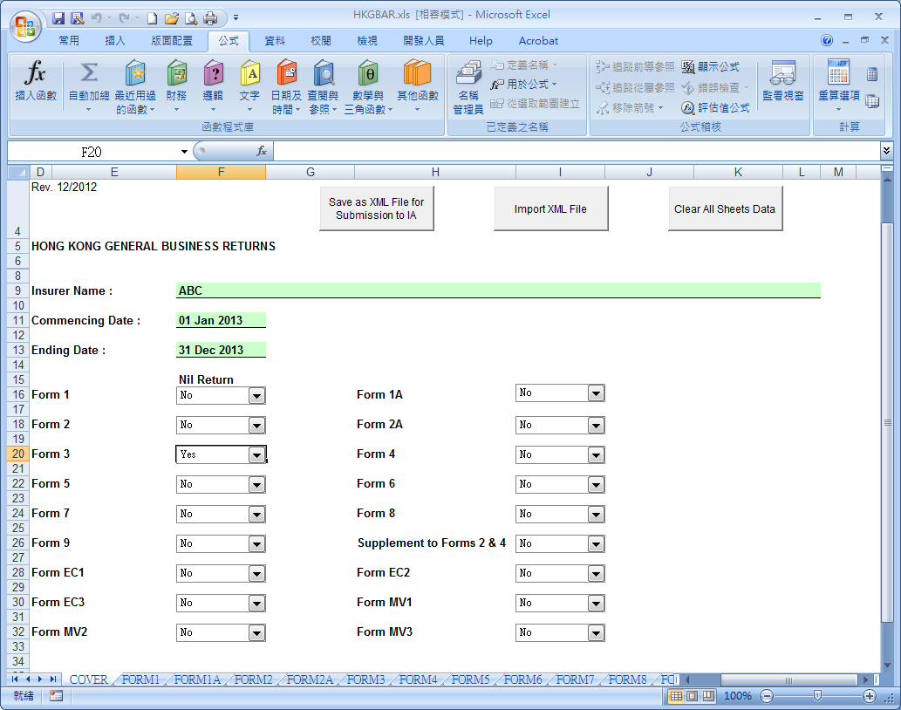
Click this button to clear all input fields on all the worksheets

III. How to save the Returns for amendments/ updates

(A) Save in Excel format

1. As normal Excel operations, you may save the Returns by clicking the “Save As” (另存新檔) icon from the menu bar to save the Excel file.

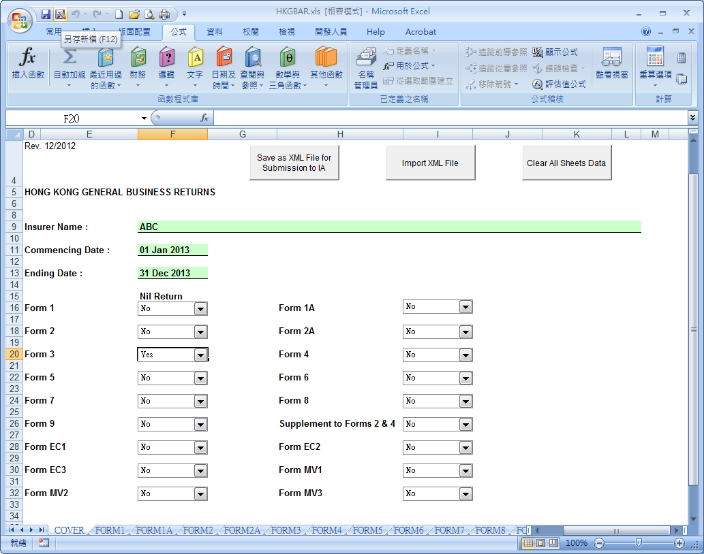
Click this icon to save the Returns in Excel format

- A dialogue box will appear. Type in the file name and the location where you want to save the file.

- Click “Save” (儲存) to save the Returns.

(B) Save in XML format

1. You may save the Returns in XML format by clicking the “Save as XML File for Submission to IA” button on the Cover Page.

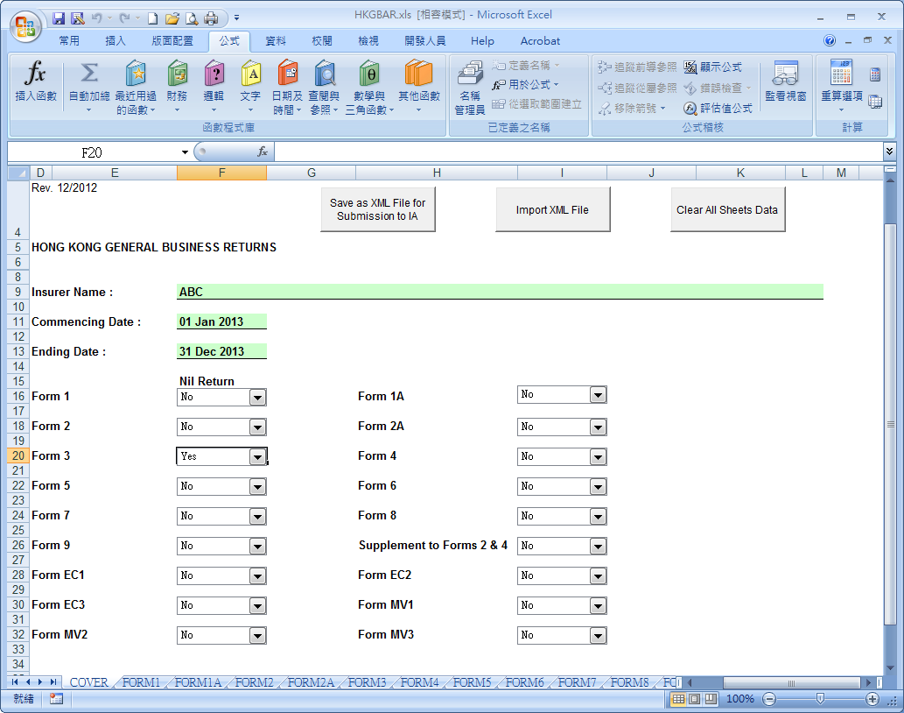
Click this button to save the Returns in XML format

- A dialogue box will appear. The name of the XML file will be automatically assigned.

- Type in the location where you want to save the file without changing the default file name.

- Click “Save” (儲存) to save the Returns.

IV. How to retrieve the saved Returns for amendments/ updates

(A) Retrieve the Excel file

- As normal Excel operations, you may retrieve the file under the Excel environment by clicking the “File Open” (開啟舊檔) icon from the menu bar.
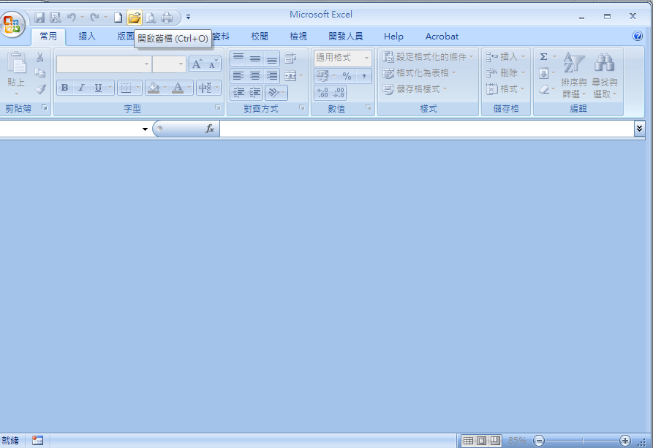
Click this icon to open a saved Excel returns file

- A dialogue box will appear. Select the file from the appropriate directory path and click “Open” (開啟).

- Please refer to steps 2 and 3 in section II for the handling of Microsoft Excel Macro.

(B) Retrieve the XML file

1. Open the corresponding e-templates previously downloaded.

2. Please refer to step 2 in section II for the handling of Microsoft Excel Macro.

3. Click the “Import XML File” button on the Cover Page.

Click this button to import the XML file

4. A dialogue box will appear asking to confirm the import and overwriting of all data. Click “Yes” (是) to confirm.

5. Another dialogue box will appear. Select the file from the appropriate directory path and click “Open” (開啟).

V. How to print a hard copy of the Returns

- As normal Excel operations, you may click the “Print” (列印) icon from the menu bar to print the Excel file.

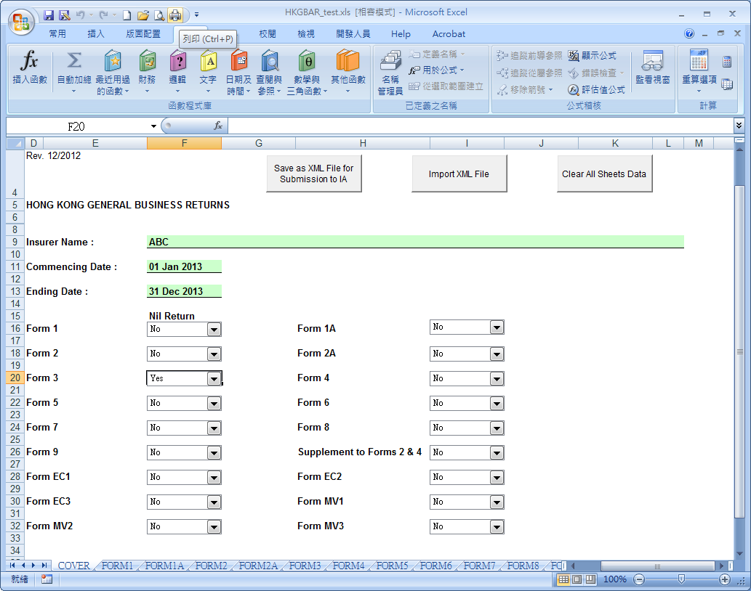
Click this icon to get a hardcopy of the Returns

- A dialogue box will appear asking for selection of printing details. Select the suitable parameters and click “OK” (確定) to print the Returns.

VI. How to submit the Returns to the Insurance Authority by electronic means

- After completing and checking the Returns, save the Returns in XML format by clicking the “Save as XML File for submission to IA” button on the Cover Page.

Click this button to save the Returns in XML format

- Submit the Returns to the IA by the Central Dataset Collection Portal (“CDCP”) or by e-mail.

- For submission of the Returns to the IA by the CDCP

The e-templates must be saved in XML format. The file could be uploaded to the CDCP after logging in the CDCP.

After uploading the file, insurers should click “Confirm Submission” to complete the submission process.

Insurers are recommended to submit the Returns by logging in the designated personnel’s CDCP account. If the Returns are submitted via the CDCP using the account of individual other than the designated personnel, a cover sheet with the signature of the designated personnel should also be uploaded to complete the submission.

- For submission of the Returns to the IA by e-mail

The e-templates must be saved in XML format. The soft copy of the covering certificate (Note) and the returns (saved in xls and xml format) should be sent to the IA’s designated e-mail address iafiling@ia.org.hk with copy to case officers. The e-mail should not contain returns of more than one insurer.

For the soft copy of the covering certificate, no signature is required (Note) if it is sent directly by the designated personnel (e.g. Key Person in Financial Control/ Compliance function, the Chief Executive, Director, Company Secretary) via his/ her email account. Otherwise, the scanned copy should bear the signature of the designated personnel.

Note: If no signature is required for the covering certificate, insurers could either send an unfilled covering certificate or include the statement “I certify that the information provided in the returns is true and correct.” in the submission email.

The subject matter and the content of an e-mail should contain identification information as specified below:
- Name of the insurer
- Short title of the returns
Short Title | Returns
HKGBQR | Hong Kong General Business Quarterly Returns
HKLTBQR | Hong Kong Long Term Business Quarterly Returns
HKGBR | Hong Kong General Business Returns
HKLTBR(HKL123) | Hong Kong Long Term Business Returns (Forms HKL1-3)
HKLTBR(M2M3) | Hong Kong Long Term Business Returns (Forms M2 & M3)
SAL | Statement of Assets & Liabilities

- Covering period of the Returns,
i.e. for Annual Returns: state the ending date of the period;
for Quarterly Returns : state the year and quarter (1, 2, 3, or 4)

